Supplier Portal - Receipting
Department of Justice and Community Safety

Table of contents
View Receipts 3
View Overdue Shipments/Receipts 4
Returns 5
Need Help? 6

View Receipts
The View Receipts page enables you to view all receipts that have been recorded for your shipped goods or completed services.
Step | Action
1 | Select the Shipments icon to open the View Receipts page
2 | You can search for a particular receipt using any of the parameters
3 | Select the Go button to display relevant receipt.  NOTE: You may need to select Go to show current receipts.
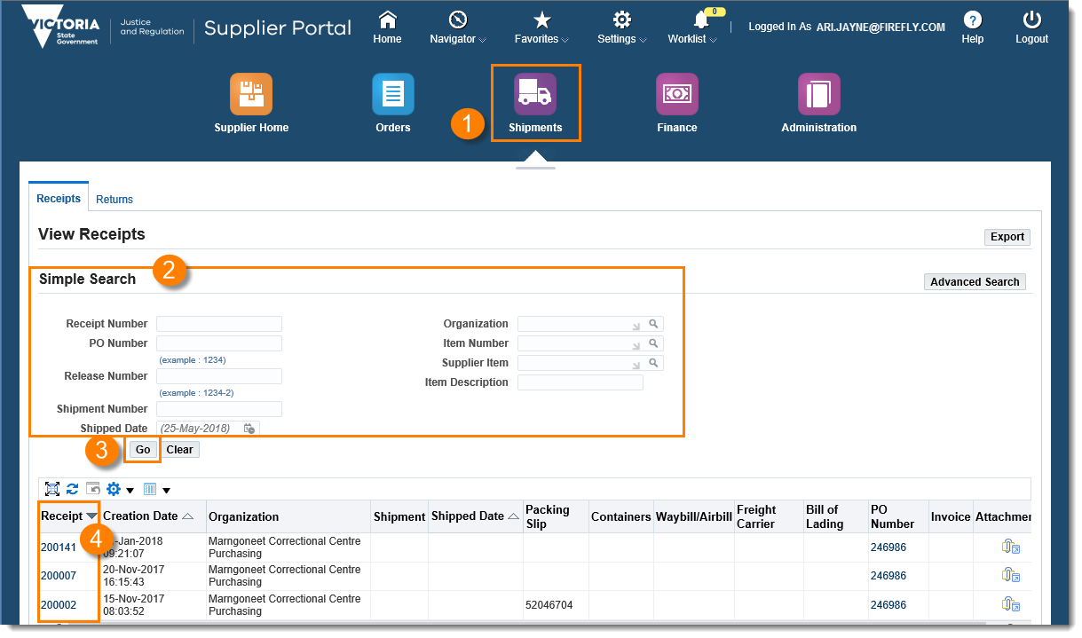
4 | Select the required receipt link from the Receipt column
 | The Receipt Detail page opens with information regarding that particular receipt, including Creation Date, Supplier details, Shipment details and purchase order information.

View Overdue Shipments/Receipts
The Overdue Receipts page enables you to view the details of past-due purchase order shipments. Past-due shipments are those items that are past the need-by-date and have not been receipted by the Department.
Step | Action
1 | Select the Shipments icon
2 | Open the Overdue Receipts tab
3 | You can search for a particular item or service using any of the parameters
4 | Select the Go button to display relevant purchase orders that have not been receipted against and are overdue
5 | Select the required purchase order number from the Receipt column
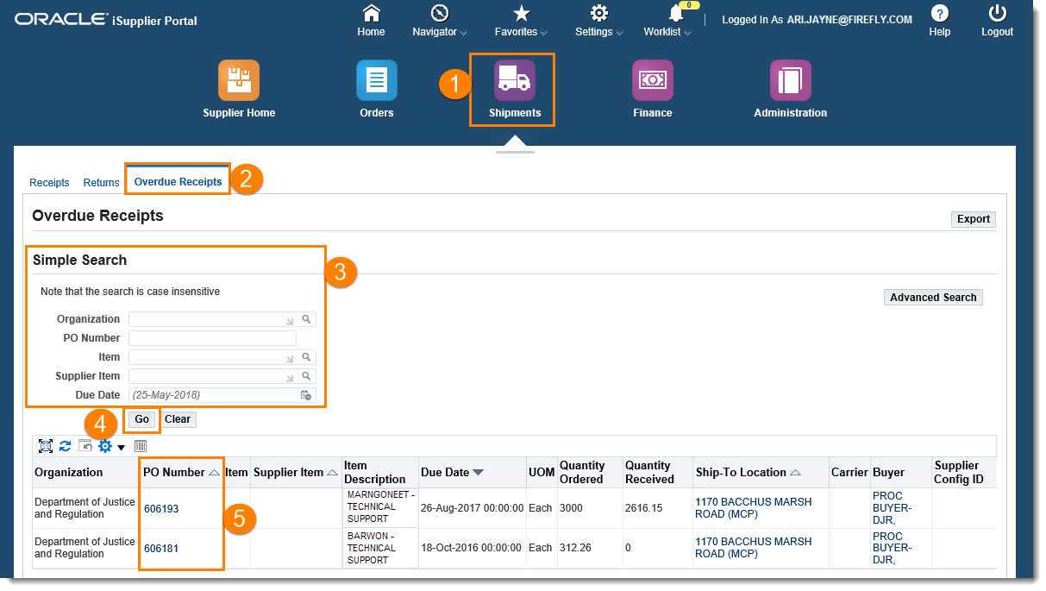
 | The Purchase Order page opens with information on the status of the purchase order

Returns
The Returns screen enables you to view the return history, including the reasons for goods being returned by the department.
Step | Action
1 | Select the Shipments icon
2 | Open the Returns tab
3 | You can search for a particular item or service using any of the parameters
4 | Select the Go button to display relevant Purchase Orders and Receipts that have returns recorded against them, as well as the reason for the return
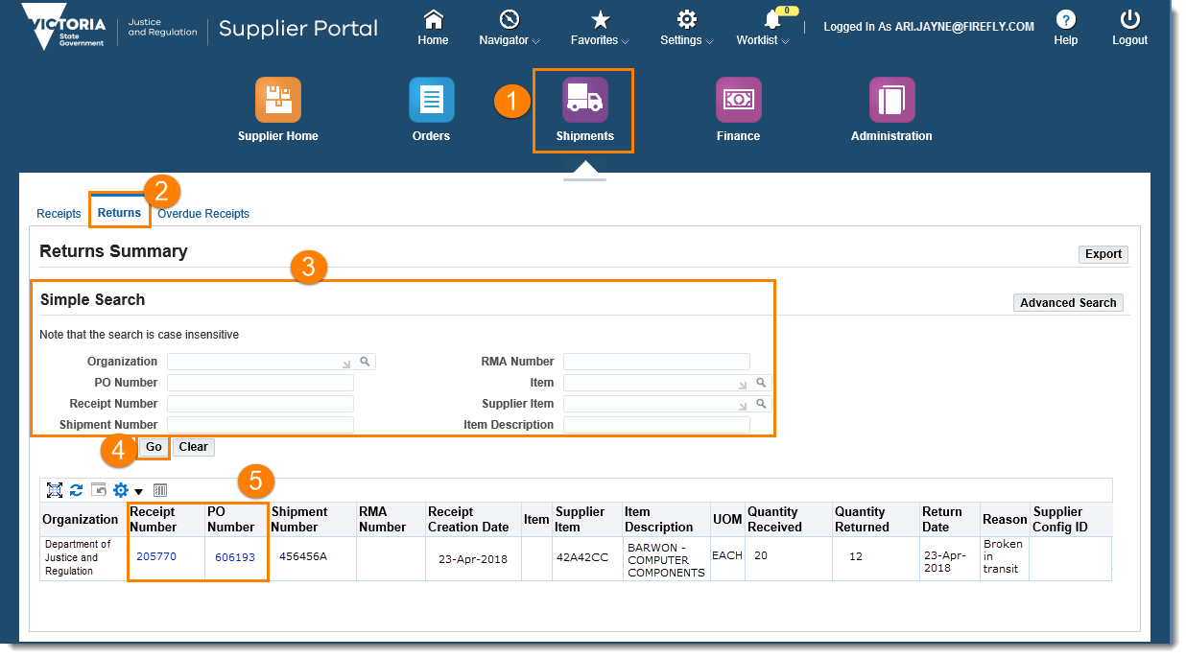
5 | Select the required purchase order number or receipt number for the return details

For general assistance with the Supplier Portal, please send request to the team: SupplierSupport@justice.vic.gov.au

For queries relating to Purchase Orders and Receipts in the Supplier Portal, contact the relevant business unit.

The Department of Justice and Community Safety and Court Services Victoria will support you in using the Supplier Portal.

Need Help?

