Supplier Portal – Manage My Site
Department of Justice and Community Safety

Table of contents
Set User Preferences 3
Maintain Company Details 5
Company Profile Links 6
Maintain Your Address Book 7
Maintain Contact Details 8
Create a New Contact 9
Update an Existing Contact 11
Add an additional address for a contact 13
Add the Business Classification 14
Adding Bank Details 16
Updating Bank Details 19
Resetting Your Password 20
Maintain Company Details 21
Adding Attachments 22
Need Help? 23

Set User Preferences
You can change your user settings or preferences at any time using the Preferences link at the top right-hand side of each screen in the Supplier Portal.
Step | Action
1 | Select the Settings link at the top of the screen
2 | Select Preferences – the General Preferences page displays. Change your preferences as per your requirements
 | 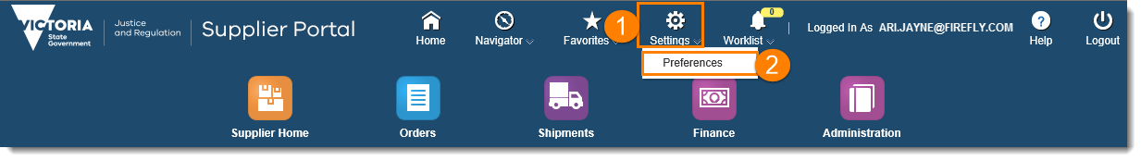
3 | General Preferences: this section will allow you to set your language, accessibility and regional settings, such as time zone, number format and currency
4 | Password: reset or change your password. Your password MUST have a minimum of ten characters – with at least one number and one letter. Your password must not contain characters that repeat next to each other OR contain your user name. It is recommended that passwords contain a mixture of upper and lowercase characters and at least one special character
5 | Notifications: select how you want to receive your notifications, e.g. HTML or plain text email

 | 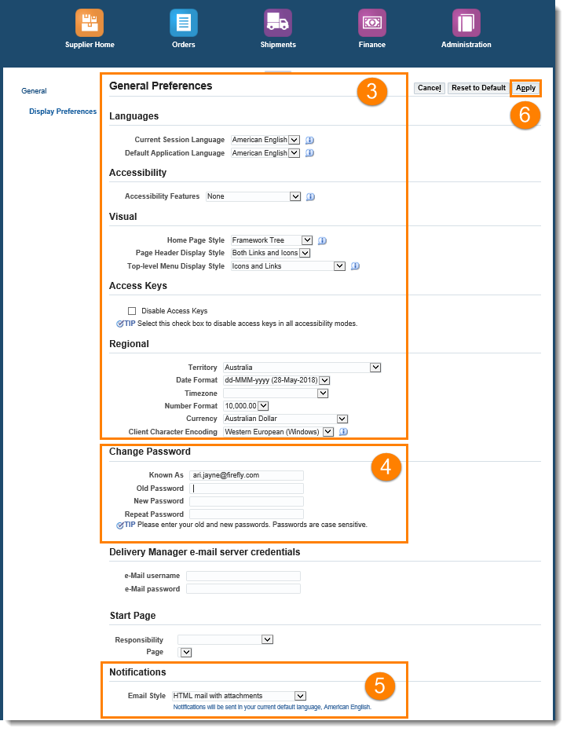
6 | Select Apply to save your changes

NOTE: Select the Cancel button to return to the system without making changes, or restore original settings by selecting Reset to Default

v

Maintain Company Details
You can maintain and update your profile directly within the Supplier Portal.

You can update:
- address book
- contact number
- bank account, and
- email addresses.

Any changes made by you will need to be approved by the department within 48 hours. It will then be reflected in the portal.

It is your responsibility to ensure that the data you input is accurate and approved by the right representative, who has the right level of authority, in your organisation.

Step | Action
1 | Select the Administration icon, the General screen opens
2 | Under the Company Profile in the left-hand menu – options appear for you to select from  Select the area in which you want to make the changes and update
3 | Add an Attachment to your company profile if required
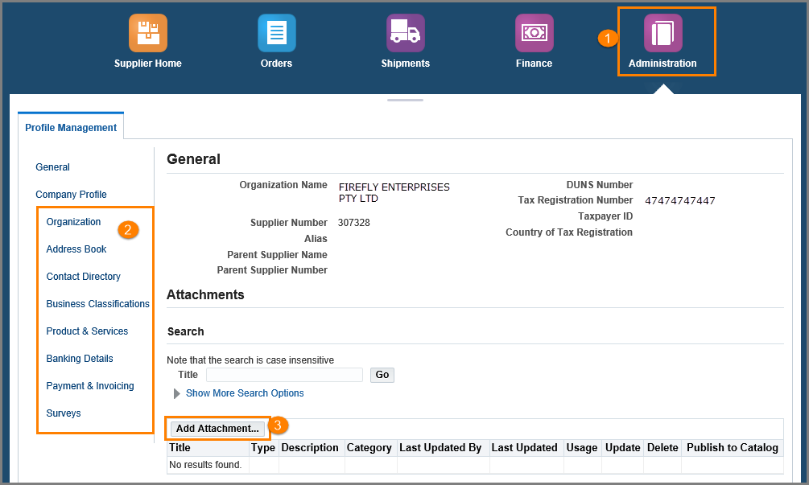

Company Profile Links
You can make the following changes in Company Profile.

Area | Description
Organisation | Allows you to add and update data and information about your company, including your  Tax Number and number of employees.  Once information is added or changed. Select Save
Address Book | Allows you to create a new address, update or remove an existing one within your company. See Maintain your Address Book
Contact Directory | Allows you to create contacts and update contact details within your company.  See Maintaining Contact Details
Business Classification | Select your Business Classification from a list, such as small business, minority owned.  See Add the Business Classification
Product & Services | Allows you to classify the type of goods or services that you offer.  Once information is added. Select Save
Banking Details | Add or update your banking details. See Add and Update Bank Details
Payment & Invoicing | A list of payments and invoices

Maintain Your Address Book
Step | Action
1 | Select the Administration icon, the General screen opens
2 | Select Address Book from the left-hand menu
3 | Select the Create button to create a new address. Add address information as required and select Save
4 | Select the Update icon to make changes to the existing address. Update fields as required and select Save
5 | Select the Remove icon to remove an address from the address book
 | 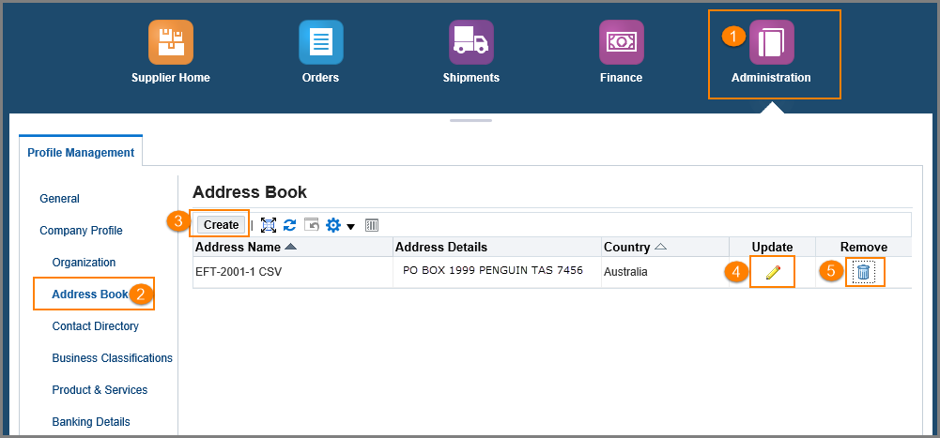

Maintain Contact Details
Step | Action
1 | Select the Administration icon, the General screen opens
2 | Select Contact Directory from the left-hand menu
3 | Select the Create button to create a new contact. Add contact information as required and select Apply
4 | Select the Update icon to make changes to an existing contact. Update fields as required and select Apply
5 | Select the Addresses icon to create additional addresses for a contact
6 | To see Inactive Contacts, select the Contact Direct: Inactive Contacts collapsible menu
 | 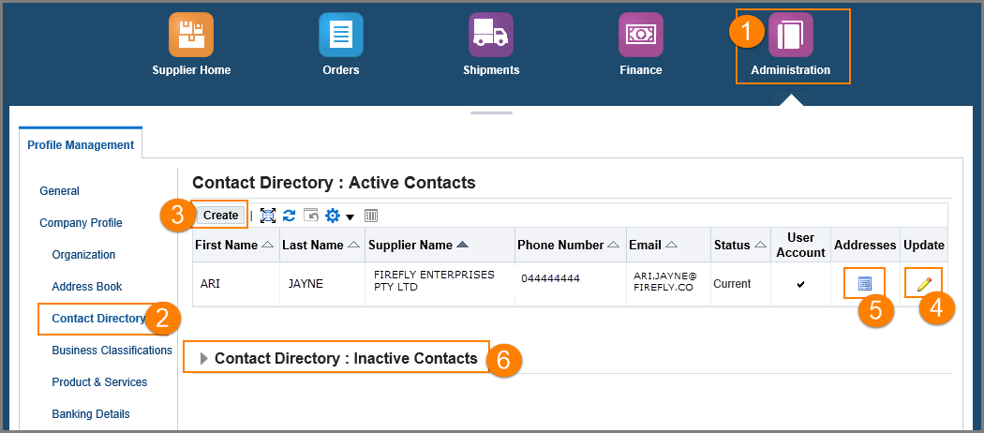

Create a New Contact

Step | Action
1 | Select the Create button
 | 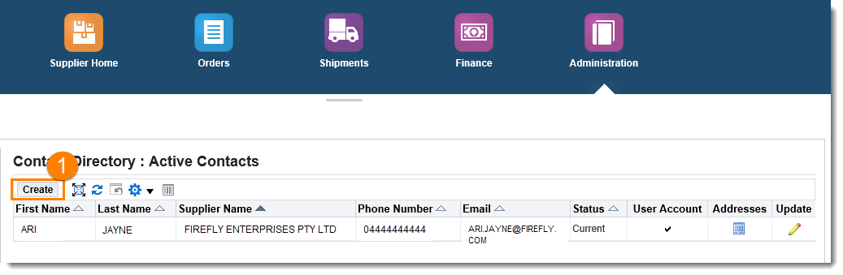
 | The Create Contact screen will display – complete all mandatory and non-mandatory fields as required
2 | Under User Account: select Create User Account checkbox if required  Enter the Supplier Name  Enter the Username (note – this is the users email address)
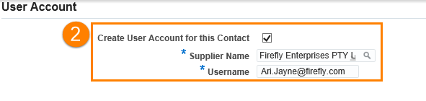
Note – when creating a new contact/user the user will receive Full Access. If the user requires View Only access, please send an email request to SupplierSupport@justice.vic.gov.au and include:
- the users full name
- the users email address
3 | To restrict access to certain sites (e.g. VOCAT) select the Modify Sites Button under the Site Restriction Tab – when the pop-up screen opens ensure that only the sites that the user should see are selected
4 | Select Apply

Step | Action
 | 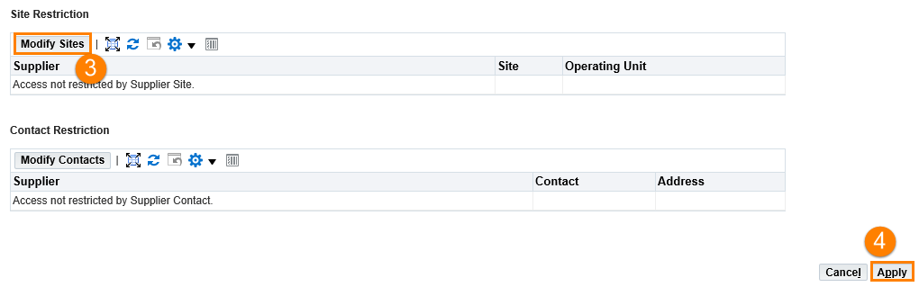

NOTE: The new contact will receive email confirmation with a User ID and a system generated password. The user will be prompted to change their password on first login.

Update an Existing Contact

Step | Action
1 | Select the Update icon
 | 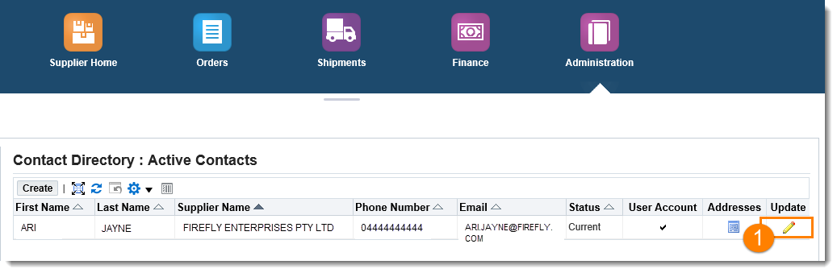
2 | The Update Contact screen displays. Update contact information as required
3 | If the contact/user is to be removed enter the Inactive Date
4 | If these are the only changes required, select the Apply button
5 | Select User Account Information collapsible arrow to reveal extra information
 | 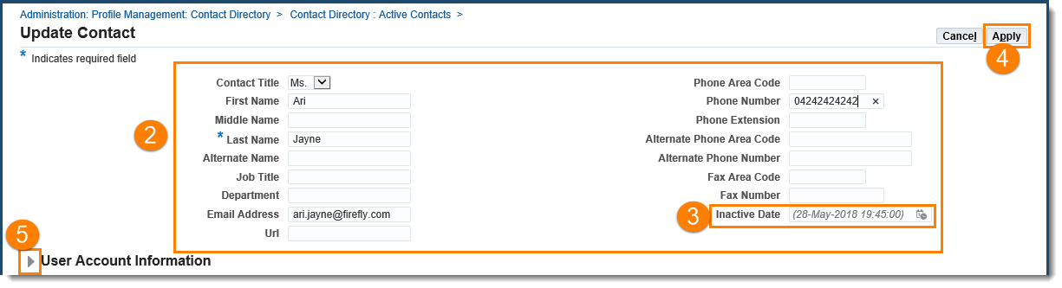
6 | Set Responsibilities as required
7 | Add User Restrictions as required
8 | Select Apply

Step | Action
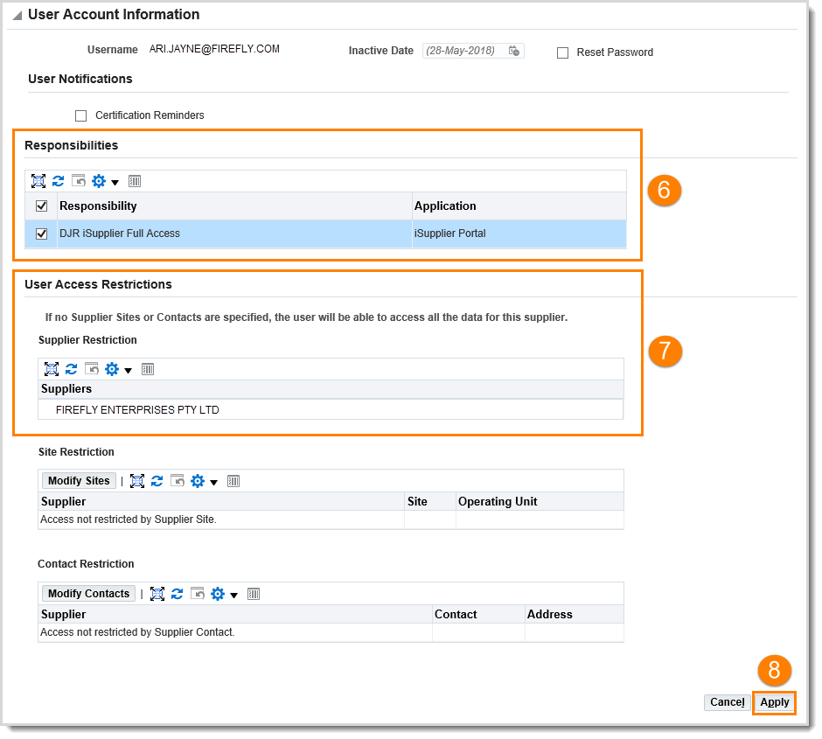

Add an additional address for a contact

Step | Action
1 | Select the Addresses icon
 | 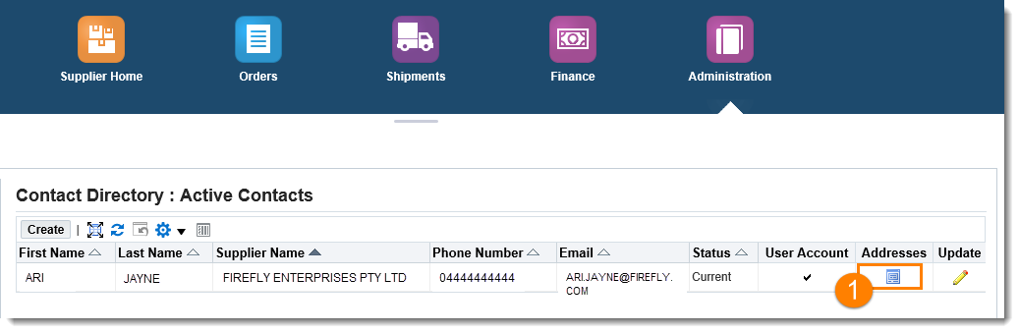
 | The Address Associations for Contact screen will display
2 | To remove an address, select the Remove icon
3 | To add a new address, select the Add icon.  Note: You cannot create a new address here, you can only select one from your Address Book. You must create any addresses first.
 | 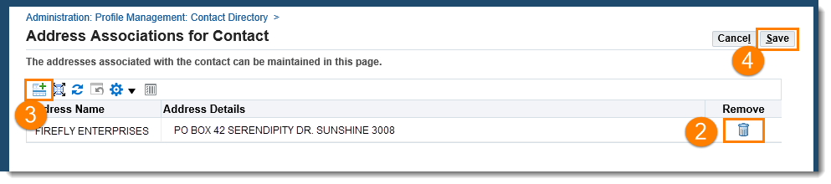
4 | When required address is found – select Save button

Add the Business Classification
Step | Action
1 | Select the Administration icon, the General screen opens
2 | Select Business Classifications from the left-hand menu
3 | Select the Applicable checkbox next to the appropriate classification
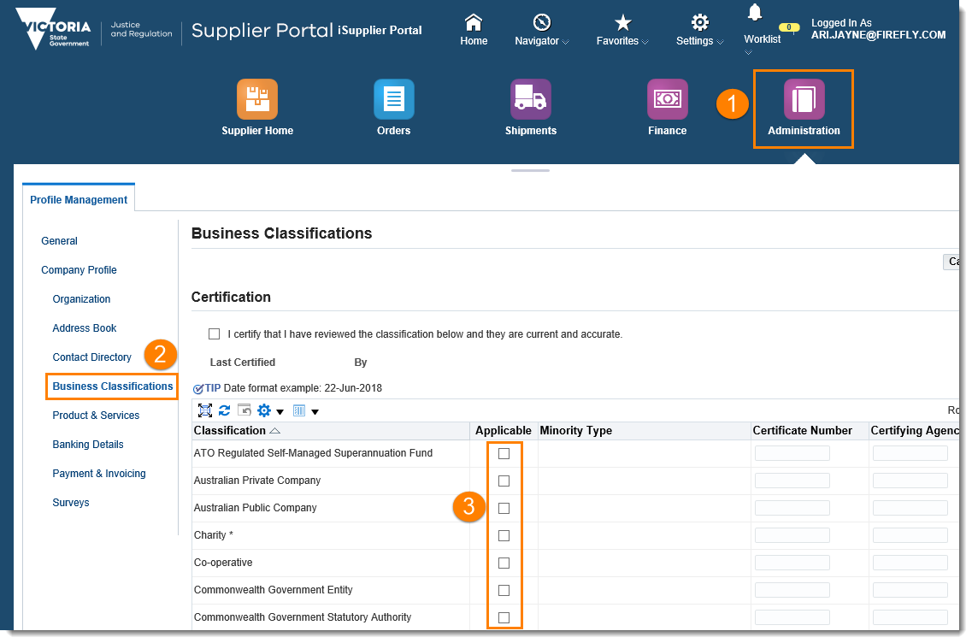
4 | Complete the fields next to the appropriate classification:  - Minority Type (if available)  - Certificate Number  - Certifying Agency  - Expiration Date (use calendar to select date)
5 | Select the Certification checkbox certifying that you have reviewed the classification and can confirm it is current and accurate
6 | Select Save

Step | Action
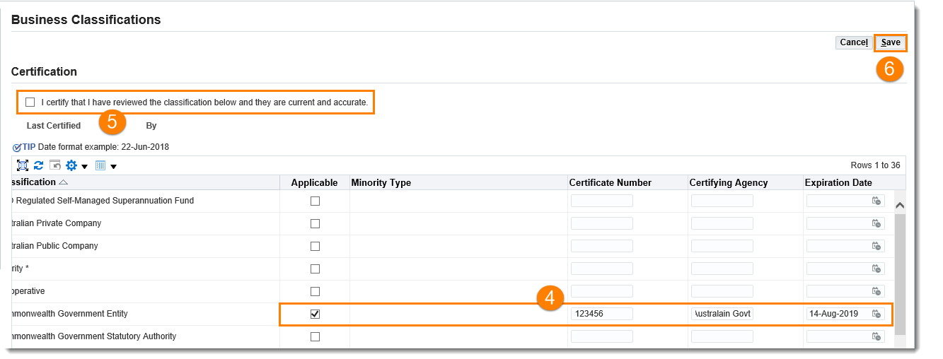
7 | Return to the General screen in Profile Management
8 | Add an appropriate attachment supporting classification where required by selecting  Add Attachments
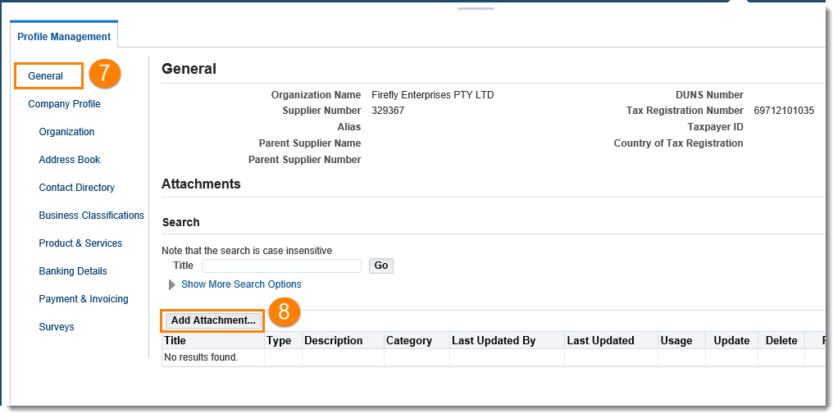
9 | Complete Add Attachment pop-up window and Apply  - Attachment Type: File  - Title: name of document  - Description: description of document  - Browse for file

Step  Adding Bank Details | Action
1 | Select the Administration icon, the General screen opens
2 | Select Banking Details from the left-hand menu
3 | Select the Create button to create new banking details
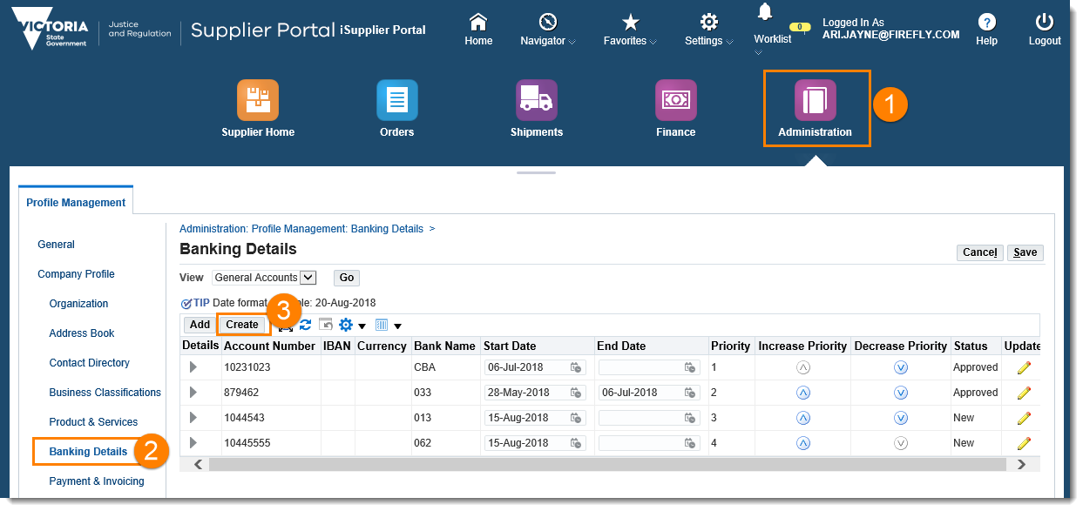
 | Please Note: You will not need to select the Add button – this is to add a bank account that is being used by your company on another site. If you wish to share bank details, please contact Supplier Support
The Create Bank Account screen opens with the following sections to complete:
- Bank – ANZ, Commonwealth etc., or a bank that does not currently exist in the system
- Branch – an existing branch or a branch that is currently not in the system
- Bank Account
- Comments – add comments for the department
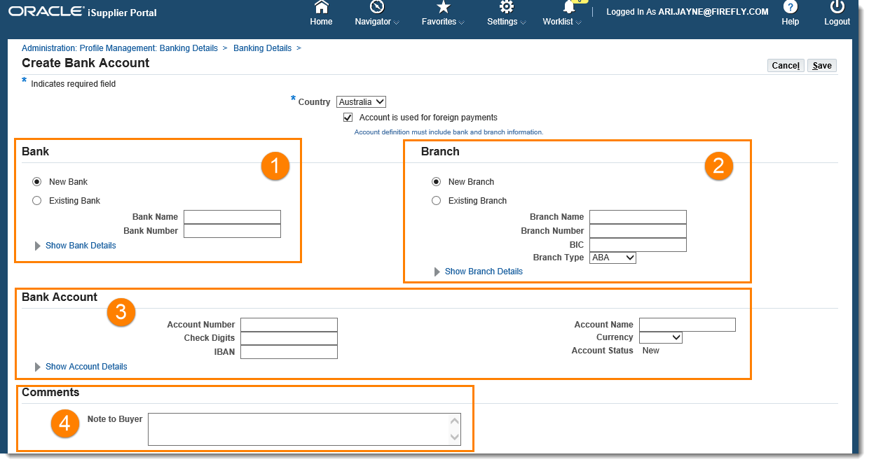
5 | Select Show Bank Details icon will display more areas to complete
 | 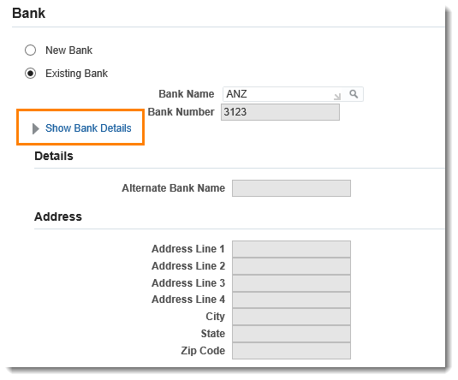
5 | Complete Branch details section – choosing whether branch currently exists within the system or needs to be added as a new branch. Select Show Branch Details link to complete additional areas
 | 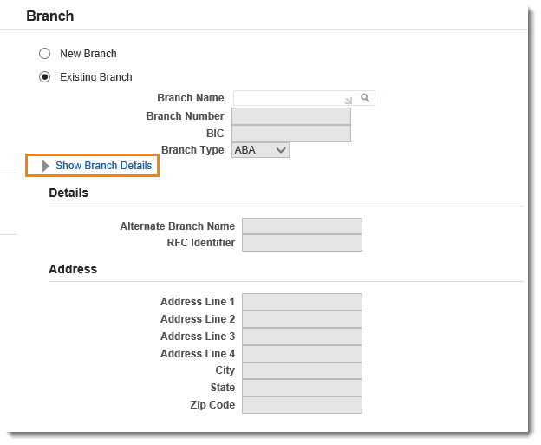
6 | Complete Bank Account details section. Select Show Account Details link to complete additional areas
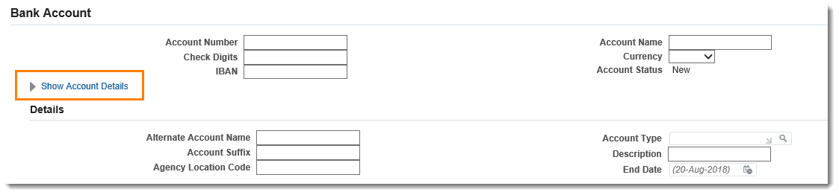
7 | Type in a Note to Buyer (the Department) advising of the attachment. Add supporting documentation through Add Attachment on the General screen
8 | Select the Save button
Please note: Supporting documents must be attached to validate the bank details

Updating Bank Details
Step | Action
1 | Select the Administration icon, the General screen opens
2 | Select Banking Details from the left-hand menu
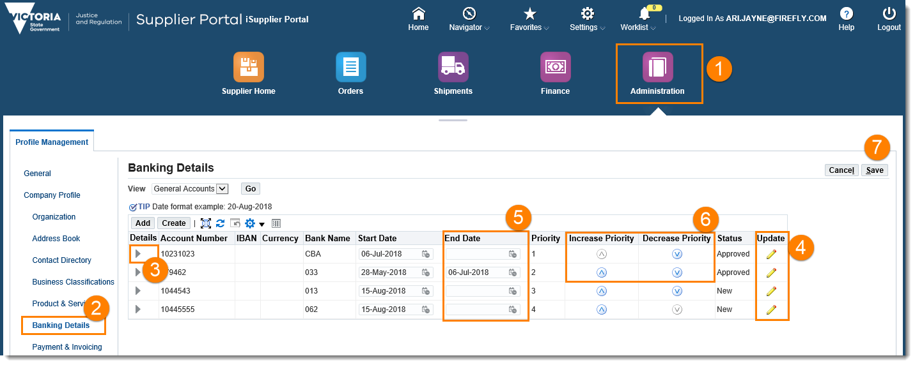
3 | Open the details collapsed menu to see more information about this account
4 | Select the Update icon to make changes to the existing account
5 | Set an end-date for the date a bank account can no longer be used
6 | Use the Increase Priority and Decrease Priority arrows to change the order in which the account numbers are used and displayed
7 | Select the Save button
8 | Add supporting documentation through Add Attachment on the General screen
 | Once the Bank Account update has been reviewed and approved by DJCS a notification email will be sent to the user who has inputted the change
Please note: Supporting documents must be attached to validate the bank details

Step | Action
1 | Access the Oracle log in page
2 | Select the Login Assistance button
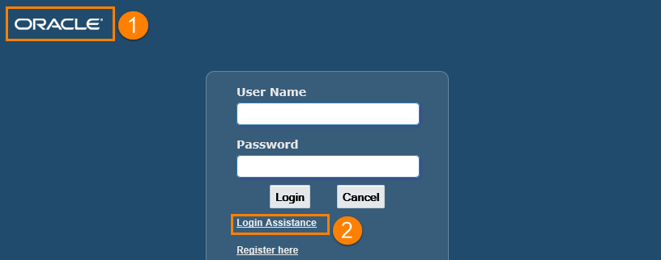
3 | Enter your User Name (note – this is your email address)
4 | Select Forgot Password
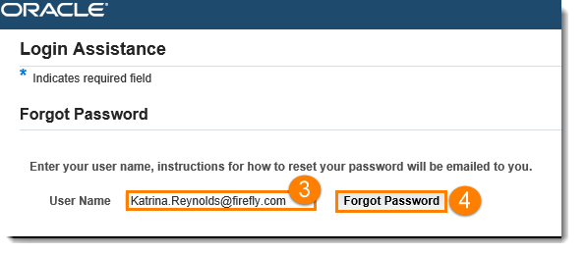
5 | The confirmation message will display and direct you to access your email to complete the password reset process.  Please note – you may need to check your junk mail folder if you do not receive the email.
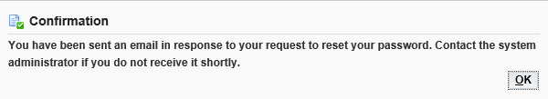

Resetting Your Password

Maintain Company Details
Step | Action
1 | Select the Administration icon, the General screen opens
2 | Under the Company Profile in the left-hand menu – options appear for you to select from  Select the area in which you want to make the changes and update
3 | Add an Attachment to your company profile if required

Adding Attachments
Attachments must be added for Business Classification and Banking Detail changes and additions.

Step | Action
1 | Select the Administration icon, the General screen opens
2 | Select Add Attachment button
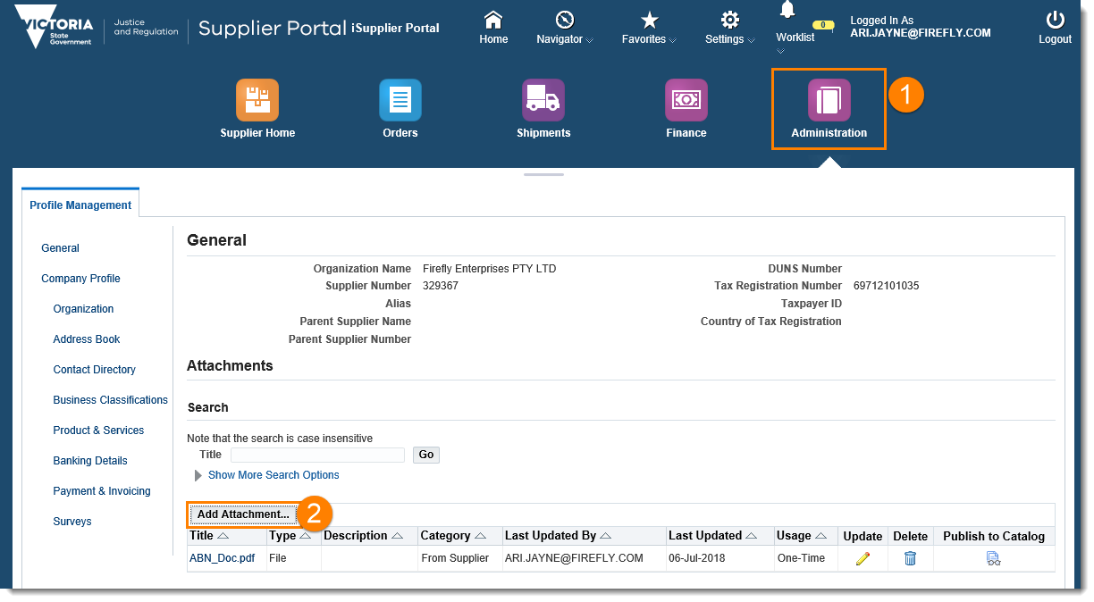
3 | The Add Attachment pop-up opens
4 | Select Attachment Type from the drop-down
5 | Type in Title of document
6 | Type a Description of the document
7 | Browse for the file – you can add any number of attachments by selecting Add Another
8 | Select the Apply button
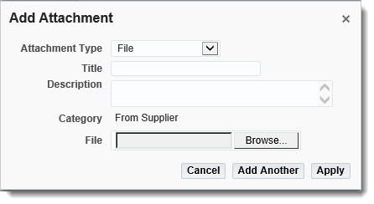

For general assistance with the Supplier Portal, please send request to the team: SupplierSupport@justice.vic.gov.au

For queries relating to Purchase Orders and Receipts in the Supplier Portal, contact the relevant business unit.

The Department of Justice and Community Safety and Court Services Victoria will support you in using the Supplier Portal.

Need Help?

