Supplier Portal - Invoices
Department of Justice and Community Safety

Table of contents
View Invoices 3
View Specific Invoice Details 4
View Payments 5
View Specific Payment Details 6
Process to create Invoices 7
How to Create Invoices 8
Need Help? 11

View Invoices
Step | Action
1 | Select the Finance icon
2 | Select the View Invoices tab
3 | You can search for a specific invoice using any of the parameters
4 | Select Go button
5 | Invoices that have been issued for the department display
6 | Select the Invoice number link to view the details of the invoice. You can also view any associated purchase order(s) or payments. The Status column indicates whether the invoice is In-Process, Approved or Cancelled
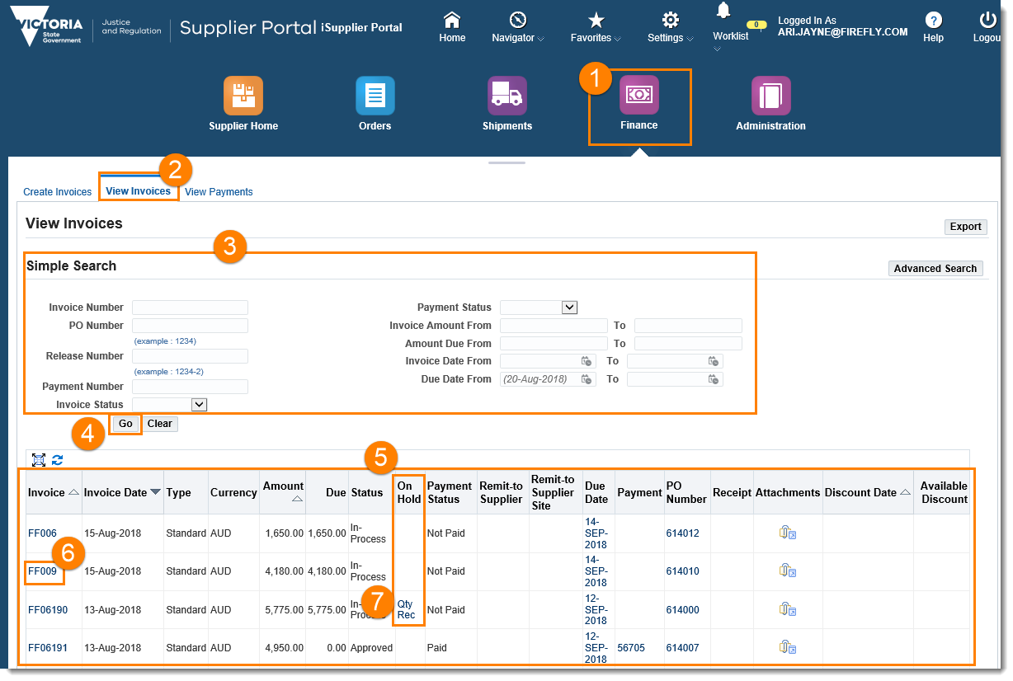
7 | If an invoice is on hold – it will appear in the On Hold column – selecting this link will open information as to why the invoice is on hold

View Specific Invoice Details
Area | Description
1 | General: General information about the invoice
2 | Amount Summary: The amount of the invoice, including freight and tax
3 | Payment Information: The amount currently paid against the invoice, including payment date
4 | Invoice Lines tab: Detailed information on the different lines on the invoice, e.g. One line excluding tax, one line for GST
5 | Scheduled payments tab: Details about a payment that is scheduled to occur, including payment method, and remaining amount to be paid
6 | Hold Reasons tab: Details about why an invoice may not have been paid, e.g. quantity billed may exceed quantity received
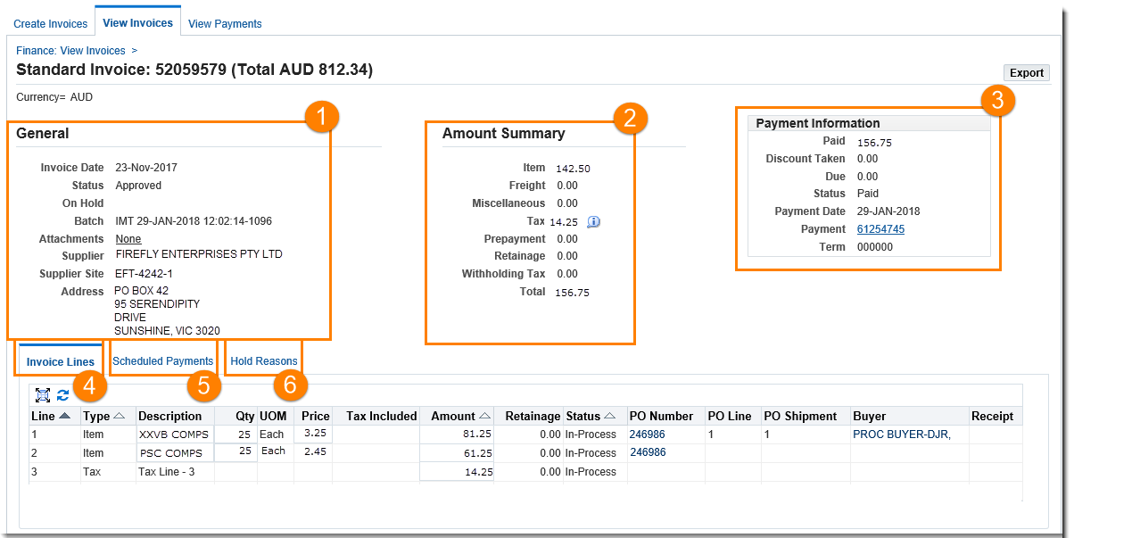
When you select an invoice to open, the Invoice page will display. From here, you can view General, Account, and Payment information.
Status | Explanation
Automatch | The invoice has been successfully matched to the purchase order by the system
Incomplete | Workflow still awaiting action
eForm Saved | Workflow completed and saved but not yet submitted for approval
Submitted | Workflow completed and submitted for approval
Approved | Workflow approved but not yet transferred for payment processing
Transferred | Workflow approved and transferred for payment processing
Cancelled | Workflow cancelled - see reason
Rejected | Workflow rejected by approver awaiting resubmission

View Payments
The View Payments page allows you to view the history of all the department payments to your invoices.
You can use the View Payments page to search using various search criteria, including:
- Payment number
- Invoice number
- Payment date
- Purchase order number Status.

Step | Action
1 | Select the Finance Icon
2 | Select View Payments tab
3 | You can search for a particular item or service using any of the parameters, select the Go button
4 | Payment details display
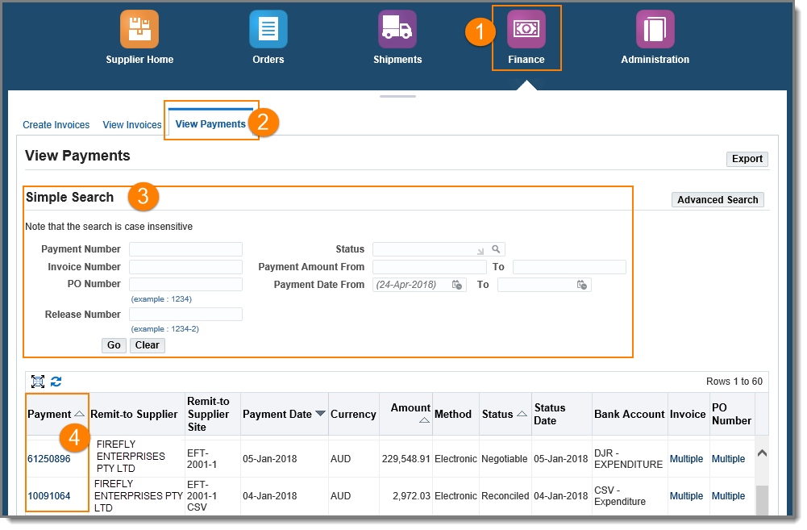
 | Select the relevant Payment number link to be taken to the payment details page
NOTE: The Status field indicates whether the payment is Negotiable or Reconciled.

View Specific Payment Details
When you select a payment to open, the Payment Number page will display. From here, you can view the payment date, and the invoice/s that were issued.

Step | Action
1 | Payment number and total: This section lists the total payment, the date of total payment, and all your Supplier details
2 | Included Invoices: This section lists all the invoices that were impacted by this this payment, as well as the date paid and the corresponding department purchase order number
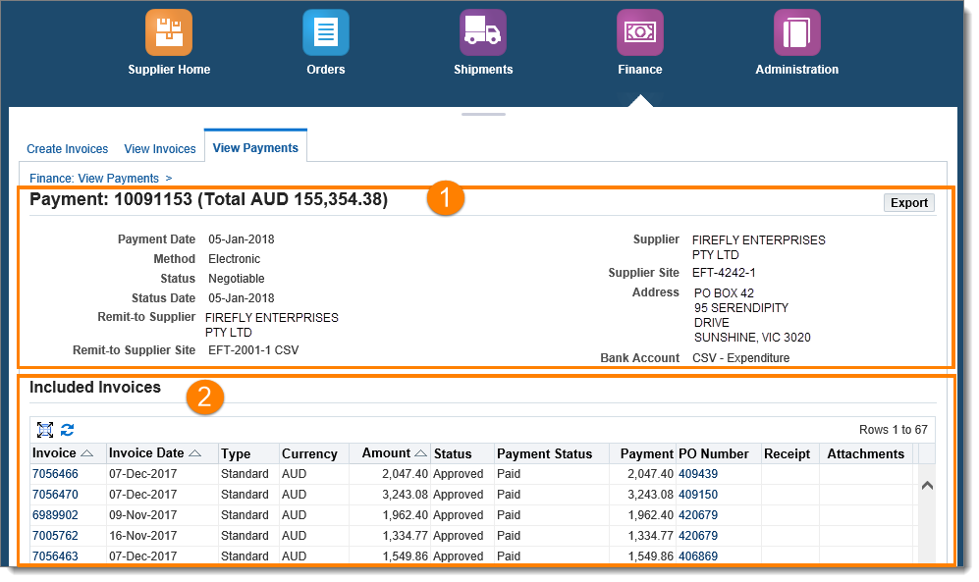

Process to create Invoices
One of the key features of the Supplier Portal is the ability to create purchase order-based invoices directly in the system. By creating an invoice in the portal, you will be issuing an invoice that will match the purchase order which helps with timeliness of payments.

1
2
3
4
5
6
Log in to the Supplier Portal

Locate the purchase order that you want to invoice against
Create the invoice and add necessary details
Review and submit your invoice to the Department of Justice and Community Safety accounts payable
The system will validate, match and pay your invoice when receipting has been completed, within the payment terms
When the invoice has been successfully matched the invoice status changes in the Supplier Portal
Note: The create invoice functionality is a feature and is NOT mandatory. You may continue to issue invoices in line with the current process.

How to Create Invoices
The Supplier Portal allows you to generate an invoice in the system against a purchase order.

Step | Action
1 | Select the Finance Icon
2 | Select the Create Invoices tab
3 | Select the Go button
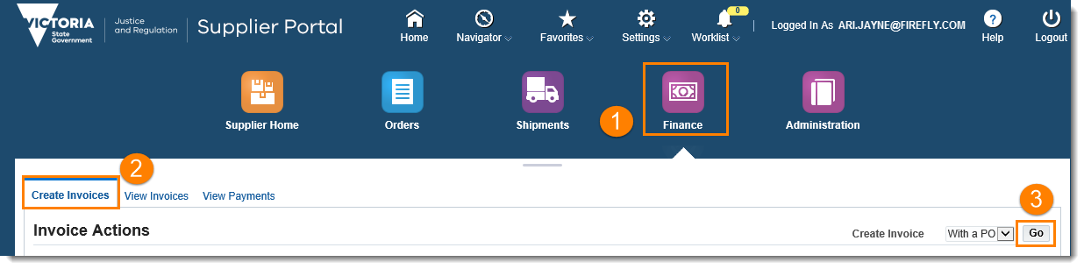
4 | Perform a simple Search to locate the purchase order and then press the Go button.  Note: The Advanced Search function can also be used if desired.
5 | Select the relevant checkboxes for the purchase order lines to be invoiced
6 | Select the Next button
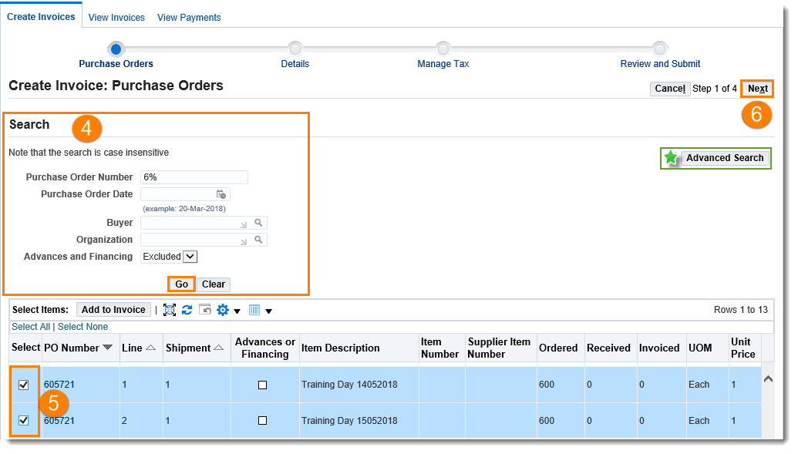

Step | Action
7 | The Create Invoice: Details screen will display
8 | Enter the Invoice Number
9 | Enter an Invoice Description
10 | Add the Delivery Docket or Waybill as the attachment
11 | Enter the Remit To Bank Account. Note – only the current active bank account that is listed in the administration tab of the Supplier Portal can be entered in this field.
12 | Update the Invoice Line Item quantities if required
13 | Select Next
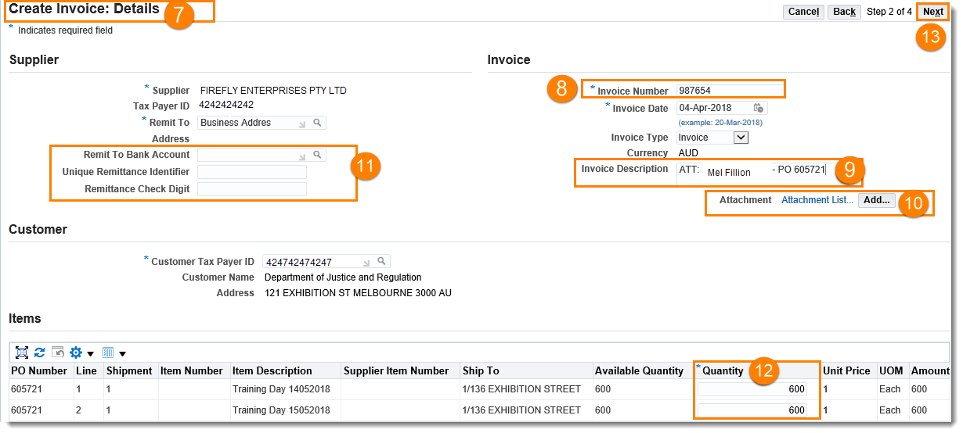
14 | The Create Invoice: Manage Tax screen will display
15 | The Summary Tax Lines section can be updated if required.  Note: If changing the Tax Rate or Tax Amount (i.e. GST does not apply) you must update the fields and then select the Calculate button

Step | Action
 | 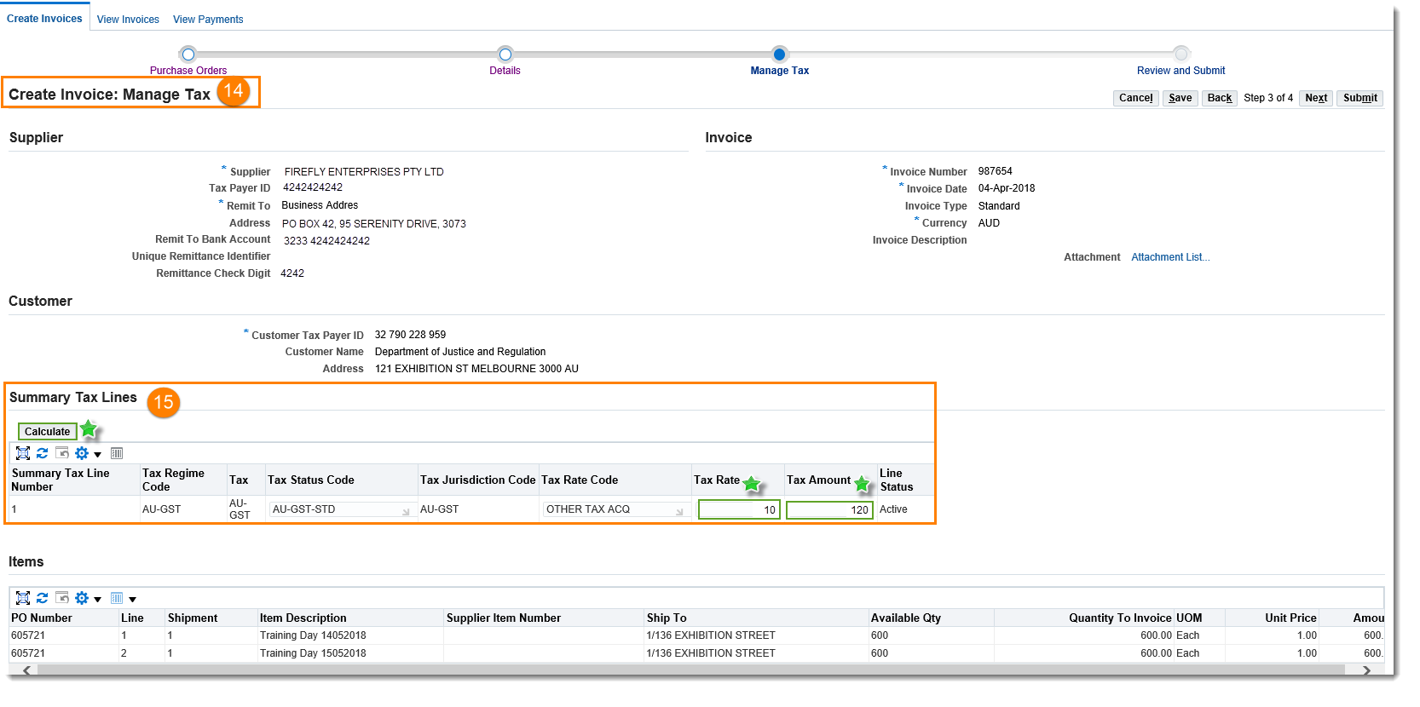
16 | Review the Invoice Summary  Note: If the Tax Lines have been updated you must select the Recalculate Total button within the Invoice Summary
17 | Select Submit
 | 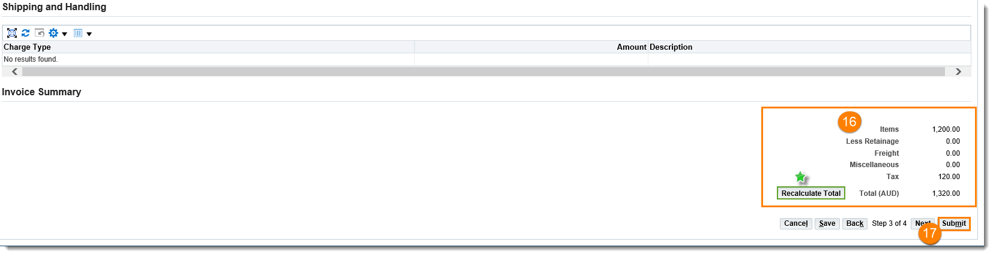
18 | A Confirmation message will display. You have completed this task.
 | 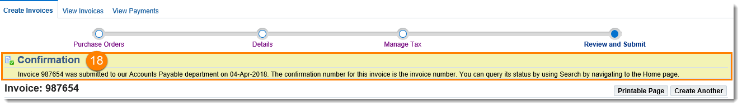
NOTE: When creating an invoice, you MUST add the corresponding Delivery Docket or Waybill as an attachment.

NOTE: When creating an invoice, you MUST add the corresponding Delivery Docket or Waybill as an attachment.

For general assistance with the Supplier Portal, please send request to the team: SupplierSupport@justice.vic.gov.au
For queries relating to Purchase Orders and Receipts in the Supplier Portal, contact the relevant business unit.

The Department of Justice and Community Safety and Court Services Victoria will support you in using the Supplier Portal.

Need Help?

