View Purchase Order

The Orders page is the central page that is used to view purchase orders. This includes purchase orders with the statuses of Open and Closed.

Step | Action
1 | Select the Orders icon to access the Order screen
2 | Review the purchase orders on the screen (Note – you can use the Advanced Search if you wish to filter the list of purchase orders)
3 | To view a specific purchase order – select the relevant PO Number link
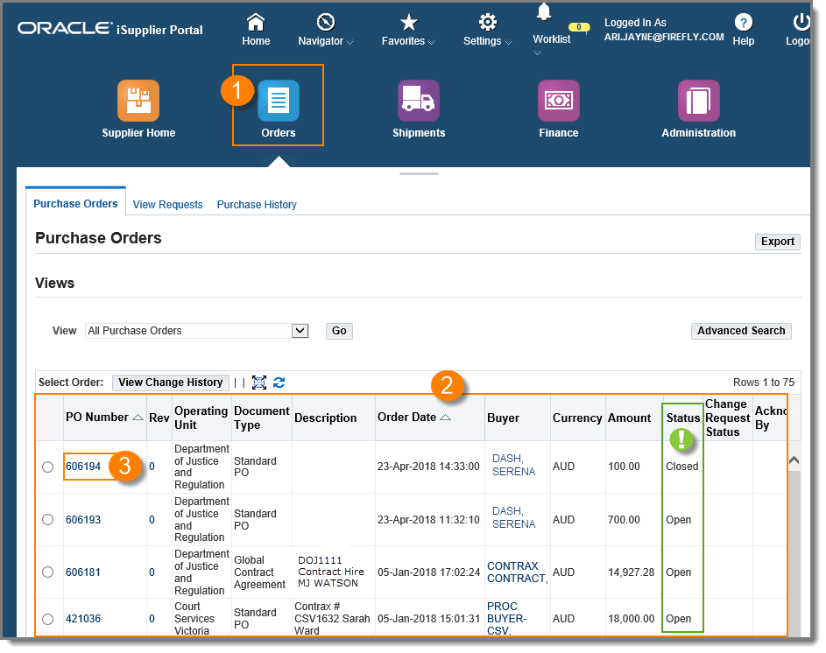
The status of the purchase order can be viewed directly in the Status column. This will indicate if the purchase order is OPEN (not received, invoiced or paid), or CLOSED (received, invoiced and paid)

Questions? Email to SupplierSupport@justice.vic.gov.au

