How to View Invoices
Quick Reference Guide

Step | Action
1 | Select the Finance icon
2 | Select the View Invoices tab
3 | You can search for a specific invoice using any of the parameters
4 | Select Go button
5 | Invoices that have been issued for the department display
6 | Select the Invoice number link to view the details of the invoice. You can also view any associated purchase order(s) or payments. The Status column indicates whether the invoice is In-Process, Approved or Cancelled
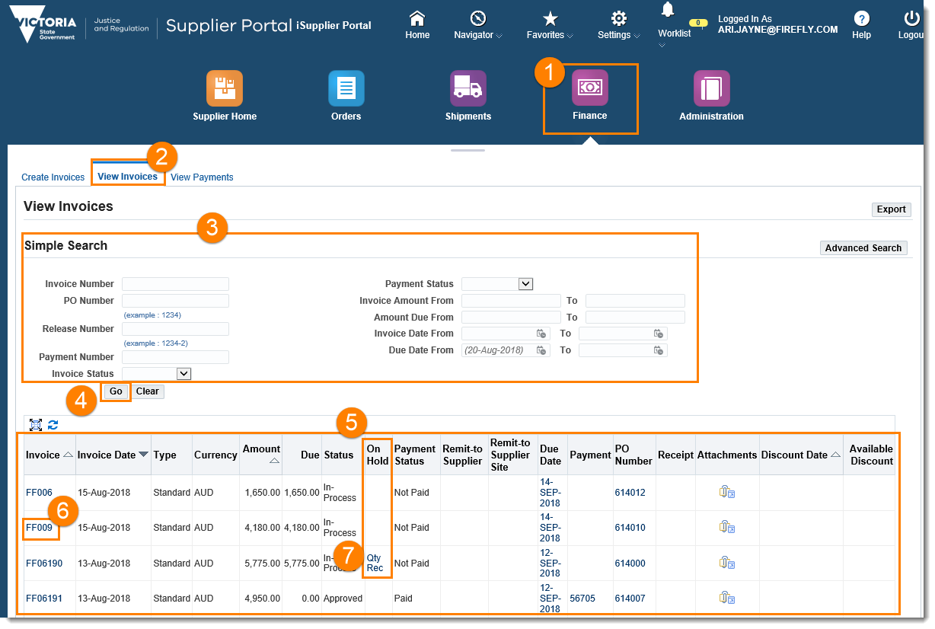
7 | If an invoice is on hold – it will appear in the On Hold column – selecting this link will open information as to why the invoice is on hold

When you select an invoice to open, the Invoice page will display. From here, you can view General, Account, and Payment information.

Area | Description
1 | General: General information about the invoice
2 | Amount Summary: The amount of the invoice, including freight and tax
3 | Payment Information: The amount currently paid against the invoice, including payment date
4 | Invoice Lines tab: Detailed information on the different lines on the invoice, e.g. One line excluding tax, one line for GST
5 | Scheduled payments tab: Details about a payment that is scheduled to occur, including payment method, and remaining amount to be paid
6 | Hold Reasons tab: Details about why an invoice may not have been paid, e.g. quantity billed may exceed quantity received
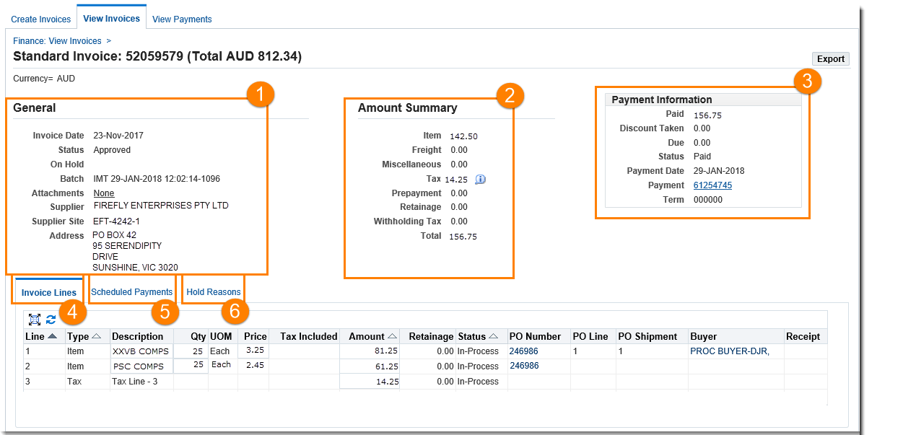

Status | Explanation
Automatch | The invoice has been successfully matched to the purchase order by the system
Incomplete | Workflow still awaiting action
eForm Saved | Workflow completed and saved but not yet submitted for approval
Submitted | Workflow completed and submitted for approval
Approved | Workflow approved but not yet transferred for payment processing
Transferred | Workflow approved and transferred for payment processing
Cancelled | Workflow cancelled - see reason
Rejected | Workflow rejected by approver awaiting resubmission

Questions? Email to SupplierSupport@justice.vic.gov.au

