Maintain Contact Details – Update an Existing Contact
Step | Action
1 | Select the Administration icon, the General screen opens
2 | Select Contact Directory from the left-hand menu
3 | Select the Update icon to make changes to an existing contact.
 | 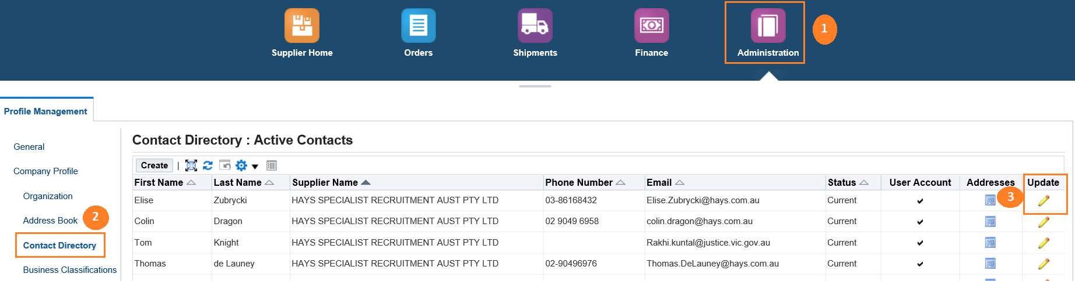
4 | The Update Contact screen displays. Update contact information as required
5 | If the contact/user is to be removed enter the Inactive Date
6 | If these are the only changes required, select the Apply button
7 | Select User Account Information collapsible arrow to reveal extra information
8 | Set Responsibilities as required
9 | Add User Restrictions as required
10 | Select Apply

Step | Action
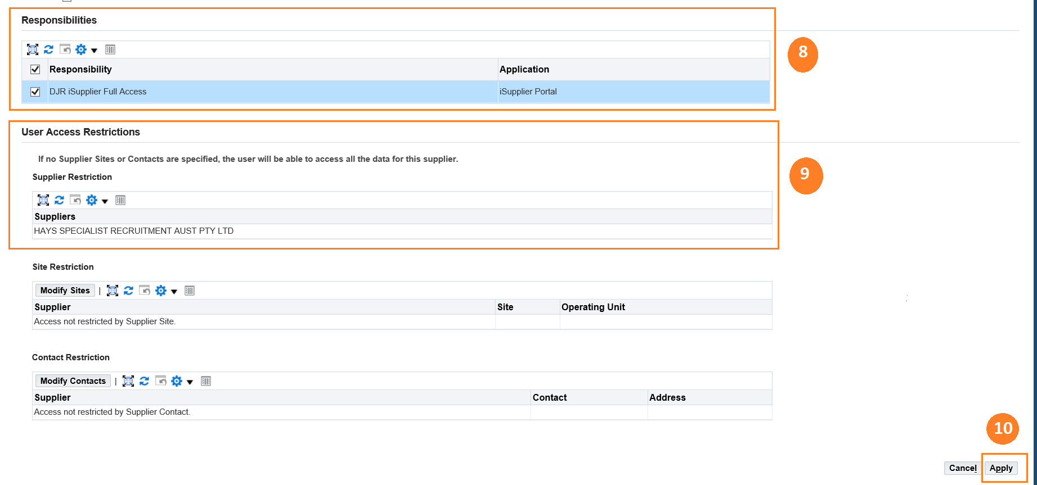
Questions? Email to SupplierSupport@justice.vic.gov.au

