Update Banking Details
Quick Reference Guide

Step | Action
1 | Select the Administration icon, the General screen opens
2 | Select Banking Details from the left-hand menu
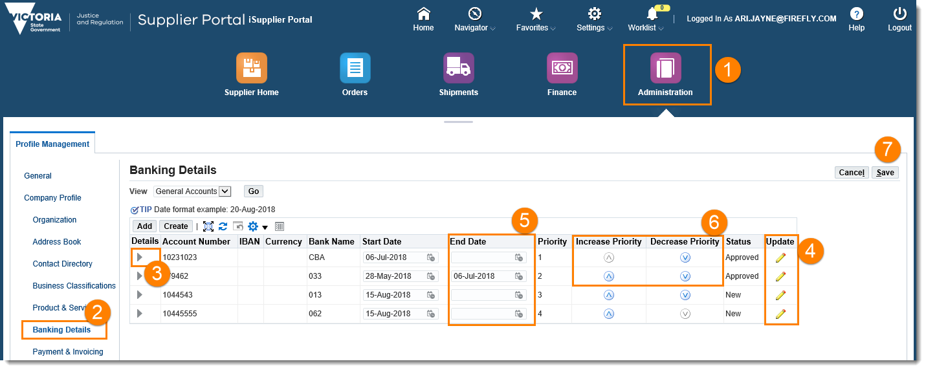
3 | Open the details collapsed menu to see more information about this account
4 | Select the Update icon to make changes to the existing account
5 | Set an end-date for the date a bank account can no longer be used
6 | Use the Increase Priority and Decrease Priority arrows to change the order in which the account numbers are used and displayed
7 | Select the Save button
8 | Add supporting documentation through Add Attachment on the General screen
 | Once the Bank Account update has been reviewed and approved by DJCS a notification email will be sent to the user who has inputted the change
Please note: Supporting documents must be attached to validate the bank details. To add attachment, follow the instructions in the Adding attachment section in Manage My Site Guide.

Question? Email to SupplierSupport@justice.vic.gov.au

