Maintain Your Address Book

Step | Action
1 | Select the Administration icon, the General screen opens
2 | Select Address Book from the left-hand menu
3 | Select the Create button to create a new address. Add address information as required and select Save
4 | Select the Update icon to make changes to the existing address. Update fields as required and select Save
5 | Select the Remove icon to remove an address from the address book
 | 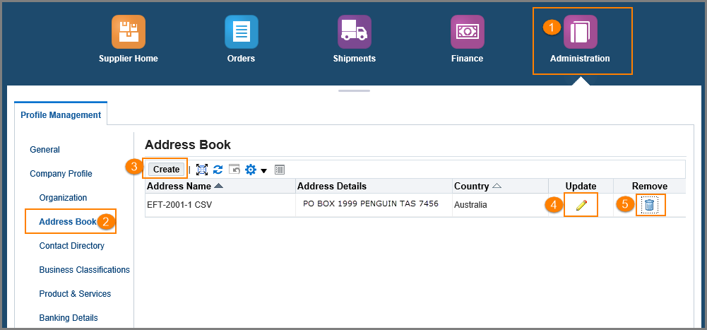
Questions? Email to SupplierSupport@justice.vic.gov.au

