How to Create Invoices
The Supplier Portal allows you to generate an invoice in the system against a purchase order.

Step | Action
1 | Select the Finance Icon
2 | Select the Create Invoices tab
3 | Select the Go button
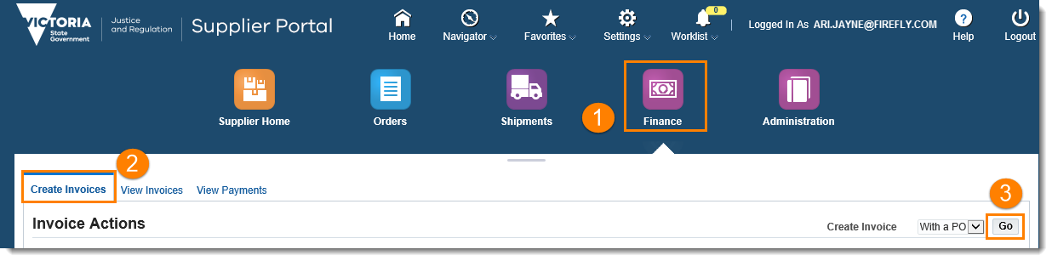
4 | Perform a simple Search to locate the purchase order and then press the Go button.  Note: The Advanced Search function can also be used if desired.
5 | Select the relevant checkboxes for the purchase order lines to be invoiced
6 | Select the Next button
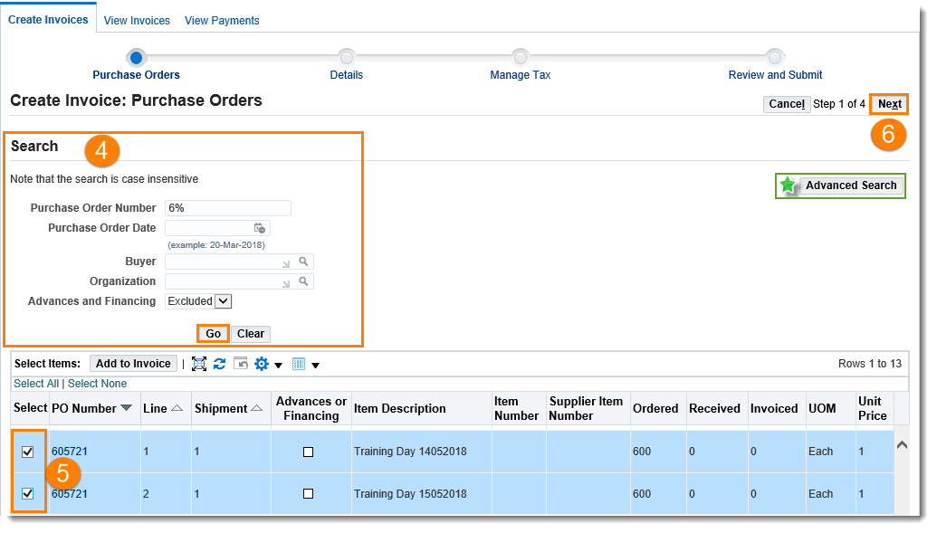

Step | Action
7 | The Create Invoice: Details screen will display
8 | Enter the Invoice Number
9 | Enter an Invoice Description
10 | Add the Delivery Docket or Waybill as the attachment
11 | Enter the Remit to Bank Account. Note – only the current active bank account that is listed in the administration tab of the Supplier Portal can be entered in this field.
12 | Update the Invoice Line Item quantities if required
13 | Select Next
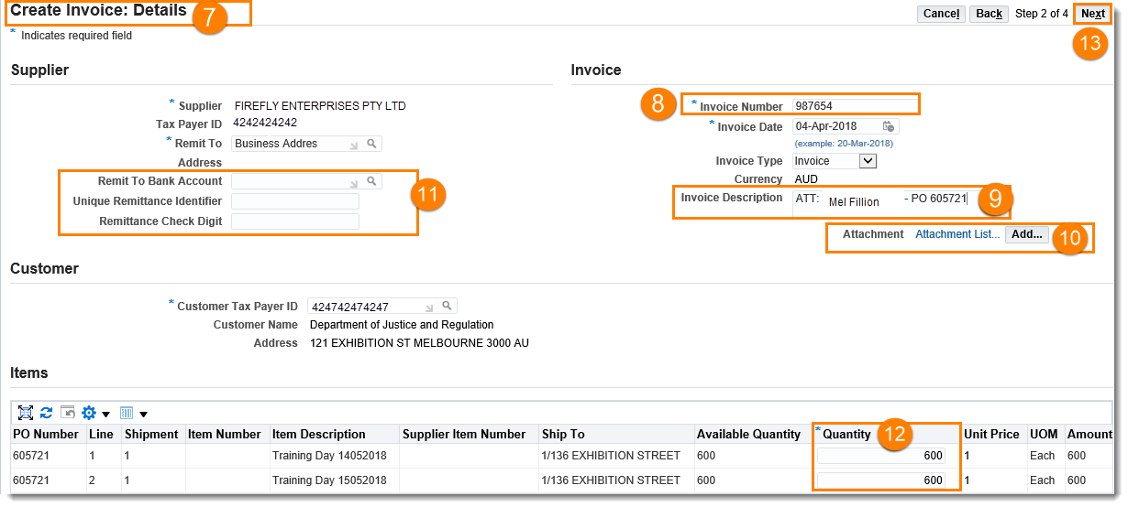
14 | The Create Invoice: Manage Tax screen will display
15 | The Summary Tax Lines section can be updated if required.  Note: If changing the Tax Rate or Tax Amount (i.e. GST does not apply) you must update the fields and then select the Calculate button

Step | Action
 | 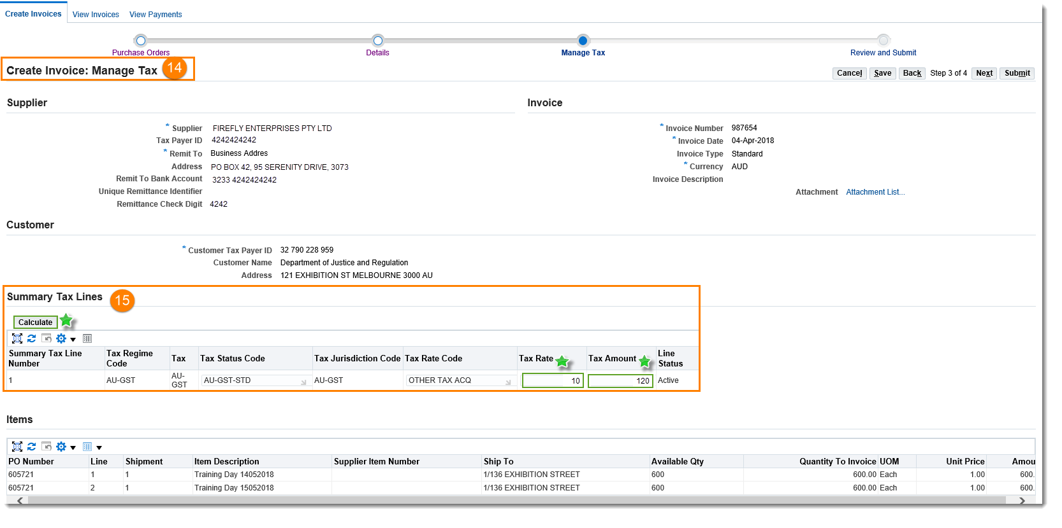
16 | Review the Invoice Summary  Note: If the Tax Lines have been updated you must select the Recalculate Total button within the Invoice Summary
17 | Select Submit
 | 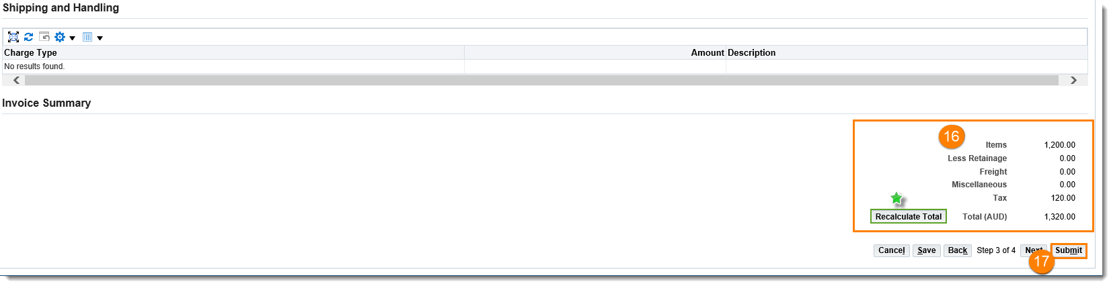
18 | A Confirmation message will display. You have completed this task.
 | 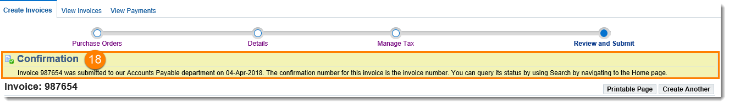

NOTE: When creating an invoice, you MUST add the corresponding Delivery Docket or Waybill as an attachment.

NOTE: When creating an invoice, you MUST add the corresponding Delivery Docket or Waybill as an attachment.

Questions? Email to SupplierSupport@justice.vic.gov.au

