Supplier Portal – Quick Reference Guide
How do I Register on Supplier Portal?

Invitation to Register
To register with the Supplier Portal, fill the Registration Form and you will receive an Invitation to Register from the department.
On receiving the email:

Step | Action
1 | Review the email
 | Note: If you have not received the email it is recommended that the junk mail or spam mail folders are checked
2 | Review the terms and conditions by selecting the link for the department’s website
3 | Select the link for the registration page
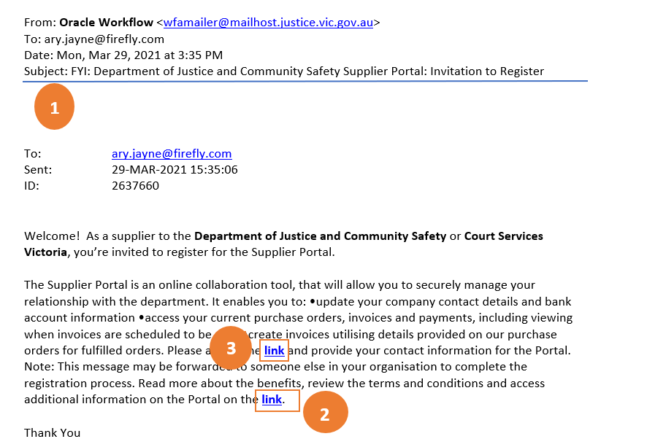
4 | The Respond to Invitation window opens

Step | Action
5 | Complete all mandatory fields:  - Email Address will default – but can be changed/overwritten  - First Name  - Last Name  - Phone Number  - Submit
 | 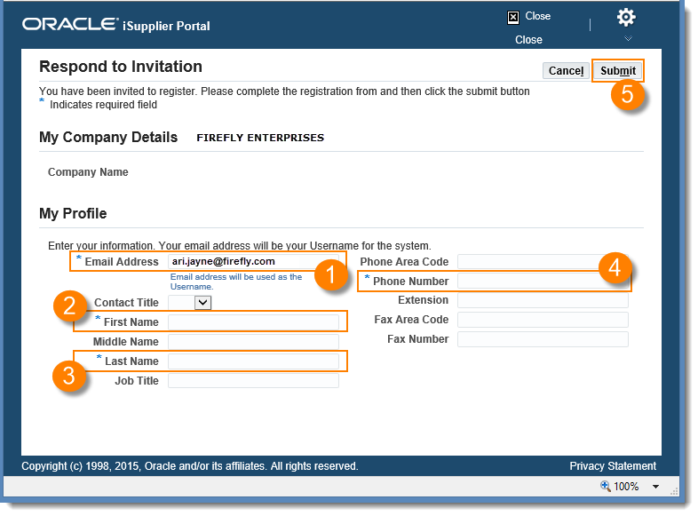
6 | The invitation is returned to the department to be registered

NOTE: The Supplier Contact must be a specific person with a specific email address, NOT a generic email ID

NOTE: The Supplier Contact must be a specific person with a specific email address, NOT a generic email ID
Step | Action
1 | Review the email
2 | Note that your username is your email address
3 | Copy the Password
4 | Select the Log On Link
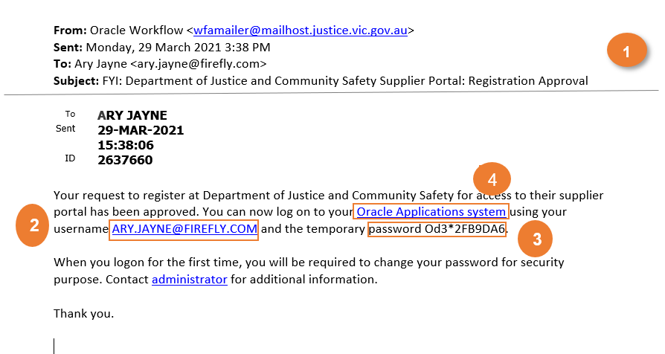
5 | The Log In screen will display
6 | Enter your username. Note – this is will be your email address
7 | Copy the password into the password box. Note – the password was displayed in the email
8 | Select the Login button
Once your individual user account is registered by the department you will receive an email to change your password and establish your account. On receiving the email:

Step | Action
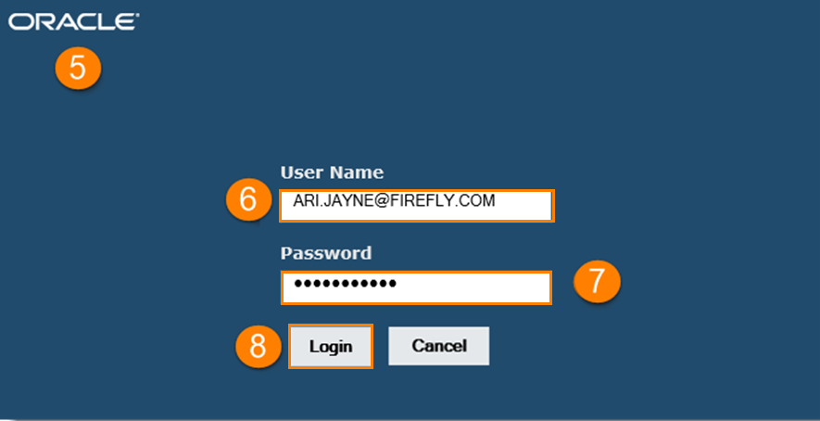
9 | Paste the password into the Current Password box
10 | Enter the New Password  Your password MUST have a minimum of ten characters – with at least one number and one letter. Your password must not contain characters that repeat next to each other OR contain your user name. It is recommended that passwords contain a mixture of upper and lowercase characters and at least one special character.  Passwords expire every 60 days.
11 | Re-enter the New Password
12 | Select the Submit Button
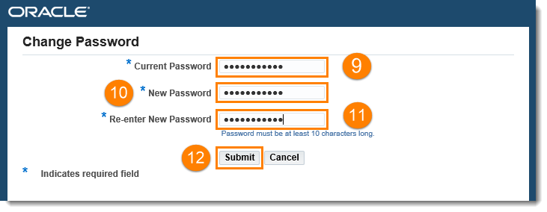
The Oracle Home Screen will display. You can now access the Supplier Portal

TIP: After logging in for the first time it is recommended that you save the URL (link) to your favourites or establish a shortcut which will allow you to access the portal quickly.

Questions? Email to SupplierSupport@justice.vic.gov.au

