Create a New Contact

Step | Action
1 | Select the Administration icon, the General screen opens
2 | Select Contact Directory from the left-hand menu
3 | Select the Create button to create a new contact.
 | The Create Contact screen will display – complete all mandatory and non-mandatory fields as required
4 | Under User Account: select Create User Account checkbox if required  Enter the Supplier Name  Enter the Username (note – this is the users email address)
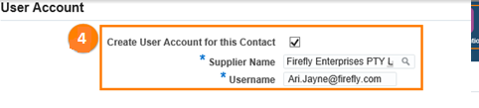
Note – when creating a new contact/user the user will receive Full Access. If the user requires View Only access, please send an email request to SupplierSupport@justice.vic.gov.au and include:
- the users full name
- the users email address
5 | To restrict access to certain sites (e.g. VOCAT) select the Modify Sites Button under the Site Restriction Tab – when the pop-up screen opens ensure that only the sites that the user should see are selected
6 | Select Apply
 | 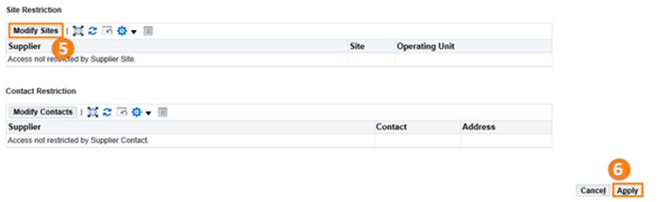

NOTE: The new contact will receive email confirmation with a User ID and a system generated password. The user will be prompted to change their password on first login.

Questions? Email to SupplierSupport@justice.vic.gov.au

