Add an additional address for a contact

Step | Action
1 | Select the Administration icon, the General screen opens
2 | Select Contact Directory from the left-hand menu
3 | Select the Addresses icon to create additional addresses for a contact
 | 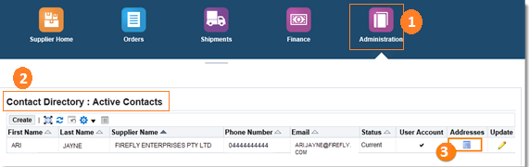
 | The Address Associations for Contact screen will display
4 | To remove an address, select the Remove icon
5 | To add a new address, select the Add icon.  Note: You cannot create a new address here, you can only select one from your Address Book. You must create any addresses first.
6 | When required address is found – select Save button

Questions? Email to SupplierSupport@justice.vic.gov.au

