Department of Justice and Community Safety
ANNUAL REPORT
2018–19
Report of operations

Publication information
The Department of Justice and Community Safety acknowledges the Traditional Owners of the land of Victoria and pays respect to their Elders, both past and present.
Aboriginal is used as the department’s standard reference for Aboriginal and Torres Strait Islander people. Prior to June 2018, ‘Koori’ was used as the department’s standard reference, and this term continues to be used in some DJCS business units, affiliated organisations and documents including the Koori Justice Unit, the Koori Courts, and the department’s Koori Inclusion Action Plan 2017-2020, Yarrwul Loitjba Yapaneyepuk – Walk the Talk Together.
Authorised and published by the Victorian Government, 1 Treasury Place, Melbourne.
ISSN 1320-8543
Printed by Impact Digital, Brunswick
October 2019
© Government of Victoria
This report is protected by copyright. Apart from any use permitted under the Copyright Act 1968, and those explicitly granted below, all other rights are reserved.
Cover image
Melbourne Justice Service Centre 50 Franklin Street officially opened on Friday 12 April 2019. Services include Adult Parole Board, Births Deaths and Marriages, Consumer Affairs Victoria, Community Corrections Services, Corrections Victoria, Post Sentence Authority and Sheriff’s Office Victoria.
Accessibility
Published in an accessible format on www.justice.vic.gov.au.
Unless indicated otherwise, content in this publication is provided under a Creative Commons Attribution 4.0 International Licence. To view a copy of this licence, visit creativecommons.org/licenses/by/4. It is a condition of the Creative Commons Attribution 4.0 Licence that you must give credit to the original author who is the State of Victoria.
This report is printed on Ecostar which is manufactured from 100% Post Consumer Recycled under the ISO 14001 environmental management system. Ecostar is an environmentally responsible paper made Carbon Neutral.

Content
Responsible body’s declaration 4
Justice and Community Safety ministers and portfolios 4
Secretary’s foreword 5
About us 6
Victorian Aboriginal Justice Agreement 12
Report of operations 14
Ensuring community safety through policing, law enforcement and prevention activities 16
Effective management of prisoners and offenders and provision of opportunities for rehabilitation and reparation 20
Effective supervision of young offenders through the provision of youth justice services promoting rehabilitation 23
A fair and accessible criminal justice system that supports a just society based on the rule of law 25
A fair and accessible civil justice system that supports a just society with increased confidence and
equality in the Victorian community 29
Reduce the impact of, and consequences from, natural disasters and other emergencies on people,
infrastructure, the economy and the environment 31
Five-year financial summary and review of financial conditions 35
Disclosure of grants and other transfers (other than contributions by owners) 36

Responsible body’s declaration
In accordance with the Financial Management Act 1994, I am pleased to present the Department of Justice and Community Safety’s Annual Report for the year ending 30 June 2019.
Rebecca Falkingham
Secretary
Department of Justice and Community Safety
October 2019

Justice and Community Safety ministers and portfolios
At 30 June 2019, the department supported four ministers across eight portfolios.
The Hon. Jill Hennessy MP
Attorney-General
Minister for Workplace Safety
The Hon Jill Hennessy MP was appointed Attorney-General and Minister for Workplace Safety inNovember 2018. The Attorney-General is the State’s first law officer. The Minister for Workplace Safety is responsible for supporting workplace safety and fairness at work.
The Hon. Ben Carroll MP
Minister for Crime Prevention
Minister for Corrections
Minister for Youth Justice
Minister for Victim Support
The Hon Ben Carroll MP was appointed Minister for Crime Prevention, Minister for Corrections, Minister for Youth Justice and Minister for Victim Support in November 2018.
The Minister for Crime Prevention is responsible for enhancing community safety through crime prevention activities.
The Minister for Corrections is responsible for the effective management of adult prisoners and offenders and provision of opportunities for rehabilitation and reparation.
The Minister for Youth Justice is responsible for the effective supervision of young offenders through the provision of youth justice services promoting rehabilitation.
The Minister for Victim Support is responsible for providing support to victims of crime.
The Hon. Lisa Neville MP
Minister for Police and Emergency Services
The Hon Lisa Neville MP was appointed Minister for Police and Emergency Services in December 2018. The Minister has broad responsibilities for policing and supporting the state’s emergency service sector to reduce the likelihood, effect and consequences of emergencies.
The Hon. Marlene Kairouz
Minister for Consumer Affairs,
Gaming and Liquor Regulation
The Hon Marlene Kairouz MP was appointed Minister for Consumer Affairs, Gaming and Liquor Regulation in June 2016. The Minister is responsible for the administration of consumer protection legislation, which seeks to ensure that Victorian businesses and consumers are informed, and for the regulation and licensing of the gambling and liquor industries.

Secretary’s foreword
I am pleased to present the Department of Justice and Community Safety Annual Report 2018–19.
Over the past year, the department has achieved excellent progress toward its vision of a justice system that works together to build a safer, fairer and stronger Victoria; and has begun its transformation to better meet the evolving needs of Victorians.
At the heart of this transformation is the Statement of Direction – the department’s four-year strategy that sets out our vision, priorities and supporting actions, guiding all the work we do.
This has also strengthened our focus on supporting our ministers to deliver on a wide-ranging reform agenda, ensuring we adopt a whole of government approach to managing justice outcomes and building trust in the justice and community safety system.
This includes supporting the Attorney-General and Minister for Workplace Safety, Jill Hennessy, to ensure our courts are transparent, effective, accessible and fair for all Victorians.
It means driving reforms for Minister for Police and Emergency Services, Lisa Neville, to strengthen police with the resources, technology and laws they need to better protect the community.
It means working with the Minister for Consumer Affairs, Gaming and Liquor Regulation, Marlene Kairouz, to deliver a fairer marketplace for Victorians by empowering consumers and businesses to know their rights and responsibilities.
And it means addressing with Minister for Crime Prevention, Corrections, Youth Justice and Victim Support, Ben Carroll, the effective management of prisoners and offenders, new opportunities for rehabilitation and reparation to reduce recidivism, while also focusing on the needs of victims in our community.
With a focus on increasing community safety, the department has prioritised policing, law enforcement and crime prevention activities, including the deployment of 1500 new police and 25 new Protective Service Officers across the state. More than $45 million has also been invested in increasing security measures in Melbourne’s CBD, including new security cameras, speakers, bollards and barriers, and the creation of pedestrian protection zones.
The department has added a significant number of beds across the prison system and early works have commenced on the new fit for purpose youth justice precinct at Cherry Creek, which includes dedicated mental health and intensive intervention units.
We have also established the new Youth Justice Commissioner to support the youth justice workforce and enhance management and supervision of young people. This has enabled 1408 diversions overseen by Children’s Court Youth Diversion coordinators, with 94 per cent of diversions successfully completed.
Following a machinery of government change, the workplace safety portfolio transferred to the department, with a significant reform program including commitments to legislate a new workplace manslaughter offence and introduce a provisional payments scheme to provide early support for injured workers.
Reforms to the Victorian fines system have improved options for vulnerable people, while increasing the timeliness of fine payments through more efficient and effective collection and enforcement.
Building increased confidence and equality in the civil justice system, significant work was completed on traditional owner settlements, delivering effective dispute resolution services, and improving online access to Births, Deaths and Marriages services.
The Justice Legislation Amendment (Access to Justice) Act 2018 also began, implementing 16 of the 57 government-supported recommendations of the Access to Justice Review. Meanwhile, more than 130 reforms to strengthen renters’ rights were introduced when the Residential Tenancies Amendment Act 2018 was passed by Parliament.
Through Service Delivery Reform and initiatives such as the Aboriginal Justice Agreement and Family Violence Reforms, the department is also reimagining its approach to strengthening partnerships and working collaboratively with justice stakeholders.
In my first year as Secretary of the Department of Justice and Community Safety, I would like to acknowledge the support of the department’s hard-working staff, agencies and community organisations, as well as our volunteers. I would like to thank everyone for their valuable contribution and for making these achievements possible.

Rebecca Falkingham
Secretary
Department of Justice and Community Safety

About us
The department’s vision is for a justice and community safety system that works together to build a safer, fairer and stronger Victoria.
The department leads the delivery of justice and community safety services in Victoria by providing policy and organisational management. Its extensive service delivery responsibilities range from managing the state’s prison system to providing consumer protection and enforcing court warrants.
The department manages the development and implementation of a range of laws, regulation and policy in areas across the portfolio (such as in gaming and emergency management) and ensures that all elements of the justice and community safety system are working efficiently and effectively.
The department has productive partnerships with more than 60 statutory entities and has the support of more than 100,000 volunteers.

A new approach. A new structure.
On 1 January 2019, the Department of Justice and Community Safety (previously Department of Justice and Regulation) was established as part of a machinery of government change to deliver on the Victorian Government’s reform agenda. Under a newly-appointed Secretary, the Board of Management was established to lead the government’s renewed focus on improving community safety, victim services, regulatory services and crime prevention, and building strong collaboration across the justice system.
A new organisational structure took effect on 1 February 2019 to support the department’s four ministers and delivery of the government’s priorities. The structure comprises the policy, program and corporate groups outlined on page 5, with many of its services delivered via our justice service centres across
Departmental structure at 30 June 2019
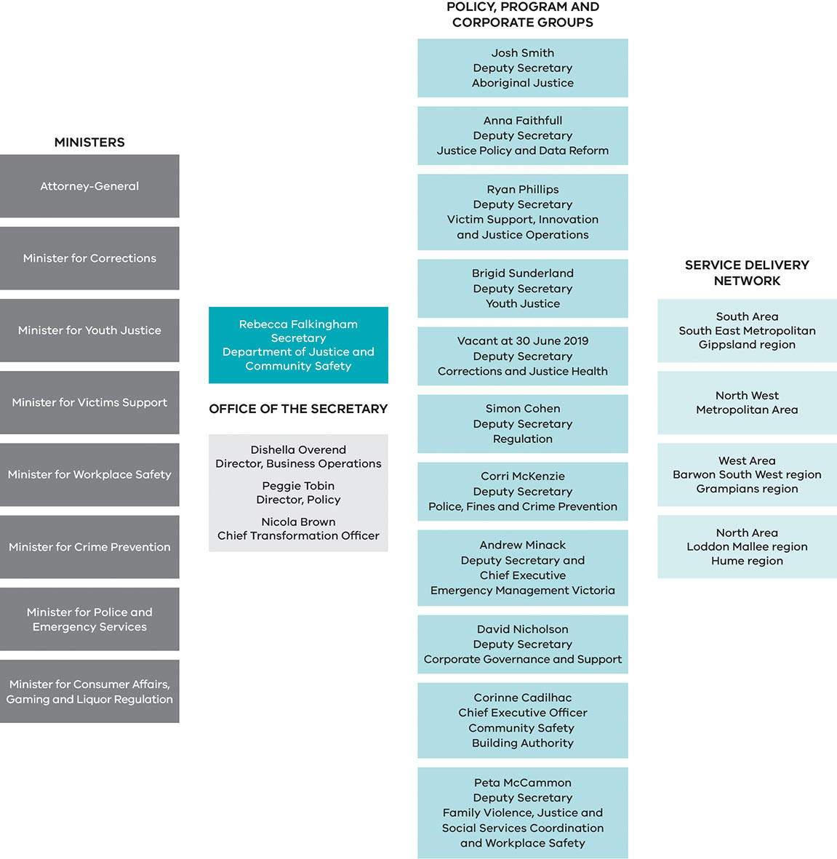

Our groups at 30 June 2019

Aboriginal Justice
The Aboriginal Justice group drives change and coordinates effort across the department to improve outcomes for Aboriginal Victorians, with a strong emphasis on supporting Aboriginal self-determination and working in partnership with Victorian Aboriginal communities, stakeholders and individuals. The group plays a significant role in the implementation of the Aboriginal Justice Agreement Phase 4 (AJA4), leads justice policy reform pertaining to Aboriginal Victorians and leads Victoria’s response for Native Title.

Justice Policy and Data Reform
The Justice Policy and Data Reform group is responsible for supporting the criminal and civil justice systems by linking and leveraging data between them, and working across government to better serve our common clients. The group collaborates with key entities across the justice system and the department to ensure policy reform is strategic, relevant, holistic and people-centred.

Victim Support, Innovation and Justice Operations
The Victim Support, Innovation and Justice Operations group works to deliver and reform services to victims of crime, placing victims at the centre of our justice system. This includes implementation of the National Redress Scheme in Victoria and strengthening the services for victims provided by the Asset Confiscation Office. The group also leads justice operations, including Births, Deaths and Marriages (BDM) and justice service centres, and works closely with stakeholders to ensure services take into account the specific needs of people and community.

Youth Justice
The Youth Justice group supports the delivery of stable and effective youth justice services. The group is responsible for continuing reforms to modernise Victoria’s youth justice system and building upon strong partnerships with the community sector and across government to improve outcomes for young people and the community.

Corrections and Justice Health
The Corrections and Justice Health group provides high-quality correctional services that help rehabilitate offenders and contribute to community safety. The group also delivers quality health services to corrections and youth justice in collaboration with key partners.

Regulation
The Regulation group incorporates regulation, dispute resolution and assurance functions, which provide the Victorian community with a greater level of confidence and consistency when accessing services in the public and private sectors. This includes regulating the gambling and liquor industries and consumer affairs, delivering the state’s working with children scheme, providing dispute resolution services to the community, conducting justice assurance and policy reviews, supporting emergency service, assurance and post sentence reviews, registering Victorians’ significant life events, and adoption services.

Police, Fines and Crime Prevention
The Police, Fines and Crime Prevention group supports improved community safety through public policy, governance and legislative advice and reform, and community crime prevention advice and programs. This includes coordinating efforts across government to counter violent extremism, management of the end-to-end infringements system and enforcement activities and management of Victoria’s road safety camera program. This group works to prevent and intervene early in the commission of crime, hold people to account and respond to offending behaviour.

Emergency Management Victoria
Emergency Management Victoria (EMV) oversees the end-to-end functioning of the state’s emergency management system. The group leads reforms to unite the emergency management sector around a common purpose – working with communities to prepare and plan for, withstand, respond to and recover from emergencies.

Corporate Governance and Support
The Corporate Governance and Support group provides critical corporate support services which are essential to the department’s ability to build a safer, fairer and stronger Victoria. This includes: helping to build a workforce that is safe, confident and capable; enabling the department to use the best-available information to guide decisions; investing in technology and digital solutions; and driving productivity.

Community Safety Building Authority
The Community Safety Building Authority’s primary functions are planning, designing, procuring and building new infrastructure assets as well as modernising and upgrading existing ones. The authority supports the department to deliver the targeted responses Victorians need through innovation in victim-centred system design and precinct-based localised delivery of integrated services.

Family Violence, Justice and Social Services Coordination and Workplace Safety
The Family Violence, Justice and Social Services Coordination and Workplace Safety group is responsible for coordinating the justice and social services systems to ensure they work effectively together and account for the specific needs of people and community, with a focus on place and inclusion. This includes major areas of reform in family violence, mental health and the National Disability Insurance Scheme (NDIS). The group also supports the government’s workplace safety reforms.

Our Statement of Direction
The department strives to achieve safer and more resilient communities, a trusted justice and community safety system with easy access to justice and safety systems and services, and a fair and accessible justice system for Aboriginal people.
A new Statement of Direction was launched in April 2019 that reflects these outcomes and will guide the department’s delivery of government and ministerial priorities. The statement sets the direction of the department and will enable us to meaningfully evaluate how we are making a difference by mapping out our vision, outcomes, priorities and supporting actions.
The department provides policy and organisational management focus for a justice and community safety system that works together to build a safer, fairer and stronger Victoria by:
- integrating services and tailoring them for local communities
- prioritising Victorians in need
- focusing on victims and survivors
- strengthening stakeholder partnerships.
The Statement of Direction will help us embed a focus on outcomes in our work so that we can assess the impact of our services for the Victorian community. While the department continues to report on our output performance (what is delivered) in line with government requirements, work has also commenced to monitor progress towards the outcomes set out in the statement. This approach to measuring and assessing impact enables insight to inform future decisions and refine programs to ensure they remain fit for purpose and responsive to policy and service delivery contexts.
In 2018–19, the department commenced work on the following initiatives to drive the change in thinking and culture required to embed an outcomes focus:
- An integrated planning framework to facilitate collaborative strategic and operational planning that aligns to agreed outcomes.
- A data and reporting framework to enable reporting against agreed outcome measures.

Transformation
The department has begun a process of transformation that will enable us to better serve the Victorian community. The transformation will support a holistic and collaborative approach to working with common challenges across government to drive reform that will have meaningful outcomes for the Victorian community, while continuing to deliver services in the justice system.
We are transforming the way we are organised and the way we work so that we can deliver on the government’s reform agenda and our people can thrive and play to their strengths.
In 2018–19, the department undertook work on a range of initiatives that align with the Victorian Government’s reform agenda. These include:
- Transforming our organisation, driving positive culture, staff safety and well-being across the organisation, and empowering and building the capability of our workforce so that we can deliver on the government’s priorities and reform agenda.
- A process of cost mapping to identify improvements in spending. This work has now merged with the base and efficiency review being undertaken by all portfolios, in accordance with the 2019–20 State Budget. The department’s review commenced in June 2019 and seeks to examine the efficiency of expenditure across the department and its entities and ensure that funding is directed to support the government’s priorities.
- Continued reforms to optimise the operation of the department’s regional services model. This included establishing standard costing models and a new resource allocation model for most service functions, with work continuing for remaining functions. Regional transformation work has matured from being internally focused to also improving the department’s external collaboration, engagement, coordination and alignment within the regional context.
Organisational reform is a key enabler to realising the department’s vision, priorities and outcomes as outlined in our Statement of Direction.

Corporate governance
Under the Public Administration Act 2004, the Secretary is responsible for the general conduct and effective, efficient and economical management of the department.
The Board of Management is the peak body in the department’s corporate governance structure, advising the Secretary on the management and administration of the department to ensure compliance with government directives, guidelines and legislation. It is responsible for integrating governance functions across the department and working collaboratively with portfolio agencies

Board of Management at 30 June 2019

Rebecca Falkingham, Secretary
Rebecca has been Deputy Secretary, Social Policy and Service Delivery Reform at the Department of Premier and Cabinet (DPC). Her achievements in that role included leading the establishment of Family Safety Victoria, the commencement of the Treaty process with Aboriginal Victorians and the ongoing transition of the NDIS.

Josh Smith, Deputy Secretary, Aboriginal Justice
Josh is a Dunghutti man from the Macleay Valley Coast in NSW and was previously Executive Director of Aboriginal Victoria with the DPC. In the Victorian public service, he has held various executive roles across health and human services, family violence, justice and Aboriginal affairs. After practising law as a solicitor for the NSW Crown Solicitors Office and at the Victorian Aboriginal Legal Service, Josh has held executive positions within the Victorian public service across family violence, health and human services portfolios. Josh is a passionate community member and has advocated for better outcomes for Aboriginals through policy development and enhanced Aboriginal self-determination.

Anna Faithfull, Deputy Secretary, Justice Policy and Data Reform
Anna has most recently led the employment practice at Social Ventures Australia. In 2019, Anna began an executive MBA at Melbourne Business School and a PhD on the social implications of the fourth industrial revolution. Anna has over ten years’ experience in government, leading and implementing whole of government reform including the Government’s response to the Royal Commission into Family Violence and the Government’s transition into the NDIS.

Ryan Phillips, Deputy Secretary, Victim Support, Innovation and Justice Operations
Ryan has led the department’s Criminal Law Policy and Operations function as Deputy Secretary from 2017. Prior to his appointment in the department, he was employed in a range of senior executive positions, including as General Counsel. Ryan has held a diverse range of policy, social justice and legal roles across the government, Aboriginal community and private sectors in Melbourne, Broome and Sydney.

Brigid Sunderland, Deputy Secretary, Youth Justice
Brigid joined the department in June 2017 as the Executive Director of Youth Justice Policy, Strategy and Business Services, working as part of a team to reform Victoria’s Youth Justice System. Prior to joining the department, she held senior positions in both the public and private sector including the DPC, the Commonwealth Attorney General’s Department and practised as a lawyer in a several private firms. Notable achievements have been in leading the state-wide roll out of the Family Violence Support and Safety Hubs and establishing The Board of Inquiry into the Hazelwood Mine Fire.

Simon Cohen, Deputy Secretary, Regulation
Simon has been Deputy Secretary for Regulation since August 2015. Prior to this Simon was the national Telecommunications Industry Ombudsman, and Victoria’s Public Transport Ombudsman. Simon is the Victorian Government’s representative on the Gippsland Regional Partnership, and current Chair of the ANZSOG Regulators Community of Practice.

Corri McKenzie, Deputy Secretary, Police, Fines and Crime Prevention
Corri has held several senior executive positions in social policy, service design and delivery in government and in the community sector. Prior to joining the public service, Corri was the General Manager of Community Services, Mission Australia and was also the Corporate Communications Manager at Google Australia and New Zealand. She has led reforms including the NDIS, the National Plan to Reduce Violence against Women and their Children, and the implementation of impact measurement and performance reporting in community services.

Andrew Minack, Deputy Secretary, Emergency Management Victoria
Andrew has had an extensive public sector career working at an executive level in a number of state and local government agencies. Most recently he was responsible for leading the work on several highly complex reform projects including the Government’s fire services reform package and establishment of new legislation that governs the funding of political parties and donations. He has also held executive roles in Victoria Police where he was responsible for corporate strategy, stakeholder engagement and performance improvement. Andrew has also worked as an executive at Parks Victoria and the Warrnambool City Council.

David Nicholson, Deputy Secretary, Corporate Governance and Support
David previously served as the Deputy Secretary Policy, with the DPC, Tasmania since June 2016. Prior to that appointment, David held the position of Deputy Secretary, Corporate at the Department of Health and Human Services, Tasmania. He commenced his career working in the private sector as a management consultant in Melbourne across a range of sectors.

Corinne Cadilhac, Chief Executive Officer, Community Safety Building Authority
Corinne is the CEO of the Community Safety Building Authority. Corinne is a senior executive with extensive experience in public administration, civil engineering and infrastructure. Her most recent position was leading Infrastructure, Planning and Major Projects at the DPC. She has also worked at the Department of Transport and Department of Infrastructure as well as in the private sector as a consultant with Sinclair Knight Merz.

Peta McCammon, Deputy Secretary, Family Violence, Justice and Social Services Coordination and Workplace Safety
Peta has built a successful career over the last 18 years in the Victorian Public Service in the Department of Justice, the Department of Human Services, Treasury and Premier and Cabinet. Peta is committed to social policy reform and has most recently held executive positions supporting the roll out of the National Disability Insurance Scheme and the implementation of the 227 Royal Commission recommendations into Family Violence.

Andrew Crisp, Emergency Management Commissioner
As the Emergency Management Commissioner, Andrew has overall responsibility for coordination before, during and after major emergencies, including the management of consequences of an emergency. As the former Victoria Police Deputy Commissioner, Regional Operations, Andrew has almost 40 years’ policing experience in roles focused on community safety across metropolitan and regional Victoria and overseas, including key emergency management leadership positions.
During his career, he has been involved in responses to several major incidents, such as the Ash Wednesday Bushfires, the 2009 Victorian Bushfires, Christchurch earthquake, Queensland floods and the 2017 Bourke Street Tragedy.

Emma Cassar, Commissioner, Corrections Victoria
Emma has worked within Corrections Victoria and the Corrections System for more than 20 years in a range of roles, starting as a Forensic Psychologist after she finished her clinical doctorate and then moving to the custodial environment. She managed several prisons across the state and acted as Director and Deputy Commissioner on several occasions. Emma has worked across both the non-government and private sector. Prior to this role she worked at KPMG in a role that focused on developing the justice and security sector. She has been the Australian representative for the global justice and security forums and brings a wealth of knowledge and experience from the national and international justice arena.

Nicola Brown, Chief Transformation Officer
Nicola has an extensive public sector career, working at the executive level in several state government departments. Most recently she was the Chief Human Resources Officer at the DPC, where she led work on organisational design, leadership, change management and employee / industrial relations. Prior to this she occupied the role of Director, People and Workplace Services at the Department of Transport Planning and Local Infrastructure, leading people and facilities strategies, and has also held the role Director People and Culture at the Department of Planning and Community Development.

Dishella Overend, Director, Business Operations
Dishella has over ten years experience in the public service, working in various policy, project, leadership and advisory roles in security and emergency management, multicultural affairs and social policy. Dishella was previously the Principal Adviser to the Chairperson of the Victorian Multicultural Commission, supporting Victoria’s diverse communities to champion and inform the development of government policy.

Peggie Tobin, Director, Policy
Peggie is an experienced public servant, having spent the past nine years working in a range of management and executive roles across the Victorian Public Service with a focus on social policy, including justice, education and Aboriginal affairs. Most recently, Peggie led the development of the Australia’s first ever treaty legislation, working with Aboriginal Victorians to design and set out the roadmap to treaty negotiations in this state.

Audit and Risk Management Committee
The Audit and Risk Management Committee is an independent committee established in accordance with the Financial Management Act 1994 (the Act) and the Standing Directions 2018 under the Act. It provides assurance to the Secretary that the department’s risk and control environment is operating effectively and efficiently.
The committee operates under an approved charter and has the following members:
- Kate Hughes, Chair
- Claire Thomas
- Natalia Southern
- Mark Trajcevski.

Our service delivery network
The community can access a range of the department’s services at our justice services centres.
Services delivered include: BDM; Consumer Affairs Victoria (CAV); Community Correctional Services (CCS); Dispute Settlement Centre of Victoria (DSCV); Sheriff Operations; Offending Behaviour Programs; prison management; Victims Assistance Program (through funds provided by the department to non–government organisations) and youth justice services.
Established to support the local community and respond effectively to the need for improved access to justice services, our centres have office locations in the following justice regions:
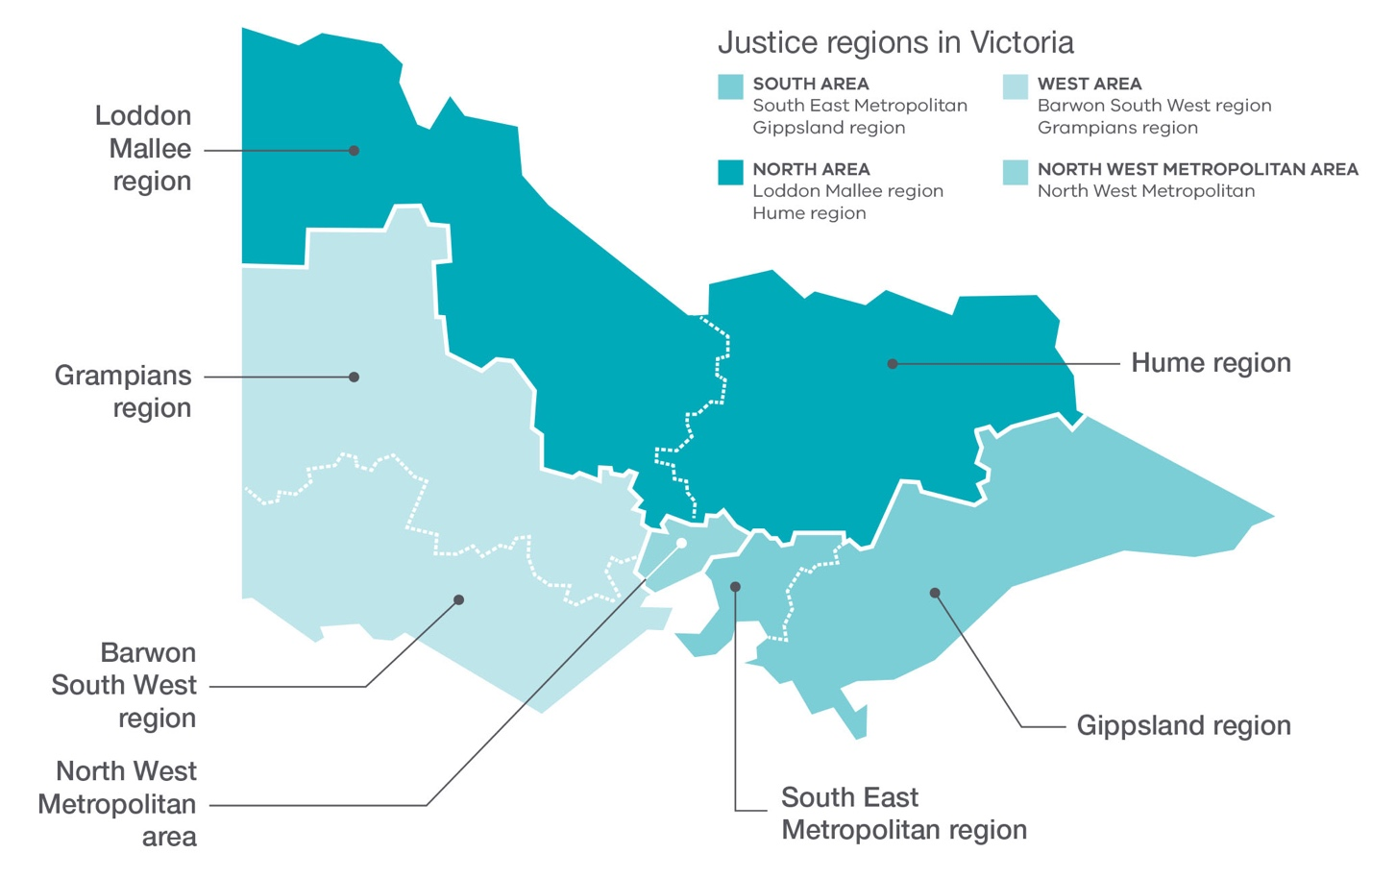

Regional highlights
Our service delivery network enables a place-based approach, empowering the local community and driving cross-sector collaboration for the delivery of integrated services to improve justice system outcomes for offenders and the broader community. The following are highlights of regional initiatives that target a specific location or cohort to respond to complex social problems.

North West Metropolitan Area

Enhancing justice literacy
In 2018–19, the department implemented the Justice Literacy Program for women in disadvantaged and culturally diverse communities with limited access to public and community services. Focusing on the Whittlesea, Wyndham and Brimbank local government areas, this program aims to improve the understanding of justice, health and community services and how to navigate them.
The Justice Literacy Program was established in partnership with Bubup Wilam, meaning ‘Children’s Place’ in the Woi Worrung language, at the Aboriginal Child and Family Centre in Thomastown. Bubup Wilam provides Aboriginal children, families and the community with access to a range of services and programs and was implemented in collaboration with the local council, Uniting Care, Expresso Community Legal Service and the Department of Health and Human Services (DHHS).
The Brimbank Justice Literacy Program focuses on the needs of recently migrated young women at risk of violence which may go unreported. The department partnered with local maternal and child health stakeholders, family violence services, the council, Community Legal Services, DHHS, and youth and cultural services, to support young women from culturally diverse backgrounds to better understand and address justice, health and wellbeing matters.
Both the Brimbank Justice Literacy Program and Bubup Wilam facilitate discussion about issues such as family violence, child protection, registering births, fines and warrants, fear of police, resolving tenancy and consumer issues, financial counselling, how to source legal assistance and other government services such as health, mental health and housing.

South Area

Trade skills provide a pathway forward
The South East Metropolitan region undertook a joint program with Frankston City Council and Holmesglen TAFE for male offenders completing community work programs to refurbish an outdoor area at the Frankston North Community Centre.
Work was completed as part of Trade Tasters, a 12 week program offering offenders the opportunity to experience working in a new trade each week. It provides male offenders with skills in trades such as plumbing, carpentry, landscaping, tiling and rendering.
Eleven offenders completed the general construction course and the local Frankston North community now enjoys the refurbished outdoor area with improved amenities.

Kickback and Kommall program in the Gippsland region
In 2018–19, the department delivered Kickback and Kommall, a program designed for young Aboriginal people in the Latrobe Valley, aged between 8 and 17 years. The program aims to reduce participants’ negative contact with the criminal justice system by enhancing life skills, increasing social inclusion, strengthening cultural links and supporting participants to become work-ready.
To deliver Kickback and Kommall’s weekly programs, the department’s youth justice workers partner with the Victorian Aboriginal Child Care Agency, The Gathering Place, local not-for-profit organisations, other Aboriginal Community Controlled Organisations (ACCOs) and government departments.

North Area

A fork in the road for offenders in the Loddon Mallee
The community work team from Bendigo CCS worked with an employment pathways broker from the Loddon Mallee region, Bendigo Community Health Services and Bendigo Kangan Institute to establish Fork in the Road. This is a community hub offering support for health and wellbeing for the broader Bendigo community.
In 2018–19, a total of 23 offenders on Community Correction Orders (CCOs) undertook hospitality training two days per week through the Fork in the Road program which commenced in November 2018. Under the supervision of Bendigo CCS staff, up to six offenders per session prepare healthy meal packs for people experiencing homelessness or a shortage of food. These packs are distributed by Bendigo Community Health Services volunteers. Participants are then linked with local Jobs Victoria Employment Network specialists who provide intensive support to build employability skills. The activity has been established as an ongoing program.

Mobile classroom engages at-risk youth in Hume region
The department began a program for young people disengaged from the education system through a mobile classroom called Save the Children OutTeach program. Interaction involves regular contact with a youth worker and a teacher with the aim of re-engaging young people with education. The program has been successful in increasing protective factors and connectedness with the community and decreasing known crime-related risk factors.
Preliminary data for 2018–19 indicates that participant outcomes include increased engagement with youth justice, improved school engagement, return to education, having education and employment goals, and improvements in basic numeracy, literacy, and communication and social skills. The department, in partnership with the Department of Education and Training (DET) and the Potter Foundation, has provided additional funding for the program to continue to 2021.

West Area

The BASE in Barwon South West
In February 2019, the department partnered with Diversitat in Geelong to deliver the BASE (Building Abilities and Skills for Employment) Hospitality project to provide work experience, education and training within a contemporary cafe environment to individuals on community work orders and newly released prisoners.
Opened in May 2019, The Base Hospitality is a community-based catering and café social enterprise offering nutritious, low cost, sustainable food and providing employment and career pathways for participants. The program aims to address entrenched disadvantage in the Geelong area. Participants are diverse, including disadvantaged youth, people facing barriers to employment, and new arrivals to the Geelong region from refugee and migrant backgrounds.
On completion of their CCOs, the BASE offers participants pathways into further education, training, and hospitality work experience and career-based employment opportunities.

Ballarat offenders raise funds to feed the homeless
In 2018–19, the Ballarat CCS community work team raised funds to provide over 1,392 meals for homeless and disadvantaged community members. The funds were raised through Wood to Work, a community work program where offenders used newly developed woodworking skills to upcycle wooden pallets into outdoor furniture and work benches. The furniture was donated to Ballarat Uniting Church to sell through their Delacombe and Wendouree stores, funding the meals supplied by the Breezeway Kitchen and provided to community members by Uniting Care

Victorian Aboriginal Justice Agreement
Burra Lotjpa Dunguludja, the fourth phase of the Aboriginal Justice Agreement (AJA), was released in August 2018. It sets out almost 100 dedicated actions for government departments, justice agencies and the community sector to implement in order to realise the vision that “Aboriginal people have access to an equitable justice system that is shaped by self-determination, and protects and upholds their human, civil, legal and cultural rights.” Burra Lotjpa Dunguludja means ‘senior leaders talking strong’ in the Yorta Yorta language.
The AJA is a formal partnership between the Victorian Government and Aboriginal communities to address Aboriginal over-representation in the justice system and improve justice outcomes for Aboriginal people and communities. It was developed through a collaborative co-design process with the Aboriginal Justice Caucus and AJA government partners.
The over-representation of Aboriginal people in the criminal justice system is a complex and enduring issue. In Victoria, Aboriginal adults are 12 times more likely than non-Aboriginal adults to be under justice supervision, and Aboriginal youth are 13 times more likely than non-Aboriginal youth to be under justice supervision.
The inaugural AJA was developed and launched in 2000 in response to recommendations from the national Royal Commission into Aboriginal Deaths in Custody. The current phase sets out a long-term strategy for change that aims to close the gap in rates of Aboriginal and non-Aboriginal people (youth and adults) under justice supervision by 2031.

Self-determination
Work towards self-determination and Treaty is creating a new relationship between the Victorian Government and Aboriginal communities that will empower Aboriginal communities and help realise generational change.
The department is playing a leading role within the Victorian Government to enable greater Aboriginal self-determination in the justice sector by providing more opportunities for Aboriginal involvement in priority setting, decision-making, policy development and program design and delivery.
Under Burra Lotjpa Dunguludja, the Aboriginal Justice Caucus has been provided with an additional $400,000 over four years to support their increased participation and leadership role in driving justice policy, legislation and service reform.

Accountability
In 2018–19, the department also successfully launched a dedicated digital presence to provide information on the AJA and the achievement of outcomes. The website, www.aboriginaljustice.vic.gov.au, includes the key Burra Lotjpa Dunguludja actions to be implemented over the next five years and updates on their progress.

Burra Lotjpa Dunguludja funding
Funding of $40.3 million—the largest amount of funding for the AJA since 2006—has been provided by the Victorian Government to implement Burra Lotjpa Dunguludja. This funding includes:
- $15 million (over four years) and $4.5 million ongoing from 2022–23 for community-determined place-based justice projects, community-based diversion programs, a therapeutic alternative to remand for Aboriginal young people, expansion of Aboriginal Community Justice Panels across the state and intensive support for families with multiple members involved in the justice system.
- $11 million (over four years) and $3.1 million ongoing to support court-based initiatives to enable greater Aboriginal participation and engagement in civil, criminal and coronial settings. $1.3 million was also provided to support the expansion of Koori Courts infrastructure.
- $10.8 million (over four years) to target Aboriginal over-representation in Victoria’s youth justice system.
- $2.2 million to expand the statewide Indigenous Arts in Prisons and Community Program (the Torch) which supports cultural strengthening and economic development opportunities.
Importantly, Burra Lotjpa Dunguludja also includes commitments that will be actioned within existing programs and services.

Women, families and victims
In 2018–19, the department expanded the Koori Women’s Diversion Program. This program diverts Aboriginal women from initial and deepening contact with the criminal justice system through intensive and holistic case management. The program supported more than 70 Aboriginal women throughout 2018–19.
Outcomes for women in the Koori Women’s Diversion Program vary according to their needs but include accessing stable accommodation, receiving treatment for physical and mental health issues, ceasing alcohol and drug use, re-engaging with children and extended family, receiving support to exit violent relationships, reconnection with culture and community, and no further contact with the justice system.
In 2018–19, the department began establishment of a new Koori Women’s Diversion site in the northern metropolitan region which complements those already operating in Mildura and Morwell. Designated drug and alcohol rehabilitation beds, funded for Aboriginal women and their children, are also provided at Odyssey House.
The department also secured ongoing funding in the 2019–20 State Budget for the Koori Women’s Place – a culturally safe space where women facing the challenges of family violence can come together to feel supported, heard and understood.

Rehabilitation and reintegration
In 2018–19, the department completed construction of six transitional housing units for Aboriginal women as part of the Aboriginal Women’s Transitional Housing Project. The project will accommodate women who are at risk of homelessness and who are exiting prison.
The Yawal Mugadjina Cultural Mentoring Program also began in 2018–19. Yawal provides culturally tailored mentorship to Aboriginal prisoners to support their transition and reintegration back into their communities. The program provides participants with cultural support in prison from Elders and Respected Persons, and ongoing community support upon release through the Local Justice Worker program.

Young Aboriginal people
Aboriginal people tend to become involved in the criminal justice system at an earlier age than their non-Aboriginal peers, with increasing frequency over time, often spending numerous short periods of time in custody on remand. Victoria’s young and rapidly-growing Aboriginal population represents both a risk and opportunity for addressing Aboriginal over-representation through early intervention, prevention and diversion.
Burra Lotjpa Dunguludja supports successful evidence-based programs delivered by ACCOs to enhance social and cultural protective factors that prevent Aboriginal children and youth becoming involved in the criminal justice system.
In November 2018, the department awarded 13 Frontline and Community Initiatives Program grants totalling $2.4 million.
In 2018–19, the department also partnered with the Commissioner for Aboriginal Children and Young People on the Koori Youth Justice Taskforce, which is examining the case files of almost 300 Aboriginal children and young people involved with the youth justice system to identify opportunities to address their over-representation in the system.
In partnership with the Aboriginal Justice Caucus, the department began development of an Aboriginal Youth Justice Strategy which will advance self-determination, amplify the voices of Aboriginal children and young people in the youth justice system, protect cultural rights and address over representation.
The department provided ongoing support to the expanded and enhanced programs which support Aboriginal children and young people whether they are at risk, have just come to the attention of the justice system, are already in the system, or are leaving custody to return to their communities. The suite of programs includes the Koori Community Based Youth Justice Program, Koori Early School Leavers Program, Koori Intensive Support Program, Aboriginal Liaison Officers, an Aboriginal Health Worker and a Koori Court Advice Service.

Place-based solutions
Burra Lotjpa Dunguludja commits to increasing the capacity of Aboriginal communities to identify justice issues in their local areas and determine their own place-based solutions, including through prevention, early intervention and diversion initiatives.
Two of these place-based projects commenced in 2018–19, the East Gippsland Collective Impact Project and a Restorative Justice Project in eastern metropolitan Melbourne. Both projects are in early stages of development.

Policy and legislative reform
As part of the Burra Lotjpa Dunguludja commitment to self-determination, the department is working with the Aboriginal Justice Caucus to consider legislative changes required to further self-determination across the justice sector and change existing legislation that disproportionately impacts on Aboriginal people.
A notable achievement for 2018–19 was made on 11 September 2018 when the Parliament of Victoria enacted the Victims and Other Legislation Amendment Act 2018 that made amendments to the Children, Youth and Families Act 2005. The amendments clarify that relevant historical care and protection orders made by courts on the application of the state were not convictions or findings of guilt. In making these amendments the laws also include a statement recognising the considerable harm and distress these historical welfare recording practices caused and the disproportionate impact on Aboriginal children and the Aboriginal community

Report of operations

Victorian Government’s Performance Management Framework
The Performance Management Framework sets out mandatory requirements for all Victorian Government departments in accordance with the Financial Management Act 1994. This provides a structure for planning, budgeting, service delivery, performance management, reporting and accountability. Each departmental system has objectives, objective indicators and outputs that are used to report against performance.

Departmental objectives, indicators and outputs
The department’s objectives reflect the effects or impacts the department seeks to have on clients, the community and other key stakeholders. They are measured by objective indicators, which have been selected to monitor the department’s progress in achieving its objectives. Environmental factors and other issues can also affect changes in objective indicators.
Outputs are the products and services delivered by the department to the community through its agencies and statutory bodies. Output performance measures help assess the department’s performance in the delivery of its outputs.
The medium-term departmental objectives, associated indicators and linked outputs are set out in the 2018–19 State Budget Paper No. 3 Service Delivery and summarised in the table below.
The Report of Operations includes reporting on objective indicators, as well as a high-level summary of key output initiatives and projects that were delivered in 2018–19. Refer to Appendix 3 for further detail regarding these key initiatives and projects, as well as reporting on output performance measures.
Departmental objectives, indicators and linked outputs
Objectives | Objective indicators | Outputs
Ensuring community safety through policing, law enforcement and prevention activities | - Community safety during the day and at night  - Crime statistics  - Road fatalities and injuries | Policing and crime prevention
Effective management of prisoners and offenders and provision of opportunities for rehabilitation and reparation | - Escapes from corrective facilities  - Percentage of community correction orders completed  - Rate of prisoner return to prison within two years  - Rate of offender return to corrective services within two years | Prisoner supervision and support  Community based offender supervision
Effective supervision of young offenders through the provision of youth justice services promoting rehabilitation | - Percentage of community-based orders successfully completed  - Young people in youth justice participating in community reintegration activities¹ | Youth justice community-based services  Youth justice custodial services
A fair and accessible criminal justice system that supports a just society based on the rule of law | - Prosecutions completed and returning guilty outcomes (percentage of total case finalisations)  - Legal advice and assistance provided  - Infringement notices processed  - Medico-legal death investigations²  - Law reform projects completed  - Number of Sentencing Advisory Council publications  - Services provided to victims of crime against the person  - Working with Children Checks processed (negative notices issued within three days of receiving decision) | Public prosecutions and legal assistance  Infringements and warrants  Criminal law support and reform  Victims and community support services
A fair and accessible civil justice system that supports a just society with increased confidence and equality in the Victorian community | - Complaint files received and handled by the Victorian Equal Opportunity and Human Rights Commission (VEOHRC)  - People assisted through Public Advocate advice and education activities  - Births, deaths and marriages registration transaction accuracy rate  - Dispute resolution services provided in the DSCV | Protection of personal identity and individual / community rights  Dispute resolution and civil justice support services
Reduce the impact of, and consequences from, natural disasters and other emergencies on people, infrastructure, the economy and the environment | - Value of domestic fire insurance claims  - Rate of deaths from fire events | Emergency management capability
A fair marketplace for Victorian consumers and businesses with responsible and sustainable liquor and gambling sectors³ | - Percentage of licenced venues with a rating that is greater than three stars  - Responsive Gamblers Help services  - Increased access by consumers, tenants and businesses to digital information | Gambling and liquor regulation  Regulation of the Victorian consumer marketplace
Note:
- This objective indicator has been renamed in 2018–19 from ‘Clients participating in community reintegration activities’ to ‘Young people in youth justice participating in community reintegration activities’ for increased clarity and consistency.
- This objective indicator has been amended in 2018–19 from ‘Clinical forensic medical services provided’ to ‘Medico-legal death investigations’ to improve clarity of purpose and to more accurately reflect the objectives of the organisation.
- This objective was amended to reflect removal of the Racing portfolio from the department to the Department of Jobs, Precincts and Regions, as a result of machinery of government changes effective 1 January 2019.

Changes to the department during 2018–19
As a consequence of policy decisions announced by the government in 2018–19, changes were made to the departmental objectives and output structure of the department during the financial year.
Changes to the department’s objectives and output structure during 2018–19
Previous 2018–19 departmental objective | Previous 2018–19 BP3 output | Amended 2018–19 departmental objective | Amended 2018–19 BP3 output | Reason for change
A fair marketplace for Victorian consumers and businesses with responsible and sustainable liquor, gambling and racing sectors | Gambling, Liquor and Racing | A fair marketplace for Victorian consumers and businesses with responsible and sustainable liquor and gambling sectors | Gambling and Liquor Regulation | This objective and output were renamed to reflect the transfer of the Racing portfolio to the Department of Jobs, Precincts and Regions.

Identifiable direct costs attributable to machinery of government change
In 2018–19, the government restructured some of its activities via a machinery of government (MOG) change in relation to racing and adoption services taking effect from 1 January 2019 and countering violent extremism taking effect from 11 February 2019. As a result of these MOG changes, the department incurred direct costs in 2018–19 of $0.11 million and anticipated future costs of $0.07 million that were attributable to the MOG changes and mainly relate to setting up the new employees access to the department’s Information and Communication Technology (ICT) systems.

Ensuring community safety through policing, law enforcement and prevention activities
This objective aims to provide a safe and secure environment for the Victorian community. This objective delivers on activities relating to the provision of effective police and law enforcement services that aim to prevent, detect, investigate and prosecute crime, and promote safer road user behaviour. It focuses on activities that enable Victorians to undertake their lawful pursuits confidently, safely and without fear of crime.

Progress toward achieving this objective

Community safety during the day and at night
This objective indicator reflects the department’s efforts to improve safety and provide a safe and secure environment for the community. ‘Community safety during the day and at night’ seeks to define the level of safety that survey respondents (as a sample of Victorians) feel when:
- at home alone during the night
- walking alone in their neighbourhood during the day
- walking alone in their neighbourhood during the night
- travelling alone on public transport during the day
- travelling alone on public transport during the night.
All indicators show an improvement in 2017–18 compared to the previous year. This is the most recent data available as 2018–19 data will be published in the 2020 Report on Government Services (ROGS).
Community safety during the day (per cent) 2013–14 to 2017–18
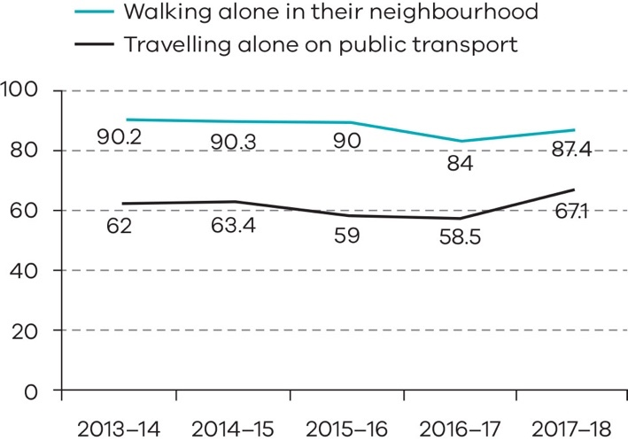
Source: ROGS 2018. Note this is the most recent data available from ROGS as 2018–19 data is published in 2020.
The percentage of Victorians surveyed who reported feeling ‘safe’ or ‘very safe’ during the day shows slight variation over five years across the two indicators of feelings of safety: walking alone in the neighbourhood and travelling alone on public transport.
In 2017–18, 87.4 per cent of Victorians surveyed felt ‘safe’ or ‘very safe’ when walking alone in their neighbourhood during the day (a marginal increase from 84.0 per cent reported in 2016–17).
For public transport, in 2017–18, 67.1 per cent of Victorians felt ‘safe’ or ‘very safe’ on public transport during the day. This result represented an 8.6 percentage point increase compared to 2016–17
(58.5 per cent).
The national average for this measure in 2017–18 was 65.3 per cent, with Victoria 1.8 percentage points above the national average.
Community safety during the night (per cent) 2013–14 to 2017–18
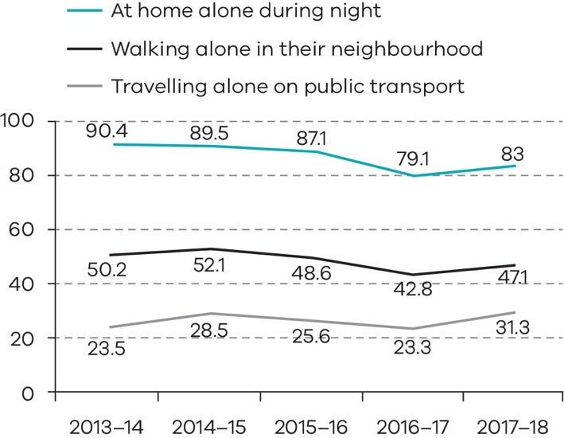
Source: ROGS 2018. Note this is the most recent data available from ROGS as 2018–19 data is published in 2020.
The percentage of Victorians surveyed who reported feeling ‘safe’ or ‘very safe’ during the night also shows slight variation over five years across the three indicators of feelings of safety: at home alone, walking alone in the neighbourhood and alone on public transport.
In 2017–18, 83 per cent of Victorians surveyed felt ‘safe’ or ‘very safe’ at home alone during the night, up from 79.1 per cent in 2016–17. In 2017–18 47.1 per cent of Victorians surveyed felt ‘safe’ or ‘very safe’ walking alone in their neighbourhood during the night (an increase from the 2016–17 result of 42.8 percent).
For public transport, 31.3 per cent of Victorians felt ‘safe’ or ‘very safe’ on public transport at night, which is a notable increase compared to the 2016–17 result of 23.3 per cent. Victoria is just below the national average (32.1 per cent) for this measure in 2017–18.

Crime statistics – Total recorded crime
As at 30 June 2019, total recorded crime increased by 1.5 per cent from 506,758 offences in 2017–18 to 514,398 offences in 2018–19. All major crime categories recorded increases except for Property and Deception offences which fell from 288,580 offences in 2017–18 to 287,716 offences in 2018–19. Residential Burglary recorded the largest decrease (-10.7 per cent) over the past 12 months.
The main offence categories contributing to the increase in crime include Justice Procedures, in particular breaches of orders, (+8.5 per cent), Drug Offences, in particular drug dealing and trafficking (+11.8 per cent), cultivation and manufacture of drugs (+15.3 per cent), drug use and possession (+ 8.1 percent), and Crimes Against the Person, in particular robbery (+7.8 per cent), and assault and related offences (+3.3 per cent).
Crime statistics are based on reports from the public and crimes detected by police. Changes to recorded crime can be due to increased presence and focus on community safety throughout Victoria, police detection and enforcement activity, the introduction of new offences or increased police powers to enforce certain offences. Changes may also be due to social, economic and environmental factors, or increasing or changing public confidence to report crime to police.
The Crime Statistics Agency (CSA) is responsible for the calculation and publication of crime statistics and a further breakdown of crime statistics is available on the CSA website www.crimestatistics.vic.gov.au.
Crime statistics 2014–15 to 2018–19: Total recorded crime
Offences | 2014-15 | 2015-16 | 2016-17 | 2017-18 | 2018-19 | % Change 2017-18 to 2018-19
Homicide and related offences | 174 | 211 | 233 | 219 | 185 | -15.5
Assault and related offences | 37,624 | 41,687 | 43,391 | 43,464 | 44,916 | 3.3
Sexual offences | 11,506 | 12,664 | 13,477 | 14,920 | 13,519 | -9.4
Abduction and related offences | 708 | 807 | 756 | 722 | 736 | 1.9
Robbery | 2,530 | 2,887 | 3,196 | 3,180 | 3,429 | 7.8
Blackmail and extortion | 212 | 191 | 204 | 191 | 256 | 34.0
Stalking, harassment and threatening behaviour | 12,108 | 12,730 | 11,830 | 11,728 | 12,352 | 5.3
Dangerous and negligent acts endangering people | 4,359 | 5,320 | 6,050 | 5,859 | 5,817 | -0.7
Total Crimes against the person | 69,221 | 76,497 | 79,137 | 80,283 | 81,210 | 1.2
Arson | 3,444 | 4,516 | 3,263 | 3,344 | 3,135 | -6.3
Property damage | 42,544 | 43,484 | 42,379 | 40,962 | 39,235 | -4.2
Burglary/Break and enter | 46,242 | 52,095 | 52,031 | 43,522 | 38,881 | -10.7
Theft | 151,802 | 181,120 | 182,123 | 166,683 | 171,306 | 2.8
Deception | 33,494 | 39,159 | 35,909 | 34,062 | 35,150 | 3.2
Bribery | 41 | 26 | 6 | 7 | 9 | 28.6
Total Property and deception offences | 277,567 | 320,400 | 315,711 | 288,580 | 287,716 | -0.3
Drug dealing and trafficking | 5,050 | 5,213 | 4,522 | 4,389 | 4,884 | 11.8
Cultivate or manufacture drugs | 1,685 | 1,740 | 1,461 | 1,272 | 1,467 | 15.3
Drug use and possession | 21,947 | 23,197 | 24,270 | 24,097 | 26,048 | 8.1
Other drug offences | 277 | 48 | 107 | 145 | 116 | -20.0
Total Drug offences | 28,959 | 30,198 | 30,360 | 29,883 | 32,515 | 8.8
Weapons and explosives offences | 14,515 | 15,996 | 15,925 | 14,837 | 16,005 | 7.9
Disorderly and offensive conduct | 19,390 | 17,124 | 16,600 | 15,990 | 14,892 | -6.9
Public nuisance offences | 2,665 | 3,488 | 3,428 | 3,776 | 3,721 | -1.5
Public security offences | 194 | 87 | 73 | 139 | 58 | -58.3
Total Public order and security offences | 36,764 | 36,695 | 36,026 | 34,742 | 34,676 | -0.2
Justice procedures | 6,878 | 12,837 | 12,758 | 12,178 | 12,918 | 6.1
Breaches of orders | 51,274 | 57,791 | 57,166 | 58,948 | 63,962 | 8.5
Total Justice procedures offences | 58,152 | 70,628 | 69,924 | 71,126 | 76,880 | 8.1
Regulatory driving offences | 30 | 18 | 14 | 18 | 19 | 5.6
Transport regulation offences | 453 | 593 | 729 | 615 | 555 | -9.8
Other government regulatory offences | 642 | 547 | 621 | 1,109 | 361 | -67.4
Miscellaneous offences | 479 | 478 | 307 | 402 | 466 | 15.9
Total Other offences | 1,604 | 1,636 | 1,671 | 2,144 | 1,401 | -34.7
Grand Total offences | 472,267 | 536,054 | 532,829 | 506,758 | 514,398 | 1.5
Source: CSA

Crime statistics – Offence rate per 100,000 population
To provide a standardised method for comparing data across years, an offence rate per 100,000 population is used for offences reported in the 2018–19 financial year. In 2018–19 the rates per 100,000 population for Other Offences (-36.0 per cent), Property and Deception offences (-2.3 per cent), Public Order and Security Offences (-2.2 per cent) and Crimes against the Person (-0.9 per cent) all decreased. In contrast, the rate per 100,000 population for Drug Offences recorded the largest increase over the past 12 months (+6.6 per cent), followed by Justice Procedures Offences (particularly breaches of orders) which increased by 5.9 per cent.
Crime statistics 2014–15 to 2018–19: Offence rate per 100,000 population
Offences | 2014-15 | 2015-16 | 2016-17 | 2017-18 | 2018-19 | % change 2017-18 to 2018-19
Homicide and related offences | 2.9 | 3.4 | 3.7 | 3.4 | 2.8 | -17.3
Assault and related offences | 624.7 | 675.3 | 686.4 | 672.7 | 681.0 | 1.2
Sexual offences | 191.1 | 205.1 | 213.2 | 230.9 | 205.0 | -11.2
Abduction and related offences | 11.8 | 13.1 | 12.0 | 11.2 | 11.2 | -0.1
Robbery | 42.0 | 46.8 | 50.6 | 49.2 | 52.0 | 5.6
Blackmail and extortion | 3.5 | 3.1 | 3.2 | 3.0 | 3.9 | 31.3
Stalking, harassment and threatening behaviour | 201.1 | 206.2 | 187.1 | 181.5 | 187.3 | 3.2
Dangerous and negligent acts endangering people | 72.4 | 86.2 | 95.7 | 90.7 | 88.2 | -2.7
Total Crimes against the person | 1,149.4 | 1,239.2 | 1,251.8 | 1,242.6 | 1,231.3 | -0.9
Arson | 57.2 | 73.2 | 51.6 | 51.8 | 47.5 | -8.2
Property damage | 706.4 | 704.4 | 670.4 | 634.0 | 594.9 | -6.2
Burglary/Break and enter | 767.8 | 843.9 | 823.1 | 673.6 | 589.5 | -12.5
Theft | 2,520.7 | 2,934.0 | 2,881.0 | 2,580.0 | 2,597.3 | 0.7
Deception | 556.2 | 634.3 | 568.0 | 527.2 | 532.9 | 1.1
Bribery | 0.7 | 0.4 | 0.1 | 0.1 | 0.1 | 25.9
Total Property and deception offences | 4,609.0 | 5,190.2 | 4,994.2 | 4,466.7 | 4,362.3 | -2.3
Drug dealing and trafficking | 83.9 | 84.4 | 71.5 | 67.6 | 74.0 | 9.5
Cultivate or manufacture drugs | 28.0 | 28.2 | 23.1 | 19.7 | 22.2 | 13.0
Drug use and possession | 364.4 | 375.8 | 383.9 | 373.0 | 394.9 | 5.9
Other drug offences | 4.6 | 0.8 | 1.7 | 2.2 | 1.8 | -21.6
Total Drug offences | 480.9 | 489.2 | 480.3 | 462.5 | 493.0 | 6.6
Weapons and explosives offences | 241.0 | 259.1 | 251.9 | 229.7 | 242.7 | 5.7
Disorderly and offensive conduct | 322.0 | 277.4 | 262.6 | 247.5 | 225.8 | -8.8
Public nuisance offences | 44.3 | 56.5 | 54.2 | 58.4 | 56.4 | -3.5
Public security offences | 3.2 | 1.4 | 1.2 | 2.2 | 0.9 | -59.1
Total Public order and security offences | 610.5 | 594.4 | 569.9 | 537.7 | 525.7 | -2.2
Justice procedures | 114.2 | 207.9 | 201.8 | 188.5 | 195.9 | 3.9
Breaches of orders | 851.4 | 936.2 | 904.3 | 912.4 | 969.8 | 6.3
Total Justice procedures offences | 965.6 | 1,144.1 | 1,106.1 | 1,100.9 | 1,165.6 | 5.9
Regulatory driving offences | 0.5 | 0.3 | 0.2 | 0.3 | 0.3 | 3.4
Transport regulation offences | 7.5 | 9.6 | 11.5 | 9.5 | 8.4 | -11.6
Other government regulatory offences | 10.7 | 8.9 | 9.8 | 17.2 | 5.5 | -68.1
Miscellaneous offences | 8.0 | 7.7 | 4.9 | 6.2 | 7.1 | 13.5
Total Other offences | 26.6 | 26.5 | 26.4 | 33.2 | 21.2 | -36.0
Grand Total offences | 7,841.9 | 8,683.6 | 8,428.7 | 7,843.7 | 7,799.1 | -0.6
Source: CSA
Note: Estimated resident population, for years preceding the current year, are taken from the Australian Bureau of Statistics (ABS), Regional Population Growth, Australia (cat. No. 3218.0) – as at 30 June. As ABS data is not available for the current year’s rates to be calculated, the CSA uses estimates created by the Victorian Government’s ‘Victoria in future’ report.
Road fatalities and injuries
This objective indicator is defined by two measures that are recorded to have occurred on Victoria’s roads during a twelve-month period:
- total reported road fatalities in vehicle collisions
- total persons reported injured in vehicle collisions.
Victoria Police aims to contribute to a reduction in road crashes and related road deaths and hospitalisations. Road fatalities and injuries are also influenced by a number of other factors, such as the condition of roads, driver education and media campaigns.
Victoria Police continues to work to keep our roads safe by implementing the Towards Zero 2016–20 Road Safety Strategy and Plan including operations targeting speeding, drug and drink driving, and high-risk drivers.
Rate of road fatalities 2014–15 to 2018–19
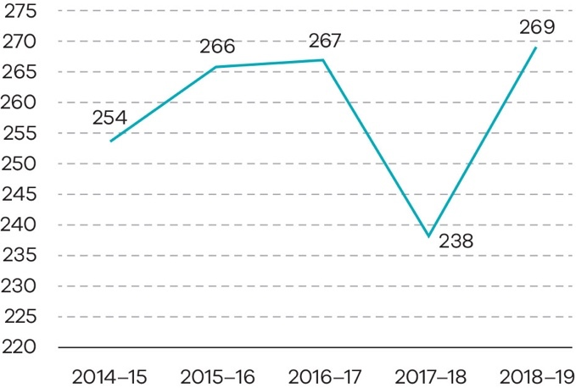
Rate of road injuries 2014–15 to 2018–19
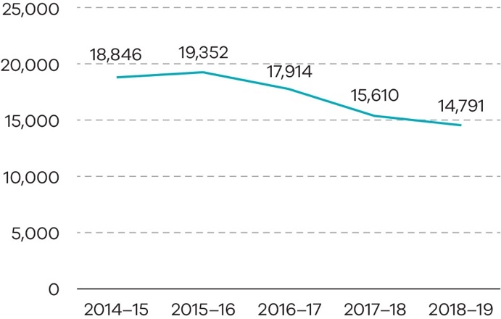
Source: Victoria Police.
Data was extracted from Victoria Police’s Collision Management Information System and is subject to variation.
In 2018–19, there were a total of 269 road fatalities in Victoria which is an increase of 31 when compared to 2017–18. The trend in road injuries in Victoria shows a significant decrease of 21.5 per cent over the past five years, from 18,846 in 2014–15 to 14,791 in 2018–19.

Effective management of prisoners and offenders and provision of opportunities for rehabilitation and reparation
This objective relates to the management of the state’s adult correctional system. The overarching purpose of the correctional system is to promote community safety. It achieves this through effective management and provision of rehabilitation and reparation opportunities to prisoners and offenders under custodial and community-based supervision.

Progress toward achieving this objective
Escapes from corrective facilities
The objective indicator ‘Escapes from corrective facilities’ includes escapes by prisoners from secure perimeter corrective facilities and open perimeter corrective facilities (open camp prisons).
Escapes from corrective facilities (number)
2014–15 to 2018–19
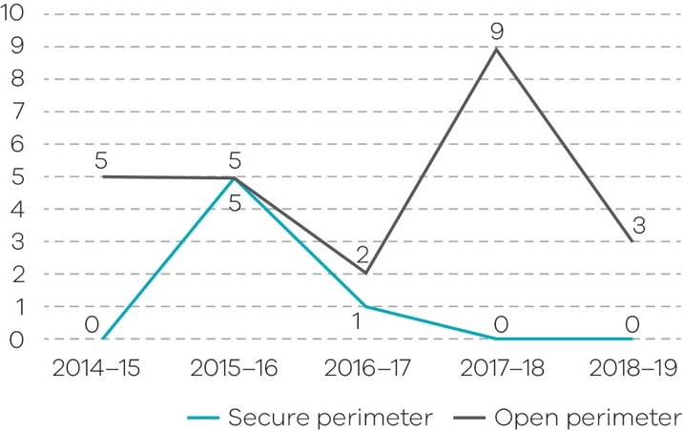
Source: Corrections Victoria
There were no escapes reported from secure perimeter corrective facilities in 2017–18 and 2018–19.
There were three escapes from open perimeter corrective facilities in 2018–19. One prisoner escaped from Beechworth Correctional Centre, one from Dhurringile Prison and one from Tarrengower Prison. All prisoners were classified as minimum security and were subsequently returned to prison.
This is a decrease from nine escapes from open perimeter facilities in 2017–18. After any escape from custody a comprehensive review is undertaken to identify any future learnings.

Percentage of community corrections orders completed
The objective indicator ‘Percentage of community corrections orders completed’ measures the proportion of orders discharged by CCS that were successfully completed. This indicator includes successfully completed parole orders, supervised court orders and reparation orders managed by CCS.
A parole order allows a prisoner to serve part of their sentence of imprisonment in the community under supervision and subject to conditions imposed by the Adult Parole Board. Supervised court orders are predominantly CCOs imposed by the courts that include at least one condition other than community work. Reparation orders comprise a range of orders that include only a requirement to perform unpaid community work. The most common reparation orders are CCOs and Fine Orders.
Percentage of community corrections orders completed
Unit of measure | 2014–15 | 2015–16 | 2016–17 | 2017–18 | 2018–19
Per cent | 66.5 | 66.2 | 62.9 | 59.2 | 56.4
Source: Corrections Victoria
Performance in 2018–19 has decreased over time due to a combination of factors, including a more complex cohort of offenders on court orders following the abolition of suspended sentences and the transition to a new fines system.
The embedding of reforms following additional investment in CCS from 2016–17 is expected to result in better outcomes for offenders in future years, including an improved successful completion rate.

Rate of prisoner return to prison within two years
This objective indicator measures the percentage of prisoners released from custody after serving a sentence, who return to prison under sentence within two years of release. This indicator is influenced by the broader operation of the criminal justice system as well as prisoner rehabilitation objectives.
Rate of prisoner return to prison within two years (per cent) 2014–15 to 2018–19
Unit of measure | 2014–15 | 2015–16 | 2016–17 | 2017–18 | 2018–19
Per cent | 44.1 | 42.8 | 43.6 | 43.7 | 43.3
Source: Corrections Victoria
Performance in 2018–19 has improved from a rate of return of 43.7 per cent in 2017–18 to a rate of return of 43.3 per cent. The increasing number of prisoners being remanded prior to sentencing has impacted this measure over the last three years.

Rate of offender return to corrective services within two years
This objective indicator measures the percentage of offenders who returned to corrective services for a subsequent sentenced episode (either prison or community corrections) within two years of successful discharge from a CCO. This indicator is influenced by the broader operation of the criminal justice system, and the effectiveness of CCS supervising offenders and providing rehabilitation opportunities.
Rate of offender return to corrective services within two years (per cent) 2014–15 to 2018–19
Unit of measure | 2014–15 | 2015–16 | 2016–17 | 2017–18 | 2018–19
Per cent | 15.2 | 14.6 | 16.2 | 16.4 | 15.6
Source: Corrections Victoria
Performance in 2018–19 improved from 16.4 per cent in 2017–18 to 15.6 per cent, noting that due to a review of application of counting rules undertaken in 2018, the offender rates differ from those published in reports prior to 2017–18.

Output initiatives and projects
The key output initiatives and projects associated with this objective, delivered by the department during 2018–19, are outlined below.
Refer to Appendix 3 for further detail regarding progress of each of these initiatives and projects, and for reporting on output performance measures.

System wide initiatives

Improving access to mental health services, alcohol and other drug treatment programs
- Opened the Apsley Secure Psychiatric Intensive Care Unit at the Thomas Embling Hospital, the state’s secure forensic mental health hospital.
- Delivered two forensic mental health initiatives from a 10-year plan to improve forensic mental health services. A program delivering improved mental health care for offenders in the community subject to community-based orders and the provision of clinical advice for magistrates and court staff in 13 Magistrates’ Courts across Victoria.
- Established a tele-psychiatry pilot to provide safe and accessible mental health services within prisons and improve attendance rates and prisoners’ experiences.
- Expanded the alcohol and other (AOD) program with six additional programs delivered in the men’s prison system during the year.

Supporting the transition back into the community
- Strengthened support for prisoners transitioning back to the community through the ReStart and ReConnect programs.
- Continued delivery of the Atrium program (previously known as the Bail Access Program) which provides participants transitioning back to the community with educational programs, housing, case management and intensive alcohol and drug treatment.

Corrections legislative reform program
- The Corrections Amendment (Parole) Act 2018 amended the Corrections Act 1986 to provide restrictive conditions for making a parole order for certain prisoners.
- The remaining provisions of the Corrections Legislation Further Amendment Act 2017 commenced operation, including the clarification of powers for police officers to use firearms when exercising powers of a prison officer.
- The Justice Legislation Amendment (Terrorism) Act 2018 amended the Corrections Act 1986 to introduce a new presumption against parole for prisoners assessed as at-risk of committing terrorism.
- The Serious Offenders Act 2018 commenced operation and expanded the current post-sentence scheme to include serious violent offenders and a new secure residential treatment facility for accommodating offenders on post-sentence orders.
- The Corrections Regulations 2019 replaced the expiring Corrections Regulations 2009 ensuring the ongoing management, security and operations of the correctional system.

Countering violent extremism
- Funding of $3.45 million was provided in the 2018–19 State Budget to ensure a consistent, integrated approach to managing prisoners and offenders and develop a framework and service delivery model, including information-sharing protocols and training for Corrections, regional and Court staff.
- Commenced a project to ensure a consistent and integrated approach to managing prisoners and offenders at risk of violent extremist behaviour with the establishment of the Countering Violent Extremism Steering Committee in January 2019, and the Countering Violence Extremism Technical working group established in May 2019.
- Increased intelligence capability to improve parole related information-sharing between agencies to protect the community from violent extremism.

Other initiatives
- All 35 recommendations from the Review of Complex Adult Victim Sex Offender Management (the Harper Review) have been implemented and the expanded post-sentence scheme for serious sex and violent offenders is now in place.
- Establishment of a new contract for electronic monitoring, with more reliable and accurate technology and equipment. Information sharing between the correctional system and Victoria Police has been strengthened with an IT solution which provides ‘real-time’ information about events such as family violence, breaches of intervention orders and field contacts.
- Commenced work to align work practices with the new Family Violence Multi Agency Risk Assessment and Management (MARAM) Framework. This included introducing ‘Managing Family Violence Practice Guidelines’ for the CCS case management workforce and automating data from corrections’ systems to enable more timely reports to the Orange Door, the entry point for Victorians to access child and family services, and family violence support services.
- Developed a consistent operating model with standardised products and pricing for all public prisons shops, enabling partial cost recovery.

Output: Prisoner supervision and support

Expanding and improving prison infrastructure and services to meet demand
- Undertook planning to enable the department to meet the future demand for prison accommodation.
- Completed advanced planning design and community consultations for the new Chisholm Road Prison, a maximum-security men’s prison. Additional funding was allocated in the 2019–2020 State Budget to increase the prison capacity to 1,248 beds.
- Added a significant number of beds across the prison system. This includes an additional 300 beds at Ravenhall Correctional Centre which has brought its capacity to 1,300 prisoners, and an increase to Metropolitan Remand Centre capacity, at 954 beds as of 30 June 2019.
- Enhanced facilities for women prisoners at the Dame Phyllis Frost Centre following the opening of the new Mental Health and Wellbeing Precinct.
- Completed the refurbishment of the Acute Assessment Unit at Melbourne Assessment Prison.
- Opened a new state-of-the-art State Training Complex for prison officers from the Security and Emergency Services Group (SESG).
- Established a new ongoing pathway between Hopkins Correctional Centre in Ararat, HM Prison Langi Kal Kal in Trawalla and the East Grampians Health Service for hospital services following a pilot.
- Continued to implement strategies to more effectively manage the growth and changing profile of the women’s prisoner population by introducing a new precinct operating model at the Dame Phyllis Frost Centre, a new classification framework and a trial of a security rating tool.

Supporting Aboriginal social and emotional wellbeing
- Delivered several initiatives as part of the Aboriginal Social and Emotional Wellbeing Plan, including the introduction of Cultural Safety Standards for health care at Dhurringile Prison, a pilot project to deliver culturally appropriate mental health services to Aboriginal prisoners and a program to enable continuity of care across select locations.
- Delivered the Yawal Mugadjina program which provided mentoring by Elders to Aboriginal men and women in prison in order to strengthen their transition and reintegration into the community.
- Commenced a pilot to deliver culturally appropriate mental health assessment training for prison health providers.
- Awarded four new Aboriginal Tertiary Scholarships to assist Aboriginal students to pursue health-related studies and provide the opportunity to participate in practical work placements.

Output: Community based offender supervision

Consolidating reforms in Community Correctional Services
- Consolidated the major projects delivered under the CCS reform and expansion program over recent years.
- Strengthened the case management model for offenders who are subject to post-sentence supervision orders to align with case management practices across the workforce.
- Commenced a graduate employment program aimed at professionalising the CCS workforce by providing an accelerated training and employment pathway for eligible graduates.
- Delivered community-based forensic AOD treatment programs for offenders on court orders designed to increase the assessment, management and effectiveness of the treatments.

Effective supervision of young offenders through the provision of youth justice services promoting rehabilitation
This objective aims to promote opportunities for rehabilitation of young people in the youth justice system and contribute to the reduction of crime in the community by providing a range of services including diversion services, advice to courts, offending related programs, community-based and custodial supervision.

Progress toward achieving this objective

Percentage of community-based orders successfully completed
‘Completion of community-based orders’ is defined as the proportion of sentenced community-based supervision orders successfully completed. Successful completion is where the earliest order expiry date or the order termination date is reached and a breach is neither pending nor finalised. Young people subject to community-based supervision within the youth justice service receive comprehensive case management including assessment, case planning, support, and offence-specific interventions.
Percentage of community based orders successfully completed 2014–15 to 2018–19
Unit of measure | 2014–15 | 2015–16 | 2016–17 | 2017–18 | 2018–19
Per cent | 90.5 | 90.4 | 90.5 | 90.3 | 89.3
Source: DHHS Client Relation Information System (CRIS)
The proportion of community-based orders successfully completed in 2018–19 was just under 90 per cent, slightly below the trend for the past four years. The Victorian youth justice system has a strong record in successfully supporting young people to complete their orders.

Young people in youth justice participating in community reintegration activities
Community reintegration activities are intended to assist young people in custody to return to their communities after serving a period of detention. This objective indicator refers to young people in custody participating in the temporary leave program. The Children Youth and Families Act 2005 makes provision for temporary leave from custody for employment, education and training, to visit family, attend hospital appointments or attend court. This enables suitable young people to go on leave into the community toward the end of their sentence, to support their successful transition back into the community.
Percentage of young people in youth justice participating in community reintegration activities 2014–15 to 2018–19
Unit of measure | 2014–15 | 2015–16 | 2016–17 | 2017–18 | 2018–19
Per cent | 70.0 | 58.7 | 53.4 | 79.4 | 75.1
Source: DHHS CRIS
There was a decrease in young people participating in community reintegration activities in 2015–16
(58.7 per cent) and 2016–17 (53.4 per cent), however this has since increased to 79.4 per cent in 2017–18 and 75.1 per cent in 2018–19.
The increase in participation rate is due to the higher proportion of young people in custody with a sentence with sufficient time on the sentence to participate in community reintegration activities, and an increased focus on parole planning and transition back into the community by way of meaningful leave.

Output initiatives and projects
The key output initiatives and projects associated with this objective, delivered by the department during 2018–19, are outlined below.
Refer to Appendix 3 for further detail regarding progress of each of these initiatives and projects, and for reporting on output performance measures.

System-wide initiatives and achievements
In 2018–19, the department continued to implement the 126 recommendations of the landmark Youth Justice Review and Strategy (the Youth Justice Review) which provides a comprehensive roadmap for reform that ensures the stability and effective operation of the youth justice system.

Early intervention for children, young people and low-risk offenders
- The 2018–19 State Budget provided $12.88 million over four years and $3.4 million ongoing to ensure ongoing, state-wide delivery of youth diversion services. Children’s Court Youth diversion (CCYD) coordinator oversaw 1,408 diversions 94 per cent of diversions were successfully completed.
- Commenced work on the first Aboriginal Youth Justice Strategy in partnership with the Aboriginal Justice Caucus, under the umbrella of Burra Lotjpa Dunguludja.
- In partnership with the Commission for Children and Young People, established the Aboriginal Youth Justice Taskforce to review the cases of all Aboriginal children and young people who came in contact with the youth justice system over a five-month period.
- Implemented programs and activities to support Aboriginal young people in custody, including an Aboriginal Health Worker, and recruiting Aboriginal Liaison Officers based at the two Youth Justice centres.
- Developed a cultural engagement program which includes engagement with community leaders and respected people from Horn of Africa and Pacific Island communities in Victoria to work with young people in custody and strengthen their association to their cultural backgrounds. The activities include the South Sudanese Mentoring Program and the Mana Toa program (mentoring, educational and sporting activities).
- Established four specialist roles to support engagement with culturally and linguistically diverse (CALD) communities, particularly young people, both within the community and in custody.
- Commenced work with the DHHS, Victoria Police and residential care providers to establish cross-agency agreement to ensure consistency and improved coordination of care for young people in both child protection and youth justice systems.

Managing the workforce for the future of the system
- Established the new Youth Justice Commissioner to support the youth justice workforce and enhance management and supervision of young people, supported by additional operational managers in the youth justice centres, youth justice workers and correctional SESG staff.
- Commenced work on a comprehensive workforce plan for youth justice, which will include strategies addressing recruitment, retention, and learning and development, in line with a key recommendation of the Youth Justice Review.

New case management framework
- Implemented a new evidence-based case management approach for young people in custody and the community, including the use of validated assessment tools to identify appropriate interventions for each young person to reduce their risk of reoffending.

Output: Youth justice community-based services
- Engaged community-based service providers to deliver Multi-Systemic Therapy (MST) and Family Functional Therapy (FFT) programs providing intensive in-home support to young people and their families to help strengthen relationships, improve communication and respond to challenging behaviour.
- Introduced new youth offending behaviour programs for young people under youth justice supervision that directly address their offending behaviour, including programs targeting violent offending, sexual offending, substance use-related and motor-vehicle related offending.

Output: Youth justice custodial services

Expanding and improving custodial infrastructure
- Early works commenced on the new fit for purpose youth justice precinct at Cherry Creek, which includes dedicated mental health and intensive intervention units and AOD treatment services.
- Continued strengthening works across Parkville and Youth Justice Precincts including works to fences, walls, doors and other potential climbing points to secure and strengthen the facilities.

Expanding primary health and mental health services for young people in custody
- Invested $18.7 million to improve health and mental health services for young people in custody with an expansion of these services delivered under new contracts with Correct Care Australasia and Melbourne Health (Orygen Youth Health).
- Orygen Youth Health commenced the delivery of the new Custodial Forensic Youth Mental Health Service with specialist assessment and treatment services provided by a multidisciplinary team of mental health professionals and operators at the two Youth Justice Centres.

Ensuring secure, safe and stable custodial environments that promote the rehabilitation of children and young people
- Established the Custodial Facilities Working Group which includes senior government and non-government youth justice experts and stakeholders, to provide advice on key issues relating to the youth justice custodial system. The group has commenced work on a number of key custodial reform initiatives, including the development of an intensive intervention unit to deliver intervention, support and supervision to high-risk and high-need children and young people, and development of a new custodial operating philosophy. This philosophy describes the core operating principles of Victoria’s Youth Justice custodial centres to strengthen the stability and security of the custodial system and ensure that the individual needs of children and young people are met.
- Developed a Memorandum of Understanding with the DET which establishes the roles and responsibilities of each department to coordinate and strengthen the delivery of education services to young people in custody.
- Established a high-risk panel to oversee and provide direction on managing young people deemed a significant risk of harm to themselves or others.

A fair and accessible criminal justice system that supports a just society based on the rule of law

This objective relates to the provision of Criminal Justice services that support legal processes and law reform. Services that support legal processes include legal assistance and education services, prosecution services, community mediation services, support for victims of crime, risk assessments for those working with or caring for children, infringement processing and enforcement activities and delivery of independent, expert forensic medical services to the justice system.
Other services that contribute to this objective include legal policy advice to the government, law reform and sentencing advisory services.

Progress toward achieving this objective

Prosecutions completed and returning guilty outcomes
This objective indicator reports the percentage of all prosecution matters within the Office of Public Prosecutions (OPP) completed with a guilty outcome. A higher percentage shows that more cases are resulting in a guilty outcome and indicates that the OPP is making sound early decisions on which matters to prosecute, and that prosecution work undertaken is of sufficient quality, in that either a guilty plea is entered by an accused, or that the accused is convicted at trial.
Prosecutions completed and returning guilty outcomes (percentage of total case finalisations) 2015–16 to 2018–19
Unit of measure | 2015–16 | 2016–17 | 2017–18 | 2018–19
Per cent | 89.6 | 90.1 | 91.8 | 91.9
Source: OPP Case Management System
In 2018–19, the proportion of all prosecution matters completed with a guilty outcome was 91.9 per cent. This was a marginal increase from the 2017–18 result (91.8 per cent), and the measure is at the highest level since comparable record-keeping began in 1995–96.
The high level can be attributed to a number of OPP and criminal justice system initiatives aimed at reducing delay and improving the efficiency and effectiveness of court processes. These include technological enhancements, refined case-management practices and an improved OPP case decision-making oversight mechanism to enhance casework quality.

Legal advice and assistance provided
This objective indicator reports the number of one-off legal advice sessions provided by Victoria Legal Aid (VLA) lawyers at VLA offices or via outreach services, or by phone or video conference. Legal assistance includes minor work (perusal of documents, written advice, telephone calls, oral or written negotiations), appearances before Courts or tribunals in less complex matters, and the number of grants for legal aid approved by VLA in the period.
Legal advice and assistance provided (number) 2015–16 to 2018–19
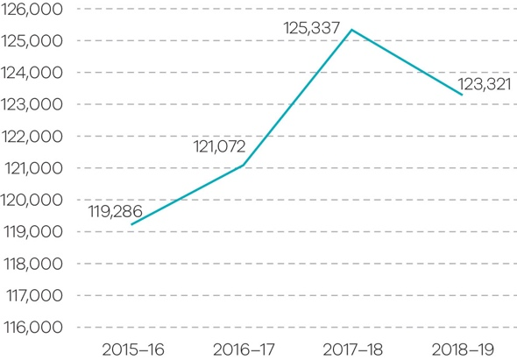
Source: Victoria Legal Aid
In the past 12 months, Legal Help answered 140,224 calls and completed a total of 6,762 information sessions via the live chat service. Clients calling into Legal Help are presenting with more complex legal issues and VLA are providing more legal advice as opposed to legal information, resulting in an increase in call duration and wait times.
VLA’s continued focus on family violence has seen an increase in the total number of family violence services provided by 16 per cent to 45,448. In the past 12 months, overall grants of legal assistance grew by five per cent to 45,180, duty lawyer services grew by three per cent to 97,796 and early intervention services by 14 per cent to 47,438.

Infringement notices processed
This objective indicator counts the number of infringement notices issued by the road safety camera network, including red light cameras, supporting the government’s Towards Zero 2016–2020 Road Safety Strategy.

Infringement notices processed (number million) 2015–16 to 2018–19
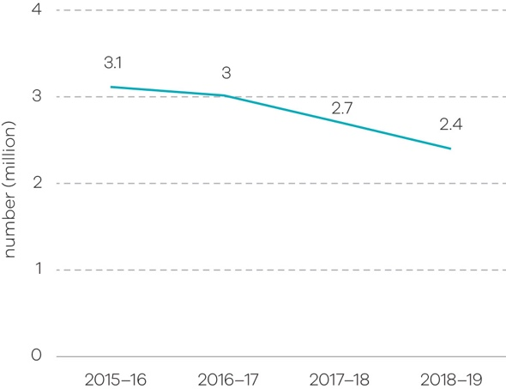
Source: Victorian Infringement Enforcement and Warrant System , Fines Victoria
In the 2018–19 financial year, 2.4 million infringement notices were processed. Infringements from road safety cameras declined by approximately 11 per cent when compared with 2017–18. This is primarily due to toll road operators increasing their in-house collection activity for toll infringements, which has resulted in significantly fewer matters being referred to Victoria Police to issue an infringement. In addition, there have been works to some road safety camera systems (reducing the number of operating cameras) which have led to a reduction in the number of infringements issued.

Medico-legal death investigations
This objective indicator reflects the number of medico-legal death investigations provided by the Victorian Institute of Forensic Medicine (VIFM). VIFM’s medico-legal death investigation workload is determined by the number of deaths reported to the coroner.
Medico-legal death investigations (number)
2015–16 to 2018–19
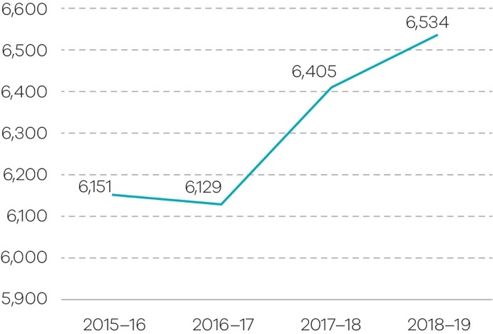
Source: VIFM Case Management System
There has been a significant increase in demand for medico-legal death investigations over the past four years, with the number of reportable deaths increasing by six per cent since 2015–16.
Due to increasing demand for its services, the VIFM continues to seek efficiencies in the way it approaches death investigation processes to ensure high quality and timely resolution of cases for the coroner and for families.

Law reform projects completed
The functions of the Victorian Law Reform Commission (VLRC) are set out in the Victorian Law Reform Commission Act 2000. The VLRC’s primary function is ‘to examine, report and make recommendations to the Attorney-General on any proposal or matter relating to law reform in Victoria that is referred to the Commission by the Attorney-General’. In addition, the Commission’s community law reform role is ‘to examine, report and make recommendations to the Attorney-General on any matter that the Commission considers raises relatively minor legal issues that are of general community concern’.
Reports to the Attorney-General regarding both these purposes contain recommendations that aim to improve and modernise the law, making it more relevant and effective.
Law reform projects completed (number) 2015–16 to 2018–19
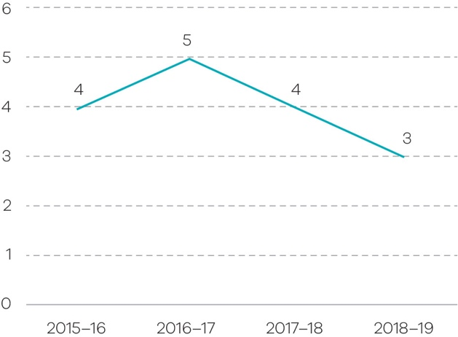
Source: VLRC
In 2018–19, the VLRC completed three law reform projects:
- Review of the Victims of Crime Assistance Act 1996 (tabled in Parliament September 2018) [Attorney-General Reference]
- Contempt of Court (published May 2019) [Consultation paper]
- Committals (published June 2019) [Issues paper]
The number of projects, their size and reporting deadlines are matters largely outside the control of the VLRC and are a function of the Attorney-General’s requirements.

Number of Sentencing Advisory Council publications
This objective indicator reports the publishing of reports on sentencing matters to fulfil the Sentencing Advisory Council’s (SAC) statutory functions. The key statutory functions of the SAC are to provide statistical information on sentencing, including information on current sentencing practices and to conduct research and disseminate information on sentencing matters. The SAC publishes a range of reports on sentencing matters to fulfil these functions.
Number of Sentencing Advisory Council publications 2016–17 to 2018–19
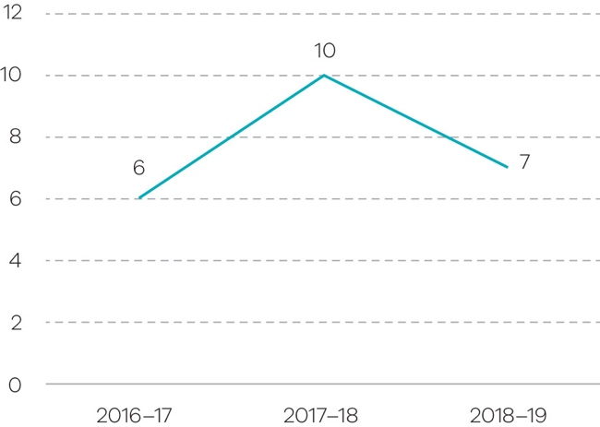
Source: SAC
In 2018–19, the SAC published the following reports:
- Sentence Appeals in Victoria: Second Statistical Research Report
- Restitution and Compensation Orders: Report
- Serious Offending by People Serving a Community Correction Order: 2017–18
- A Quick Guide to Sentencing (Fifth edition)
- Animal Cruelty Offences in Victoria
- Firearms Offences: Current Sentencing Practices
- Cross-over Kids: Vulnerable Children in the Youth Justice System.

Services provided to victims of crime against the person
This objective indicator measures the delivery of a suite of support services to victims of crime, including the Victims of Crime Helpline (Helpline), Victims Assistance Program (VAP), Victims Register and Child Witness Service (CWS).
The Helpline provides telephone support, needs assessment and referrals to victims of crime and their families. The VAP provides victims with personalised practical and psychological support to manage the effects of violent crime, and to navigate the criminal justice system.
The Victims Register is a state-wide service that supports victims of offenders who have committed violent crimes and have been sentenced to a term of imprisonment. The CWS is a state-wide service that supports children (age four to 18 years) who are identified as witnesses in criminal matters. The CWS aims to reduce the re-traumatisation of child witnesses that can occur as a result of giving evidence in court.
Services provided to victims of crime against the person (number) 2014–15 to 2018–19
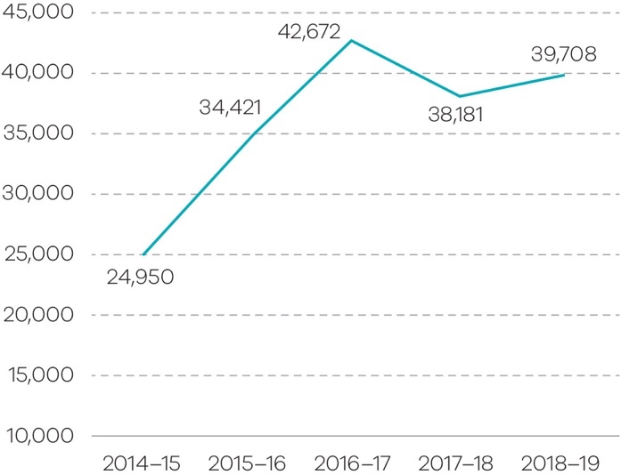
Source: Community Operations and Victims Support Agency
In 2018–19, referrals from police who attend a family violence incident involving a male victim accounted for 58.9 per cent of referrals, followed by e-referrals from police for male and female victims of crimes against the person (28.7 percent). The Helpline inbound calls increased 13.2 per cent from 2017–18.
In the 2018–19 State Budget, the CWS received additional funding of $6.9 million over four years, which enabled the recruitment of four additional full-time staff. In 2018–19, the CWS provided 981 clients (563 new clients) with 7,368 hours of support.

Working with Children Checks processed (negative notices issued within three days of receiving decision)
This objective indicator measures the percentage of negative Working with Children Notices issued within three days of receiving the decision.
Working with Children Checks processed - negative notices issued within three days of receiving decision 2015–16 to 2018–19
Unit of measure | 2015–16 | 2016–17 | 2017–18 | 2018–19
Per cent | 100 | 100 | 99.9 | 100
Source: Working with Children Check Victoria, ChildCheck database
In 2018–2019, Working with Children Check Victoria (WWCCV) processed 411,000 applications. This is a
10.3 per cent decrease on the number processed in 2017–2018 (458,000).
Over the last four years there has been a 40.2 per cent increase in the number of negative notices issued, from 472 notices in 2015–16 to 662 in 2018–19.
WWCCV continues to meet requirements to issue negative notices within three days of receiving decision.

Output initiatives and projects
The key output initiatives and projects associated with this objective, delivered by the department during 2018–19, are outlined below.
Refer to Appendix 3 for further detail regarding progress of each of these initiatives and projects, and for reporting on output performance measures.

Output: Public prosecutions and legal assistance

Ensuring legal assistance services meets the needs of the community
- Continued to work with VLA and Community Legal Centres (CLCs) in partnership with health and education providers, employment and financial counselling services, and housing and specialist family violence services to ensure legal assistance is provided to vulnerable and disadvantaged Victorians.
- Worked with the Victoria’s legal assistance sector to improve Commonwealth funding arrangements for legal assistance services in Victoria by being involved in the National Partnership Agreement on Legal Assistance Services 2015–2020 (NPA) Review conducted August–December 2018.

Output: Infringements and warrants

Modernising the infringement system to strengthen road safety
- Continued implementation of reforms to the fines system in Victoria, which will lead to more efficient and effective collection and enforcement options, with improved options for vulnerable people to deal with their fines. The fines reforms have led to an increase in the timely payment of fines.

Output: Criminal law support and reform

Continuing to deliver reforms to tackle family violence
- A range of reforms in the Justice Legislation Amendment (Family Violence Protection and Other Matters) Act 2018 commenced, including:
- trialling a scheme for complainants to give recorded statements for use as their evidence-in-chief in proceedings for family violence offences
- including forced marriage and dowry-related abuse as examples of behaviour that may constitute family violence in the Family Violence Protection Act 2008
- allowing the Children’s Court to make therapeutic treatment orders for children aged 15–17 years and
- establishing the Specialist Family Violence Court Division in legislation, which will facilitate the roll-out of these specialist courts.
- Provided $1.75 million to five community organisations to develop trial programs which targeted Aboriginal communities, women and gender diverse perpetrators, fathers, and men with issues such as substance abuse and problem gambling.
- Undertook activities to implement whole of government family violence reforms including the Family Violence Information Sharing Scheme, the Child Information Sharing Scheme, and the Family Violence MARAM Framework.
- Continued to fund a range of Aboriginal community-led family violence initiatives to support Aboriginal Victorians at risk of family violence through behaviour change and prevention programs including Djirra and the Victorian Aboriginal Legal Service (VALS).

Monitoring impacts of bail law reforms
- Following the conclusion of the Bail Review conducted by the Hon. Paul Coghlan QC, the department established the bail reform implementation working group to monitor the early impact of bail reforms.
- The bail data working group commenced research and development work across relevant bail data sources to better understand the impact of the Coghlan Bail Review reforms and to improve the quality of bail data in the future.

Continuing counter-terrorism reform in collaboration with the Commonwealth and other jurisdictions
- Legislation addressing 20 of the 42 recommendations of the Expert Panel on Terrorism and Violent Extremism Prevention and Response Powers was included in the Justice Legislation Amendment (Terrorism) Act 2018. Work is underway to implement the other recommendations for which the department is responsible.

Fully implemented Betrayal of Trust recommendations
- Finalised implementation of recommendations of the Family and Community Development Committee Inquiry into the Handling of Child Abuse by Religious and Other Non-Government Organisations ‘Betrayal of Trust’ Final Report.

Commonwealth Royal Commission into Institutional Responses to Child Sexual Abuse
- Coordinated the implementation of recommendations from the Commonwealth Royal Commission into Institutional Responses to Child Sexual Abuse (Child Abuse Royal Commission) across government.
- Published the Victorian Government first annual report on implementation of the 409 recommendations of the Child Abuse Royal Commission.
- Supported the implementation of the Victorian participation in the National Redress Scheme for Survivors of Child Sexual Abuse which provides critical support to survivors who have suffered child abuse in institutional settings.

Transition to the National Disability Insurance Scheme
- Worked with other agencies to prepare for transition to the NDIS, which impacts the delivery of disability services for people involved in the justice system.

Output: Victims and community support services
- Ms Fiona McCormack was appointed as the second Victims of Crime Commissioner. Ms Cormack was most recently the former CEO of Domestic Violence Victoria.
- The Victims and Other Legislation Amendment Act 2018 received Royal Assent and introduced a range of reforms that strengthen victims’ rights.
- Commenced a Family Violence Restorative Justice pilot which enables victim-survivors to participate in restorative conversations, supporting them to address the harm they experienced as a result of family violence.
- Held trials to develop best practice intervention for perpetrators of family violence, build evidence on effective ways to respond to target cohorts and address service gaps and improve behaviour change.
- Began a pilot to enable victims on the Victims Register to submit their views on potential post-sentence directions to the Post Sentence Authority.
- VLRC tabled its review of the effectiveness and operation of the Victims of Crime Assistance Act 1996 and the Victims of Crime Assistance Tribunal (VOCAT) in Parliament. The Victorian Government accepted all 100 of the VLRCs recommendations in principle and the department has begun implementing the reforms.
- The Victim Support Agency (VSA) opened six new Victims Assistance Program (VAP) co-locations, developed a draft critical incident response framework and training program for the victims’ services sector and worked with emergency management stakeholders to ensure a seamless service response to victims of critical incidents.

A fair and accessible civil justice system that supports a just society with increased confidence and equality in the Victorian community

This objective aims to support the Victorian community through the provision of services relating to: rights and equal opportunity; life-event registration and identity protection; and advocacy and guardianship for Victorians with a disability or mental illness.

Progress toward achieving this objective

Complaint files received and handled by the Victorian Equal Opportunity and Human Rights Commission (VEOHRC)
This objective indicator focuses on the number of complaints received by the VEOHRC that raise a possible contravention of the Equal Opportunity Act 2010 or the Racial and Religious Tolerance Act 2001 and seek access to the dispute resolution service.
Complaint files received and handled by the VEOHRC (number) 2014–15 to 2018–19
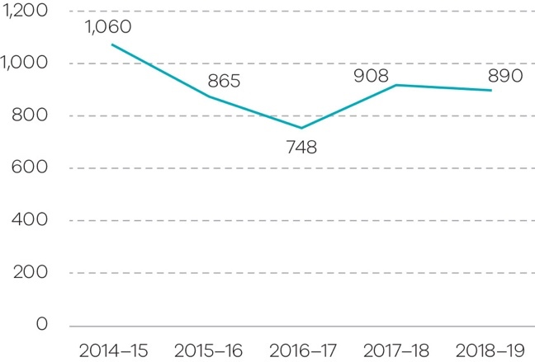
Source: VEOHRC
The number of complaint files handled by VEOHRC in 2018–19 (890) has remained at a similar level to the previous year (908) due to various education and community engagement activities.
Of the complaint files accepted for dispute resolution, the largest area of complaint was employment, followed by goods and services, and accommodation. Disability discrimination was the most frequent attribute of the complaint, followed by discrimination on the basis of race, sex, sexual harassment, employment activity and age.
A growing number of complaints involved discrimination against a person on the basis of multiple protected attributes, such as experiences of race, religious belief and disability discrimination.

People assisted through Public Advocate advice and education activities
This objective indicator counts the number of recorded instances of information and advice provided by the Office of the Public Advocate (OPA) and the number of people who attended community education sessions delivered by OPA.
Information and advice can relate to powers of attorney, guardianship, administration, or other matters relating to disability. It might be provided to a person with disability, their family members, or to legal professionals.
People assisted through Public Advocate advice and education activities (number) 2014–15 to 2018–19
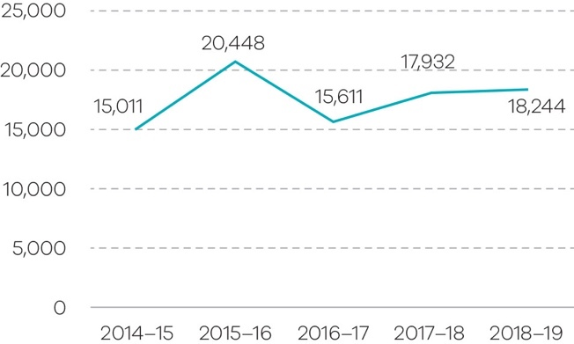
Sources: OPA
Information and advice are provided through enquiries to the advice service. These are primarily telephone enquiries, but also include some email and written correspondence, as well as direct attendance by a member of the public at OPA’s office. In 2018–19, OPA provided advice in response to 13,644 requests for information and advice.
OPA also conducted 167 community education sessions in 2018–19 to community groups and professional bodies, such as health services, disability service providers, and legal professionals.

Births, deaths and marriages registration transaction accuracy rate
This objective indicator reflects the level of accuracy of the Registry of Births, Deaths and Marriages (BDM), and its data entry service provider, in capturing registration data provided by applicants. By achieving a high accuracy rate, BDM is able to ensure a high level of confidence concerning personal identity, particularly in relation to a citizen’s birth, death and marriage.
BDM’s core business system Registry Information Online (RIO) was implemented in February 2019. The new system provides a full range of online services that allow customers and service partners to apply for birth, death, marriage, change of name and relationship registrations online. The system has enhanced data validations to assist in assessing the accuracy of information provided by customers and stakeholders.
Accuracy of the births, deaths and marriages register (per cent) 2015–16 to 2018–19
Unit of measure | 2015–16 | 2016–17 | 2017–18 | 2018–19
Per cent | 99.8 | 99.3 | 99.5 | 98.6
Source: BDM Core Management System
Since RIO was implemented there has been significant uptake of online services, particularly birth certificates with over 30,000 new births registered since February 2019.
The transition to the new system has had a minor impact on BDM’s accuracy level as the 2018–19 result of 98.6 per cent is consistent with the 2017–18 result of 99.5 per cent.

Dispute resolution services provided in the DSCV
This objective indicator counts the number of direct client contacts for dispute resolution services, including telephone calls and face to face interviews; the number of files started in the civil mediation program; and the number of direct capacity-building community engagement sessions delivered by DSCV to organisations and members of the Victorian community.
Dispute resolution services (number) provided in the DSCV 2015–16 to 2018–19
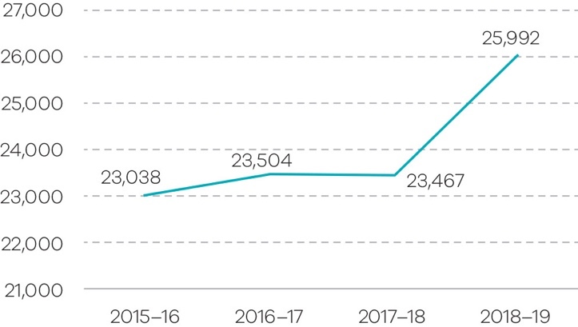
Source: DSCV
The number of dispute resolution services provided by the DSCV in 2018–19 has increased by 10.8 per cent since 2017–18. The 2018–19 result is due to the commencement of the Access to Justice Partnership initiative with the Victorian Civil and Administrative Tribunal as part of the Fast Track Mediation and Hearing Program.

Output initiatives and projects
The key output initiatives and projects associated with this objective, delivered by the department during 2018–19, are outlined below.
Refer to Appendix 3 for further detail regarding progress of each of these initiatives and projects, and for reporting on output performance measures.

Output: Protection of personal identity and individual/community rights
- The Victorian Government and Taungurung Traditional Owner group signed a comprehensive agreement providing funding, land grants and procedural rights over future uses of Crown land, with measures to strengthen the economic, social and cultural outcomes of Traditional Owner groups.
- Continued negotiations with Wotjobaluk and Eastern Maar Traditional Owners.
- Implementation of BDM’s new core business system, with almost all BDM services now available online. Uptake of online services has been strong by the general public.
- Promoted birth registration and birth certificate possession among Aboriginal communities through a range of community outreach and campaign activities, including by providing certificates free of charge to eligible customers.
- Piloted a new service ‘Notify Others’, in collaboration with participating funeral directors, which aims to reduce the administrative burden faced by bereaved families. Following the success of this pilot, a second pilot has been designed which will trial an online service and increase the numbers of participating customers and funeral directors.

Output: Dispute resolution and civil justice support services

Dispute Settlement Centre of Victoria
- Partnered with the Victorian Civil and Administrative Tribunal to expand alternative dispute resolution services across Victoria for small consumer claims through the Fast Track Mediation and Hearing Program.

Improving civil justice support services
- Continued to work with stakeholders to implement recommendations of the Access to Justice Review. The department facilitated commencement of the Justice Legislation Amendment (Access to Justice) Act 2018 (the Act) which implements 16 of the 57 government-supported recommendations of the Review.
- Led legislative amendments in the Act to modernise court fees by expanding the fee regulation powers for the County and Magistrates’ Courts. This facilitates a more flexible fee structure that takes account of the actual costs of different steps in litigation and enhances efficiency in the court.
- The Justice Legislation Amendment (Family Violence Protection and Other Matters) Act 2018 was passed to assist Victorian courts and tribunals to utilise contemporary technology to ensure the quick and efficient delivery of justice.
- Continued consultation with justice partners to assess successful court interventions such as the Drug Court, the Assessment and Referral Court List and the Court Integrated Services Program to improve services for more offenders in more geographic areas and those with complex needs.

Ensuring civil laws in Victoria are just, protective of individual rights, contemporary and efficient
- In March 2019, the Guardianship and Administration Act 2019 was passed to replace the Guardianship and Administration Act 1986. The new Act establishes a modern guardianship and administration framework which better protects the rights of people with disabilities to make and participate in decisions that affect their lives.
- In May 2019, the Open Courts and Other Acts Amendment Act 2019 was passed to ensures adult victims of sexual assault or family violence, or adults who as children had been so subjected, are now able to opt for disclosure of their identity on the conviction of the offender. Exceptions may be made by the Court if there are any non-consenting victims who wish to retain anonymity.

Reduce the impact of, and consequences from, natural disasters and other emergencies on people, infrastructure, the economy and the environment
This objective aims to deliver a coordinated, ‘all communities – all emergencies’ approach to emergency management, focusing on risk mitigation and active partnership with the Victorian community.
Emergency management encompasses prevention, preparation and planning for, responding to and recovering from natural disasters (such as bushfires, floods and severe storms), the consequences of terrorism, hazardous material incidents (such as chemical spills and gas leaks), and individual and personal emergencies (such as land and sea rescues, car accidents and residential and commercial fires).

Progress toward achieving this objective

Value of domestic fire insurance claims
The value of asset losses from fire events is the estimated monetary value of damage to domestic property and contents caused by the fire and firefighting operations based on insurance claims (excluding land value). The value of insurance claims from fire events is the sum of the incurred claims on insurance companies related to fires and explosions reported to Insurance Statistics Australia (ISA).
Average ($) value of domestic fire insurance claims in Victoria 2014–15 to 2017–18
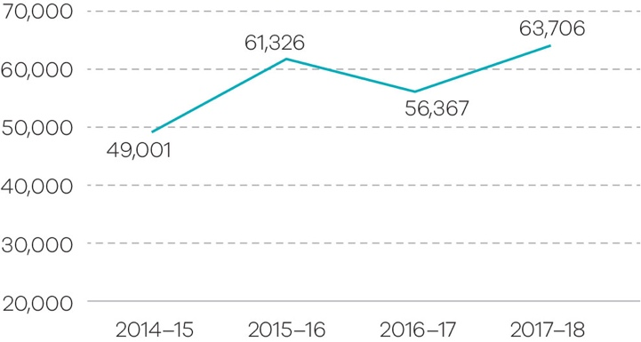
Source: ROGS 2019. Note this is the most recent data available from ROGS as 2018–19 data is published in 2020. Time series financial data are adjusted to 2017–18 dollars using the Domestic Final Demand (DFD) deflator (2017–18 = 100).
The value of fire event insurance claims in Victoria showed a 30 per cent increase over a four year period, from an average claim of $49,001 in 2014–15 to an average claim of $63,706 in 2017–18. In 2017–18, the average value of fire event insurance claims in Victoria is in line with the Australian average of $62,415.
Total ($) value per person in the population in Victoria 2014–15 to 2017–18
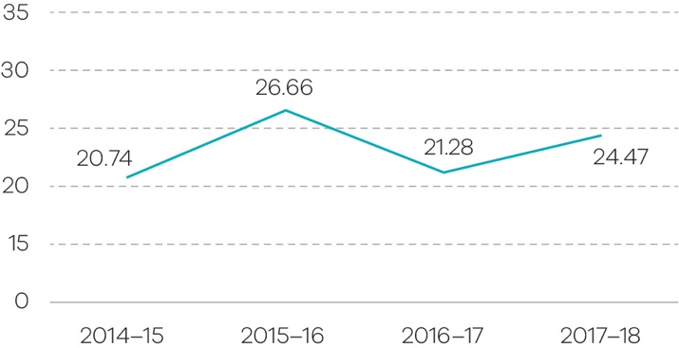
Source: ROGS 2019. Note this is the most recent data available from ROGS as 2018–19 data is published in 2020. Time series financial data are adjusted to 2017–18 dollars using the Domestic Final Demand (DFD) deflator (2017–18 = 100).
The claim per person value has fluctuated in Victoria over the past four years, with the lowest claim value shown in 2014–15 ($20.74 per person in the population), and the highest claim value in 2015–16 ($26.66 per person in the population). Events such as Wye River-Separation Creek, Scotsburn and Barnawatha-Chiltern bushfires may have contributed to the increase in insurance claims seen in 2015–16, where landowners have experienced building, livestock or crop loss as a result of fires.
The annual number of structure fires in Victoria has remained steady over the last four years, from 5,663 in 2014–15 to 5,672 in 2017–18.

Rate of deaths from fire events
‘Rate of deaths from fire events’ is defined as the number of deaths per million people in a calendar year, whose underlying cause of death is fire – related to smoke, fire and flames – including all structure and landscape fires.
Rate of deaths from fire events in Victoria (per million people) 2014–15 to 2017–18
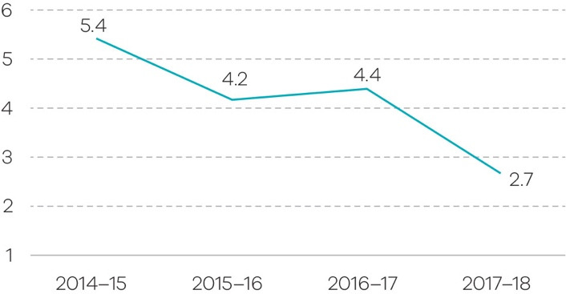
Source: ROGS 2018. Note this is the most recent data available from ROGS as 2018–19 data is published in 2020.

The rate of deaths from fire events in Victoria has decreased by 50 per cent from 5.4 deaths per million people in 2014 to 2.7 deaths per million people in 2017. However, it should be noted that annual fire death rates can be particularly volatile because of the small number of fire deaths and the influence of large irregular fire events.

Output initiatives and projects
The key output initiatives and projects associated with this objective, delivered by the department during 2018–19, are outlined below.
Refer to Appendix 3 for further detail regarding progress of each of these initiatives and projects, and for reporting on output performance measures.

Output: Emergency management capability

Leading change
- Began development of a State Risk Management Framework to guide planning priorities and to support the objectives of the Community Resilience Framework which establishes a common approach and understanding of community resilience.
- Administered $24.68 million in grants to multiple programs supporting volunteering for equipment needs, facility upgrades and volunteer recruitment and retention.
- As part of the Emergency Management Diversity and Inclusion Framework, EMV delivered targeted leadership, training and awareness programs and research on effectively engaging and enabling diverse communities to participate in emergency management.

Stewardship
- The Firefighters Presumptive Rights Compensation and Fire Services Legislation Amendment (Reform) Bill 2019 (the Bill) received Royal Assent on 2 July 2019. The Bill includes establishing the presumptive rights to cancer compensation for career and volunteer firefighters.
- The Emergency Management Legislation Amendment Act 2018 was passed by Parliament, establishing a comprehensive framework for emergency management planning at state, regional and municipal levels.
- Developed the Resilient and Recovery Strategy and supporting outcomes framework to guide the role of government in recovery. This was facilitated through an Inter-Department Committee comprising government departments with a role in post-emergency recovery.
- Managed the new Victorian Emergency Management Institute in Mount Macedon, to deliver learning and development to sector personnel.
- Members within Victoria’s critical infrastructure sector prepared their annual Sector Resilience Plan 2018–19, reporting on initiatives completed over the last year, and those proposed for next year.

System delivery
- In line with the Emergency Management Act 2013, EMV delivered the third update to the Strategic Action Plan, a three-year rolling plan which aims to achieve the vision of ‘Safer more resilient communities’.
- Newly established Marine Search and Rescue (MSAR) office within EMV worked with volunteer MSAR units and other stakeholders to deliver projects on finance and insurance, training and assessment, performance standards, operational protocols and vehicle risk and capability.
- Continued delivery of the Emergency Management Operational Communications program including upgrading radio services for Victoria Police, Victoria SES, Life Saving Victoria and Corrections Victoria. Also invested in the State’s Mobile Data Network and the development of a smartphone application to supplement the state’s mission-critical state-wide pager system.
- Developed an impact assessment model to operate across all hazards and all phases of an emergency to capture information to build a picture of community resilience.
- Contributed to government wide efforts to identify and manage high risk waste sites, including supporting the Resource Recovery Facilities Audit Taskforce led by the Environment Protection Authority and supporting the Worksafe-led Executive Oversight Group for the clean-up of identified illegal, hazardous liquid industrial waste warehouses.

High-performing organisation
- EMV is undergoing an organisational reset to enable effective stewardship of the emergency management sector. Work has begun to realign organisational structure and activities to support EMV’s Future Direction Statement, establish an operations funding model and continue to build a positive and enabling culture.
- Continued implementation of EMV’s ‘Plan for our People’, which focuses on building a positive working environment. This included the introduction of an integrated health and wellbeing program, and a series of diversity and inclusion initiatives.
- Established a whole of government agreement that contributes to sustainable workforce generation in support of major emergencies. This includes mitigating the risks of differing employment conditions across government and collaborating with stakeholders to develop a cost model that demonstrates the implications of changes to conditions.

AA fair market place for Victorian consumers and businesses with responsible and sustainable liquor and gambling sectors
This objective relates to harm minimisation through the regulation of the gambling and liquor industries by promoting the empowerment of consumers and businesses to know their rights and responsibilities and promoting a well-functioning market economy through regulation and support to consumers and businesses.

Progress toward achieving this objective

Percentage of licensed venues with a rating greater than three stars
This objective indicator demonstrates how the department is encouraging and rewarding responsible behaviours. The star rating of a licence is determined based on the following criteria:
★ Three or more non-compliance incidents in the previous 12 months
 One or two non-compliance incidents in the previous 12 months
 No non-compliance incidents in the previous 12 months
 No non-compliance incidents in the previous 24 months
 No non-compliance incidents in the previous 36 months
Percentage of licensed venues with a rating greater than three stars 2015–16 to 2018–19
Unit of measure | 2015–16 | 2016–17 | 2017–18 | 2018–19
Per cent | 86.6 | 85.0 | 85.0 | 88.0
Source: Victorian Commission for Gambling and Liquor Regulation iAlarm Licence Database
The star rating system encourages responsible practices in licensed premises and contributes to the promotion of responsible industry behaviour.
In 2018–19, a total of 19,062 (88 per cent) liquor licences had a star rating greater than three. This is slightly higher than the result for 2017–18 with 18,666 licences with a star rating of three and above.

Responsive Gamblers Help services
This objective indicator measures the percentage of clients who receive a service within five days of referral to a Gambler’s Help service, funded by the Victorian Responsible Gambling Foundation (VGRF).
Percentage of clients who receive a service within five days of referral 2015–16 to 2018–19
Unit of measure | 2015–16 | 2016–17 | 2017–18 | 2018–19
Per cent | 99 | 94 | 95 | 96
Source: Victorian Responsible Gambling Foundation GH Connect Database
Data continues to reflect that the state-wide system of Gambler’s Help services are responding in a timely manner and supporting Victorians experiencing gambling related harm. This is in the context of an environment where, due largely to stigma, only approximately 10 per cent of those experiencing gambling problems seek formal help.
The 2018–19 result of 96 per cent is a one per cent increase on the 2017–18 result.

Increased access by consumers, tenants and businesses to digital information
This objective indicator measures the volume of consumer, tenant and business information disseminated throughout the community, mainly through access to online information provided by Consumer Affairs Victoria (CAV). The increasing use of technology and rapidly developing digital marketplace requires CAV to deliver services both through digital and traditional channels. By providing accurate information and support across digital channels, CAV empowers Victorians to exercise their consumer rights, and enables businesses to comply with consumer protection laws.
The data for this objective indicator is an annual figure, derived from online or digital information.
Increased access by consumers, tenants and businesses to digital information 2015–16 to 2018–19
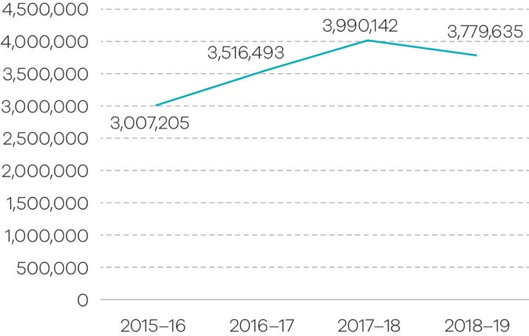
Source: CAV
In 2018–19, Victorian consumers, tenants and businesses accessed information from CAV via a range of digital platforms, as demonstrated by:
- almost 3.7 million visits to its website, which provides education, advice and self-help resources in a range of formats that are easy to find, understand and act on
- 10,240 Twitter followers and 45,657 Facebook page likes at 30 June 2019
- over 117,000 transactions completed via myCAV, with more than 78,000 accounts created since its launch. myCAV provides Victorians with an online portal to apply for a licence or registration and manage their obligations, with instantaneous updates and lodgements.

Output initiatives and projects
The key output initiatives and projects associated with this objective, delivered by the department during 2018–19, are outlined below.
Refer to Appendix 3 for further detail regarding progress of each of these initiatives and projects, and for reporting on output performance measures.

Output: Regulation of the Victorian consumer marketplace

Victorians exercise their consumer rights
- CAV provided information and advice to over 295,000 callers and more than 62,000 written and online queries throughout 2018–19. Almost 3.7 million people visited the CAV website, providing access to education and self-help resources.
- The Tenancy and Consumer Program assisted almost 9,000 vulnerable tenants and consumers providing information, negotiation and advocacy support. Financial counselling was provided to over 29,000 Victorians and family violence financial counselling was provided to more than 3,000 Victorians.

A fair and safe rental market
- Over 130 reforms to strengthen renters’ rights were introduced when the Residential Tenancies Amendment Act 2018 was passed by Parliament. CAV has commenced development of associated regulations, forms and guidelines.
- The inaugural Commissioner for Residential Tenancies, Dr Heather Holst, began her role with a key focus to champion the rights of renters.

Enforcement of consumer laws
- CAV took a range of successful enforcement actions, including in the following cases:
- Melbourne South Eastern Real Estate was fined $750,000 in fines and costs for misleading or deceptive conduct.
- Mr Wen Hui Xu was fined $190,000 and Wens Bros Trading Pty Ltd was fined $225,000 for selling products that did not meet safety standards, that failed information standards, and selling goods covered by a ban.
- Civil penalties were imposed against Micheal Arrow for accepting payment for domestic building work and failing to supply that work.

Output: Gambling and Liquor Regulation
- The Victorian Government began regulating interactive wagering services under the National Consumer Protection Framework. The regulation prohibits wagering providers from offering credit or other benefits, and placed limitations on bonus bets and direct marketing.
- Legislative reforms to the Liquor Control Reform Act 1998 commenced, which improve protection of minors from alcohol-related harm and reduce red tape for industry.

Five-year financial summary and review of financial conditions
 |  |  |  |  | ($ thousand)
 | 2019 | 2018 | 2017 | 2016 ^{(ii)} | 2015 ^{(iii)}
Income from government ^{(i)} | 7,573,700 | 6,837,664 | 6,054,737 | 5,510,616 | 5,178,419
Total income from transactions | 7,718,448 | 6,957,167 | 6,166,460 | 5,617,256 | 5,283,278
Total expenses from transactions | (7,651,800) | (6,937,704) | (6,160,999) | (5,608,125) | (5,277,809)
Net result from transactions | 66,648 | 19,463 | 5,461 | 9,131 | 5,469
Net result for the period | (25,894) | 29,824 | (1,543) | 6,764 | (8,435)
Net cash flow from operating activities | 154,300 | 88,966 | 100,076 | 109,504 | 86,714
Total assets | 5,128,510 | 4,809,430 | 3,826,386 | 3,439,423 | 3,597,308
Total liabilities | 1,853,824 | 1,753,930 | 1,116,384 | 984,926 | 1,085,039
i. Income from government includes both output and special appropriations.
ii The 2015–16 comparative has been adjusted to correct a prior period error. Costs were incorrectly included in a building asset under construction, these costs should have been expensed.
iii The 2014–15 comparative has been adjusted to correct a prior period error on moving assets in and out of trusts by using revenue and expenses. Additionally, in 2014­–15, some items of equipment and expense were incorrectly capitalised as part of a building asset.

Income from government and total income from transactions increased in 2018–19 due to:
- Increased funding received for initiatives announced in previous budgets mainly for the corrections and emergency management portfolios. These initiatives include funding for additional firefighters, Management of Serious Offenders, Prison Capacity expansion and the full year funding impact for the Ravenhall Correctional Centre.
- New funding received for initiatives announced in the 2018–19 Budget and the 2018–19 Pre-Election Budget Update, including Strengthening the youth justice system, Melbourne CBD security measures, National Redress Scheme for Institutional Child Sex Abuse and Corrections systems capacity.
- New and increased Victoria Police funding for initiatives including Additional drug tests on our road and the Community Safety Statement.
- The above increases are partly offset by a net funding reduction for machinery of government changes which came into effect on 1 January 2019.
Total expenses from transactions increased in 2018–19 due to:
- An increase in grant funding passed onto entities such as Victoria Police, Country Fire Authority, Metropolitan Fire and Emergency Services Board and Victoria Legal Aid.
An increase in outsourced contract costs mainly for new and increased prison correction service fees, including the full year impact for the Ravenhall Correctional Centre, and increased contract and community service costs across the prison system.
- Growth in the employee benefit expenses primarily in the corrections and youth justice portfolios due to the increase in staff numbers following the opening of new beds and strengthening of the youth justice system.
Net result for the period has decreased in 2018–19 due to:
- Losses in other economic flows. This was mainly driven by the derecognition and subsequent recognition of borrowings for the Ravenhall Correctional Centre which was refinanced by the GEO Consortium in 2018–19 and the impairment of the Victorian Infringement Enforcement Warrant System software.
- The loss was partly offset by an increase in net result from transactions mainly driven by funds held in trust for the delivery of the Emergency Management Operational Communications program and surplus income received for operating costs associated with capital investments.
Total assets increased in 2018–19 mainly due to additional capital expenditure on assets under construction across prisons and youth justice facilities, which were announced for the State’s capital program in previous budgets.
Total liabilities increased in 2018–19 mainly due to the increased finance lease liability following the refinancing of the Ravenhall Correctional Centre and increased employee benefits due to increased staff numbers mainly in the corrections and youth justice portfolios.
Detailed financial information about the performance of each of the department’s output activities is contained in note 4 of the financial statements.
In general, delivery of services by the output activities of the department were within defined budgetary objectives. A comparison of budget and actual financial statements is contained under Budget Portfolio Outcomes in Appendix 2.

Disclosure of grants and other transfers (other than contributions by owners)
The department has provided assistance to certain companies and organisations. Financial assistance provided in 2018–19 was as follows:
Organisation | ($ thousand)
Policing and Crime Prevention
Victoria Police | 3,362,390
Local councils | 9,109
Community support groups | 6,502
Other | 2,746
Sub total | 3,380,747
Enforcing and Managing Correctional Orders
Community support groups | 1,763
Court Services Victoria | 1,384
Other | 1,706
Sub total | 4,853
Youth Justice Services
Other | 1,431
Sub total | 1,431
Criminal Justice Services
Victoria Legal Aid | 188,083
Office of Public Prosecutions | 79,762
Victorian Institute of Forensic Medicine | 41,486
Community support groups | 38,841
Sentencing Advisory Council | 1,777
Court Services Victoria | 2,098
Other | 1,764
Sub total | 353,811
Civil Justice Services
Victorian Equal Opportunity and Human Rights Commission | 9,197
Community support groups | 1,160
Court Services Victoria | 434
Other | 1,493
Sub total | 12,284
Emergency Management
Country Fire Authority | 619,023
Metropolitan Fire and Emergency Services Board | 417,287
Victoria State Emergency Service Authority | 60,675
Emergency Services Telecommunications Authority | 50,505
Ambulance Victoria | 12,913
Life saving clubs | 9,792
Local councils | 4,946
Community support groups | 2,934
Other | 803
Sub total | 1,178,878
Industry Regulation and Support
Victorian Commission for Gambling and Liquor Regulation | 43,394
Community support groups | 21,724
Racing clubs and services | 19,854
Court Services Victoria | 19,480
Victorian Responsible Gambling Foundation | 2,912
Other | 4,133
Sub total | 111,497
Total | 5,043,501

One additional minimum-security prisoner absconded while on escorted leave in 2017–18. This incident is not classified as an open perimeter or secure perimeter escape according to ROGS counting rules.
The previously published figure for 2016–17 was 33.1 per cent.
Since 2017–18 there has been a change to the way legal information is counted, with the number of sessions now counted rather than the number of matters. This has resulted in a lower number of services recorded compared to previous years. The figures for 2015–16 and 2016–17 have been retrospectively updated to reflect this change.
This objective indicator was introduced in the 2016–17 State Budget.
OPA advice and education activities results for 2014–15, 2015–16 and 2016–17 have been adjusted to reflect a more accurate method of calculating the incidence of telephone advice. This method was developed in 2016–17 and counts the number of confirmed instances of advice, as recorded in the case management system, rather than the previous method of counting all incoming calls, some of which did not progress to advice provision.
Data relating to insurance claims may not reflect actual asset losses due to insurance pay-outs being limited by the estimated value of assets a policy holder provides when taking out insurance. The data provided by Insurance Statistics Australia only covers an estimated 69 per cent of Australian dwellings and new for old policies replace an old asset for a new equivalent.
This objective was amended to reflect removal of the Racing portfolio from the department to Department of Jobs, Precincts and Regions, as a result of machinery of government changes effective 1 January 2019.

