Department of Justice and Regulation
Annual Report
2017-18

Publication information
The Department of Justice and Regulation acknowledges the Traditional Owners of the land of Victoria and pays respect to their Elders, both past and present.
Aboriginal is used as the Department of Justice and Regulation’s standard reference for Aboriginal and Torres Strait Islander people. Prior to June 2018, ‘Koori’ was used as the department’s standard reference, and this term continues to be used in some DJR business units, affiliated organisations and documents including the Koori Justice Unit, the Koori Courts, and the department’s Koori Inclusion Action Plan 2017-2020, Yarrwul Loitjba Yapaneyepuk- Walk the Talk Together.
Authorised and published by the Victorian Government, 1 Treasury Place, Melbourne.
Printed by Impact Digital, Brunswick
October 2018
© Government of Victoria
This report is protected by copyright. Apart from any use permitted under the Copyright Act 1968, and those explicitly granted below, all other rights are reserved.

Accessibility
If you would like to receive this publication in an accessible format please telephone (03) 8684 0300.
Also published in an accessible format on www.justice.vic.gov.au.
Unless indicated otherwise, this work is made available under the terms of the Creative Commons Attribution 3.0 Australia licence. To view a copy of this licence, visit creativecommons.org/licenses/by/3.0/au. It is a condition of this Creative Commons Attribution 3.0 Licence that you must give credit to the original author, which is the State of Victoria.
Designed by Think Productions
This report is printed on Ecostar which is manufactured from 100% Post Consumer Recycled under the ISO 14001 environmental management system. Ecostar is an environmentally responsible paper made Carbon Neutral.

Justice and regulation ministers and portfolios 3
Secretary’s foreword 5
About us 6
Regional highlights 10
Victorian Aboriginal Justice Agreement 13
Report of operations 15
Ensuring community safety through policing, law enforcement and prevention activities 17
Effective management of prisoners and offenders and provision of opportunities for rehabilitation and reparation 27
Effective supervision of young offenders through the provision of youth justice services promoting rehabilitation 35
A fair and accessible criminal justice system that supports a just society based on the rule of law 42
A fair and accessible civil justice system that supports a just society with increased confidence and equality in the Victorian community 57
Reduce the impact of, and consequences from, natural disasters and other emergencies on people, infrastructure, the economy and the environment 67
A fair market place for Victorian consumers and businesses with responsible and sustainable liquor, gambling and racing sectors 73
Five-year financial summary and review of financial conditions 80
Disclosure of grants and other transfers (other than contributions by owners) 81

Responsible body’s declaration
In accordance with the Financial Management Act 1994, I am pleased to present the Department of Justice and Regulation Annual Report for the year ending 30 June 2018.
Greg Wilson
Secretary
Department of Justice and Regulation
September 2018

Justice and regulation ministers and portfolios
At 30 June 2018, the department supported the following six ministers across the justice portfolios.
The Hon Martin Pakula MP
Attorney–General
Minister for Racing
The Hon Martin Pakula MP was appointed Victorian Attorney–General and Minister for Racing in December 2014.
The Attorney–General is responsible for the state’s legal system. The Attorney–General’s broad ministerial responsibilities include state equal opportunity and human rights laws, Aboriginal land justice, family violence, and the registration of births, deaths and marriages.
The Minister for Racing’s portfolio responsibilities include ensuring the thoroughbred, harness and greyhound industries thrive in a responsible and sustainable way for years to come.
The Hon Marlene Kairouz MP
Minister for Consumer Affairs, Gaming and Liquor Regulation
The Hon Marlene Kairouz MP was appointed Minister for Consumer Affairs, Gaming and Liquor Regulation in June 2016.
The Minister is responsible for the administration of consumer protection legislation, which seeks to ensure that Victorian businesses and consumers are informed.
The portfolio also includes the regulation and licensing of the gambling and liquor industries.
The Hon James Merlino MP
Minister for Emergency Services
The Hon James Merlino MP was appointed Minister for Emergency Services in June 2016.
The Minister for Emergency Services’ responsibilities include supporting the state’s emergency service sector to reduce the likelihood, effect and consequences of emergencies on the Victorian community.
The Hon Jenny Mikakos MP
Minister for Families and Children
The Hon Jenny Mikakos MP was appointed Minister for Families and Children in December 2014.
The Minister for Families and Children’s portfolio responsibilities include the performance, reform and investment in the youth justice system.
The Hon Lisa Neville MP
Minister for Police
The Hon Lisa Neville MP was appointed Minister for Police in May 2016.
The Minister for Police has broad responsibilities for police and crime prevention.
The Hon Gayle Tierney MP
Minister for Corrections
The Hon Gayle Tierney MP was appointed Minister for Corrections in November 2016.
The portfolio responsibilities of the Minister for Corrections cover the adult corrections system.

Secretary’s foreword
It has been another extremely busy year for the Department of Justice and Regulation. A particular highlight has been the outstanding work between the Department and Aboriginal Justice Caucus members and other members of the Aboriginal Justice Forum on the fourth phase of the Aboriginal Justice Agreement. The Agreement reflects our ongoing commitment to work with community to tackle over-representation of Aboriginal people in the criminal justice system.
Work has also been underway to implement key police and crime prevention initiatives outlined in the inaugural community safety statement in partnership with Victoria Police. The Community Safety Statement 2018/19 was launched on 12 April 2018 and the valuable work of the community crime prevention program continued.
The department continued to respond to growth in the adult corrections system by ensuring that infrastructure meets both current and future needs. In late 2017, Ravenhall Correctional Centre commenced operations – a medium-security men’s prison, with the capacity to accommodate 1300 prisoners. Planning has commenced in relation to over 470 additional prison beds announced in December 2017 and the new 700-bed maximum security men’s prison within the Lara prison precinct that featured in the 2018–19 State Budget.
There has also been extensive reform to the corrections system, with work continuing to implement all 35 recommendations from the Harper Review, including the establishment of the new independent statutory body to oversee the post-sentence scheme. The Post-Sentence Authority commenced on 27 February 2018.
In youth justice, the department has continued significant investment in staff recruitment and training, as well as infrastructure at Parkville and Malmsbury. Work has also begun on development, design and consultation for the new youth justice facility at Cherry Creek, which is due to commence receiving young people in 2021. The department has successfully integrated youth justice into the portfolio which is due to the commitment of our leadership team and dedicated staff.
An enormous amount of criminal justice reform has taken place in 2017–18. Two stages of legislative change to Victoria’s bail and remand system have now commenced, implementing 22 recommendations from the Bail Review. This change makes it harder for people to get bail for a much broader range of serious violent and serious sexual offences including rape, armed robbery, aggravated home invasion and aggravated carjacking.
Significant work has been undertaken across the civil justice system, including in relation to traditional owner settlements, implementation of recommendations arising from the Access to Justice Review, delivering effective dispute resolution services and continuing to improve the performance of the Registry of Births, Deaths and Marriages.
The department is continuing to play a leading role across Government in implementing 111 recommendations from the Royal Commission into Family Violence in partnership with Courts, Victoria Police and justice agencies. This generational reform will change and strengthen how the justice system responds to both victims and perpetrators of family violence.
The department has also led the preparation of the Government Response to the Commonwealth Royal Commission into Institutional Child Sexual Abuse, and Victoria has committed to the National Redress Scheme in response to key recommendations from both the Commonwealth Royal Commission and Betrayal of Trust report.
These achievements would not be possible without the hard work of the department’s staff and the various agencies and community organisations that we collaborate with, and the support of our volunteers. I would like to thank everyone for their contribution to the important work of the department throughout the year.
Greg Wilson
Secretary
Department of Justice and Regulation
September 2018

About us
The department leads the delivery of justice and regulation services in Victoria by providing policy and organisational management.
The department has productive partnerships with more than 60 statutory entities and the support of more than 100,000 volunteers. It has extensive service delivery responsibilities ranging from managing both the state’s adult and youth custodial systems to providing consumer protection.
The department develops and implements a range of laws, regulation and policy in areas across the portfolio (such as civil justice, emergency management, liquor, gaming and racing) and ensures that all elements of the justice and regulation system are working efficiently and effectively.
Vision
The department’s vision is for a safe, just, innovative and thriving Victoria, where the rule of law is upheld and rights and responsibilities are respected.
Outcomes framework
Traditionally, government has assessed performance by measuring outputs (counting what gets delivered) rather than outcomes (the impact it aims to achieve).
The department has developed an outcomes framework, which is currently being embedded into our processes and reflects the whole of government approach to outcomes.
The department’s outcomes for members of the Victorian community are detailed below.
Victorians are safe
Victorians are free from crime and harm
Victorians are responsible for their actions
Victorians are held to account

Victorians are connected and resilient
Victorian communities are informed and engaged
Victorian communities respond and adapt
Victorian communities are inclusive

Victorians have equal rights and responsibilities
Victorians experience dignity and respect
Victorians experience social and economic wellbeing
Victorians take up opportunities to exercise their rights

For further information about departmental objectives, indicators and outputs refer to the report of operations (pages 15-16).

Corporate governance
Under the Public Administration Act 2004, the Secretary is responsible for the general conduct and effective, efficient and economical management of the department. A number of standing executive committees ensure good corporate governance with a focus on improving organisational performance.
The Justice Senior Executive Group (JSEG) is the peak body in the corporate governance structure. It advises the Secretary on the management and administration of the department to ensure compliance with government directives, guidelines and legislation. It is responsible for integrating governance functions across the department and working collaboratively with portfolio agencies.
Department of Justice and Regulation corporate governance structure at 30 June 2018

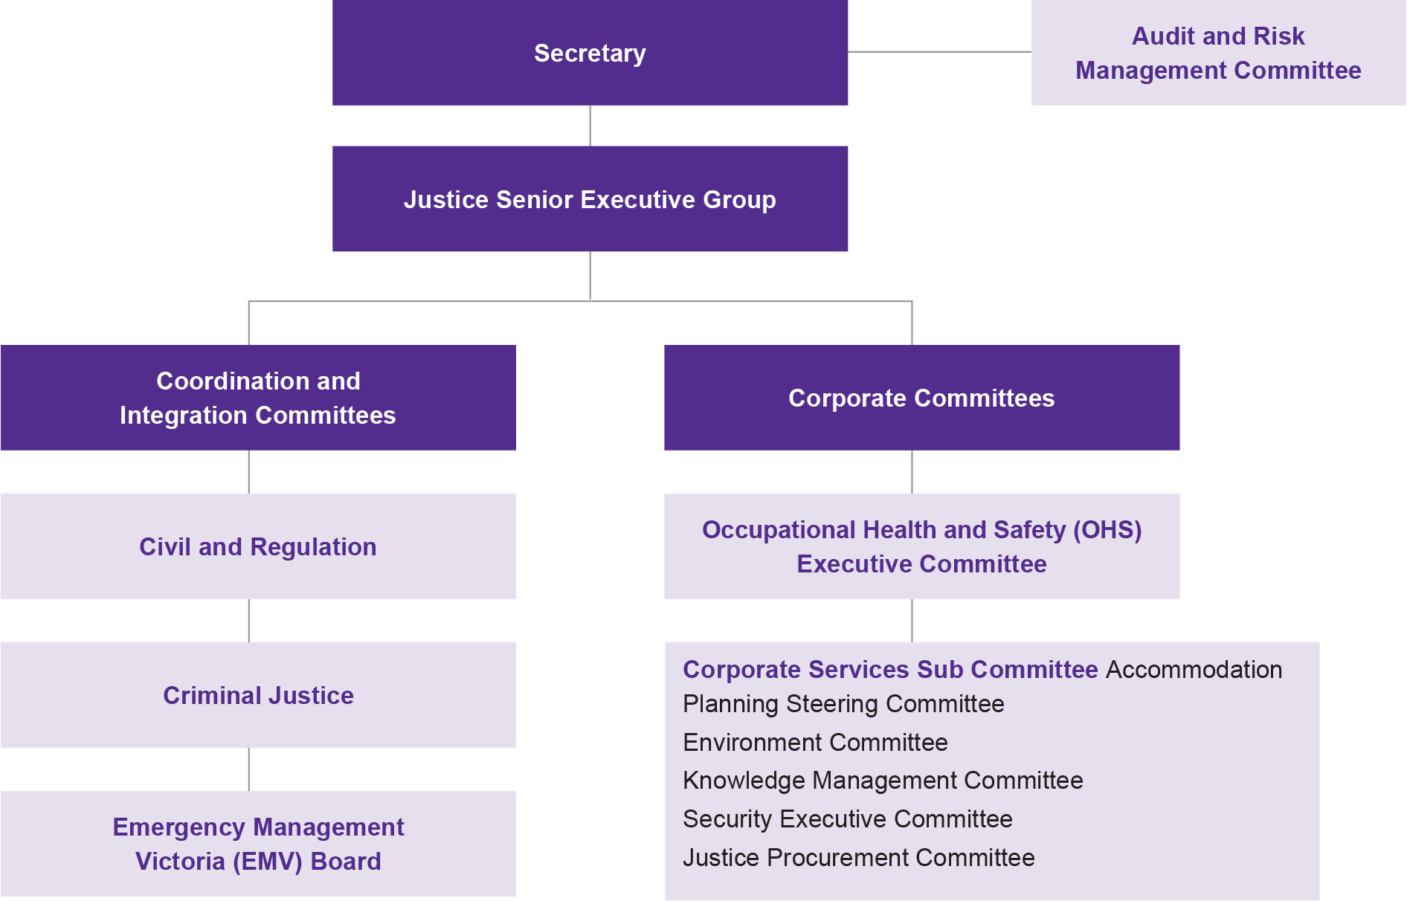

Organisational structure
The department comprises policy and program areas, corporate divisions and regional services.
Organisational structure at 30 June 2018
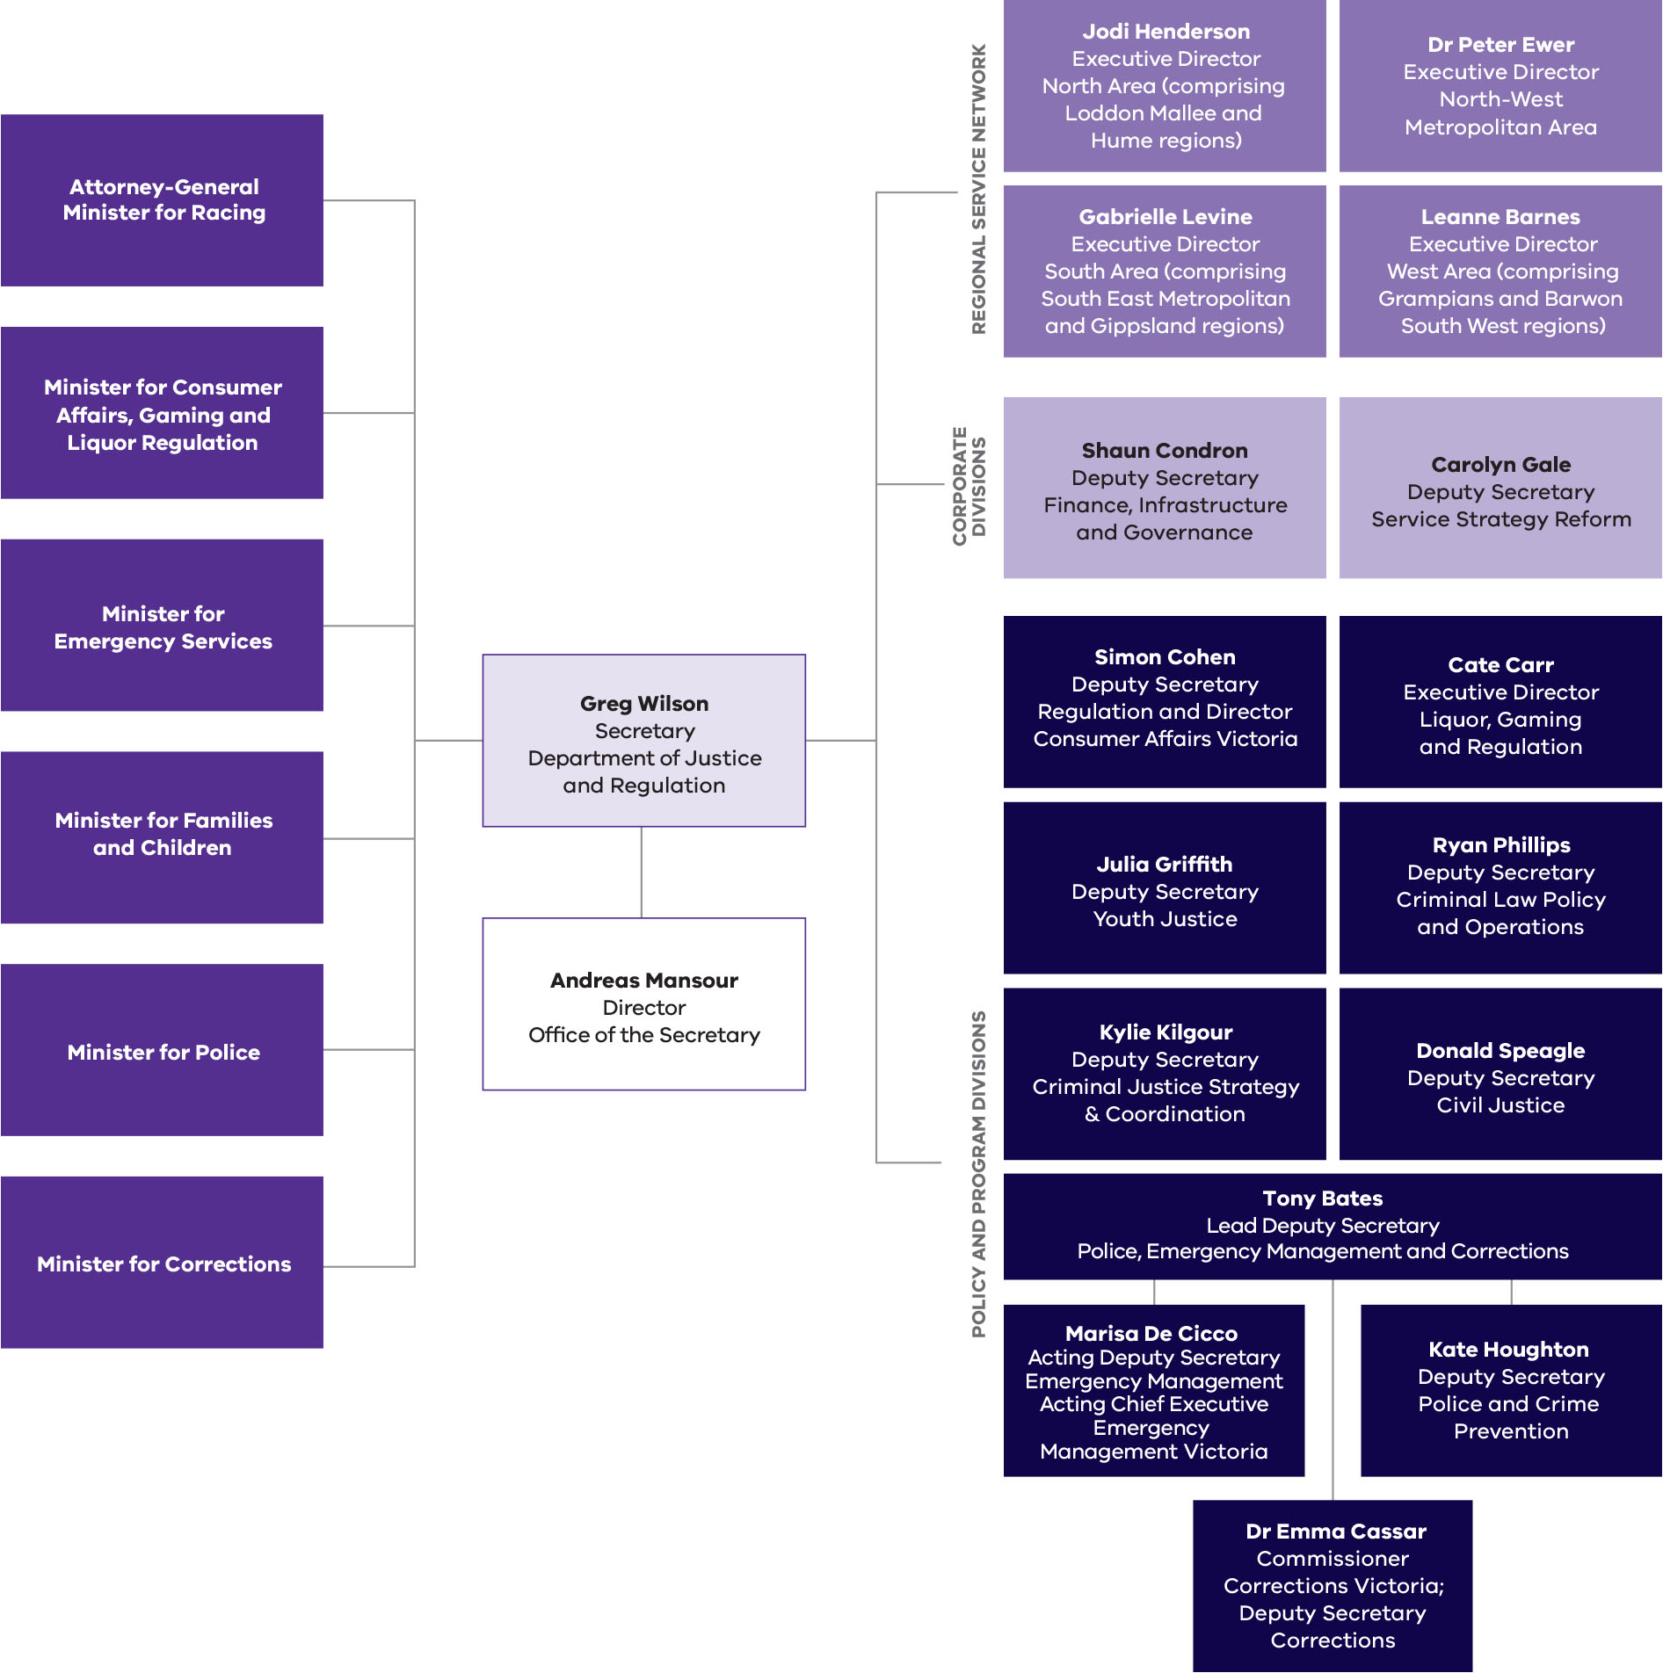
Policy and program divisions
The department consists of the following divisions:
- The Office of the Secretary supports the Secretary to discharge the responsibilities of the head of the department.
- Civil justice is responsible for civil law policy and legislation (including in relation to courts and tribunals, and the regulation of the legal profession), alternative dispute resolution, identity management through the Registry of Births, Deaths and Marriages (BDM) and other rights–based services delivered by government and agencies.
- Criminal justice strategy and coordination provides cross–portfolio criminal justice strategy advice, project management and coordination including: family violence reforms; response to the Commonwealth Royal Commission into Institutional Child Sexual Abuse; and bail reforms.
- Criminal law policy and operations includes responsibility for criminal law policy and legislative reform, Infringement Management and Enforcement Services (IMES), the administration of the Working with Children (WWC) Check, and provision of services to victims of crime.
- Liquor, gaming and racing provides advice on liquor, gambling and racing policy matters in Victoria and administers the Victorian Racing Industry Fund grants program.
- Police, emergency management and corrections:
- Police and crime prevention enhances community safety through public policy, governance and legislative advice and reform, community crime prevention advice and programs, and manages fixed camera operations to support road safety.
- Corrections promotes community safety through the effective management of prisoners and individuals on Community Correction Orders (CCO) as well as the provision of opportunities for rehabilitation and reparation.
- Emergency management, is led by Emergency Management Victoria (EMV), which works with communities, government agencies and businesses to strengthen their capacity to withstand, plan for, respond to and recover from emergencies, whether as a result of natural or man–made events or disasters.
- Regulation comprises Consumer Affairs Victoria (CAV), Domestic Building Dispute Resolution Victoria (DBDRV) and assurance functions provided through the Inspector–General for Emergency Management (IGEM), Justice Assurance and Review Office (JARO), support to the Community Safety Trustee and Post Sentence Authority.
- Youth justice provides programs and resources to assist young offenders to develop the knowledge, skills and attitudes to manage their lives effectively without further offending. The youth justice service promotes opportunities for rehabilitation and seeks to contribute to the reduction of crime in the community through supervision, offending related programs and linkages to appropriate support services.
Corporate divisions
Corporate services are provided by:
- Finance, infrastructure and governance oversees and leads the key public accountability requirements of the department including finance, asset management, procurement, performance reporting, risk management, audit and integrity functions. The division also manages the governance and delivery of major infrastructure projects, and information and communications technology (ICT) functions, including associated programs and projects and security management and assurance to the portfolio. The Chief Finance Officer supports the Secretary in discharging statutory obligations under the Financial Management Act, the Standing Directions of the Minister for Finance and the finance aspects of other relevant legislation.
- Service strategy reform delivers service transformation projects, strategic planning, data modelling and analysis, works in partnership with the Aboriginal community to tackle over–representation of Aboriginal people in the justice system and is responsible for human resources policy and services, including management of occupational health and safety. It also oversees the department’s freedom of information obligations, information privacy and delivers communication advice and education campaigns.
Regional services
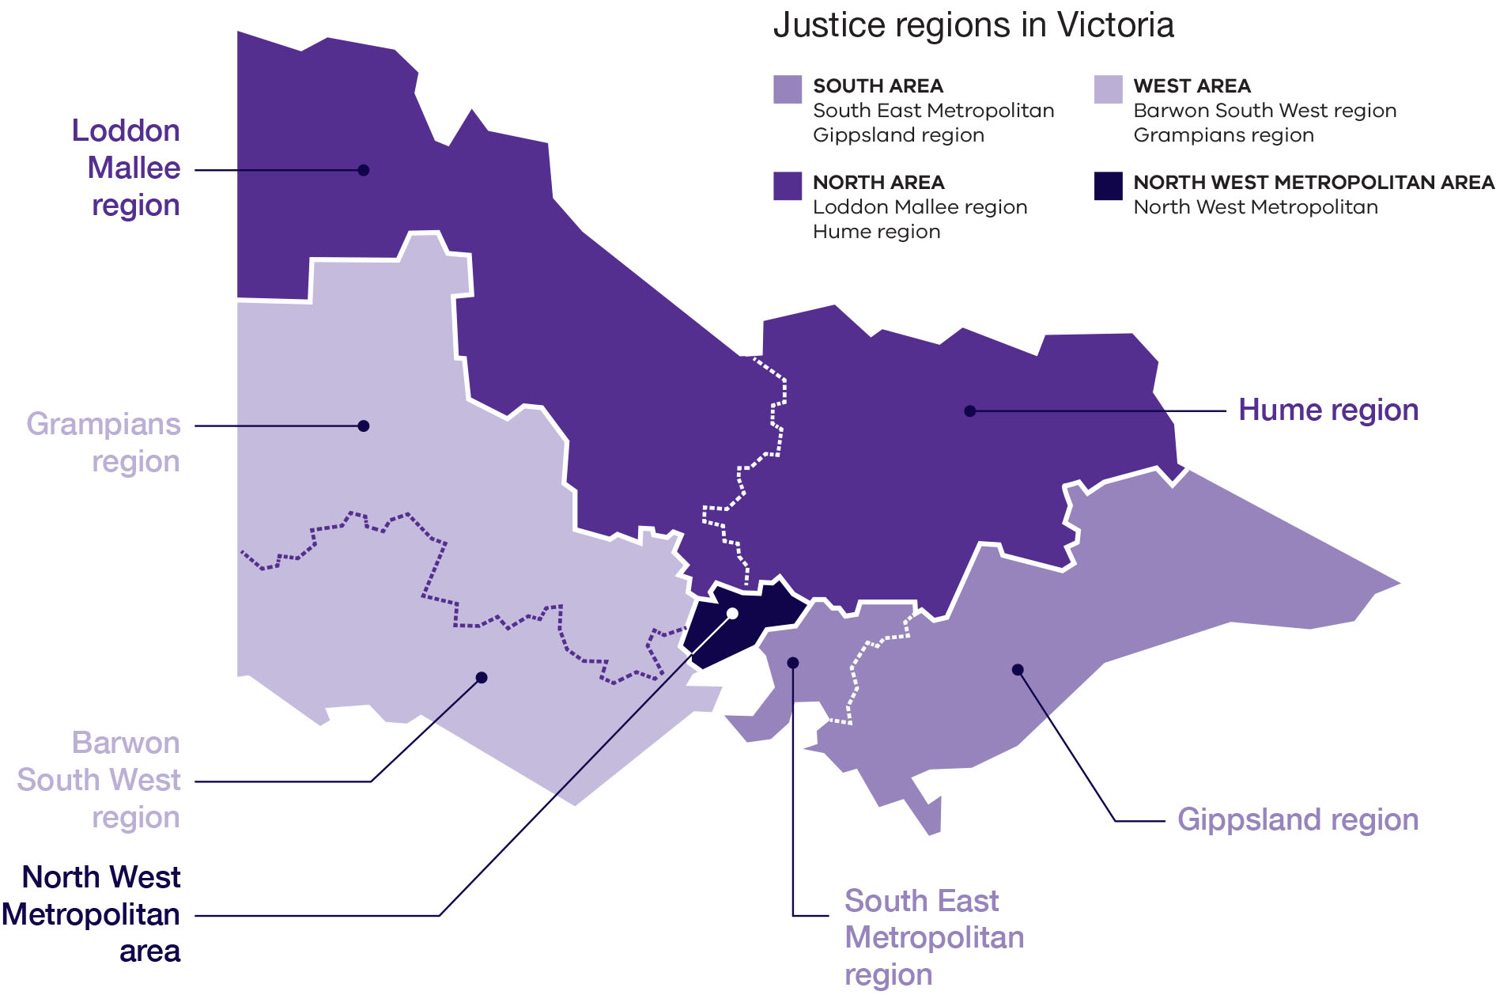

The Regional Service Network (RSN) comprises four areas:
- North West Metropolitan Area
- North Area (includes Hume and Loddon Mallee regions)
- South Area (includes Gippsland and South East Metropolitan regions)
- West Area (includes Barwon South West and Grampians regions).
The role of the RSN is to work in collaboration with program areas and communities to deliver justice services that are efficient, effective and address the needs of clients and the community.
Regions use their experience with, and connections to, communities to ensure service delivery meets local needs and priorities, drives innovation and service improvement, and enhances policy development.
Services delivered include: BDM; CAV; Community Correctional Services (CCS); Dispute Settlement Centre of Victoria (DSCV); IMES; Offending Behaviour Programs; prison management; Victims Assistance Program (through funds provided by the department to non–government organisations) and youth justice services.
Support is provided for the: Crime Prevention Place Based Targeted Grants Program; Regional Aboriginal Justice Advisory Committees; and Regional Crime Prevention Reference Groups.
For further information about Justice Service Centre (JSC) locations visit the department’s website: https://www.justice.vic.gov.au/service-locations
Regional highlights
North West Metropolitan Area
Cultivating Place —Cultivating People (CPCP)
CPCP is a program that operates across the North West Metropolitan Area, which seeks to respond to:
- limited community work program opportunities
- a need to increase pathways for offenders into education and employment
- food security issues for individuals and families in the area.
The program operates across 11 sites in the area including:
- prisons, such as the Metropolitan Remand Centre and Dame Phyllis Frost Centre, where seedlings are sown
- community gardens, where offenders who undertake unpaid community work grow and harvest fresh produce
- kitchens, where offenders doing unpaid work prepare food and meals for the disadvantaged in the area, providing a vocational pathway for them to improve their training and job prospects while also giving back to the community.
During 2017–18 the program:
- prepared meals for over 250 community members per week
- facilitated 42 offenders completing food handling certificates as a result of their community work at Fareshare
- established seven sites where community gardens grow and provide fresh, nutritious and affordable food for the local community
- continued partnerships with Oz Harvest, Second Bite and FoodBank programs.

North Area
Aboriginal dispute resolution in Loddon Mallee
Twelve young Aboriginal and Torres Strait Islander men enrolled in years 7 to 12 at the Clontarf Academy based at the Robinvale Secondary College have been trained in conflict resolution.
The dispute resolution training increases the capacity of participants to resolve conflicts, tackles lateral violence and enhances community safety.
New justice service centre in Wodonga
On 13 September 2017, the new Wodonga JSC was officially opened.
The JSC provides services delivered by the CCS, BDM, DSCV, sheriffs and youth justice.
The new office was decorated with Aboriginal artwork that was produced as a part of a locally run competition in schools and the broader community. This artwork helps build local connections and creates a more culturally welcoming environment.
South Area
Investing in the community engagement in Doveton
Throughout 2017–18, the South East Metropolitan Region sought to improve justice outcomes in the Doveton community. A 2015 report identified Doveton as one of Victoria’s most disadvantaged communities in Victoria.
The department has been delivering outreach services in Doveton, including providing access to CAV, DSCV and sheriffs. Regional staff have supported the local Culturally and Linguistically Diverse community providing information about birth certificate applications, consumer law, renting, scams, and fines and payment plans.
Staff from the South East Metropolitan Region attended community events throughout the year including: the annual Celebrate Doveton event and the Dandenong and District Aboriginal Cooperative Back to School Day. The outreach services have given the community the opportunity to interact with justice programs and enquire about services in their own environment.
Ongoing justice initiatives in Doveton include:
- increased local community work sites creating pathways for offenders into education and employment
- a place–based environmental project supporting four social inclusion kitchen gardens including the Casey Aboriginal Gathering Place garden program; Doveton Neighbourhood Learning Centre; Myuna Farm; and Doveton College
- investment in crime prevention including improving safety initiatives in local parks and reserves.
Cultural, Community, Career Connections for Young Aboriginal, Maori and Pacific Islander Adults program in Frankston North
The Cultural, Community, Career Connections for Young Aboriginal, Maori and Pacific Islander Adults program operates in Frankston North. The aim of the program is to provide a culturally safe environment to support youth to reconnect with their culture through a range of cultural strengthening, leadership activities and connections to elders.
This project is a partnership between the department, Frankston City Council, Department of Health and Human Services (DHHS), secondary schools in the region, training and employment agencies, local businesses and cultural organisations. The program has worked with over 30 young people aged 15–25 over the course of the two year project. Government and community agencies refer young people who are at risk of entering or becoming entrenched in the justice system to the program.
Highlights from the program include:
- creating a multilayered support network for participants using a traditional cultural village strategy and total wrap–around service for trauma
- development of an aligned youth leadership project to link participants with a positive peer and mentor group
- fostering stronger community connections between the Maori and Aboriginal communities in Frankston North
- establishment of a new Aboriginal apprenticeship program.
West Area
Barwon prisoners producing school items for disadvantaged children in Geelong
In 2017–18, prisoners at Barwon Prison designed and manufactured pencil cases, library bags and aprons. These school items were distributed to 300 disadvantaged school children in the Geelong region through the St Vincent De Paul Society.
Through the manufacturing process, offenders are provided with vocational skills from Box Hill Institute and staff from prison industries, an important step in improving their employability when they re-enter the community.
Family violence awareness at Barwon Prison
In 2017–18, 87 prisoners took the White Ribbon oath and signed a pledge to prevent men’s violence against women. Forty prisoners also participated in a family violence awareness run/walk on the prison’s running track within the main compound.
Reignite Geelong Project
This project supports 18 young people from the Geelong area who have been referred due to their high recidivism rates. The project employs three specialist youth workers who support the young person, their families and, where applicable, peers to reduce offending. Young people are supported with their future education, training or employment options; mental health support; family support; access to legal and health information; as well as life skills and general wellbeing.
Ballarat community work program
A number of offenders subject to community work orders have constructed handmade furniture which generated $4500 income via Uniting Church opportunity shops. The funds have provided 900 meals for homeless and disadvantaged people in the local area.
The program is a collaboration between Ballarat CCS, Federation University and Uniting Ballarat and provides both woodworking and workplace skills to offenders.
Koori Art Trail at Lake Beaufort
An art trail on the shore of Lake Beaufort features artworks created by Koori Prisoners from Langi Kal Kal Prison and is the product of a partnership between the prison and the Pyrenees Shire.
The public display of artwork creates a sense of pride for the Koori prisoners involved who—through creating the works—have the opportunity to reconnect with, and celebrate their culture. It also increases the engagement of the local community with the prison and beautifies the local area.
Victorian Aboriginal Justice Agreement
Aboriginal Victorians are over-represented in the justice system at a rate of 12 times the representation of non-Aboriginal Victorians. The department has a long standing commitment, shared with the Aboriginal community, to address this issue.
The Victorian Aboriginal Justice Agreement (AJA) is an agreement between the Victorian Government and Aboriginal community to work together to improve Aboriginal justice outcomes. The AJA is the longest continuous agreement between the Aboriginal community and government in Australia. It commenced in 2000 with AJA1 (2000–2005) and has been followed by subsequent agreements, AJA2 (2006–2012) and AJA3 (2013–18).
Now in the final year of AJA3 implementation, 2017–18 saw the completion of key projects such as the evaluation of AJA3 and the development of the next phase of the AJA for launch in 2018. The department also continued to fund and implement key initiatives to reduce Aboriginal over–representation across the criminal justice system.
Evaluation of AJA3
The evaluation of AJA3 commenced in 2017 in parallel with the development of a fourth phase of the Agreement. The evaluation was made up of a suite of evaluative activities, some focused on the impact of the AJA and others looked more deeply into specific locations or mechanisms for learning and improvement. The purpose of the evaluation was to investigate whether the partnership model of the AJA increases collaboration and contributes to improved justice outcomes; determines whether the current governance models are still the most appropriate and efficient; examines how effectively AJA3 addresses Aboriginal over-representation in the justice system; and identifies opportunities for improvement under AJA4.
The evaluation found that the over–representation of Aboriginal people in the justice system remains disproportionately high and the conditions that led to the signing of the first AJA are as valid today as they were in 2000. However, initiatives and programs implemented under the umbrella of the AJA are achieving positive outcomes and significant progress has been made towards delivering on AJA3’s six strategic objectives across all regions.
Importantly, the evaluation found that the AJA partnership has reached a level of maturation not replicated elsewhere and has been crucial to affect real change in terms of embedding cultural awareness and the adoption of an Aboriginal lens for the development of new strategies, policies and initiatives. The AJA has been instrumental in giving voice to Aboriginal people across Victoria – from small regional communities through to highly urbanised centres — and has facilitated and enabled the development of strong and durable relationships between justice agencies and members of the Victorian Aboriginal community.
The evaluation confirmed that the eighteen year partnership between government and the Victorian Aboriginal community provides a robust foundation to build upon. The AJA has enabled the establishment of major initiatives, such as Victoria’s Koori Courts, the Wulgungo Ngalu learning place, the Koori Women’s Diversion Program and Local Justice Worker Program. Aboriginal justice focused programs, positions, plans and business units now operate across Victoria specifically to address the needs of the Victorian Aboriginal community. For example, in 2017-18, the government expanded the Aboriginal Community Liaison Officer (ACLO) program, which helps to build a solid foundation of trust and respect between Victoria Police and the Aboriginal community. ACLOs foster communication and interaction between police and the Aboriginal community to resolve issues, improve understanding and support positive aspirations. The AJA has built the capacity of the department as much as it has strengthened the capacity of community. It has provided a channel for justice agencies to better connect with the people we serve — to gain insights and understanding that have previously eluded us.
The key evaluation findings and recommendations will be addressed through the implementation of AJA4. They will also be made available on www.aboriginaljustice.vic.gov.au.
Enabling community based responses
AJA3 emphasises the importance of community–based responses to justice issues, initiated by Aboriginal Community-Controlled Organisations (ACCOs) that play a leading role in the development and delivery of services.
In 2017–18, the department continued to support and enable the Aboriginal community sector to develop and implement programs, as detailed in the following sections.
Family violence investment
The whole of government family violence investment package, announced in the 2017–18 State Budget, provided a major injection of funding to support Aboriginal Victorians at risk of family violence through behaviour change and prevention programs.
- Dardi Munwurro received $3 million over four years and $750,000 ongoing to commence the Ngarra Jarranounith intensive residential program for Aboriginal male perpetrators of family violence. Ngarra Jarranounith aims to break the cycle of inter–generational trauma of family violence in Aboriginal families and communities. Delivered by Aboriginal men for Aboriginal men, the program provides behaviour change programs for perpetrators with a focus on parenting, life skills and post–release support
- Djirra (formerly the Aboriginal Family Violence Prevention and Legal Service) received $4.29 million (and $1.43 million ongoing) to run its Sisters Day Out, Dilly Bag and Young Luv programs. Djirra also received $1.1 million to pilot the Koori Women’s Place in Abbotsford
- $11.0 million was provided to support the delivery of culturally appropriate family violence legal representation and support services.
Koori Women’s Diversion Program
In responding to the complexity of issues leading to Aboriginal women’s imprisonment, the department has continued to support and grow the Koori Women’s Diversion Program. The Koori Women’s Diversion Program provides intensive case management support to Aboriginal women to break the cycle of victimisation, violence and offending. The first pilot was designed and run in Mildura and the program now also operates at Odyssey House and in Morwell. Work has commenced to establish a new site in line with funding announced in the 2017–18 State Budget of $3.9 million over three years and $1.21 million ongoing to continue the program.
Community based grants
- Across Victoria, 25 community–based partnership projects have been funded under the Koori Youth Crime Prevention Grants, a partnership between the department’s Community Crime Prevention and Koori Justice Units. The focus for funding was on projects that delivered community strengthening, enhanced family relationships and parenting skills, and offered a holistic approach. More than $1.5 million worth of grants were awarded to projects to empower and re-engage Aboriginal young people through camps, sporting activities, workshops and education to help prevent them from coming into contact with the criminal justice system.
- Four Community Initiatives Programs are supported every second year to provide resources to local communities to develop pilot initiatives and undertake research that will reduce negative contact between the Aboriginal community and the criminal justice system.
- Six Frontline Youth Initiatives Programs are supported every second year to support communities to engage Koori youth at risk of contact with the criminal justice system in health and wellbeing activities that reduce the likelihood of future negative contact with the justice system.
Kaka Wangity, Wangin-Mirrie Grants
The Kaka Wangity, Wangin-Mirrie Grants support organisations to deliver Aboriginal cultural programs within prisons and CCS. Programs supported through these grants aim to reduce the risk of reoffending and improve reintegration into the community. Funding of $2.25 million over three years (2016–19) has supported programs that focus on cultural strengthening, reducing family violence, healing, parenting, and women’s healing and victimisation.
Local Justice Worker Program
The Local Justice Worker Program supports Aboriginal people to meet the conditions of their community-based orders through supervised community work opportunities in culturally–appropriate environments and connecting with relevant programs and services available in the community. Local Justice Workers also assist to successfully resolve outstanding fines in partnership with the Sheriff’s Office and act as one key point of contact between local Aboriginal communities and Justice agencies. The program is delivered by community organisations in 18 locations across Victoria.
Development of the fourth phase of the AJA
The department has been working closely with the Aboriginal Justice Caucus and AJA government partners under the auspice of the Aboriginal Justice Forum (AJF) to develop AJA4. The new agreement, Burra Lotjpa Dunguludja, was launched on 27 August 2018
The development of AJA4 has been led by the Aboriginal partners of the AJF and responds to the government’s overarching policy commitment to further self-determination. The new agreement will give shape to Victorian Aboriginal communities’ aspirations for change in the justice system. A central focus of AJA4 will be to build on the strength of Aboriginal culture, families and communities to address the widening gap between the rates of Aboriginal and non–Aboriginal people under justice supervision, in order to meet the government’s commitment to closing the gap by 2031.
In developing AJA4, the department has continued to play a leading role across government in progressing the Aboriginal community’s desire for self–determination. This has included greater involvement of Aboriginal communities in priority setting, decision–making, policy and program design and delivery.

Report of operations
The report of operations includes:
- key initiatives and projects
- report on progress towards achieving objectives
- report on performance against output performance measures.
Victorian Government’s Performance Management Framework
The Performance Management Framework sets out mandatory requirements for all Victorian Government departments in accordance with the Financial Management Act. This provides a structure for planning, budgeting, service delivery, performance management, reporting and accountability. Each departmental system has objectives, objective indicators and outputs that are used to report against performance.

Departmental objectives, indicators and outputs
The department’s objectives reflect the effects or impacts the department seeks to have on clients, the community and other key stakeholders. They are measured by objective indicators, which have been selected to monitor the department’s progress in achieving its objectives. Environmental factors and other issues can also affect changes in objective indicators.
Outputs are the products and services delivered by the department to the community through its agencies and statutory bodies. Output performance measures help assess the department’s performance in the delivery of its outputs.
The medium-term departmental objectives, associated indicators and linked outputs are set out in the 2017–18 State Budget Paper No. 3 Service Delivery.
Departmental objectives, indicators and linked outputs
Objectives | Objective indicators | Outputs
Ensuring community safety through policing, law enforcement and prevention activities | - Community safety during the day and at night  - Crime statistics  - Road fatalities and injuries | - Policing and crime prevention
Effective management of prisoners and offenders and provision of opportunities for rehabilitation and reparation | - Escapes from corrective facilities  - Percentage of community correction orders completed  - Rate of prisoner return to prison within two years  - Rate of offender return to corrective services within two years | - Prisoner supervision and support  - Community based offender supervision
Effective supervision of young offenders through the provision of youth justice services promoting rehabilitation | - Percentage of community based orders successfully completed  - Young people participating in community reintegration activities | - Youth justice community based services  - Youth justice custodial services
A fair and accessible criminal justice system that supports a just society based on the rule of law | - Prosecutions completed and returning guilty outcomes (percentage of total case finalisations)  - Legal advice and assistance provided  - Infringement notices processed  - Clinical forensic medical services provided  - Law reform projects completed  - Number of Sentencing Advisory Council publications  - Services provided to victims of crime against the person  - Working with Children Checks processed (negative notices issued within three days of receiving decision) | - Public prosecutions and legal assistance  - Infringements and warrants  - Criminal law support and reform  - Victims and community support services
A fair and accessible civil justice system that supports a just society with increased confidence and equality in the Victorian community | - Complaint files received and handled by the Victorian Equal Opportunity and Human Rights Commission (VEOHRC)  - People assisted through Public Advocate advice and education activities  - Births, deaths and marriages registration transaction accuracy rate  - Dispute resolution services provided in the DSCV | - Protection of personal identity and individual / community rights  - Dispute resolution and civil justice support services
Reduce the impact of, and consequences from, natural disasters and other emergencies on people, infrastructure, the economy and the environment | - Value of domestic fire insurance claims  - Rate of deaths from fire events | - Emergency management capability
A fair marketplace for Victorian consumers and businesses with responsible and sustainable liquor, gambling and racing sectors | - Percentage of licenced venues with a rating that is greater than three stars  - Responsive Gamblers Help services  - Wagering turnover on Victorian racing as a proportion of the national market  - Increased access by consumers, tenants and businesses to digital information | - Gambling, liquor and racing  - Regulation of the Victorian consumer marketplace

Outcomes
For further information about departmental outcomes refer to About Us (page 4).

Ensuring community safety through policing, law enforcement and prevention activities
This objective aims to provide a safe and secure environment for the Victorian community.
This objective delivers on activities relating to the provision of effective police and law enforcement services that aim to prevent, detect, investigate and prosecute crime, and promote safer road user behaviour. It focuses on activities that enable Victorians to undertake their lawful pursuits confidently, safely and without fear of crime.
In 2017–18, the department reported progress against this objective using the following objective indicators and outputs.
Objective indicators
- Community safety during the day and at night
- Crime statistics
- Road fatalities and injuries
Outputs
- Policing and Crime Prevention
Output: Policing and crime prevention
The Community Safety Statement 2017 outlined a range of community safety outcomes that the Victorian Government and Victoria Police wants to achieve. It also identified a range of policing priorities and $2 billion of investment to deliver on them. This included funding for 2,729 new police, new equipment, technology, infrastructure and capability, as well as new laws to tackle serious crime. Highlights of this work are included below.
Supporting delivery of the Community Safety Statement 2017
New firearms laws
On 9 May 2018, amendments to the Firearms Act 1996 came into effect, which introduce: a new firearm prohibition order regime; new offences to deal with offenders who commit drive–by shootings; and the ability to crack down on illegal firearm manufacturing.
Firearm prohibition orders (FPOs) are designed to be used in scenarios where no other appropriate mechanism exists to prevent a person from obtaining a firearm, but sufficient intelligence exists to indicate that it is contrary to the public interest for that person to possess a firearm. FPOs have a set duration of 10 years for persons over the age of 18 years and five years for a person aged 14 to 17.
The changes to the Firearms Act also improve the licensing and regulation of legal firearms and legitimate firearm activity including:
- improvements to the legitimate advertising of legal firearms online
- providing better opportunity for individuals to participate in supervised pistol shoots
- streamlining the transition between junior and adult firearms licences to bridge the gap between the two.
Supporting Protective Service Officers (PSOs) and Police Custody Officers (PCOs)
Parts of the Justice Legislation Amendment (PSOs and Other Matters) Act 2017 commenced in April 2018 and provided legislative changes to:
- support the mobile deployment of PSOs on the public transport network
- provide additional police powers to PSOs, enabling them to respond to crime and anti–social behaviour across the public transport network.
The new legislation expands the places where transit PSOs can operate to include “in the vicinity” of their designated place, enabling flexible and mobile patrols.
The first 25 of the additional 100 flexible PSOs, which the government funded in the Community Safety Statement 2017 have been employed and are providing additional capacity to the PSO workforce to enable mobile PSO patrols on trains and across the public transport network.
The Justice Legislation Amendment (PSOs and Other Matters) Act also created the new role of PCO supervisor to undertake custodial duties at police stations. PCO supervisors can manage, transport and supervise detained persons in police cells instead of Victoria Police officers performing these duties. This change frees up police time and allows officers to prioritise frontline community policing.
Streamline police powers to obtain DNA
The department has been working with Victoria Police to streamline police powers to obtain DNA. These reforms assist police to efficiently obtain DNA and investigate serious crimes while reducing the administrative burden on police and the courts. The reforms are contained in the Justice Legislation (Police and Other Matters) Bill 2018, which was introduced into Parliament on 19 June 2018.
Senior police officers will have the power to authorise the taking of DNA samples from adults and children aged 15 to 17 suspected of committing certain serious offences where it is justified in all the circumstances.
New oversight mechanisms will apply to monitor the authorisation, use, retention and destruction of DNA samples, including new reporting requirements and monitoring powers.
Body–worn cameras
The Justice Legislation Amendment (Body-worn Cameras and Other Matters) Act 2017 received Royal Assent on 8 November 2017 and commenced on 18 April 2018. These reforms ensure that body-worn cameras can be used lawfully and that footage is protected appropriately. The amendments support the field–testing of body–worn cameras by Victoria Police occurring in Epping and Ballarat ahead of the proposed roll–out of these cameras to all front-line police officers.
The second tranche of body–worn camera legislation was part of the Justice Legislation Amendment (Family Violence Protection and Other Matters) Act 2018, received Royal Assent on 14 August 2018. Amendments in this Act enable Victoria Police using body–worn cameras to take statements and collect other evidence at family violence incident scenes. The proposed amendments provide for the trial of a scheme where trained police officers will take recorded statements from victims of family violence offences for use as their evidence–in–chief in proceedings for these offences. The recorded statements will be able to be used in family violence intervention order proceedings as well as other proceedings by court order.
For further information about family violence reform refer to page 51.
Public order and new powers requiring the removal of face covering or leaving areas
The Crimes Legislation Amendment (Public Order) Act 2017 was passed by the Parliament on 10 August 2017 and commenced operation on 13 September 2017.
The Crimes Legislation Amendment (Public Order) Act contains a range of measures to address serious disturbances of public order, including outbreaks of violence at protests, demonstrations and other public events. It amends the Control of Weapons Act 1990 to provide additional powers to police. The Chief Commissioner of Police has the authority to declare a specific area or event to be a designated area under the Control of Weapons Act. The making of a declaration provides additional powers to search people and vehicles within that area for the duration of the designation.
The Crimes Legislation Amendment (Public Order) Act provides additional powers for police to use within a designated area such as the ability to require a person wearing a face covering to either remove their face covering or leave the area immediately. If a person removes their face covering, they are free to remain. If they refuse, and refuse to leave the area, they commit an offence.
The Crimes Legislation Amendment (Public Order) Act also provides police with powers to deal with persons intending to engage in violent behaviour. A police officer who reasonably believes a person intends to engage in anti-social behaviour that would constitute affray or violent disorder can direct them to leave the designated area. If the person refuses they commit an offence.
The laws respect the right of Victorians to engage in peaceful protest, whilst ensuring that police are able to deal with those who seek to disrupt peaceful protests and other events. The laws relating to face coverings apply only to face coverings worn primarily to hide the wearer’s identity or to shield the wearer from capsicum spray. They do not apply to face coverings worn for religious or cultural purposes.
The Crimes Legislation Amendment (Public Order) Act clarifies offences relating to violent anti–social behaviour and abolishes the old common law offences of affray, rout, and riot. Every other Australian jurisdiction has abolished these common law offences and replaced them with statutory offences. In their place are two new statutory offences, affray and violent disorder. The new offence of affray captures all conduct that would be captured by the common law offence of affray. The maximum penalty is five years imprisonment. The new offence of violent disorder is punishable by a maximum penalty of ten years imprisonment. The offence is committed when six or more persons use violence for a common purpose, and that conduct damages property or causes injury to a person.
Each of these offences carries a higher penalty if committed by a person wearing a balaclava or other face covering. In the case of affray, the increased penalty will be seven years. For those who commit violent disorder while wearing a face covering, a maximum penalty of 15 years will apply.
The Crimes Legislation Amendment (Public Order) Act requires local government bodies to consult with Victoria Police when considering any application for a permit that relates to a proposed protest. This will ensure Victoria Police is advised in advance of proposed protests, so that they can work together with the relevant council to minimise the risk of violence.
Cash for scrap metal reforms
The Justice Legislation Amendment (Protective Services Officers and Other Matters) Act 2017 received Royal Assent on 26 September 2017 and came into operation on 30 May 2018. Among other matters, the Act amends the Second–Hand Dealers and Pawnbrokers Act 1989 to introduce a ban on the receipt and payment of cash for the sale and purchase of scrap metal.
Second–hand dealers are now banned from paying or receiving cash payments for scrap metal, dealing in unidentified scrap motor vehicles without police authorisation, and must keep detailed records of all transactions involving scrap metal. Police have new search and entry powers that will allow them to enter business and storage premises without a warrant if they reasonably believe that dealing in scrap metal is taking place.
The Second–Hand Dealers and Pawnbrokers (General, Exemption and Record-Keeping) Regulations 2018 also came into operation on 30 May 2018, replacing the Second–Hand Dealers and Pawnbrokers Regulations 2008 and the Second-Hand Dealers and Pawnbrokers (Exemption) Regulations 2008. The new Regulations require second–hand dealers who deal in scrap metal to become registered as second-hand dealers through the Business Licensing Authority (BLA) by 1 September 2018. The BLA will assess registration applicants to determine whether they are suitable to be registered.
Launch of the Community Safety Statement 2018/19
In April 2018, the Victorian Government released the Community Safety Statement 2018/19. This followed on from the inaugural statement, which was released in December 2016 and supported by an investment of $2 billion for 2729 new police and other major initiatives for Victoria Police and the department to deliver.
The 2018/19 Statement was based on the findings of a community consultation managed by the department during 2017. The statement includes further investment in Victoria Police for the equipment, infrastructure and personnel needed to address priority capability requirements. The statement includes a significant program of policy and legislative reform and continued commitments to community crime prevention to be delivered by the department.
Implementation of the Community Safety Statements is being publicly monitored by the Community Safety Trustee.
For further information about the Community Safety Trustee refer to page 211
Strengthening drug laws
In 2017–18, the department continued to support the implementation of the Victorian Government’s Ice Action Plan including through the commencement of the Drugs, Poisons and Controlled Substances Miscellaneous Amendment Act 2017.
On 1 November 2017, the Drugs, Poisons and Controlled Substances Miscellaneous Amendment Act established new laws stopping the overt sale of synthetic drugs in Victorian retail outlets. The changes include a number of new offences that prohibit the production, sale, commercial supply and advertisement of psychoactive substances.
Amendments also came into effect to reduce the large commercial and commercial trafficable quantities for methylamphetamine (ice), both when measured in its pure form and when mixed or cut with other substances
Persons found to have trafficked anywhere between 50 and 100 grams of high–purity ice can now be prosecuted for commercial trafficking instead of simple trafficking. Similarly, those found to have trafficked between 500 and 750 grams of high–purity ice can now face large commercial trafficking charges.
Violent extremism
In 2017–18, the department continued to work with law enforcement agencies and state, territory and Commonwealth governments to develop legislative changes to address violent extremism and terrorism.
In June 2017, the Victorian Government established the independent Expert Panel on Terrorism and Violent Extremism Prevention and Response Powers (Expert Panel), led by former Victorian Chief Commissioner of Police, Ken Lay AO APM, and former Victorian Court of Appeal Justice, the Hon David Harper AM QC. The Expert Panel reviewed the operation and effectiveness of Victoria’s laws to prevent, monitor, investigate and respond to acts of terrorism and violent extremism.
The Expert Panel made 42 recommendations in two reports. The first report, released on
21 September 2017, focused on reforms to police powers to deal with terrorism and made 16 recommendations. The second report, released on 20 November 2017, considered reforms to enhance the ability of relevant agencies and institutions to prevent, investigate, monitor and respond to terrorist acts, making 26 recommendations. All of the recommendations from both reports were accepted in principle by the Victorian Government.
The Justice Legislation Amendment (Terrorism)Act 2018, which received Royal Assent on 7 August 2018, implements the legislative aspects of all recommendations from the Expert Panel’s first report, and recommendations from its second report. The changes relate to preventative detention, special police powers, protecting counter-terrorism intelligence, oversight and reporting on the use of counter-terrorism powers, use of force, presumptions against bail and parole and information sharing. In addition, the Act implements outstanding recommendations from the 2014 Review of Counter-Terrorism Legislation in Victoria.
The findings of the New South Wales Inquest into the deaths arising from the Lindt Cafe Siege were released on 24 May 2017. The Inquest made 45 recommendations relating to a wide range of matters, many of which were specific to the New South Wales law and order context.
The Expert Panel considered the Inquest’s recommendation in relation to use of force by police in the event of a terrorist incident. It recommended clarification of the existing legislative provision, to provide greater confidence to police and protective services officers who may be called upon to use force. This recommendation was incorporated into the Justice Legislation Amendment (Terrorism) Act.
Towards Zero 2016–2020 Road Safety Strategy and Plan
The department continued to develop road safety policy over 2017–18, including in the areas of drug driving, to support the government’s Towards Zero Road Safety Strategy 2016–20.
Towards Zero is a partnership between the department, DHHS, Transport Accident Commission, VicRoads and Victoria Police.
In April 2018, legislative amendments developed through the partnership came into effect. These reforms strengthen penalties for road safety offences, including mandating licence loss for all drink driving offences and toughening penalties for drug driving.
Community Crime Prevention Program
During 2017–18, the department continued its Community Crime Prevention Program. This program collaborates with and supports councils and community organisations to implement effective local crime prevention initiatives through the delivery of a range of grants and crime prevention resources. The program empowers communities to address the root causes of crime and crime trends while also building the evidence base of what works to prevent crime. The program strengthens partnerships and collaboration with key Victorian community safety organisations, such as Neighbourhood Watch and Crime Stoppers, to deliver crime prevention responses to local issues and communities.
Number plate theft reduction
The government committed to respond to issues associated with the prevalence of the theft of number plates and their use to avoid identification in petrol drive–offs, tollway evasion, ram-raids and burglaries as part of the Community Safety Statement 2017.
The department has been working with partner organisations to trial a series of number plate theft reduction initiatives to determine those that best reduce this high–volume crime. The first of these initiatives commenced in December 2017 with a local trial in the City of Hume. The trial aims to raise awareness of number plate theft and its impact, and to reduce the risk of number plate theft through partnerships with Neighbourhood Watch, the Victorian Automobile Chamber of Commerce, and local police stations.
This is the first step in a broader government plan to reduce number plate theft across the state. Further work is underway to explore technology–based interventions, to identify ways to disrupt criminal uses of stolen number plates.
Melbourne CBD security upgrade
Following the Bourke Street tragedy, the government provided $10 million to fund priority infrastructure security improvements in the Melbourne CBD. This included: upgrading the CCTV network to provide broader coverage across the city; installing a new public address system that complements other channels through which emergency information is provided; and designing and implementing off–street and on–street measures, such as bollards and other physical solutions, to provide a protected secure environment for pedestrians in the event of a hostile vehicle attack.
The roll–out of these security measures is a multi–agency project. The department has coordinated this project in collaboration with other government departments and agencies, the City of Melbourne, community stakeholders, and the owners and occupiers of the sites.
The public address system is currently operational. Both the public address system and the CCTV network continue to be progressively expanded across the Melbourne CBD throughout 2018. Initial design work has been finalised for the permanent protective measures, with the installation of a first stage of works at Bourke Street Mall complete.
Community Safety Fund
The Community Safety Fund provides grants of up to $10,000 for community organisations and Victorian councils to support effective crime prevention initiatives within local communities.
In 2017–18, 110 projects were approved for funding representing an investment of $0.72 million.
Public Safety Infrastructure Fund
The Public Safety Infrastructure Fund supports Victorian councils to undertake the development and improvement of public safety and security infrastructure. Infrastructure grants between $10,000 and $250,000 support projects using good urban design and technology, including CCTV and lighting, to help improve community safety, security and confidence in public places.
In 2017–18, 20 projects were approved for funding, representing an investment of $3.48 million.
Graffiti Prevention Grants
Graffiti Prevention Grants of between $5,000 and $25,000, provide funding for Victorian councils to partner with community stakeholders to develop and deliver projects to prevent graffiti vandalism in local communities.
Twenty–four approved projects were executed
in 2017–18, representing an investment of
$0.45 million.
Youth Crime Prevention Grants
The Youth Crime Prevention Grants program is aimed at addressing offending behaviour and recidivism by young people aged between 10–24 years who have had contact with, or have a demonstrated risk of being involved with, the criminal justice system.
Forty–three approved projects represent an investment of $9.2 million across 2017–18 to 2018–19, comprising:
- $7.7 million allocated to 18 projects in priority communities with higher crime rates and experiencing significant socio–economic disadvantage. These projects are currently being implemented and are on track.
- $1.5 million allocated to 25 Koori Youth Crime Prevention Grants in recognition that Koori young people have disproportionately high rates of disadvantage and are significantly over-represented in the criminal justice system. These projects are currently being implemented and are on track.
Communities That Care
As part of the 2016–17 State Budget, $0.96 million was provided to expand Communities That Care, building on the pilot that commenced in 2014. This included $0.66 million to expand the program to an additional three communities (Colac, Baw Baw and Hobsons Bay) over the next three years and $0.3 million in program funding to support further evidence–based initiatives at existing sites (Cardinia, Geelong, East Gippsland, Bendigo and Warrnambool). In 2017–18, funding agreements were executed giving effect to these commitments.
Community Safety Networks
The department has partnered with Victoria Police to deliver the $5.56 million Community Safety Networks project across 12 locations in Victoria over two years (2017–18 and 2018–19). This is part of the community engagement priority set out in the Community Safety Statement 2017. In 2017–18, six of the 12 sites became operational, while work has commenced to develop the further six sites to open in the second year of the project.
The department has worked closely with Victoria Police to ensure that the project increases engagement between the community and police through online and face–to–face local community engagement and local safety committees. Over 2370 local community members were directly engaged either via one of the 26 face-to-face events or the online engagement. Funding has also been allocated to Neighbourhood Watch and for local Crime Stoppers campaigns.
Crime Statistics Agency (CSA)
CSA has been the official source of recorded crime information in Victoria since its establishment on 1 January 2015.
The CSA has released quarterly crime statistics since March 2015, including comprehensive financial year releases every September which focus on profiles of victims and offenders and repeat contact with Police. In December 2017 a new measure of criminal incidents was added to the standard suite for quarterly reporting, addressing a key commitment in the Community Safety Statement 2017. In addition to the quarterly statistical releases, the CSA has also provided around 1000 customised data requests to clients across government and non-government organisations, academia, media and the public in the past 12 months.
The agency contributed to key projects across government, including the 2016–17 update of the Victorian family violence database and the development of the Victorian Family Violence Data Framework.
The CSA also published four research papers in 2017–18. These papers focused on: characteristics of chronic offenders; police cautions and the impact on youth offending; co-offending among young Victorian offenders; and seriousness of crime of first–time young offenders.
Progress toward achieving this objective
Objective indicator: Community safety during the day and at night
This objective indicator reflects the department’s efforts to improve safety and provide a safe and secure environment for the community.
‘Community safety during the day and at night’ seeks to define the level of safety that survey respondents (as a sample of Victorians) feel when:
- at home alone during the night
- walking alone in their neighbourhood during the day
- walking alone in their neighbourhood during the night
- travelling alone on public transport during the day
- travelling alone on public transport during the night.
Community feelings of safety during the day
The percentage of Victorians surveyed who reported feeling safe or very safe during the day shows variation over four years across the two indicators of feelings of safety: walking alone in the neighbourhood and alone on public transport.
In 2016-17, 84.0 per cent of Victorians surveyed felt safe or very safe when walking alone in their neighbourhood during the day. This result represents a decrease from 90.2 per cent in 2013–14.
For public transport, in 2016–17, 58.5 per cent of Victorians felt safe or very safe on public transport during the day. This result represented a 0.5 percentage point decrease compared to 2015–16 (59.0 per cent).
The national average for this measure in 2016-17 was 56.0 per cent, with Victoria 2.5 percentage points above the national average.
Community safety during the day 2013–14 to 2016–17
Unit of measure | 2013-14 | 2014-15 | 2015-16 | 2016-17
Community feelings of safety walking alone in their neighbourhood during the day
Per cent | 90.2 | 90.3 | 90.0 | 84.0
Community feelings of safety travelling alone on public transport during the day
Per cent | 62.0 | 63.4 | 59.0 | 58.5
Source: Report on Government Services (ROGS) 2018. Note this is the most recent data available from ROGS. 2017-18 data are published in 2019.
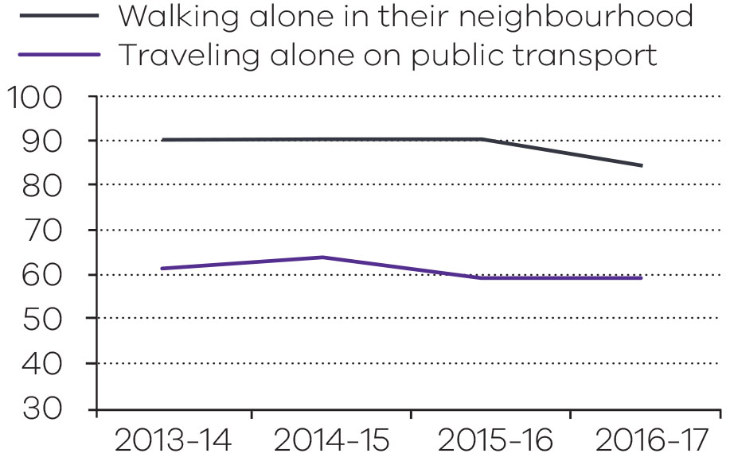

Community feelings of safety during the night
The percentage of Victorians surveyed who reported feeling safe or very safe during the night also shows slight variation over four years across the three indicators:
- feelings of safety at home
- walking alone in the neighbourhood
- alone on public transport.
The percentage of Victorians surveyed who felt safe or very safe at home alone during the night shows a decrease, from 87.1 per cent in 2015–16 to 79.1 per cent in 2016-17.
In 2016-17, 42.8 per cent of Victorians surveyed felt safe or very safe walking alone in their neighbourhood during the night, compared to 48.6 per cent in 2015-16. This result represented
a 5.8 percentage point decrease from the
2015-16 result.
For public transport, in 2016-17, 23.3 per cent of Victorians felt safe or very safe on public transport at night, which was a decrease compared to the 2015-16 result (25.6 per cent). Victoria is 0.7 percentage points below the national result
(24.0 per cent) for this measure in 2016-17.
Perceptions of safety on public transport are influenced by a number of factors external to the control of police services, such as the frequency and types of public transport available.
Community safety during the night 2013–14 to 2016–17
Unit of measure | 2013-14 | 2014-15 | 2015-16 | 2016-17
Community feelings of safety at home alone during the night
Per cent | 90.4 | 89.5 | 87.1 | 79.1
Community feelings of safety walking alone in their neighbourhood during the night
Per cent | 50.2 | 52.1 | 48.6 | 42.8
Community feelings of safety traveling alone on public transport during the night
Per cent | 23.5 | 28.5 | 25.6 | 23.3

Source: Report on Government Services (ROGS) 2018. Note this is the most recent data available from ROGS. 2017-18 data are published in 2019.
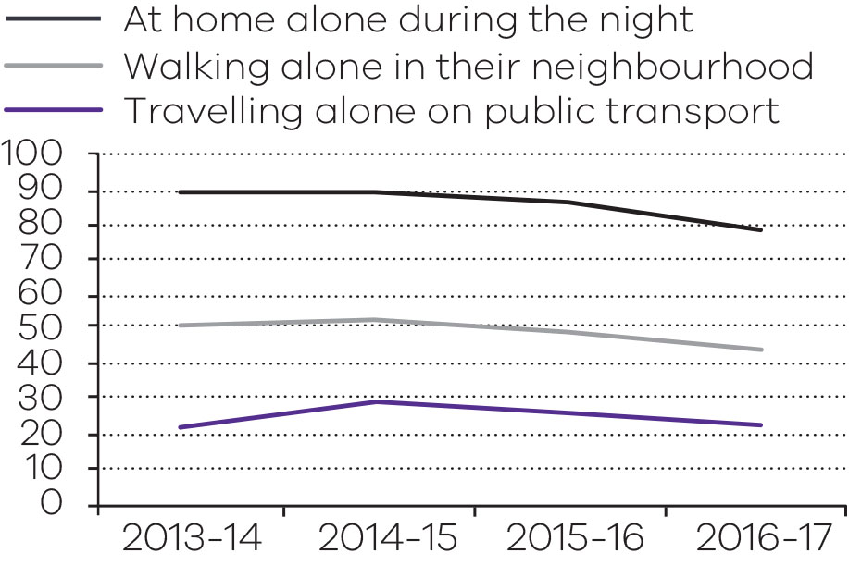
Objective indicator: Crime Statistics
Crime Statistics is reported quarterly by the CSA, and is defined as the number of offences recorded by offence category.
Total recorded crime has dropped consistently over the last financial year. The recorded decrease at the end June 2018 was 4.9 percent. Property, drug and public order offences have all dropped. Three categories – crimes against the person, justice procedures and other offence categories have increased.
Crime statistics are based on reports from the public and crimes detected by police. Changes to recorded crime can be due to increased presence and focus on community safety throughout Victoria, police detection and enforcement activity, the introduction of new offences or increase in legal powers to enforce certain offences.
Changes may also be due to social, economic and environmental factors, or increasing or changing public confidence to report crime to police.
The CSA is responsible for the calculation of crime statistics. Further breakdown of crime statistics is available from the CSA website www.crimestatistics.vic.gov.au/

Crime statistics 2014–15 to 2017–18: Total recorded crime
Offences | 2014-15 | 2015-16 | 2016-17 | 2017-18 | % change  2016-17 to 2017-18
Homicide and related offences | 174 | 211 | 231 | 220 | -4.8
Assault and related offences | 37,629 | 41,697 | 43,404 | 43,518 | 0.3
Sexual offences | 11,506 | 12,666 | 13,478 | 14,946 | 10.9
Abduction and related offences | 708 | 807 | 757 | 722 | -4.6
Robbery | 2,530 | 2,887 | 3,199 | 3,175 | -0.8
Blackmail and extortion | 212 | 191 | 204 | 192 | -5.9
Stalking, harassment and threatening behaviour | 12,109 | 12,725 | 11,832 | 11,760 | -0.6
Dangerous and negligent acts endangering people | 4,338 | 5,319 | 6,078 | 5,868 | -3.5
Crimes against the person | 69,206 | 76,503 | 79,183 | 80,401 | 1.5
Arson | 3,445 | 4,515 | 3,226 | 3,258 | 1.0
Property damage | 42,547 | 43,488 | 42,382 | 41,000 | -3.3
Burglary/Break and enter | 46,254 | 52,103 | 52,039 | 43,518 | -16.4
Theft | 151,813 | 181,182 | 182,143 | 166,677 | -8.5
Deception | 33,499 | 39,177 | 35,920 | 34,102 | -5.1
Bribery | 41 | 26 | 6 | 7 | 16.7
Property and deception offences | 277,599 | 320,491 | 315,716 | 288,562 | -8.6
Drug dealing and trafficking | 5,050 | 5,198 | 4,519 | 4,282 | -5.2
Cultivate or manufacture drugs | 1,688 | 1,749 | 1,504 | 1,318 | -12.4
Drug use and possession | 21,951 | 23,210 | 24,282 | 24,105 | -0.7
Other drug offences | 262 | 18 | 18 | 69 | 283.3
Drug offences | 28,951 | 30,175 | 30,323 | 29,774 | -1.8
Weapons and explosives offences | 14,526 | 16,003 | 15,926 | 14,841 | -6.8
Disorderly and offensive conduct | 19,390 | 17,106 | 16,583 | 15,892 | -4.2
Public nuisance offences | 2,666 | 3,490 | 3,428 | 3,772 | 10.0
Public security offences | 194 | 87 | 73 | 140 | 91.8
Public order and security offences | 36,776 | 36,686 | 36,010 | 34,645 | -3.8
Justice procedures | 6,883 | 12,840 | 12,770 | 12,212 | -4.4
Breaches of orders | 51,306 | 57,813 | 57,203 | 59,121 | 3.4
Justice procedures offences | 58,189 | 70,653 | 69,973 | 71,333 | 1.9
Regulatory driving offences | 30 | 18 | 14 | 19 | 35.7
Transport regulation offences | 457 | 611 | 744 | 617 | -17.1
Other government regulatory offences | 643 | 558 | 642 | 1,120 | 74.5
Miscellaneous offences | 488 | 482 | 288 | 391 | 35.8
Other offences | 1,618 | 1,669 | 1,688 | 2,147 | 27.2
Total offences | 472,339 | 536,177 | 532,893 | 506,862 | -4.9

Source: Crime Statistics Agency Year ending 30 June 2018.
Crime Statistics 2014–15 to 2017–18: offence rate per 100,000 population.
Offences | 2014-15 | 2015-16 | 2016-17 | 2017-18 | % change  2016-17 to 2017-18
Homicide and related offences | 2.9 | 3.4 | 3.7 | 3.4 | -6.9
Assault and related offences | 623.7 | 674.8 | 686.4 | 672.7 | -2.0
Sexual offences | 190.7 | 205.0 | 213.1 | 231.0 | 8.4
Abduction and related offences | 11.7 | 13.1 | 12.0 | 11.2 | -6.8
Robbery | 41.9 | 46.7 | 50.6 | 49.1 | -3.0
Blackmail and extortion | 3.5 | 3.1 | 3.2 | 3.0 | -8.0
Stalking, harassment and threatening behaviour | 200.7 | 205.9 | 187.1 | 181.8 | -2.8
Dangerous and negligent acts endangering people | 71.9 | 86.1 | 96.1 | 90.7 | -5.6
Crimes against the person | 1,147.1 | 1,238.1 | 1,252.2 | 1,242.8 | -0.7
Arson | 57.1 | 73.1 | 51.0 | 50.4 | -1.3
Property damage | 705.2 | 703.8 | 670.2 | 633.8 | -5.4
Burglary/Break and enter | 766.7 | 843.2 | 822.9 | 672.7 | -18.3
Theft | 2,516.4 | 2,932.1 | 2,880.4 | 2,576.5 | -10.5
Deception | 555.3 | 634.0 | 568.0 | 527.1 | -7.2
Bribery | 0.7 | 0.4 | 0.1 | 0.1 | 14.0
Property and deception offences | 4,601.4 | 5,186.6 | 4,992.7 | 4,460.6 | -10.7
Drug dealing and trafficking | 83.7 | 84.1 | 71.5 | 66.2 | -7.4
Cultivate or manufacture drugs | 28.0 | 28.3 | 23.8 | 20.4 | -14.3
Drug use and possession | 363.9 | 375.6 | 384.0 | 372.6 | -3.0
Other drug offences | 4.3 | 0.3 | 0.3 | 1.1 | 274.7
Drug offences | 479.9 | 488.3 | 479.5 | 460.2 | -4.0
Weapons and explosives offences | 240.8 | 259.0 | 251.8 | 229.4 | -8.9
Disorderly and offensive conduct | 321.4 | 276.8 | 262.2 | 245.7 | -6.3
Public nuisance offences | 44.2 | 56.5 | 54.2 | 58.3 | 7.6
Public security offences | 3.2 | 1.4 | 1.2 | 2.2 | 87.5
Public order and security offences | 609.6 | 593.7 | 569.5 | 535.5 | -6.0
Justice procedures | 114.1 | 207.8 | 201.9 | 188.8 | -6.5
Breaches of orders | 850.4 | 935.6 | 904.6 | 913.9 | 1.0
Justice procedures offences | 964.5 | 1,143.4 | 1,106.5 | 1,102.7 | -0.4
Regulatory driving offences | 0.5 | 0.3 | 0.2 | 0.3 | 32.7
Transport regulation offences | 7.6 | 9.9 | 11.8 | 9.5 | -18.9
Other government regulatory offences | 10.7 | 9.0 | 10.2 | 17.3 | 70.5
Miscellaneous offences | 8.1 | 7.8 | 4.6 | 6.0 | 32.7
Other offences | 26.8 | 27.0 | 26.7 | 33.2 | 24.3
Total offences | 7,829.3 | 8,677.1 | 8,427.0 | 7,835.1 | -7.0
Source: Crime Statistics Agency Year ending 30 June 2018.
Note: Estimated resident population, for years preceding the current year, are taken from the Australian Bureau of Statistics (ABS), Regional Population Growth, Australia (cat. no. 3218.0) - as at 30 June. As ABS data is not available for the current year’s rates to be calculated, the CSA uses estimates created by the Victorian Government’s ‘Victoria in future’ report.
Objective indicator: Road fatalities and injuries
This objective indicator is defined by two measures that are recorded to have occurred on Victoria’s roads during a twelve month period:
- total reported road fatalities in vehicle collisions
- total persons reported injured in vehicle collisions.
During 2017-2018, Victoria recorded a decrease in road injuries and fatalities on Victorian roads.
Victoria Police is committed to reducing road trauma and enhancing community safety on our roads. The Towards Zero 2016-2020 Road Safety Strategy remains a key focus for Victoria Police and their road safety partners. This strategy aims to lower the number of lives lost on Victoria’s roads to 200 or less by 2020, and reduce serious injuries by at least 15 per cent.
In 2017-2018, the number of reported fatalities on Victorian roads decreased by 28 compared with 2016-2017. The number of injuries and collisions decreased to the lowest recorded numbers over the past five years. Drivers continue to account for the majority of fatalities, comprising 48.5 per cent of the total road fatalities.
Pedestrians killed on the road this year compared to last year remained the same at 35 pedestrian deaths each year.
The number of motorcycle fatalities has reduced from 40 in 2016-2017 to 36 in 2017-2018, a reduction of 10 per cent.
The number of road injuries decreased by almost 14 per cent over the last 12 months, from 17,914 in 2016-17 to 15,454 in 2017-18.

Rate of road fatalities and injuries 2014–15 to 2017–18
Unit of measure | 2014-15 | 2015-16 | 2016-17 | 2017-18
Road fatalities
Number | 254 | 266 | 267 | 239
Road injuries
Number | 18,846 | 19,352 | 17,914 | 15,454
Source: Victoria Police.
Data was extracted from Victoria Police’s Collision Management Information System as at 5 July 2018 and is subject to variation.
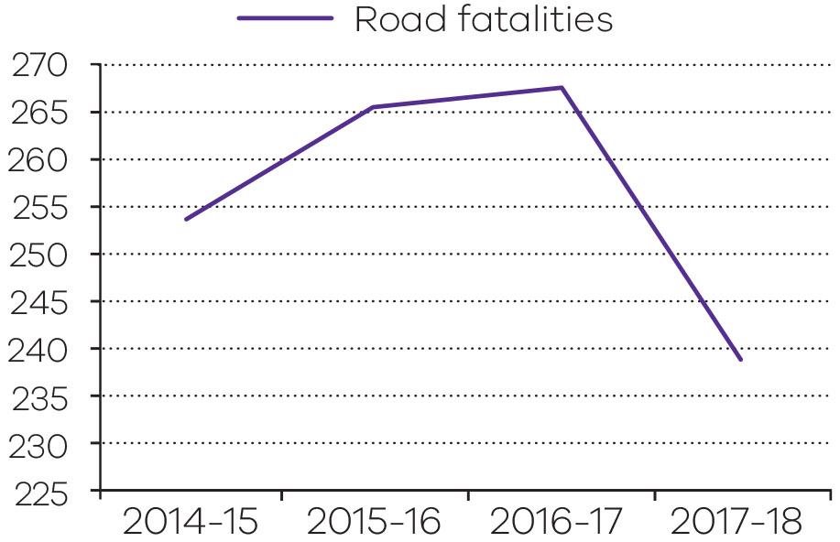
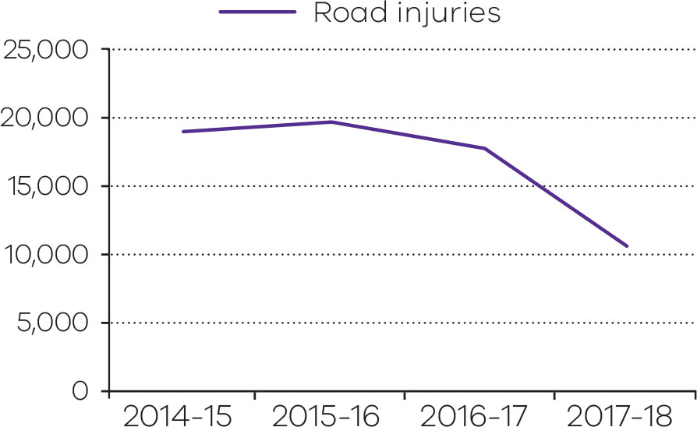
Output performance measures: Policing services and crime prevention
Victoria Police strives to reduce violence and crime through law enforcement, judicial support, community assistance, guidance and leadership.
The output reflects the government’s focus on reducing the overall incidence and fear of crime and enhancing the safety of individuals and families.
The Community Crime Prevention Program supports local communities in preventing crime as well as addressing local crime issues.
Performance measures | Unit of measure | 2017-18 actual | 2017-18 target | Performance variation (%) | Result
Quantity
Community calls for assistance to which a Victoria Police response is dispatched | number | 892 374 | 1 036 000 | -13.9 | ■
This is a demand driven measure. The actual is below the target due to a decrease in both demand and crime across the four quarters of 2017-18.
Contravention of family violence intervention order (FVIO) offences per 100 000 population. | number | 624.3 | ≥650 | -3.9 | ○
Crimes against property – excluding family violence related crime (rate per 100 000 population) | number | 4 308.6 | ≤5 100 | 15.5 | ✓
The 2017-18 actual is below target due to a decreasing trend in property crime. There has been a significant reduction in all burglaries, with residential burglary and vehicle related crime decreasing significantly.
Crimes against property – family violence related crime (rate per 100 000 population) | number | 152 | ≥150 | 1.3 | ✓
Crimes against the person – excluding family violence related crime (rate per 100 000 population) | number | 692.9 | ≤660 | -5.0 | ■
The actual is above the target due to an increase in Non-Family Violence common assault offences in 2017-18.
Crimes against the person – family violence related crime (rate per 100 000 population) | number | 549.9 | ≥590 | -6.8 | ■
The actual is below the target due to the stabilising of family violence related crime in line with a reduction in overall total recorded crime.
Number of alcohol screening tests conducted by booze and drug buses | number | 1 337 208 | 1 100 000 | 21.6 | ✓
The actual is above the target due to additional road safety operations during 2017-18 and an increase in resources allocated to booze buses as a result of new police constables, which are supporting the Towards Zero strategy.
Number of hours of family violence related education provided to police | number | 1 598 | 1 700 | -6.0 | ■
The actual is below the target due to an amendment to training schedules and timing issues throughout the first year of operation of the Centre of Family Violence.
Number of prohibited drug screening tests conducted by booze and drug buses and highway patrol units | number | 100 212 | 100 000 | 0.2 | ✓
Police record checks conducted to contribute to community safety | number | 716 768 | 703 000 | 2.0 | ✓
Total reported road fatalities in vehicle collisions | number | 239 | ≤225 | -6.2 | ■
The actual is above the target due to a high proportion of fatalities occurring on country roads throughout 2017-18.
Total persons reported injured in vehicle collisions | number | 15 454 | <18 700 | 17.4 | ✓
The actual is below the target due to continued road safety campaigns and high profile operations that focus on improving driver behaviour. This is a positive result.
Quality
Community Crime Prevention grant payments properly acquitted | per cent | 100 | 100 | 0.0 | ✓
Perceptions of safety - walking locally at night | per cent | 51.8 | 50 | 3.6 | ✓
Proportion of community satisfied with policing services (general satisfaction) | per cent | 78.9 | 77 | 2.5 | ✓
Proportion of drivers tested who comply with alcohol limits | per cent | 99.9 | 99.5 | 0.4 | ✓
Proportion of drivers tested by road safety cameras who comply with posted speed limits | per cent | 99.8 | 99.5 | 0.3 | ✓
Proportion of drivers tested who return clear result for prohibited drugs | per cent | 90.3 | 93 | -2.9 | ○
Proportion of successful prosecution outcomes | per cent | 95 | 92 | 3.3 | ✓
Proportion of the community who have confidence in police (an integrity indicator) | per cent | 83.9 | 87 | -3.6 | ○
Timeliness
Proportion of crimes against the person resolved within 30 days | per cent | 46.7 | ≥42 | 11.2 | ✓
The 2017-18 actual is above target due to efficiency improvements that have enabled a positive impact in reducing resolution times.
Proportion of property crime resolved within 30 days | per cent | 25.9 | ≥22 | 17.7 | ✓
The 2017-18 actual is above target due to efficiency improvements that have enabled a positive impact in reducing resolution times.
Cost
Total output cost | $ million | 3 092.0 | 3 037.0 | 1.8 | ○
Note:
✓ Performance target achieved or exceeded.
○ Performance target not achieved – within 5 per cent variance.
■ Performance target not achieved – exceeds 5 per cent variance.

Effective management of prisoners and offenders and provision of opportunities for rehabilitation and reparation
This objective relates to the management of the state’s adult correctional system.
The overarching purpose of the correctional system is to promote community safety through community-based and custodial supervision of prisoners and offenders through effective management and services to provide opportunities for rehabilitation and reparation.
In 2017–18, the department reported progress against this objective using the following objective indicators and outputs.
Objective indicators
- Escapes from corrective facilities
- Percentage of community correction orders completed
- Rate of prisoner return to prison within two years
- Rate of offender return to corrective services within two years
Outputs
- Prisoner Supervision and Support
- Community Based Offender Supervision
2017–18 system-wide initiatives and achievements
Implementing the Serious Offender Reforms to the post-sentence scheme (Harper Review)
During 2017–18, work has continued on implementing all 35 recommendations of the Review of Complex Adult Victim Sex Offender Management (the Harper Review).
The Serious Sex Offenders (Detention and Supervision) Amendment (Governance) Act 2017 commenced on 27 February 2018. The Act:
- established a new independent statutory body, the Post Sentence Authority, to oversee the post-sentence scheme
- enabled summary offences related to an alleged breach of the conditions of a supervision order to be uplifted from the Magistrates’ Court to a higher court that is hearing and determining the alleged breach offence
- established multi-agency panels and imposed statutory obligations on responsible agencies to coordinate service delivery.
The Serious Offenders Act 2018 established the new post-sentence scheme. It received Royal Assent on 26 June 2018 and, upon commencement, will:
- expand the current post-sentence scheme to include serious violent offenders
- enhance powers to deal with imminent and escalating risks of post–sentence offenders by creating new Emergency Detention Orders (EDOs)
- enable the Secretary to apply to the Supreme Court for an EDO, requiring an offender on a supervision order (or interim order) to be detained in prison for up to seven days
- expand accommodation options by providing a legal framework for the supervision of offenders in a new secure residential treatment facility that will offer a new ‘step up / step down’ option for accommodating offenders on post-sentence orders.
Construction of the new Rivergum Residential Treatment Centre, a secure 20–bed residential facility, has commenced. This treatment centre, located next to the Hopkins Correctional Centre, will provide accommodation for serious sex and violent offenders and is due to be completed by the end of 2018.
Construction of a 10-bed post-sentence detention unit at Barwon Prison has also commenced. The unit will house the state’s most serious violent offenders, who are deemed unsuitable to live in the community after their prison sentence. Construction is due to be completed by early 2019.
Corrections Victoria, in partnership with DHHS, has also been working on increasing the capacity of forensic residential disability services.
Sex offender management
The Serious Sex Offenders (Detention and Supervision) Act 2009 enables the post-sentence supervision or detention of serious sex offenders who have completed their custodial sentences and are deemed by the courts to present an unacceptable risk to the community. The primary purpose of the Act is to enhance the protection of the community. The secondary purpose is to facilitate the treatment and rehabilitation of offenders who are subject to post-sentence supervision or detention orders. Community safety is the paramount consideration in managing offenders who are subject to post-sentence orders.
On 30 June 2018, there were 136 serious sex offenders who were subject to a supervision order (including nine on an interim order) and three serious sex offenders in custody subject to a detention order.
Reducing reoffending and harm to the community
The department, through Corrections Victoria, delivers a range of specialised programs and services that encourage positive behaviour change to reduce reoffending and enhance community safety. To this end, integrated programs and services are tailored to specific cohorts, including sex offenders, violent offenders and those whose offending relates to misuse of alcohol and drugs.
Programs related to family violence have also been embedded in service delivery for prisoners and offenders, including support for women prisoners who have experienced violence, through delivery of the Out of the Dark family violence recovery program and specialist trauma counselling in women’s prisons.
The 2017–18 State Budget provided $41 million to deliver a range of additional programs over four years focused on reducing reoffending. Key elements are:
- an increased volume of alcohol and drug treatment programs
- expanded post-release support services for those prisoners being discharged from prison who require assistance, with a focus on remand and short-sentence prisoners. Program delivery is on track to increase places from 990 per annum to 3,000 per annum in 2021.
The expansion of post-release services is being complemented by a new cultural mentoring program for Aboriginal prisoners, which is being developed in consultation with the Koori community.
The department has also:
- strengthened cultural awareness and competence in the delivery of services for Aboriginal men and women prisoners, and supported the development of the fourth AJA
- provided enhanced access to key rehabilitation programs through both prisons and CCS
- strengthened the delivery of programs focused on family violence for prisoners and offenders
- been involved in planning and collaboration with other departments to ensure that the needs of prisoners with a disability are met during the transition to full implementation of the National Disability Insurance Scheme (NDIS) (for further information about NDIS refer to page 56).
Delivering public value
Activities conducted by the department during 2017–18 to drive the sustainability and efficiency of the correctional system include:
- Continuing to rigorously monitor new and existing service contracts for private prisons, including the Ravenhall Correctional Centre, as well as contracts relating to support services such as prisoner transport. This work aims to ensure high levels of performance and continuous improvement in contract management processes.
- Responding to the report by the Victorian Auditor-General’s Office (VAGO) into the Safety and Cost Effectiveness of Private Prisons, which was tabled in Parliament on 29 March 2018. The report concluded that the operators are delivering cost efficient services for the state that have largely met service and performance requirements. All six recommendations directed to the department have been accepted and an action plan has been developed to respond to these.
- Ongoing release of statistics and information on the Victorian corrections system aimed at improving transparency, and stakeholder and community understanding of the system. Detailed ten–year trend tables on the key characteristics of both prisoners and community–based offenders were published for the first time in June 2018 and will be updated on an annual basis.
Corrections legislative reform program
Significant legislative reform continued in the Corrections portfolio over 2017–18, as detailed in the following sections.
Corrections Legislation Amendment Act 2016
On 1 August 2017, the final stage of reforms in this Act commenced, which involved new powers to supervise high-risk prisoners on parole.
Corrections Legislation Miscellaneous Amendment Act 2017
This legislation, which amended the Corrections Act, Serious Sex Offenders (Detention and Supervision) Act and the Children, Youth and Families Act 2005, was passed on 10 August 2017 and commenced on 16 August 2017. It included reforms to:
- Strengthen parole laws for the release on, and cancellation of, parole for prisoners convicted of terrorism or foreign incursion offences, defensive homicide, carjacking or home invasion. These prisoners can only be released by the Serious Violent Offender or Sexual Offender division of the Adult Parole Board under a two-tier decision-making process. These laws do not impact the Commonwealth’s ability to grant or deny parole for Commonwealth offences.
- Improve the operation of the Serious Sex Offenders (Detention and Supervision) Act. This includes reforms to allow the courts to update core conditions of supervision orders (such as conditions to address violent offending and behaviour), improve processes for the review and renewal of orders, and expand reporting requirements on the use of force by supervision officers, police officers and specified officers.
- Introduce a ban on the use or possession of remotely piloted aircraft (commonly referred to as drones) and helicopters within 400 feet above or outside the vicinity of a prison, residential facility or youth justice facility. This ban commenced on 1 February 2018.
Corrections Legislation Further Amendment Act 2017
This legislation was introduced into Parliament on 6 September 2017 and was passed on 13 December 2017. It included new contraband offences in the Corrections Act, which commenced on 20 December 2017.
Other key reforms that commenced on this date include new powers for security officers to provide security services for the Adult Parole Board and its staff, new powers to remove electronic monitoring devices and equipment from prisoners and offenders, and a new power to enable paid prisoner employment outside of prison.
For further information about the Post Sentence Authority refer to page 211.
Output: Prisoner supervision and support
During 2017–18, there was a steady rise in Victoria’s prison population. Prisoner numbers increased from 7151 at 30 June 2017 to 7668 at 30 June 2018. This represented a 7.2 per cent increase on the previous year, or 517 additional prisoners.
This growth has continued to be driven by people entering the prison system on remand. On 30 June 2018, there were 2711 prisoners on remand, which represented 35.4 per cent of the prison population. This compared with 2224 remandees on 30 June 2017.
Expanding and improving prison infrastructure
In 2017–18, the department has progressed a number of key activities to expand and improve prison infrastructure to address the continued growth in prisoner numbers.
On 12 October 2017, the Ravenhall Correctional Centre was officially opened. Ravenhall is a medium-security 1000-bed men’s prison with a built capacity for 1300 prisoners. The first prisoners were received on 13 November 2017.
Due to the increasing number of remand prisoners in Victoria, 450 remandees are included in the prisoner profile at Ravenhall Correctional Centre.
Work has continued on upgrading and enhancing the Metropolitan Remand Centre, with strengthening of infrastructure completed in March 2018. The remaining work is on schedule for completion in 2018.
In July 2017, work on a new 70-bed accommodation unit, including a purpose built mental health precinct, and infrastructure upgrades at the Dame Phyllis Frost Centre commenced. The project is expected to achieve practical completion in the second half of 2018. In August 2017, 12 additional cellular beds were also commissioned at the Dame Phyllis Frost Centre.
During 2017–18, work commenced on:
- the upgrade and refurbishment of male mental health units at the Melbourne Assessment Prison and Port Phillip Prison
- 20 additional secondary health beds in the male prison system
- a new gatehouse, kitchen, medical centre and programs centre at Barwon Prison.
Planning has also commenced for delivery of initiatives funded through the 2018–19 State Budget as well as those provided in the 2017–18 Budget Update. These include:
- more than 470 additional prison beds as part of the $345.5 million investment provided in the 2017–18 Budget Update
- $689.5 million in the 2018–19 State Budget to build a new 700-bed maximum-security men’s prison within the Lara prison precinct
- $91 million committed in the 2018–19 State Budget to provide increased capacity and security upgrades across the prison system, including construction of a prisoner management unit at the Fulham Correctional Centre and operational funding for the new mental health and wellbeing precinct at the Dame Phyllis Frost Centre.
Improving access to mental health, alcohol and other drug treatment programs in prison
Significant investment has been made into voluntary mental health treatment within the prison system. Bed–based services have been funded at the Dame Phyllis Frost Centre from 2018 as part of the aforementioned new precinct, replacing the existing Marrmak facility and also including outpatient mental health services for female prisoners.
The new Ravenhall Correctional Centre provides 75 bed-based voluntary mental health treatment services for male prisoners with mental illness across the prison system, as well as 100 specialist mental health outpatient services for prisoners accommodated at the prison.
Upgrades to mental health units at the Melbourne Assessment Prison and Port Phillip Prison are currently underway and are due to be completed in 2018.
The department contracts service providers to deliver alcohol and other drug (AOD) services and programs within the prison system with a view to improving prisoner health, reducing harm and reduce substance–related reoffending.
Significant achievements over 2017–18 included adding the successful ‘Sustaining Change’ program to a number of sites and the implementation of a Koori men’s program to better support the cultural needs of Koori men with AOD concerns.
The number of AOD short health programs was increased in 2017–18, to ensure that remand prisoners and prisoners with short sentences have easy access to AOD interventions.
Enabling prisoners to make a healthy transition back into the community
The department has a range of programs to prepare prisoners for release and transition into the community, including ensuring that their physical and mental health needs, and treatment needs for alcohol and other drugs, continue to be met once they are released back into the community. The prisoner transition and reintegration pathway commences upon initial reception into custody and provides information, targeted support and referrals to funded service providers.
For further information on reducing reoffending and harm to the community refer to page 29.
Aboriginal social and emotional wellbeing
The department provides tailored programs to support the cultural needs of Aboriginal prisoners and offenders. The Aboriginal Social and Emotional Wellbeing Plan is designed to improve outcomes for Aboriginal people in prison in Victoria.
In 2017–18, the department:
- Managed two Koori Tertiary Scholarships, which provided financial support for Aboriginal and/or Torres Strait Islander people to undertake full-time study in a health-related field. The scholarships aim to increase the number of Aboriginal and Torres Strait Islander health professionals working in the corrections system
- Delivered the Victorian Aboriginal Community Controlled Health Organisation’s cultural safety training, and Indigenous Psychological Services’ mental health assessment training to prison health care providers
- Continued to manage the Aboriginal health care pilot, a two-year pilot designed to ensure that Aboriginal women and men exiting particular facilities are supported to access health care services in the community. The pilot is being delivered by three Aboriginal-run organisations: Ngwala Willumbong (at Dame Phyllis Frost Centre); Rumbalara Aboriginal Cooperative (at Dhurringile Prison); and the Gippsland and East Gippsland Aboriginal Cooperative (at Fulham Correctional Centre)
- Appointed an Aboriginal Clinical Governance Officer to develop a set of standards that promote cultural safety in the delivery of health care to Aboriginal and Torres Strait Islander people.
Correctional system performance
The corrections system continues to experience significant growth, particularly in the remand population, which has almost tripled in the last five years. This growth has also necessitated the accommodation of remand prisoners at locations that previously held only sentenced prisoners. The placement and management of remand prisoners also presents unique challenges due to their different needs and circumstances.
Escapes from custody in Victoria
There were 10 escapes from prison custody in Victoria during 2017–18. All 10 prisoners were subsequently returned to prison. Of these escapes, four were from Beechworth Correctional Centre, four from Dhurringile Prison and one from Judy Lazarus Transition Centre, all of which are minimum-security facilities. There was also one escape by a prisoner while on escorted leave, which was not categorised as either a ‘secure’ or ‘open’ escape according to national Report on Government Services (ROGS) counting rules.
Deaths of prisoners in custody in Victoria
There were 17 deaths in prison custody in Victoria during 2017–18. The provisional cause of death in eight of these cases was natural causes, while five cases involved apparent unnatural causes. In four cases, the apparent cause was unknown.
The cause of all prisoner deaths is provisional and subject to confirmation by the Coroner.
Drug testing in Victorian prisons
Victoria operates one of the most extensive drug testing programs in Australia.
The percentage of positive random drug test results decreased from 4.20 per cent in 2016–17 to 3.97 per cent in 2017–18. This was the lowest level of positive tests recorded in the past five years.
In 2017–18, the total number of drug tests conducted, including random, general and targeted tests, was 37,489 – an increase of 7.8 per cent when compared with the 34,776 tests in 2016–17.
In addition, 12,755 breath tests were conducted in 2017–18, an increase of 15.5 per cent compared with the number conducted in 2016–17.
Self-harm, assaults and offender care in Victorian prisons
The rate of self-harm by prisoners in Victorian prisons in 2017-18 (6.6 incidents per 100 prisoners) was the second lowest for the current five-year period, while the attempted suicide rate was the highest during the same period (0.3 incidents per 100 prisoners).
The rate of assaults on prisoners by other prisoners decreased from 31.4 assaults per 100 prisoners in 2016-17 to 25.9 assaults per 100 prisoners in 2017-18. Before this outcome, the rate had increased progressively for the previous seven years. The rate of assaults on staff or other persons by prisoners also decreased from 5.3 per 100 prisoners in 2016-17 to 4.7 per 100 prisoners in 2017-18.
The decrease in assault incidents is understood to have been influenced by improved strategies to reduce violence across prisons as well as the opening of Ravenhall Correctional Centre, which has increased the overall capacity of the prison system and reduced system pressures arising from the growing prisoner population.
National Corrective Services performance comparisons
National performance data from all Australian states and territories is compiled to compare the efficiency and effectiveness of a range of government services, including Corrective Services. The data is published annually in the ROGS by the Steering Committee for the Review of Government Services Provision.
Data published in early 2018, relating to the provision of services in 2016–17, showed Victoria had the second-lowest imprisonment rate and the second-lowest community corrections rate in Australia.
Victoria also had the highest overall prisoner employment rate in the country, while the participation rate for prisoner education was the fourth-highest in Australia and above the national average.
Comparative data for 2017–18 will be published in early 2019.

Prison service statistics
 | 2013-14 | 2014-15 | 2015-16 | 2016-17 | 2017-18
Average daily prison population | 5,800 | 6,350 | 6,320 | 6,853 | 7,258
Containment and Supervision – escapesa
Number of escapes—total | 7 | 5 | 10 | 3 | 10
Number of escapes—secure prisons | 0 | 0 | 5 | 1 | 0
Number of escapes—open prisons | 7 | 5 | 5 | 2 | 9
Number of escapes—other | 0 | 0 | 0 | 0 | 1
Escape rate—total (per 100 prisoners) | 0.12 | 0.08 | 0.16 | 0.04 | 0.14
Escape rate—secure prisons (per 100 prisoners) | 0.0 | 0.0 | 0.09 | 0.02 | 0.0
Escape rate—open prisons (per 100 prisoners) | 0.77 | 0.49 | 0.57 | 0.22 | 1.10
Number of attempted escapes | 4 | 1 | 5 | 2 | 4
Containment and Supervision-deathsb
Total number of deaths in custody | 11 | 15 | 19 | 20 | 17
Death rate (per 100 prisoners) | 0.19 | 0.24 | 0.30 | 0.29 | 0.23
Number of deaths from apparent unnatural causes | 0 | 3 | 1 | 4 | 5
Death rate apparent unnatural causes  (per 100 prisoners) | 0.0 | 0.05 | 0.02 | 0.06 | 0.07
Total number of Aboriginal deaths in custody | 0 | 1 | 1 | 2 | 4
Number of Aboriginal deaths from apparent unnatural causes | 0 | 0 | 0 | 0 | 0
Aboriginal death rate apparent unnatural causes (per 100 prisoners) | 0.0 | 0.0 | 0.0 | 0.0 | 0.0
Containment and Supervision—self harm
Self mutilations (per 100 prisoners) | 6.9 | 5.9 | 7.0 | 7.3 | 6.6
Attempted suicides (per 100 prisoners) | 0.2 | 0.1 | 0.2 | 0.1 | 0.3
Containment and Supervision—assaultsc
Assault rate—assaults on prisoners by other prisoners | 19.1 | 20.3 | 26.9 | 31.4 | 25.9
Assault rate—assaults on staff or other persons by prisoners | 5.6 | 4.5 | 5.9 | 5.3 | 4.7
Containment and Supervision—illicit drugs
Percentage of positive random drug testsd | 5.40 | 4.28 | 5.70 | 4.20 | 3.97
Number of visits (average per prisoner) | 21.8 | 22.0 | 19.8 | 19.4 | 18.5
Reparation—Employment
Employment rate—all prisonerse (%) | 88.1 | 89.3 | 87.5 | 87.1 | 91.5
Note:
a. The escape categories conform to the current definition of escapes in the Report on Government Services prepared by the Steering Committee for the Review of Commonwealth/State Service Provision. Escapes by prisoners on unescorted leave, in work parties or activities outside the prison perimeter without direct one-to-one supervision are classified as ‘other’ escapes. Apart from these, all escapes, including during transfers between prisons or escorts outside the prison under one-to-one supervision, are classified according to the security level of the prison.
b. The cause of all prisoner deaths is subject to confirmation by the Coroner. The number of deaths from apparent unnatural causes for 2015-16 and 2016-17 has been updated.
c. The assault rate is based on the number of victims of all assaults, including victims who were not injured. The measure in this report differs from the definition adopted for the Report on Government Services which disaggregates assaults by seriousness but excludes minor assaults that did not result in bodily harm or require any form of medical intervention.
d. The rate for 2017-18 is preliminary as at 26 July 2018 and subject to change.
e. The prisoner employment rate is calculated as the proportion of all prisoners except those in full-time education or programs, remandees who chose not to work and others whose situation precludes their participation in work, such as hospital patients, aged prisoners and prisoners in transit.

Progress toward achieving this objective
Objective indicator: Escapes from corrective facilities
The objective indicator ‘Escapes from corrective facilities’ includes escapes by prisoners from secure perimeter corrective facilities and open perimeter corrective facilities (open camp prisons).
The number of escapes from corrective facilities provides an indication of the ability of the system to provide safe and secure containment of prisoners, thereby contributing to community safety.
Data for this objective indicator are collected on an annual basis and published in the Report on Government Services (ROGS).
There were no escapes reported from secure perimeter corrective facilities and nine escapes from open perimeter corrective facilities in 2017-18. Four prisoners escaped from Beechworth Correctional Centre, four from Dhurringile Prison and one from Judy Lazarus Transition Centre. All prisoners were classified as minimum security and were subsequently returned to prison. This is an increase from two escapes from open perimeter facilities in 2016-17. After any escape from custody a comprehensive review is undertaken to identify any future learnings.
Escapes from corrective facilities 2014-15 to 2017-18
Unit of measure | 2014-15 | 2015-16 | 2016-17 | 2017-18
Escapes from corrective facilities: secure perimeter
Number | 0 | 5 | 1 | 0
Escapes from corrective facilities: open perimeter
Number | 5 | 5 | 2 | 9

Objective indicator: Rate of prisoner return to prison within two years
The objective indicator ‘Rate of prisoner return to prison within two years’ measures the percentage of prisoners released from custody after serving a sentence, who return to prison under sentence within two years of release. This indicator is influenced by the broader operation of the criminal justice system as well as prisoner rehabilitation objectives.
Data for this objective indicator are collected on an annual basis and published in the ROGS. The denominator for the measure is all prisoners who are discharged from prison following a sentenced episode. A return to prison under sentence means the person has returned to custody as a result of a new sentence of imprisonment imposed by the courts or because their parole was cancelled. A prisoner who receives a new sentence after initially returning to prison on remand will have their time to return counted from when they were remanded in custody.
Performance against this indicator was 43.7 per cent in 2017-18, consistent with the previous year. The increasing number of prisoners being remanded prior to sentencing has impacted this measure over the last two years.
Rate of prisoner return to prison within two years (per cent) 2014–15 to 2017–18
Unit of measure | 2014-15 | 2015-16 | 2016-17 | 2017-18
Per cent | 44.1 | 42.8 | 43.6 | 43.7

Output performance measures: Prisoner supervision and support
This output relates to the safe, secure and humane containment of prisoners as well as the delivery of programs and effective case management to engage prisoners in positive behavioural change.
Performance measures | Unit of measure | 2017-18 actual | 2017-18 target | Performance variation (%) | Result
Quantity
Average daily prison utilisation rate of total prison capacity | per cent | 89.6 | 90–95 | -0.4 | ○
Total annual daily average number of prisoners | number | 7 258 | 7 165-7 590 | 0.0 | ✓
Quality
Proportion of benchmark measures in prison services agreement achieved | per cent | 77.9 | 90 | -13.4 | ■
The 2017-18 outcome is lower than the target due to pressures on the prison system from an increasing remand population, with significant prisoner turnover and movement impacting service delivery.
Proportion of eligible prisoners in employment | per cent | 91.5 | 89 | 2.8 | ✓
Rate of prisoner participation in education | per cent | 36.3 | 36 | 0.8 | ✓
Rate of return to prison within two years | per cent | 43.7 | 41 | 6.6 | ■
The actual is above the target due to an increase in the number of prisoners spending time on remand prior to receiving a sentence. This has resulted in prisoners being returned to custody more quickly.
Timeliness
Assessment of prisoners ‘at risk’ undertaken within two hours | per cent | 99.6 | 100 | -0.4 | ○
Cost
Total output cost | $ million | 1 319.0 | 1 302.7 | 1.3 | ○
Note:
✓ Performance target achieved or exceeded.
○ Performance target not achieved – within 5 per cent variance.
■ Performance target not achieved – exceeds 5 per cent variance.
Output: Community based offender supervision
Embedding CCS reforms
CCS provides for the management and supervision of offenders on court orders, serious sex offenders on post-sentence supervision, and prisoners on parole. It focuses on offender rehabilitation by providing real opportunities to tackle the drivers of offending behaviour.
In 2017–18, the number of offenders subject to a CCO stabilised after several years of rapid growth. On 30 June 2018, there were nearly 14,000 offenders being managed by CCS.
The department continued to embed reforms to CCS following investment of $332.3 million from the 2015–16 and 2016–17 State Budgets. These reforms strengthened management of offenders through a new service delivery model and more than 300 additional staff.
Building on the launch of the new service delivery model in early 2017, further initiatives during 2017–18 included:
- implementation of a staff supervision framework and regional delivery of a CCS staff supervision training package to all staff
- development of a higher education curriculum framework, which details the learning needs of graduates entering the CCS workforce and the supports required to ensure they are job-ready
- commencement of a placement pilot for students who are completing a CCS-relevant qualification
- development of audio-visual tools for staff to use with offenders to explain the nature and expectations of a CCO, parole order, court-ordered conditions and community work obligations
- strengthening the provision of forensic alcohol and other drug treatment services
- ongoing monitoring of the reforms to identify further opportunities to improve practice and ensure the objectives are achieved
- establishment of the ‘forensic mental health in community health’ program at six locations to provide community-based mental health assessment and treatment services for offenders on CCOs who have moderate-severity mental health issues and who have a condition on their order to undertake mental health treatment
- development of a Mental Health Advice and Response Service (MHARS) that will facilitate pre-sentence referrals to mental health treatment and provide clinical advice to magistrates on the mental health of
accused persons, which became operational in mid-2018.
For further information about forensic mental health services refer to the section below.
Investment in infrastructure under the CCS reform process saw completion of work on a number of new and existing JSCs across the state during 2017–18. These include:
- a new centre at Laverton North, opened in December 2017
- a new centre at Coolaroo that commenced operations in April 2018
- refurbishment and upgrade of existing locations at Bairnsdale and Werribee.
Six new regional justice locations have been constructed since 2016 as part of the CCS reform agenda, as well as seven sites that have been relocated and 13 others which have been expanded or upgraded. Further sites are due for completion over 2018–19.
Meet the need for forensic mental health services
The department has continued to improve the integration of responses to mental health in the criminal justice system through the Forensic Mental Health Implementation Plan. This has been achieved through an ongoing partnership with Court Services Victoria (CSV), DHHS and Victoria Police via the work of the Forensic Mental Health Advisory Board.
The Forensic Mental Health Implementation Plan is a strategy that has been jointly developed by the department and DHHS. This was in response to the government’s commitment to address the over-representation of people with mental illness in Victoria’s criminal justice system over the next decade.
The 2017–18 State Budget provided $83.03 million to expand mental health support for those who are in, or at risk of entering, the criminal justice system across courts, corrections, community mental health, youth justice and police services. The immediate priorities funded though the Forensic Mental Health Implementation Plan aim to increase opportunities to divert people with mental illness from the criminal justice system and improve offender access to appropriate mental health assessment, treatment and support services.
Strengthening community-based forensic alcohol and drug services
In collaboration with DHHS, the department has been working with the AOD and CCS sectors to implement the new community-based forensic alcohol and drug service delivery model. The model has drawn on substantial expertise and clinical advice to ensure that the AOD and CCS sectors work collaboratively to manage the treatment needs of offenders on community-based orders.
The forensic alcohol and drug service delivery model represents a significant change within the forensic AOD treatment sector. A number of initiatives have already been implemented through the new model, which include:
- a new screening and assessment tool to better identify an individual’s risk of substance-related harm and the relationship to their risk of reoffending
- new AOD treatment interventions with trials of a new 42-hour and group-based program, Kickstart, which is specifically designed and targeted at high-risk offenders
- an individual 15-hour program for those found unsuitable for a group program
- creation of a new collaborative practice framework which has been trialled in Bendigo and Coolaroo and will now be expanded across the state.
Progress toward achieving this objective
Objective indicator: Percentage of CCOs successfully completed
The objective indicator ‘Percentage of community corrections orders successfully completed’ measures the proportion of orders discharged by CCS that were successfully completed.
This indicator includes successfully completed parole orders, supervised court orders and reparation orders managed by CCS. The successful completion of community correction orders provides an indication of the capacity to effectively and appropriately manage offenders in the community. This includes providing opportunities for rehabilitation and reparation through case management and enforcing compliance with conditions, including AOD programs, mental health programs and community work.
A parole order allows a prisoner to serve part of their sentence of imprisonment in the community under supervision and subject to conditions imposed by the Adult Parole Board. The aim of parole is to increase community safety through providing prisoners with a structured and supervised transition from prison to the community. Supervised court orders are predominantly CCOs imposed by the courts that include at least one condition other than community work. Reparation orders comprise a range of orders that include only a requirement to perform unpaid community work. The most common reparation orders are CCOs and Fine Default Orders.
Data for this objective indicator are collected quarterly and published on a disaggregated basis for performance reporting purposes. These data are also published annually in the State Budget Paper 3 on a disaggregated basis, which reflects the performance of the different activity streams (parole, supervised court orders, and reparation orders). The aggregated objective indicator provides a useful overall snapshot of the performance of the community corrections system.
Performance in 2017-18 has decreased due to a combination of factors, including growth in offender numbers and a more complex cohort of offenders on court orders following the abolition of suspended sentences. The impact of additional investment in CCS from 2016–17 is expected to result in improved outcomes for offenders in future years, including an improved successful completion rate.
Completion of community correction orders (per cent) 2014–15 to 2017–18
Unit of measure | 2014-15 | 2015-16 | 2016-17 | 2017-18
Per cent | 66.5 | 66.2 | 62.9 | 59.2

Objective indicator: Rate of offender return to corrective services within two years
The objective indicator ‘Rate of offender return to corrective services within two years’ measures the percentage of offenders who returned to corrective services for a subsequent sentenced episode (either prison or community corrections) within two years of successful discharge from a community correction order. This indicator is influenced by the broader operation of the criminal justice system as well as the effectiveness of community corrections supervising offenders and providing rehabilitation opportunities.
Data for this objective indicator are collected on an annual basis and published in the ROGS.
The rate of offender return in 2017-18 was 16.4 per cent, similar to the previous year, noting that due to a review of application of counting rules undertaken in 2018, the offender rates differ from those published in previous annual reports.
The table below reflects updated figures for previous years using the corrected calculation.

Rate of offender return to corrective services within two years (per cent) 2014–15 to 2017–18
Unit of measure | 2014-15 | 2015-16 | 2016-17 | 2017-18
Per cent | 15.2 | 14.6 | 16.2 | 16.4

Output performance measures: Community based offender supervision
This output relates to the effective supervision of offenders in the community, including ensuring compliance with orders of the court and Adult Parole Board, engagement in programs to reduce reoffending and reparation to the community.
Performance measures | Unit of measure | 2017-18 actual | 2017-18 target | Performance variation (%) | Result
Quantity
Average daily offenders with reparation orders | number | 2 889 | 2 900 | -0.4 | ○
Average daily offenders with supervised court orders | number | 10 855 | 11 450 | -5.2 | ■
The actual is below the target due to the stabilisation in the number of new orders being imposed at court following the significant growth in 2015-16 due to the abolition of suspended sentences.
Average daily prisoners on parole | number | 818 | 1 000 | -18.2 | ■
The actual is below the target due to fewer prisoners with parole eligible sentences and a reduction in the average length of parole orders.
Community-work hours performed | number (000) | 712 | 850 | -16.2 | ■
The actual is below the target due to a combination of factors including a more complex offender cohort, fewer hours being ordered by the court and fewer fine orders being issued.
Quality
Rate of return to corrective services within two years of discharge from a community corrections order | per cent | 16.4 | 33 | -50.3 | ✓
The actual is below the target due to a review of application of national counting rules, meaning the offender return rates have changed significantly from those published in previous reports. The target was set prior to this correction taking place.
Successful completion of parole orders | per cent | 78.7 | 70 | 12.4 | ✓
The actual is above the target due to the ongoing improvements to the operation of Victoria’s parole system.
Successful completion of reparation orders | per cent | 63.8 | 73 | -12.6 | ■
The actual is below the target due to a combination of factors including a more complex offender profile impacting on successful completions.
Successful completion of supervised court orders | per cent | 53.7 | 64 | -16.1 | ■
The actual is below the target due to a combination of factors including a more complex offender profile impacting on successful completions.
Timeliness
Offenders with a treatment or rehabilitation program condition who have been appropriately referred to a program within set timelines | per cent | 91.8 | 95 | -3.4 | ○
Successful completion of violence related programs for family violence offenders in community corrections | per cent | 63.9 | 80 | -20.1 | ■
The 2017-18 outcome is lower than the target due to a more complex offender profile resulting in increased program withdrawals.
Cost
Total output cost | $ million | 229.2 | 262.2 | -12.6 | ✓
The actual result is lower than the target mainly due to delays in Allied Health staff recruitment, the transfer of appropriation from output to capital and a funding transfer to the Prisoner Supervision and Support output. All relates to the implementation of the management of serious offenders initiative.
Note:
✓ Performance target achieved or exceeded.
○ Performance target not achieved – within 5 per cent variance.
■ Performance target not achieved – exceeds 5 per cent variance.

Effective supervision of young offenders through the provision of youth justice services promoting rehabilitation
This objective aims to promote opportunities for rehabilitation for young people in the youth justice system and contribute to the reduction of crime in the community by providing a range of services including diversion services, advice to courts, offence related programs, community based and custodial supervision.
In 2017–18, the department reported progress against this objective using the following objective indicators and outputs.
Objective indicators
- Percentage of community based orders successfully completed
- Young people participating in community reintegration activities
Outputs
- Youth Justice Community Based Services
- Youth Justice Custodial Services
2017–18 system-wide initiatives and achievements
Ensure the effective transition of the youth justice system into the department
A new departmental division has been established to provide increased accountability and executive oversight of the youth justice system, which improves both services and outcomes for young people. The department recognises the requirement for a differential approach for children and young people in the criminal justice system, with a clear focus on early intervention, diversion and rehabilitative interventions responsive to the needs and risks
of young people.
The department has actively worked to strengthen our partnerships at all levels with other service systems, including health and human services and education and training. This is in addition to working with the community sector, and with families and communities to deliver effective youth justice services.
Implement the reforms outlined in the Youth Justice Review
In August 2017, the government released the Youth Justice Review and Strategy: Meeting needs and reducing offending by Ms Penny Armytage and Professor James Ogloff (Youth Justice Review), the first independent review of youth justice in 17 years. The review delivers recommendations to create a more contemporary and evidence based youth justice system.
The government has accepted all of the recommendations from the Youth Justice Review, either in full or in principle, and the 2017–18 Budget Update provided an initial investment of $50 million to implement the review’s priority recommendations. The department has been implementing the reform agenda set out by the Youth Justice Review. This includes:
- taking a range of actions to strengthen the custodial centres supporting their effective operation and rehabilitation of young offenders
- strengthening the infrastructure of the centres and informing the modern design of the highly secure new Cherry Creek facility
- establishing a new Custodial Classification and Placement Service, consistent with other custodial systems
- implementing a targeted recruitment strategy and boosting training and skills for staff to stabilise the custodial workforce and ensure the safety of the centres
- employing new Safety and Emergency Response Team (SERT) staff and training all SERT staff in tactical options to strengthen incident response in the facilities
- preparing for the effective implementation of the Youth Control Order (YCO) and the introduction of the Intensive Bail Monitoring and Supervision Scheme
- increasing the delivery of offending behaviour programs for young offenders, including programs targeting violence, to reduce their risk of reoffending
- strengthening the response to the overrepresentation of Aboriginal children and young people, increasing the number of Aboriginal Liaison Officers and providing additional culturally responsive programs for Aboriginal young people in custody
- introducing new assessment tools to assess all young offenders for their risk of reoffending, violent behaviour, and identify acquired brain injuries, intellectual disabilities, and other mental health concerns; including using validated assessment tools to identify appropriate interventions for each young person to reduce their risk of reoffending
- developing a new evidence based approach to case management informed by the Youth Justice Review with all staff progressively receiving this training.
The 2018–19 State Budget provides $145 million to strengthen the youth justice system and continue the reform agenda.
A Youth Justice Reference Group has been established as the key advisory body for the youth justice reform program, and includes representatives from the Centre for Multicultural Youth and Youth Support and Advocacy Service, Children’s Court of Victoria, Commission for Children and Young People, Victoria Legal Aid (VLA), Victoria Police, service providers and independent experts.
To ensure the department’s stakeholders are kept informed of the reform work and developments in youth justice, quarterly stakeholder forums have been held. Further, a Youth Justice E-news has been established so that staff, service providers and community organisations are informed about the developments and youth justice reforms.
Manage demand and plan for the future of the system
Following reforms to bail and sentencing laws, the department has continued to plan for current and future demand in the youth justice system through the expansion and improvement of custodial infrastructure and services.
Strengthening works and bed expansion
The first phase of the repair and upgrade works relating to the damaged sections of the Melbourne Youth Justice Centre at Parkville was completed in July 2017 and the units are now in use. Works commenced in January 2018 to strengthen and fortify the Remand North and South buildings at Parkville. At Malmsbury Youth Justice Centre, strengthening works were completed in relation to accommodation units in the secure area. The upgrades of the Coliban Unit were finalised in June 2018, enabling it to now house sentenced young people in a secure setting.
The 2017–18 Budget Update provided $79.6 million in additional asset funding for 68 new beds and security infrastructure across the youth justice system to meet growing demand and to help keep the community safe. The new beds will allow the youth justice system to meet demand until the new facility at Cherry Creek opens in 2021.
A Malmsbury Youth Justice Precinct Community Advisory Group has been established to support the expansion and strengthening of the Malmsbury Youth Justice Centre. The advisory group includes a number of community representatives who have strong ties in the Malmsbury community. The community representatives will work to ensure local interests in the precinct are identified and addressed. The advisory group also includes representatives from the Country Fire Authority (CFA), Macedon Ranges Shire Council, Victoria Police and the local Aboriginal community.
Cherry Creek
Work on the design and development of the
$288 million new youth justice facility at Cherry Creek commenced in 2017–18.
The design of the facility takes into consideration the recommendations from key reviews including: Review of the Parkville Youth Justice Precinct conducted by Neil Comrie; the outcomes and recommendations from the Youth Justice Review; and The Same Four Walls report by the Commission for Children and Young People.
The design has also been informed by a wide range of youth justice experts and stakeholders. The principal consultant and the managing contractor have both been appointed and work has begun on pre–design and master planning for the new facility. The design and construction phase is due to commence in 2018. The facility is scheduled to begin taking young people, both sentenced and on remand, in early 2021.
The Youth Justice Reference Group has provided advice on the design of the new youth justice centre at Cherry Creek, and will remain engaged on the project as it progresses.
Five focus group sessions were held in October 2017, focusing on the design of the centre, operating model, rehabilitation, education, transition and reintegration of young people, and the cultural responsiveness of the facility for Aboriginal young people. Representatives from the community, youth services providers and experts across rehabilitation, design, and training and education participated.
To ensure the local community is informed and engaged on the project, six community information sessions were held in 2017-18 in Werribee and Little River with more than 112 local community members attending. In addition, over 3,200 letters were sent to local households informing them of the project.
Health and rehabilitation services
During 2017–18, the department progressed several key program and service delivery initiatives, including:
- establishment of a Youth Justice Primary Healthcare Quality Framework and Youth Offending Programs Quality Framework
- development of new service models for primary health, primary mental health and youth offending programs
- implementation of youth mental health initiatives in collaboration with DHHS, including a forensic youth mental health service in the community, and expansion of the Mental Health Court Liaison Service at the Children’s Court
- working with DHHS to develop AOD programs in the community that are better tailored to youth on community based orders.
Youth Justice legislative reform
The Children and Justice Legislation Amendment (Youth Justice Reform) Act 2017 received Royal Assent on 26 September 2017, and all reforms commenced by 30 June 2018. These legislative reforms will ensure that those responsible for serious offending are dealt with appropriately including:
- changing the maximum period of detention in a youth justice centre from three to four years
- increased penalties for escape and related offences including offences committed within youth justice facilities
- increased consequences for assaults on youth justice staff by detainees, and a presumption that any sentence of detention imposed for escape or property damage while in custody will be served cumulatively on any other period of detention
- the Children’s Court requiring to consider protection of the community when sentencing in relation to all Category A and B serious youth offences
- ensuring the Youth Parole Board is told about any critical incidents involving young people in detention, which may be taken into account when considering their eligibility for parole
- improving information sharing about young people between the Secretary of the department, the Youth Parole Board and Victoria Police
- providing a legislative basis for the state-wide pre-plea diversion program in the Children’s Court
- establishing the YCO, a new sentencing option.
Output: Youth justice community based services
Improve the management of young people in the youth justice system in order to strengthen community safety
YCO and Intensive Monitoring and Bail Supervision
On 1 June 2018, the new YCO and Intensive Monitoring and Control Bail Supervision Scheme (intensive bail) commenced.
The YCO provides the courts with a new sentencing option for children and young people who have the potential to be rehabilitated in the community with intensive support and stringent monitoring and supervision.
The new order will be judicially monitored on a regular basis and provide evidence-based interventions. This works when a young person and their family, caregivers, community, school and social networks minimise or reduce the risk of re-offending and progressing into the youth justice system. This will include mandating a child or young person’s participation in education, training or employment to support them to become productive members of the community.
The intensive bail scheme requires young people to report more regularly to the department and Victoria Police as well as complying with education, training or work requirements. If the young person fails to meet these requirements, they risk having their bail revoked.
The service design for YCOs and intensive bail have incorporated a number of recommendations from the Youth Justice Review and is aligned with current youth justice reform.
The department is employing an additional 40 highly qualified staff in the community to supervise young people subject to intensive bail or YCOs.
The department has also strengthened resources in community supervision, establishing two new General Managers in the west and south metropolitan areas and new case management staff.
Children’s Court Youth Diversion
Since January 2017, the Children’s Court Youth Diversion service has been delivered state–wide at scheduled sittings of the 57 Children’s Courts.
Legislation to establish the statutory pre–plea diversion service commenced in December 2017, addressing a Royal Commission into Family Violence recommendation.
During 2017-18, 1404 diversions were overseen by Diversion Service coordinators. These diversions related to 1356 young people.
The department’s Diversion Service coordinators attend all scheduled sittings of the criminal division of the Children’s Court state–wide. Diversion coordinators conduct assessments and provide advice to the court regarding suitability for, and compliance with, diversion.
Diversion activities focus on repairing harm caused by offending and strengthening a young person’s connection to family, carers and the community. Diversion activities can include attending counselling; participating in relevant offending behaviour programs; participating in a restorative justice session; addressing anger management strategies; participating in education, training or employment; attending treatment for drug and alcohol abuse.
The 2018–19 State Budget provided $12.9 million over four years to continue the Children’s Court Youth Diversion Service to ensure this important early intervention strategy continues to be available.
Aboriginal Youth Justice Strategy
The department is working in partnership with the AJF and Aboriginal Justice Caucus, to develop an Aboriginal Youth Justice Strategy. In 2017–18, $1.3 million was provided for this purpose as part of the $50 million investment provided in the 2017–18 Budget Update to implement the Youth Justice Review priority recommendations.
This will establish a stronger response to the over representation of Aboriginal young people in the youth justice system and support self-determination. Led by the Aboriginal Justice Caucus, the strategy will embed a strong response to youth in AJA4 and an Aboriginal youth justice advisory group will provide input into youth justice policy and program development.
The 2018–19 State Budget provided $10.8 million over four years for culturally specific supports to reduce and divert Aboriginal young people from a custodial sentence, and support and rehabilitate those admitted to custody.
Community-based Koori Youth Justice Program
The Koori Youth Justice Program supports Aboriginal communities to address the complex needs of young Aboriginal people. The department has contracted 13 ACCOs and one community service organisation to deliver the community based Koori Youth Justice Program.
The program delivers diverse, broad and responsive assistance to Aboriginal young people at risk of contact with the youth justice service as well as those already in contact with the system.
The program offers diversion support and early intervention services to reduce Aboriginal over–representation in the youth justice system. The program seeks to actively divert young Aboriginal people from offending behaviour by strengthening family and community protective factors. It also facilitates youth justice case management services to ensure young people participate in culturally responsive interventions.
In 2017–18, a total of 106 Aboriginal young people were reported to have been supported with statutory assistance and 177 were provided diversion opportunities through the Community Based Koori Youth Justice program.
In 2017, an independent evaluation of the program undertaken found that there was a 27 per cent increase in the number of young Aboriginal people who engaged with the program since its expansion. The evaluation highlighted that one of the greatest strengths of the program was that it is delivered in a culturally appropriate way, and all staff who deliver the program are Aboriginal.
The 2018-19 State Budget provided $5 million over four years to continue the Koori Youth Justice Program in its expanded form.
Progress toward achieving this objective
Objective indicator: Percentage of community-based orders successfully completed
‘Completion of community-based orders’ is defined as the proportion of sentenced community-based supervision orders successfully completed. Successful completion is where the earliest order expiry date or the order termination date is reached and a breach is neither pending nor finalised. Data for this objective indicator is collected on an annual basis and published in the ROGs.
The proportion of community-based orders successfully completed in 2017–18 remains over 90 percent, consistent with the trend for the past four years. The Victorian youth justice system has a strong record in successfully supporting young people to complete their orders.
Young people subject to community-based supervision within the youth justice service receive assessment, case planning, support, and offence specific interventions. Examples of offence specific interventions are the Male Adolescent Program for Positive Sexuality (for sex offenders), and the Adolescent Violence Intervention Program. The case management entails referral to specialist providers for psychological treatment, and referral to community service organisations for support services, including the Youth Justice Community Support Service.
The Koori Youth Justice Program provides support to Aboriginal young people involved with or at risk of entering the criminal justice system. Culturally appropriate support and advocacy is provided through Aboriginal cultural support workers and Koori intensive support practitioners.
Percentage of community based orders successfully completed 2014–15 to 2017–18
Unit of measure | 2014-15 | 2015-16 | 2016-17 | 2017-18
Per cent | 90.5 | 90.4 | 90.5 | 90.3
Output performance measures: Youth justice community based services
This output provides community statutory supervision and support to young people subject to community based dispositions in order to divert young people from the youth justice system and minimise the likelihood of further offending.
Performance measures | Unit of measure | 2017-18 actual | 2017-18 target | Performance variation (%) | Result
Quantity
Average daily number of young people under community-based supervision | number | 852 | 1 200 | -29.0 | ■
The actual is below the target due to the continued reduction in young people under community-based supervision.
Proportion of youth justice young people under community-based supervision | per cent | 80.9 | 89 | -9.1 | ■
The actual is below the target due to the continued reduction in the proportion of young people under community-based supervision.
Quality
Community-based orders completed successfully | per cent | 90.3 | 85 | 6.2 | ✓
The actual is above the target due to the higher number of young people successfully completing their orders.
Timeliness
Young people on supervised orders who have a client assessment and plan completed within six weeks of the commencement of the order | per cent | 89 | 95 | -6.3 | ■
The actual is below the target however, performance against this measure is expected to improve following enhancements to young offender case management as part of the Youth Justice Reform Program.
Cost
Total output cost | $ million | 55.7 | 61.9 | -10.0 | ✓
The actual result is lower than the target mainly due to transfers to other outputs for corporate costs allocation associated with the transfer of Youth Justice functions from the Department of Health and Human Services to the Department of Justice and Regulation after the published 2017-18 Budget. Additionally, the lower actual result also reflects the carryover of funds into 2018-19 for the Strengthening Youth Justice Response initiative.
Note:
✓ Performance target achieved or exceeded.
○ Performance target not achieved – within 5 per cent variance.
■ Performance target not achieved – exceeds 5 per cent variance.

Output: Youth justice custodial services
Modernise practice, increase efficiencies and improve services
The department has been actively implementing a targeted recruitment campaign attracting custodial workers to work in the two youth justice centres. This recruitment activity has assisted in stabilising the youth justice centres and providing appropriate support to young people, who are sentenced or on remand.
Since the launch of the recruitment campaign in July 2017, over 145 entry–level youth justice custodial workers have been recruited and five new squads have been deployed.
In 2017–18, as part of the $50 million provided in the 2017–18 State Budget Update to address the priority recommendations of the Youth Justice Review, the department employed additional Aboriginal Liaison Officers who provide cultural support and advocacy to young Aboriginal people in custody, assist them in staying connected to their families and communities, and assist in their transition back to community. The 2018–19 State Budget provides for another Aboriginal Liaison Officer, which contributes to the highest ever number of Aboriginal workers in Victorian Youth Justice custodial centres.
In 2017–18, the department has undertaken the following training to strengthen the youth justice workforce:
- All Youth Justice SERT have been trained in tactical options and formation line skills to improve the effectiveness of incident response and management, which prevents the escalation of incidents.
- The youth justice custodial induction program has been extended with an increased focus on security, scenario based learning, simulated activities as well as additional time for cultural awareness training, introduction to mental health and working with young people with an acquired brain injury.
- A new emergency management model for youth justice custodial centres has been implemented, while training and exercises in emergency management procedures have been delivered.
- A new behaviour management model was introduced in August 2017 to provide a consistent and practical behaviour management approach across all youth justice precincts to equip staff with strategies to manage unacceptable behaviour from young people. All custodial staff have been trained in the new model
Safety and security
During the year the following safety and security measures have been undertaken:
- Establishment of a new Youth Justice Custodial Classification and Placement Unit. The Unit reviews the security risk of all young offenders in custody to ensure they are placed at the appropriate security level. This provides a solid framework to support youth justice staff to place young people within custodial facilities to both manage their risk and best support their rehabilitation.
- Establishment of the Youth Justice Intelligence Unit at both custodial centres that are working with youth justice staff to monitor the behaviour of young people and collect intelligence information.
- New SERT staff have been recruited progressively to increase the safety and security of youth justice centres with the 2017–18 State Budget Update funding 21 positions.
- Provision of Corrections Victoria Security and Emergency Services Group staff to Parkville and Malmsbury to bolster the safety and security of these youth justice centres.
Funding was secured in the 2018–19 State Budget to continue these initiatives.
Progress toward achieving this objective
Objective indicator: Young people participating in community reintegration activities
Community reintegration activities are intended to assist young people in custody to return to their communities after serving a period of detention. Community reintegration activities refers to young people in custody participating in the temporary leave program. The Children Youth and Families Act 2005 makes provision for temporary leave from custody and legislates the purposes for which such leave may be permitted. These include for employment, education and training, attending hospital appointments or attending court. This enables suitable young offenders to go on leave into the community toward the end of their sentence, to support their successful transition back into the community.
There was a decrease in young offenders participating in community reintegration activities in 2015–16 and 2016–17, however this has since increased in 2017–18 to 79.4 per cent. This increase in participation rate is due to the higher proportion of young offenders in custody, serving longer sentences, being eligible to participate in community reintegration activities, as well as an increased focus on parole planning and transition back into the community by way of meaningful leaves.
Young people participating in community integration activities 2014–15 to 2017–18
Unit of measure | 2014-15 | 2015-16 | 2016-17 | 2017-18
Per cent | 70.0 | 58.7 | 53.4 | 79.4

Output performance measures: Youth justice custodial services
This output provides supervision and rehabilitation, through the provision of case management, health and education services and the establishment of structured community supports, to assist young people address offending behaviour, develop nonoffending lifestyles and support reintegration of young people into the community on their exit from custody.
Performance measures | Unit of measure | 2017-18 actual | 2017-18 target | Performance variation (%) | Result
Quantity
Annual daily average number of young people in custody: male (under 15 years) and female | number | 22.4 | 15–25 | 0.0 | ✓
Annual daily average number of young people in custody: males (15 years plus) | number | 178.2 | 140–190 | 0.0 | ✓
Average daily custodial centre utilisation rate: males (15 years plus) | per cent | 99 | 90–95 | 4.2 | ✓
Average daily custodial centre utilisation rate: males (under 15 years) and female | per cent | 74.7 | 40–65 | 14.9 | ✓
The actual is above the target due to a higher number of young people in this cohort detained in custody.
Quality
Young people participating in community re-integration activities | per cent | 79.4 | 65 | 22.2 | ✓
The actual is above the target due to an increase in the number of sentenced young people in custody who are eligible to participate in community reintegration activities.
Timeliness
Young people on custodial orders who have a client assessment and plan completed within six weeks of the commencement of the order | per cent | 89 | 95 | -6.3 | ■
The actual is below the target however, performance against this measure is expected to improve following enhancements to young offender case management as part of the Youth Justice Reform Program.
Cost
Total output cost | $ million | 100.7 | 103.4 | -2.6 | ✓
Note:
✓ Performance target achieved or exceeded.
○ Performance target not achieved – within 5 per cent variance.
■ Performance target not achieved – exceeds 5 per cent variance.

A fair and accessible criminal justice system that supports a just society based on the rule of law
This objective relates to the provision of criminal justice services that support legal processes and law reform. Services that support legal processes include legal assistance and education services, prosecution services, community mediation services, support for victims of crime, risk assessments for those working with or caring for children, infringement processing and enforcement activities and the delivery of independent, expert forensic medical services to the justice system.
Other services that contribute to this objective include legal policy advice to government, law reform, and sentencing advisory services.
In 2017–18, the department reported progress against this objective using the following objective indicators and outputs.
Objective indicators
- Prosecutions completed and returning guilty outcomes (percentage of total case finalisations)
- Legal advice and assistance provided
- Infringement notices processed
- Clinical forensic medical services provided
- Law reform projects completed
- Number of Sentencing Advisory Council publications
- Services provided to victims of crime against the person
- Working with Children Checks processed (negative notices issued within three days of receiving decision)
Outputs
- Public Prosecutions and Legal Assistance
- Infringements and Warrants
- Criminal Law Support and Reform
- Victims and Community Support Services
Output: Public prosecutions and legal assistance
Ensure legal assistance meets the needs of the community
The Victorian Government has continued to invest in the legal assistance sector in order to deliver a stronger, safer and fairer justice system for all Victorians.
The 2018–19 State Budget provided an additional $37.3 million to VLA to deliver more legal services, including duty lawyers and grants of legal aid.
$3.6 million has been allocated over two years to support community legal centres (CLCs) to operate health justice partnerships, where lawyers are placed at health services to help vulnerable clients experiencing legal difficulties.
Implement reforms to support access to justice
The government’s response to the Access to Justice Review accepted 57 of the review’s 60 recommendations in full or in part. Of these recommendations, 20 relate to VLA, which will have a new role in coordinating Victoria’s legal assistance sector, working with government, community legal centres and private lawyers to coordinate the delivery of legal assistance services across the state. The review also recommended changes to VLA’s governance framework to improve its transparency and accountability to government and other stakeholders, including strengthening the VLA Board’s skills base and improving VLA’s expenditure and performance reporting.
The Justice Legislation Amendment (Access to Justice) Act 2018, which received Royal Assent on 29 May 2018, implemented 16 recommendations from the Access to Justice Review and builds on the $34.7 million provided in response to the review.
During 2017–18, the department has continued to work with VLA and the legal assistance sector to ensure that all recommendations that affect the sector are implemented.
For further information about the Access to Justice Review, refer to page 70.
National Partnership Agreement on Legal Assistance Services
The National Partnership Agreement on Legal Assistance Services (NPALAS) governs the Commonwealth Government’s financial contribution for legal assistance services in each state and territory. In Victoria it covers delivery of services delivered by VLA and CLCs to disadvantaged Victorian’s with a range of legal assistance needs.
The NPALAS 2015–20 guaranteed funding levels for 14 Victorian community legal centres for the first two years of the agreement, with this funding ceasing on 30 June 2017. Along with the withdrawal of the guaranteed funding, there was also going to be a reduction in base funding for community legal centres funded under the NPALAS. This situation would have seen federal funding for Victorian CLCs decrease by approximately 30 per cent from 1 July 2017. Following significant pressure from CLCs, broader legal sectors across the nation, and state and territory governments, the Commonwealth Government ultimately did not proceed with the funding cuts. On 24 April 2017, the Commonwealth announced it would be committing $39 million over three years for CLCs, effectively reinstating funding under the NPALAS. Of this funding, Victorian CLCs received $9.344 million, which is proportionate to what the Commonwealth was previously withdrawing.
A Review of the National Partnership Agreement (NPA) by an Independent Reviewer commenced in June 2018. The outcomes of this review are intended to inform the next NPALAS with the Commonwealth from 2020. The department has been supporting the review, engagement with legal assistance stakeholders and continue to work towards a new agreement.
Progress toward achieving this objective
Objective indicator: Prosecutions completed and returning guilty outcomes (percentage of total finalisations)
In 2017-18, the proportion of all prosecution matters completed with a guilty outcome was 91.8 per cent. This was above the 2016–17 result (90.1 per cent) and is at the highest level since comparable record-keeping began in 1995–96. The increase can be attributed to a number of initiatives within the Office of Public Prosecutions (OPP), and across the criminal justice system, aimed at reducing delay and improving the efficiency and effectiveness of court processes. This includes improved case-management practices at the OPP, in particular an improved case decision making oversight mechanism implemented at the OPP, which brings forward issues earlier for resolution in the criminal prosecution process while improving casework quality.
Prosecutions completed and returning guilty outcomes (percentage of total case finalisations) 2014–15 to 2017–18
Unit of measure | 2014-15 | 2015-16 | 2016-17 | 2017-18
Per cent | 89.0 | 89.6 | 90.1 | 91.8

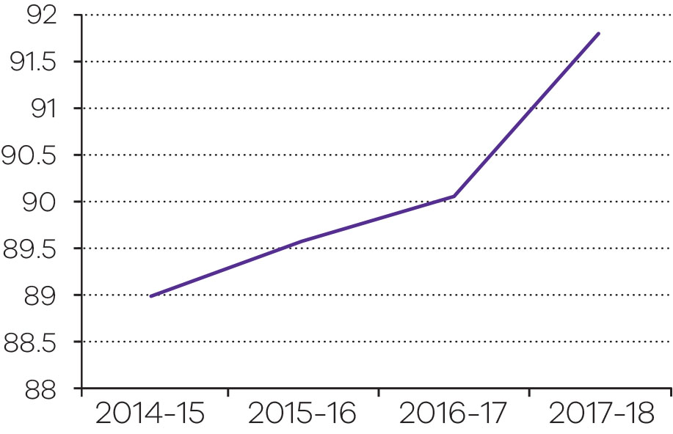
Objective indicator: Legal advice and assistance provided
In 2017–18, the demand for legal assistance provided by Victoria Legal Aid (VLA) continued to grow as a result of several factors, including an increasing community focus on family violence, the impact of bail and sentencing reforms and additional police and child protection officers.
VLA clients are increasingly presenting with more complex legal demands, which require more intensive forms of assistance through grants of legal aid.
Community demand for Legal Help telephone service continues to remain strong, and VLA has made operational changes to the service to meet this growing demand. In the past 12 months, Legal Help answered 135,193 calls, an increase of eight per cent compared to last year. Legal Help staff are spending more time on the phone with clients, to assist them with more complex problems, but operational improvements mean call waiting times have stabilised.
VLA has invested significant effort in reviewing and improving its services, including:
- the completion of a review of child protection legal aid services, and the implementation of its recommendations
- the successful rollout of a new online and referral booking tool (ORBIT), which has halved the time it takes for clients to access legal services
- operational changes at Legal Help to stabilise and improve performance so it can provide an expanded, contemporary and modernised service
- review of VLA’s means test eligibility criteria in order to provide greater access to legal services for those most in need
- ongoing support for the implementation of recommendations from the Royal Commission into Family Violence
- provision of services at the interim Night Court at Melbourne Magistrates’ Court.
All of these initiatives are focused on improving the efficiency and quality of services provided by VLA.
Legal advice and assistance provided 2013–14 to 2017–18
Unit of measure | 2014-15 | 2015-16 | 2016-17 | 2017-18
Number | 137,668 | 126,284 | 129,260 | 135,254

Output performance measures: Public prosecutions and legal assistance
This output delivers activities relating to Victoria’s public prosecutions service and VLA.
The OPP provides an independent, effective and efficient prosecutions service on behalf of the Director of Public Prosecutions. In addition to the prosecution of serious crimes, the OPP also provides professional support to prosecution witnesses and victims of crime involved in its cases.
VLA is an independent statutory authority which provides a range of legal services for both Victorian and Commonwealth law matters. These services include legal representation, legal advice and advocacy and education services.
Performance measures | Unit of measure | 2017-18 actual | 2017-18  target | Performance variation (%) | Result
Quantity
Judicial officer sitting days requiring  prosecutors – OPP | number | 12 227 | 10 500–12 500 | 0.0 | ✓
Number of briefs prepared and hearings attended (OPP) | number | 79 501 | 69 500–75 500 | 5.3 | ✓
The actual is above the target due to an increase in hearing volumes across all jurisdictions in both Melbourne and regional Victoria.
Number of victim and witness consultations (OPP) | number | 14 002 | 11 000–13 000 | 7.7 | ✓
The actual is above the target due to additional staff and improvements in the service delivery model in the OPP Witness Assistance Service.
Community Legal Education and Information Services – VLA – excluding family violence related services | number | 109 729 | 123 500–128 500 | -11.2 | ■
The actual is below the target due to the reprioritisation of resources away from less intensive services to meet the increased demand for intensive court-related services, particularly for duty lawyer services and grants of legal assistance in family violence.
Community Legal Education and Information Services – VLA –family violence related services | number | 25 525 | 11 500 | 122.0 | ✓
The actual is above the target due to an increased focus on family violence legal services and the implementation of new Family Advocacy and Support Services.
Duty lawyer services – excluding family violence related services (VLA) | number | 70 939 | 57 400–59 400 | 19.4 | ✓
The actual is above the target for this new measure due to a significant increase in demand for in-court duty lawyer services. This trend is expected to continue owing to an increase in the number of clients in remand and the implementation of bail review recommendations and sentencing reforms.
Grants of legal assistance provided by VLA – excluding family violence related services | number | 30 996 | 31 800 | -2.5 | ○
Legal advice and minor assistance for clients - excluding family violence related services (VLA) | number | 37 000 | 38 800 | -4.6 | ○
Family violence legal services (VLA) | number | 39 086 | 32 000 | 22.1 | ✓
The actual is above the target due to the increased focus on family violence legal services, including intensive services such as grants of legal assistance and duty lawyer services, along with improved recording of data.
Number of unique clients who accessed one or more of VLA’s legal services | number | 94 485 | 84 000 | 12.5 | ✓
The actual is above the target due to an increase in demand for duty lawyer services and grants of legal assistance in family violence and is consistent with the redirection of resources to more intensive assistance services.
Quality
Guilty outcomes (guilty pleas and trial convictions) as a percentage of case completions (OPP) | per cent | 91.8 | 87 | 5.5 | ✓
The actual is above the target due to an improved case decision making oversight mechanism implemented at the OPP, which brings forward issues for earlier resolution in the criminal prosecution process improving casework quality.
Timeliness
Proportion of trials listed which did not proceed to adjournment on application of the Crown (OPP) | per cent | 99 | 99 | 0.0 | ✓
Applications for legal aid processed within 15 days (VLA) | per cent | 93.7 | 95 | -1.4 | ○
Cost
Total output cost | $ million | 251.8 | 249.9 | 0.8 | ○
Note:
✓ Performance target achieved or exceeded.
○ Performance target not achieved – within 5 per cent variance.
■ Performance target not achieved – exceeds 5 per cent variance.
Output: Infringements and warrants
Fines Reform
On 1 July 2017, the Victorian Government introduced key social justice initiatives to provide more options for people suffering hardship to resolve their fines, including:
- the Work and Development Permit scheme which provides disadvantaged people with the non–financial option to ‘work off’ infringement fine debt under the supervision of a sponsor agency by participating in activities such as drug and alcohol counselling, unpaid voluntary work, life skills and vocational courses and mentoring programs (for those under the age of 25 years) offered through accredited providers and health practitioners
- the Family Violence Scheme which enables victim survivors to apply to have their fines withdrawn or placed on hold in circumstances where family violence substantially contributed to the offending conduct or the victim’s liability
- improvements to the Time Served Scheme which enables prisoners to be released from prison with a ‘clean slate’ with respect to infringement fine debt, supporting rehabilitation and reintegration into the community post-release, and reducing the possibility of re–imprisonment for fine-related debt.
On 31 December 2017, the Fines Reform Act 2014 commenced, establishing a new fines recovery model in Victoria and a new administrative body, Fines Victoria. Fines Victoria acts on behalf of the government and is a single, centralised point of contact for the public to pay or deal with their unpaid fines.
To support the new legislative framework and Fines Victoria, the department purchased a new IT solution known as the Victorian Infringement Enforcement and Warrants (VIEW) system. The VIEW system, when implementation is completed, will support the end–to–end management of the fines lifecycle.
Progress toward achieving this objective
Objective indicator: Infringement notices processed
In the 2017–18 financial year, 2.7 million infringement notices were issued. The road safety camera network continues to operate to support the government’s Towards Zero 2016–2020 Road Safety Strategy. Victoria’s road safety cameras play a critical role in keeping Victorian roads safe, helping to save lives and change driver behaviour across the state.
Road trauma costs the Victorian community more than $3 billion per year. Road safety cameras target speeding and red light offences, helping to ensure road users are doing the right thing so unnecessary deaths and life-changing injuries can be prevented.
Overall, infringements from road safety cameras declined by approximately 10 per cent when compared with 2016–17. This is primarily due to increased roadworks and the impact of the deactivation of road safety cameras following the WannaCry virus. In addition, toll road operators have increased their in-house collection activity, consequently reducing the number of matters referred to Victoria Police for the issue of an infringement.
The Road Safety Camera Commissioner conducted several investigations into the camera network during 2017–18, including the impact of a software virus on the road safety camera network. In July 2017, the Commissioner released an interim report which found that, in all instances, the network was operating correctly and detecting offences appropriately. In May 2018, the Commissioner made a number of recommendations to strengthen the oversight and governance of the road safety camera network. The department has committed to implementing all of the Commissioner’s recommendations.
Infringement notices processed 2014–15 to 2017–18
Unit of measure | 2014-15 | 2015-16 | 2016-17 | 2017-18
number (million) | 3.3 | 3.1 | 3.0 | 2.7

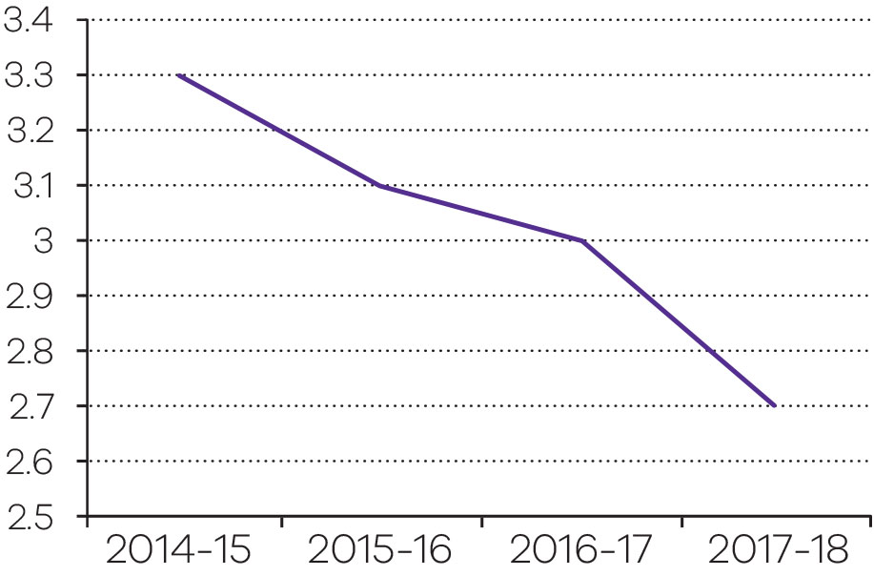

Output performance measures: Infringements and warrants
This output reports on activities relating to the management of traffic and other infringement notices, the confiscation of assets obtained through criminal activity and enforcement action by the Office of the Sheriff.
These activities serve as an administrative method for dealing with minor criminal offences, where a person alleged to have committed an offence has the option of paying a fixed penalty rather than going to court. The fixed penalty is intended to serve as a deterrent.
Performance measures | Unit of measure | 2017-18 actual | 2017-18 target | Performance variation (%) | Result
Quantity
Infringement notices processed | number (million) | 2.7 | 2.9–3.1 | -6.9 | ■
The actual is below the target as infringements notices processed were lower than anticipated due to increased roadworks and the impact of the deactivation of road safety cameras following the WannaCry virus. In addition, toll road operators have increased their collection activity, reducing the number of matters referred to Victoria Police for the issue of an infringement.
Warrants actioned | number | 349 768 | 995 000 | -64.9 | ■
The actual is below the target due to the transition to a new legislative scheme and IT system for fine enforcement on 31 December 2017. Since January 2018, Sheriff Officers have been performing limited enforcement activities while system functionality has been progressively implemented. A number of enforcement processes, including vehicle and driver licence sanctions, have been transferred to the Director, Fines Victoria. These new processes encourage people to pay and/or deal with their fines before they reach the warrant stage.
Quality
Prosecutable images | per cent | 97 | 93 | 4.3 | ✓
Timeliness
Clearance of infringements within 180 days | per cent | 69 | 75 | -8.0 | ■
As part of the transition to Fines Reform in December 2017, including the introduction of a new IT system for the fines system, some enforcement activity was reduced. It is anticipated that clearance rates will improve as enforcement activities increase throughout 2018.
(Please note; the actual provided reflects activity as at 31 March 2018. Data for April to June 2018 was not available at the time of reporting.)
Confiscated assets sold or destroyed within 90 days | per cent | 89 | 85 | 4.7 | ✓
Cost
Total output cost | $ million | 223.2 | 217.6 | 2.6 | ○
Note:
✓ Performance target achieved or exceeded.
○ Performance target not achieved – within 5 per cent variance.
■ Performance target not achieved – exceeds 5 per cent variance.
Output: Criminal law support and reform
Continue to deliver reforms to tackle family violence
The Royal Commission into Family Violence provided a once-in-a-generation opportunity to examine the family violence system from the ground up, and was tasked with finding solutions to prevent family violence, better support victim survivors and hold perpetrators to account.
The Royal Commission’s final report made 227 recommendations, 111 of which are being led by the department and justice entities, including courts and Victoria Police.
The department continues to implement these recommendations and strengthen the justice system’s response to family violence.
Legislative reform
Reforms contained in the Family Violence Protection Amendment Act 2017 commenced during 2017–18 as the necessary implementation tasks, such as training and infrastructure, were completed. The amendments reformed the operation of Family Violence Intervention Orders (FVIO) and Family Violence Safety Notices (FVSN).
In June 2018, the Justice Legislation Amendment (Family Violence Protection and Other Matters) Bill 2018 was introduced into Parliament and received Royal Assent on 14 August 2017. The Act:
- allows for a recorded statement taken by police at family violence incidents to be used as evidence in court (being trialled at Epping and Ballarat sites)
- enables victim survivors to file FVIO applications online by making a formal declaration of truth
- allows courts to make interim FVIOs on their own motion at any point during the criminal process, such as during bail hearings, committal hearings, during a trial, at sentencing, and on appeal
- expands the examples of family violence set out in the Family Violence Protection Act 2008 to include dowry–related abuse and forced marriage.
The National Domestic Violence Order Scheme Act 2016 provides for a national recognition scheme for Victorian FVIO, FVSN and Domestic Violence Orders made in other Australian states and territories, and New Zealand. On 25 November 2017, the National Domestic Violence Order Scheme Act commenced operation together with the equivalent legislation in other states and the territories.
Family violence reform—legal assistance
The department has continued to improve access to justice for victim survivors of family violence and to strengthen legal advice available to perpetrators in order to reduce their likelihood of reoffending. Funding to support family violence reform has included a $9.032 million boost to Victorian CLCs. This has been made available through:
- $3.505 million allocated to 33 CLCs under the Community Legal Centre Family Violence Fund to help provide support to family violence victims and improved access to legal services.
- $3.417 million allocated to 33 CLCs under the Community Legal Centre Assistance Fund to support critical programs and free legal services for vulnerable Victorians who cannot afford a lawyer.
- $2.110 million allocated to 20 CLCs under the Family Violence Duty Lawyer Fund to provide specialist family violence duty lawyers in Magistrates’ Courts.
For further information about access to justice refer to page 70.
Family violence perpetrator interventions to be trialled across the justice system
Work to improve the justice portfolio response to perpetrators has included:
- case management and support packages for family violence perpetrators in the community to address perpetrators with complex needs
- court based initiatives to address lesbian, gay, bisexual, trans and gender diverse, and intersex (LGBTI) perpetrators and perpetrators with complex needs
- family violence practitioners in the Children’s Court
- a grants program for the development of innovative perpetrator interventions with five grants totalling $1.75 million provided to community service organisations.
Continue to reform the family violence response in the corrections system
The department, through Corrections Victoria, has undertaken a number of activities over the last 12 months including:
- reviewing current processes for identifying female offenders at risk of, or with a history of, family violence and responding through therapeutic interventions and education programs
- increasing the number of women receiving family violence and sexual assault counselling, as well as expanding services for specialist trauma counselling to women exiting prison from remand or being supervised by CCS post–release
- undertaking a successful CCS pilot, Beyond the Violence in CCS – an eight week program that enables women to voice their experiences of family violence and the impact on them and their children
- completing work to identify service needs of culturally and linguistically diverse victims
- participating in the 18 Risk Assessment Management Panels across Victoria.
For further information about the corrections system refer to page 28.
Specialist counsellors for family violence victim survivors to achieve financial recovery
The 2017–18 State Budget provided $6 million over four years, for a specialist family violence financial counselling service. The funding provides for 10.6 fulltime equivalent family violence financial counsellors and a part time social worker. These specialist staff have serviced more than 3,550 clients since October 2016.
This specialist service is an extension of CAV’s existing Financial Counselling Program. The program provides free, independent and confidential telephone or face–to–face counselling sessions delivered by community agencies across Victoria. Over 33,000 Victorians were assisted with financial counselling in 2017–18.
The 2017–18 State Budget funding also allowed the delivery of family violence training to almost 200 financial counsellors across Victoria, lifting the whole sector’s ability to assist the recovery of victims of economic abuse.
Swift, certain and fair approaches to sentencing family violence offenders
In October 2017, the Sentencing Advisory Council (SAC) provided advice on the desirability of swift and certain approaches to family violence offenders within Victoria’s sentencing regime in response to a request from the Attorney–General.
The Magistrates’ Court has commenced a pilot program trialling the use of swift and certain concepts in the listing of charges of contravening a CCO made in relation to a family violence offence or sexual offence.
The government will consider the outcomes of this pilot program when responding to recommendations from the SAC’s report.
Providing more support for Aboriginal Victorians at risk of family violence
The 2017–18 State Budget provided $26.48 million to support a number of Aboriginal community–led initiatives for family violence prevention and response. Some of these initiatives are detailed below.
The Koori Women’s Place
The Koori Women’s Place (KWP) is a two–year pilot program by Djirra, an Aboriginal community controlled organisation that provides a culturally safe family violence service for Aboriginal women victim survivors and their children. This program received $1.13 million in funding in the 2017–18 State Budget.
The KWP commenced in February 2018 and provides Aboriginal women victim survivors of family violence and their children trauma-informed wrap-around case management support and a single-entry coordination point to local family and children’s services. Between February and May 2018, the KWP supported 21 clients and their families and delivered 11 workshops.
Culturally appropriate legal services
The 2017–18 State Budget provided $11 million for sustainable state–wide culturally appropriate legal services that are delivered by two Aboriginal community controlled legal services (Djirra and Victorian Aboriginal Legal Service) so that both parties to a matter can access culturally safe legal representation.
Community–led family violence prevention and early intervention
The 2017–18 State Budget provided $4.29 million (and $1.43 million ongoing) for Aboriginal and Torres Strait Islander women to have the opportunity to participate in Djirra’s family violence prevention and early intervention initiatives including:
- Sister’s Day Out, a one–day workshop to promote women’s safety by reducing social isolation, facilitating community networks and strong cultural connections, and raising awareness about the causes and impacts of family violence.
- Dilly Bag, a three to four day intensive personal development workshop to reduce vulnerability to family violence and enhance Koori women’s capacity to take on a leadership role in family violence prevention.
- Young Luv, a culturally safe space for Koori women between the ages of 13 and 18 to explore the dynamics of healthy relationships, safe dating and online safety, and to recognise and know what to do when faced with dangerous behaviours or unsafe situations.
Ngarra Jarranounith Place
Ngarra Jarranounith Place is an intensive residential behaviour change program for Aboriginal male perpetrators of family violence. The program is delivered by Dardi Munwurro, an Aboriginal community controlled organisation with expertise in culturally safe programs for Aboriginal men. It is a 16-week residential program with a focus on healing, positive parenting, life skills and post release support. Ngarra Jarranounith receives referrals from the justice system and Aboriginal community controlled organisations. The program was launched in November 2017 and has the capacity to support up to 24 men a year. In January 2018, the first intake of Aboriginal men commenced the program.
Reform following the review into Victoria’s bail system
Following the Bourke Street tragedy in January 2017, the government asked former Supreme Court Judge and Director of Public Prosecutions, the Hon Paul Coghlan QC, to urgently review Victoria’s bail system.
The Bail Review focused on legislative and practical reforms to manage risk and maximise community safety.
Implementation of recommendations
The government has implemented 22 of the 37 recommendations made by Mr Coghlan in his first and second advice to government published in May 2017.
Twelve of the remaining Bail Review recommendations are complex for justice agencies and include:
- reviewing and reforming summary crime processes
- changes to the police database to obtain real-time information on bail from the courts database
- additional training for bail justices
- assessing the feasibility of audio visual capability for after-hours bail applications from police stations.
Extensive consultations by government with stakeholder groups such as the courts, Corrections Victoria, VLA and Victoria Police have allowed more careful consideration of other recommendations such as the legal test allowing the Director of Public Prosecutions to appeal bail decisions to the higher courts.
Three outstanding recommendations relating to recording and storing bail justice hearings, rewriting the Bail Act 1977 and providing police the ability to seek a stay of a bail justice decision are also being further considered as part of ongoing implementation with stakeholders.
Legislative change
Two pieces of amending legislation were delivered in 2017–18 to implement 22 recommendations of the Bail Review.
The Bail Amendment (Stage One) Act 2017 makes it harder for people to get bail for a much broader range of serious violent and serious sexual offences including rape, armed robbery, aggravated home invasion and aggravated carjacking.
People who commit serious offences whilst on bail, summons, parole or undergoing a sentence also need to show reasons as to why they should be granted bail again.
The Bail Amendment (Stage Two) Act 2018 gives a police officer of, or above, the rank of sergeant the power to remand accused people in custody for up to 48 hours, and require that only a court can grant bail to certain serious repeat offenders. This Act also restricts the role of bail justices to making bail decisions in relation to Aboriginal people, children and vulnerable adults.
The majority of the Stage One Act commenced on 21 May 2018 with the remainder commencing on 1 July 2018. All of the Stage Two Act commenced on 1 July 2018.
The department continues to work with affected stakeholders on the implementation of these extensive reforms to the bail and remand system.
Bail and Remand Court
The Bail Review recommended that the Magistrates’ Court establish a statewide Bail and Remand Court.
The government has invested $72.4 million over five years for a Bail and Remand Court which commenced operation on 30 April 2018. This partially progresses the Bail Review recommendation 29.
The Bail and Remand Court operates from 9.00am to 10.00pm daily.
Establish a standard sentence scheme
The government established a standard sentence scheme in 2017. The Sentencing Amendment (Sentencing Standards) Act 2017 repealed the baseline sentencing provisions and introduced a standard sentence scheme. The standard sentence scheme commenced on 2 February 2018.
The scheme applies to 12 of the most serious offences, including murder, rape and sexual offences involving children.
A standard sentence of 40 per cent of the maximum penalty is now legislated and must be taken into account in sentencing. For example, the maximum sentence for rape is 25 years imprisonment, and the standard sentence is 10 years imprisonment. A court is required to provide reasons for how the sentence imposed relates to the standard sentence.
Enhance guideline judgments
The Sentencing Amendment (Sentencing Standards) Act also enhanced the guideline judgment scheme by allowing the Attorney–General to apply for a guideline judgment to address identified broad and systemic issues where it is in public interest. Guideline judgments allow the Court of Appeal to provide broad sentencing guidance to courts and are mechanisms to promote greater consistency in sentencing.
The changes to the guideline judgment scheme allow the Court of Appeal to include numerical guidance on sentencing ranges and, in doing so, influence current sentencing practices.
The enhancements to the guideline judgment scheme commenced on 2 February 2018.
Work with the Sentencing Advisory Council to ensure sentencing meets community expectations
In 2017, the government announced plans to establish an independent sentencing guidelines council to develop sentencing guidelines for the courts, having regard to the views of the Victorian community, judiciary and legal stakeholders.
The SAC consulted with the community, justice stakeholders and the judiciary on features and model for a Victorian sentencing guidelines council. The SAC provided its advice to government in March 2018.
The government has been considering this advice. Ongoing discussions with the judiciary have continued to determine exactly how a Victorian sentencing guidelines council could operate to ensure it effectively provides comprehensive and methodical guidance to sentencing courts.
Expungement of historical convictions for homosexual activity
Victoria has a scheme to expunge historical convictions for homosexual activity that would not be a criminal offence today. Under the scheme, an individual (or the appropriate representative of a deceased person) can make a confidential application to the Secretary of the department to have their conviction or finding of guilt for an historical homosexual offence expunged.
A person with an expunged conviction may legally claim not to have been convicted or found guilty of that offence; is not required to disclose that conviction or finding of guilt for any purpose; and cannot be denied a job or position due to that conviction or finding of guilt. The historical conviction will no longer show up on a police records check.
In 2017–18, there were 5 successful applications for expungement.
Consider the criminal justice system response to offenders who are unfit to plead or not guilty by reason of mental impairment
The department continues to develop policy options and consult with stakeholders in relation to improving the criminal justice system’s response to offenders who are unfit to plead or not guilty by reason of mental impairment.
Develop new models of therapeutic justice
The department continues to review successful court interventions (including the Drug Court, Assessment and Referral Court List, and the Court Integrated Services Program) to develop a model of integrated therapeutic approaches that can be more widely used in the court system.
Funding of $1.1 million over two years was provided in the 2018–19 State Budget to develop a comprehensive model in collaboration with justice and health partners. The department has commenced initial consultations to develop such a model.
Implementing Betrayal of Trust recommendations
The department has been implementing the remaining recommendations of the Family and Community Development Committee Inquiry into the Handling of Child Abuse by Religious and Other Non-Government Organisations ‘Betrayal of Trust’ Final Report (Betrayal of Trust), which are due to be completed by the end of 2018.
The Legal Identity of Defendants (Organisational Child Abuse) Act 2018 responds to recommendation 26.1 and received Royal Assent on 5 June 2018. The Act overcomes the issues faced by child abuse plaintiffs who wish to sue unincorporated non–government organisations (NGO) that control and use trusts to conduct their activities. In these circumstances, the Act requires the NGO to nominate an entity that is capable of being sued to act as a proper defendant. If the NGO does not do so, the trustees of an associated trust can become the proper defendants in the proceedings on behalf of the NGO, and incur any liability which arises from the proceeding.

Commonwealth Royal Commission into Institutional Responses to Child Sexual Abuse
On 15 December 2017, the Commonwealth Royal Commission into Institutional Responses to Child Sexual Abuse published its final report.
The final report made 409 recommendations, 189 of which were new recommendations. The remaining 220 recommendations were included in three previous reports: Working With Children Checks (2015); Redress and Civil Litigation (2015); and Criminal Justice (2017). A total of 320 recommendations apply to the State of Victoria.
The Victorian Government responded to this final report on 11 July 2018. The government has accepted or accepted in principle 293 recommendations, is considering a further 24 recommendations and has noted 92 recommendations that do not apply to Victoria.
The department will coordinate the implementation of recommendations across the Victorian Government, including the preparation of annual reports on the progress of implementation.
National Redress Scheme
On 9 March 2018, the Victorian Government announced its in–principle agreement to join the National Redress Scheme (the Scheme) for survivors of institutional child sexual abuse.
On 8 May 2018, the government introduced the National Redress Scheme for Institutional Child Sexual Abuse (Commonwealth Powers) Bill 2018 into the Parliament of Victoria. The Bill refers the necessary powers to the Commonwealth Parliament in order to enable Victorian state and non-government institutions to participate in the Scheme.
The Scheme commenced on 1 July 2018, and will provide critical support to survivors who have suffered child abuse in institutional settings, including access to a monetary payment, counselling and/or a direct personal response.
Working with Children Check
The WWC Check assists in protecting children from sexual or physical harm by ensuring that people who work with, or care for, children are subject to a screening process. The WWC Check scheme is part of a wider suite of government activities aimed at reducing harm to children.
Amendments introduced on 1 August 2017 implement key recommendations from the Royal Commission into Institutional Responses to Child Sexual Abuse to help keep children safe from harm. The key changes include:
- the removal of references to ‘supervision’ from the Working with Children Act 2005 to ensure that a WWC Check is required regardless of whether the child–related work is being supervised or not
- the expansion of the definition of ‘direct contact’ in the Working with Children Act to include oral, written or electronic communication in addition to face–to–face and physical contact.
The WWC Check has earned strong community support with over 2.6 million applications having been processed since the establishment of the scheme in April 2006. Since 2006, 4090 people have been issued a negative notice, thereby preventing them from working with children.
The number of new applications received annually has been rising steadily since the scheme was fully implemented in 2010–11. In 2017–18, the WWC Check Unit processed 458,114 applications, an increase of approximately 43 per cent on the number lodged in 2016–17.
Child Safe Standards and Reportable Conduct Scheme
The Child Safe Standards and Reportable Conduct Scheme commenced on 1 July 2017. The Child Safe Standards are compulsory for all entities that provide services or facilities to children and are designed to assist entities to prevent child abuse, encourage the reporting of abuse and improve responses to allegations of child abuse. The Reportable Conduct Scheme requires the department to respond to allegations of child abuse (and other child-related misconduct) made against staff and volunteers and to notify the Commission for Children and Young People of those allegations.
In 2017–18, the department embedded policies and processes to respond to allegations of reportable conduct under the Reportable Conduct Scheme and commenced reporting allegations to the Commission for Children and Young People. In addition, the department has increased awareness of the Child Safe Standards and the Reportable Conduct Scheme across the department through its internal communication and learning and development activities; regularly engaged with the Commission for Children and Young People on compliance with the Child Safe Standards and its role as a relevant authority; and engaged with other departments through an interdepartmental community of practice on the Child Safe Standards.
National Disability Insurance Scheme
The department completed the second year of transition to the NDIS focusing on the NDIS interface with the criminal justice system and contributing to the Commonwealth’s quality and safeguarding measures for NDIS providers.
The department progressed arrangements for the continued provision of disability supports to people with disability in the justice system transitioning to the NDIS.
A project was completed that identified service delivery gaps in the correctional services and youth justice systems, undertook a cost benefit analysis of justice plans and plans of service and made recommendations on their use in a range of future criminal justice service models that could operate in conjunction with the NDIS once it is fully established.
A further project commenced to develop policy options for the design and delivery of other forensic disability supports, which remain the responsibility of the Victorian Government to manage the offending risk of some people with disabilities. This work will inform an effective and sustainable forensic disability system post–NDIS implementation.
Agreement was reached on a federated model of NDIS worker screening, where the Commonwealth has broad design responsibility and states and territories will have operational responsibility for conducting the worker screening and for recognising each other’s checks. Significant work was undertaken to finalise the national agreement, develop worker screening standards and protocols for exchange of information and contribute to the development of the Commonwealth legislation.
Progress toward achieving this objective
Objective indicator: Clinical forensic medical services provided
Clinical forensic medical services include examinations of victims of crime and alleged perpetrators and the provision of expert reports to the Courts, Victoria Police, legal and medical practitioners and private and public agencies. These services are provided by clinicians working either exclusively in the field of clinical forensic medicine, or in other medical specialties including general practice.
Since 2014-15, there has been an increase of over 19 per cent in the number of clinical forensic medical services provided by the Victorian Institute of Forensic Medicine (VIFM). This increase can be explained by the incidence of drug and alcohol use in the community, as well as demographic and age related changes in the Victorian population. The increase in demand could also be caused by heightened community awareness of family violence and sexual assault, which has seen an increase in reporting of these incidents to Victoria Police.
Implementation of the recommendations arising from the Royal Commission into Family Violence and the policies and practices put in place by referring agencies, such as Victoria Police, as well as the scope of services provided by VIFM, may continue to influence this trend into the future.
Clinical forensic medical services provided 2014–15 to 2017–18
Unit of measure | 2014-15 | 2015-16 | 2016-17 | 2017-18
number | 2,269 | 2,483 | 2,431 | 2,711

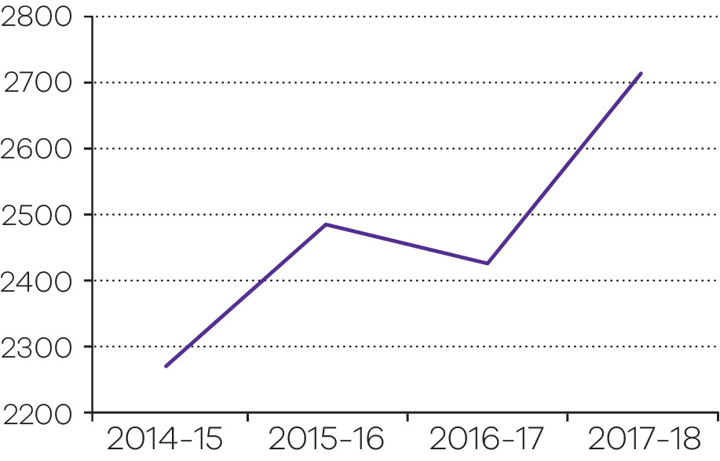
Objective indicator: Law reform projects completed
The functions of the Victorian Law Reform Commission (VLRC) are set out in the Victorian Law Reform Commission Act 2000. The VLRC’s primary function is ‘to examine, report and make recommendations to the Attorney-General on any proposal or matter relating to law reform in Victoria that is referred to the Commission by the Attorney-General’. In addition, the Commission’s community law reform role is ‘to examine, report and make recommendations to the Attorney-General on any matter that the Commission considers raises relatively minor legal issues that are of general community concern’.
Reports to the Attorney-General regarding both these purposes contain recommendations that aim to improve and modernise the law, making it more relevant and effective.
In 2017–18, the VLRC completed four law reform projects.
Primary publications included:
- Attorney-General references:
- Access to Justice – Litigation Funding and Group Proceedings – a report was tabled in Parliament in June 2018.
- Final publications included three consultation papers:
- Access to Justice – Litigation Funding and Group Proceedings – a consultation paper was published in July 2017
- Victims of Crime Assistance Act – Supplementary Consultation Paper – a supplementary consultation paper was published in September 2017 following the receipt of supplementary terms of reference in July 2017
- Neighbourhood Tree Disputes – a community law reform project – a consultation paper was published in December 2017.
The number of projects, their size and reporting deadlines are matters largely outside the control of the VLRC and are a function of the Attorney-General’s requirements, rather than being at VLRC’s discretion.

While the community law reform role is at the discretion of the VLRC, this outreach function is limited by the requirement in the Victorian Law Reform Commission Act (s.5(1)(b)) that such projects ‘not require a significant deployment of the resources available to the Commission’.
Law reform projects completed 2014–15 to 2017–18
Unit of measure | 2014-15 | 2015-16 | 2016-17 | 2017-18
number | 61 | 4 | 5 | 4

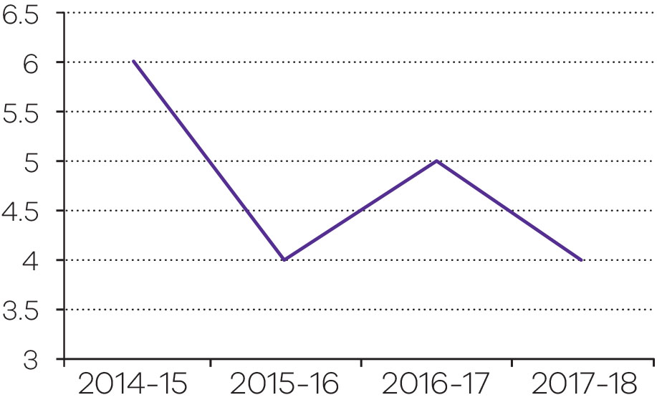
Objective indicator: Number of Sentencing Advisory Council publications
The key statutory functions of the SAC are to provide statistical information on sentencing, including information on current sentencing practices and to conduct research and disseminate information on sentencing matters. The SAC publishes a range of reports on sentencing matters to fulfil these functions.
Publications in 2017–18 included:
- Contravention of Community Corrections Orders
- Secondary Offences in Victoria
- Swift, Certain and Fair Approaches to Sentencing of Family Violence Offenders – Final Report
- A Sentencing Guidelines Council for Victoria: Issues Paper
- Theft: Sentencing Outcomes in the Magistrates’ Court
- A Quick Guide to Sentencing (4th ed.)
- Restitution and Compensation Orders – Issues and Options Paper
- Serious Offending by People Serving a Community Corrections Order: 2016-17
- A Sentencing Guidelines Council for Victoria – Final Report
- Trends in Minor Drug Offences Sentenced in the Magistrates’ Court of Victoria.
The Council exceeded its Budget Paper 3 measure of six publications in 2017-18, in part, because the Council’s three overlapping references from the Attorney-General did not require extensive data analysis. Consistent with the Council’s 2017-18 Business Plan, the Council’s data analysts instead prepared several short publications with a narrow statistical focus.
Number of Sentencing Advisory Council publications 2014–15 to 2017–18
Unit of measure | 2014-15 | 2015-16 | 2016-17 | 2017-18
number | N/A* | N/A* | 6 | 10
*This is a new objective indicator, introduced in the 2016–17 State Budget.
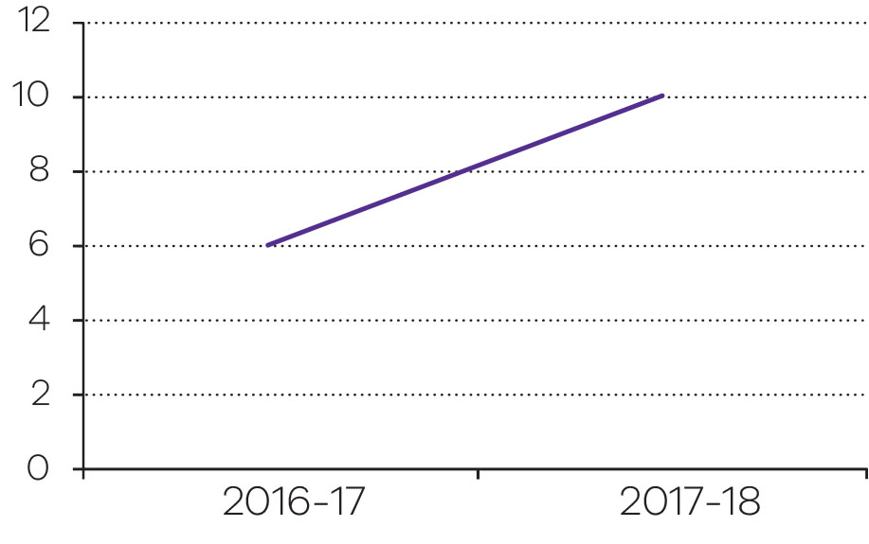
Output performance measures: Criminal law support and reform
This output delivers a broad range of services such as the provision of law reform and sentencing advisory information, access to justice and support services for the Victorian community, including forensic medical and scientific services and medico-legal advice.
Performance measures | Unit of measure | 2017-18 actual | 2017-18 target | Performance variation (%) | Result
Quantity
Clinical forensic medical services by the Victorian Institute of Forensic Medicine (VIFM) | number | 2 711 | 2 100–2 500 | 8.4 | ✓
Demand for this measure is driven by Victoria Police. The actual is above the target due to an increase in the number of cases seen by police, with a flow-on effect on clinical forensic services.
Medico-legal death investigations (VIFM) | number | 6 405 | 5 800–6 200 | 3.3 | ✓
Provision of expert forensic medical and scientific evidence in court (VIFM) | number | 197 | 150–250 | 0.0 | ✓
Community education and consultation sessions conducted by Victorian Law Reform Commission (VLRC) | number | 55 | 100 | -45.0 | ■
The actual is below the target due to a significant change in the 2018 Victorian Certificate of Education Legal Studies curriculum with the school based education sessions rescheduled to the latter half of the 2018 calendar year. This information was not available when setting the BP3 targets.
Law reform projects conducted by VLRC | number | 4 | 3 | 33.3 | ✓
The actual is above the target due to supplementary terms of reference received in July 2017 for the Commission Reference on the Review Victims of Crime Assistance Act 1996, which required the production of an additional supplementary consultation paper.
Number of Sentencing Advisory Council (SAC) publications | number | 10 | 6 | 66.7 | ✓
The actual is above the target due to the SAC preparing several short publications with a narrower statistical focus.
Quality
Audited medico-legal death investigation reports with no significant diagnostic errors (VIFM) | per cent | 99 | 95 | 4.2 | ✓
Teachers and students who are satisfied with education programs delivered by VLRC | per cent | 0 | 85 | -100 | ■
The actual is below the target as the relevant education sessions, on which the survey is based, have not been held in the 2017-18 financial year. The VLRC’s school sessions have been rescheduled to the latter half of the 2018 calendar year.
Timeliness
Medical and scientific investigations on the body of the deceased completed within two days (VIFM) | per cent | 79 | 75–85 | 0.0 | ✓
Medico-legal death investigation reports issued within agreed period (VIFM) | per cent | 68 | 60–70 | 0.0 | ✓
Cost
Total output cost | $ million | 82.8 | 66.2 | 25.1 | ■
The actual result is higher than the target mainly due to additional funding for the Victorian Institute of Forensic Medicine and the implementation of Family Violence initiatives. In addition, there were increased costs due to increasing demands on the Criminal Justice System and the delivery of the Attorney-General’s significant legislative program.
Note:
✓ Performance target achieved or exceeded.
○ Performance target not achieved – within 5 per cent variance.
■ Performance target not achieved – exceeds 5 per cent variance.
Output: Victims and community support services
Increase support for victims of crime
In 2017–18, the department developed a number of legislative and policy reforms that improve processes and reduce trauma for victims, including:
- amending the Victims of Crime Assistance Act 1996 to remove the time limit of two years for applications in relation to child abuse
- amending the Sentencing Act 1991 to prevent a court from taking into account an offender’s prior good character in sentencing for a child sex offence if that fact assisted the offender to commit the offence
- removing Children’s Court publication restrictions to allow adult victims of juvenile offenders to share their stories publicly.

Work has started on the development of other proposed legislative reforms arising from the VLRC Victims of Crime in the Criminal Trial Process report including:
- amending the Victims’ Charter to better communicate and meet the needs of victims before, during and after the criminal trial process
- creating a new role for the Victims of Crime Commissioner to improve the management of complaints
- providing clarity for the admission of Victim Impact Statements in criminal proceedings.
In 2017–18, the department has developed two pilot programs to assist victims:
- A family violence restorative justice service, which will allow family violence victims to participate in facilitated processes where they can talk about their experiences and play an active role in decision making. The service is scheduled to commence in 2018.
- An intermediaries’ scheme — Intermediaries are skilled communication specialists, who are neutral officers of the court, available to assist vulnerable witnesses to give their best evidence. This involves helping communication with the witness and assisting the witness to give evidence to police and in court. Legislation has been developed to underpin the operation of the scheme. The service commenced in mid–2018.
In 2017–18, the following was undertaken to continue to improve services for victims:
- A preliminary analysis of the need to improve digital engagement with victims of crime, which will inform the development of a three year strategy.
- Consultation with police and other agencies has occurred to review protocols for referrals of male victims of family violence to the Victims of Crime Helpline (the Helpline).
- Four additional Aboriginal Victims Assistance Program workers were recruited across Hume, Barwon South West and Loddon Mallee. These positions will improve access to the justice system for Aboriginal victims of crime, facilitate access to mainstream services for Aboriginal victims and increase the cultural competency of the victim support sector to respond appropriately to Aboriginal victims.
In mid–2017, the SAC was asked to review how restitution and compensation orders work.
The government has also asked the VLRC to review the effectiveness of the Victims of Crime Assistance Act and the Victims of Crime Assistance Tribunal for family violence victims. In 2017–18, this review was extended to cover all victims of crime.
Both reviews are due to be completed in the first half of the 2018–19 financial year.
Progress toward achieving this objective
Objective indicator: Services provided to victims of crime against the person
There are a range of programs in place which provide services to victims of crime against the person.
The Victims Support Agency (VSA) operates a telephone advice and referral service, the Victims of Crime Helpline (the Helpline). Helpline staff refer eligible victims and their families to case management services through the department funded state-wide Victims Assistance Program (VAP). The Helpline operates 8am-11pm, seven days a week.
The VAP provides case management services including practical support to victims such as urgent accommodation and transport, food vouchers, childcare, access to legal advice and court support to assist in their recovery.
The 2017–18 State Budget allocated funding for Victims Services for the delivery of VAP services and the Helpline. In addition, one off funding was provided to victims services via a Treasurer’s Advance to meet the surge in demand following the Bourke Street incident in January 2017.
The department and Victoria Police continue to support a service model to co-locate victim support case managers at designated police stations across Victoria. There are 29 co-locations across Victoria, as well as a dedicated service at the Spencer Street Police Complex, which supports Crime Command investigating serious crimes, such as homicide, armed crime and sex crimes and a dedicated service at the Major Collision Investigation Group (MCIG), to support victims and families of the most serious road-related offences (culpable driving, dangerous driving causing serious injury or death).
The 2017-18 State Budget also allocated funding to recruit, train and employ Aboriginal VAP workers to provide specialised support to Aboriginal victims of crime against the person, including family violence. The positions are intended to improve cultural competency of the victim support sector, improve access to the criminal justice system and facilitate referral to mainstream services for Aboriginal victims. Four staff have been recruited in 2017-18. This will build to nine staff by 2021.
As a result of the state-wide rollout of the Victoria Police e-Referral system (VPeR) in October 2014, the Helpline receives referrals for male and female victims of crime against the person (non-family violence) directly. The Helpline receives electronic referrals to support ‘male victims of family violence’ (L17) from police. In 2017–18, the VSA received 14,362 e-referrals for male victims of family violence (L17), 8,404 electronic referrals for crimes against the person (VPeR) and a total of 11,556 inbound calls which is consistent with the referral trend for Helpline across all referral sources in 2016-17.

Services provided to victims of crime against the person 2014–15 to 2017–18
Unit of measure | 2014-15 | 2015-16 | 2016-17 | 2017-18
number | 24,950 | 34,421 | 42,672 | 38,181

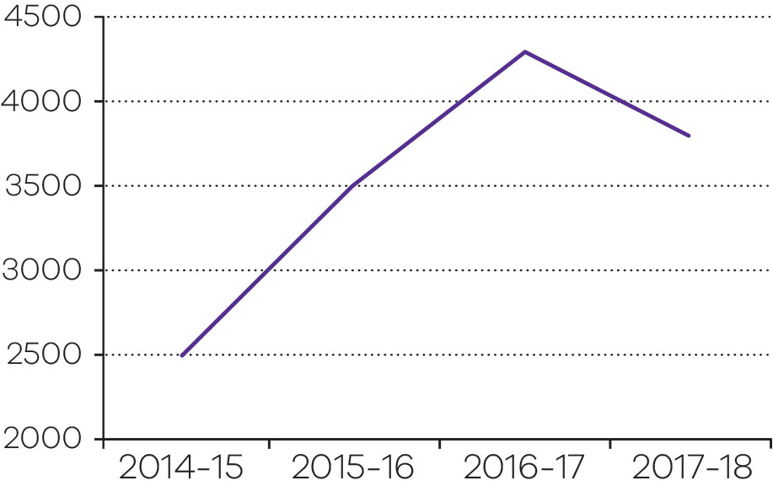
Objective indicator: Working with Children Checks processed (negative notices issued within three days of receiving decision)
In the period between 1 July 2017 and 30 June 2018, the WWC Check unit processed 458,000 applications, an increase of 43 per cent on the number lodged in the period 1 July 2016 to 30 June 2017 (320,000). The increase is due to the commencement of the Child Safe Standards (Phase 2) on 1 January 2017, and amendments introduced on 1 August 2017 implementing key recommendations from the Royal Commission into Institutional Responses to Child Sexual Abuse, to help keep children safe from harm.
The increase in applications will continue to put pressure on existing resources required to administer the scheme.
Over the last four years the WWC Check unit has issued the following numbers of negative notices:
- 2014-15 406
- 2015-16 472
- 2016-17 611
- 2017-18 768
The WWC Check unit continues to meet requirements to issue these negative notices within three days of receiving decision.
Working with Children Checks processed – (negative notices issued within three days of receiving decision)
Unit of measure | 2014-15 | 2015-16 | 2016-17 | 2017-18
per cent | 100 | 100 | 100 | 99.9

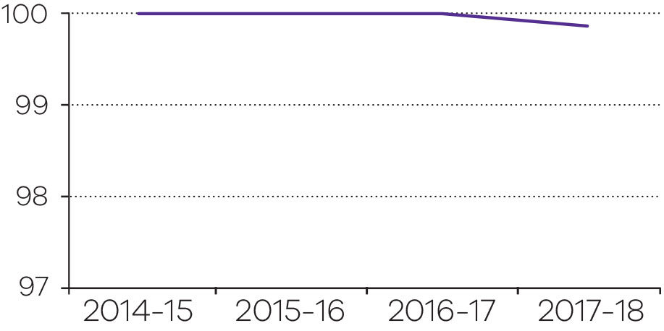

Output performance measures: Victims and community support services
This output delivers programs that focus on victims and community support services.
The WWC Check Unit, through the administration of the Working with Children Act, aims to reduce the incidence of sexual and physical offences against children by only allowing Victorian adults who pass the working with children check to work with children.
The VSA is responsible for coordinating a whole of government approach to services for victims of crime against the person and for representing the voice of victims within the justice system. It provides practical assistance to help victims recover from the effects of crime and is pivotal in linking the service system.
Consistent with Victoria’s commitment to the AJA, other initiatives undertaken focus on crime prevention and reducing reoffending of Koories in the criminal justice system.
Performance measures | Unit of measure | 2017-18 actual | 2017-18 target | Performance variation (%) | Result
Quantity
Victims receiving a service from the Victims of Crime Helpline, Victims Register, Youth Justice Group Conferencing, and Victims Support (VSA) | number | 25 163 | 17 600 | 43.0 | ✓
The actual is above the target due to strong demand for Male Family Violence referrals, strong levels of VPeR e-referrals from Victoria Police and an overall increase in some violent crime continuing to drive the increase in service delivery.
Victims receiving a service from the Victims Assistance Program (VSA) | number | 13 018 | 12 400 | 5.0 | ✓
The actual is above target, reflecting the flow on impact of additional Victims Assistance Program (VAP) funding for case management services. In addition, the result is partially due to an increased demand flowing from the increase in rates of violent crime types, direct access to services at 29 Police Stations, and Bourke Street Incident and Flinders Street Incident related activity.
Diversion initiatives established to support the Koorie community | number | 39 | 35 | 11.4 | ✓
As a result of the 2017-18 Victorian Budget, Family Violence Investment Package, several new initiatives have been established to progress the Royal Commission into Family Violence recommendations including prevention, legal services, perpetrator and victim support programs.
Number of Working with Children Checks processed | number (000) | 458 | 200–250 | 83.2 | ✓
The actual is above the target due to the implementation of Child Safe Standards (Phase 2) on 1 January 2017, which continues to result in the higher than expected number of checks processed. As a result of Child Safe Standards, many organisations have updated their policies to require all individuals to obtain WWC checks, regardless of legal requirements.
Changes to the Working with Children Act 2005 on 1 August 2017 to implement a number of Royal Commission recommendations have likely contributed to the increase in applications.
Quality
Working with Children Checks: Assessment issued within three days of receiving CrimTrac clear notification | per cent | 100 | 98 | 2.0 | ✓
Working with Children Checks: Negative notices issued within three days of receiving the delegate’s decision | per cent | 99.9 | 100 | -0.1 | ○
Cost
Total output cost | $ million | 74.6 | 55.1 | 35.4 | ■
The actual result is higher than the target reflecting additional funding support for the Working With Children Check scheme, and the flow-on impacts of the government’s response to the Bourke Street and Flinders Street incidents.
Note:
✓ Performance target achieved or exceeded.
○ Performance target not achieved – within 5 per cent variance.
■ Performance target not achieved – exceeds 5 per cent variance.

A fair and accessible civil justice system that supports a just society with increased confidence and equality in the Victorian community
This objective aims to support the Victorian community through the provision of services relating to: rights and equal opportunity; life–event registration and identity protection; and advocacy and guardianship for Victorians with a disability or mental illness.
In 2017–18, the department reported progress against this objective using the following objective indicators and outputs.
Objective indicators
- Complaint files received and handled by the Victorian Equal Opportunity and Human Rights Commission (VEOHRC)
- People assisted through Public Advocate advice and education activities
- Births, deaths and marriages registration transaction accuracy rate
- Dispute resolution services provided by the Dispute Settlement Centre of Victoria (DSCV)
Outputs
- Protection of Personal Identity and Individual / Community Rights
- Dispute Resolution and Civil Justice Support Services
Output: Protection of personal identity and individual/community rights
Negotiate agreements with traditional owners under the Traditional Owner Settlement Act 2010
The Victorian Government’s preferred approach to native title claims made under the Native Title Act 1993 (Cth) is to settle claims out of court using the Traditional Owner Settlement Act 2010 (Vic). Agreements under the Traditional Owner Settlement Act recognise the identity and rights of Aboriginal traditional owner groups that have a traditional and cultural association to particular parts of Victoria. The agreements provide funding, land grants and procedural rights over future uses of Crown land, together with a range of measures to strengthen traditional owner groups’ economic, social and cultural outcomes.
In 2017–18 the government and the Taungurung traditional owner group conducted detailed negotiations. In February 2018, the government recommenced negotiations with the Gunditjmara traditional owner group. The government approved two further groups to enter into negotiations, doubling the number of groups in negotiations in 2017–18 to four.
Aboriginal barrister, Tim Goodwin, completed an independent review into the threshold stage of the Traditional Owner Settlement Act process. Implementation of the recommendations is anticipated to remove barriers to timely progress of groups through that stage.
The government approved a range of new policies to enhance the fairness and attractiveness of the offers it makes to resolve native title claims under the Traditional Owner Settlement Act, responding to the first compensation award by the Federal Court. It is hoped that the new policies will lead to several groups reaching agreements with the state under the Act in 2018–19.
In June 2018, the Attorney-General appointed Professor Mick Dodson AM to undertake the scheduled five–year review of the Recognition and Settlement Agreement between the State and the Dja Dja Wurrung Clans Aboriginal Corporation. The government also approved the establishment of a dedicated implementation team in the Native Title Unit, to respond to concerns over a lack of compliance by the state with obligations in existing agreements, and to enhance the achievement of intended outcomes for traditional owners from the agreements.
Increase support for vulnerable members of Victoria’s community
Guardianship
The government introduced new guardianship and administration laws in March 2018.
The Bill provides for a more modern framework that gives greater recognition to the rights and dignity of adults with impaired decision–making capacity because of disability. The Bill also provides for further statutory recognition of supported decision–making, including through the appointment of a supportive guardian or a supportive administrator to help a person to make and implement their own decisions.
Office of the Public Advocate
The Office of the Public Advocate (OPA) promotes and protects the rights and dignity of Victorians with disability. OPA’s responsibilities include acting as the guardian of last resort, conducting investigations into the need for guardianship, and advocating for people with disability. A key challenge for OPA is the ongoing high demand for its guardianship, investigation and advocacy services.
The 2018–19 State Budget provided $5.4 million over two years for OPA, the first budget supplementation for OPA’s core services since 2008–09. The supplementary funding will be directed to increasing the capacity of OPA’s guardianship and investigation teams, as well as improving OPA’s ability to respond to the increasing number and complexity of the legal issues it deals with. The funding will also enhance OPA’s ability to support the Independent Third Person program.
Elder abuse
The department is participating in a national working group to promote collaboration between the Commonwealth, states and territories on policy, legal and service frameworks that relate to the prevention and mitigation of elder abuse.
In 2017–18, the working group considered the recommendations of the Australian Law Reform Commission in its 2017 Elder Abuse Inquiry, including developing a national plan to combat elder abuse (for approval by the Council of Attorneys–General).
Embedding a human rights culture in the Victorian public service
Throughout 2017–18, the department continued to strengthen human rights culture across the Victorian public service.
This work included education and training on the Charter of Human Rights and Responsibilities Act 2006 (the Charter). Fixed–term funding of $1.8 million was provided for this purpose as part of the Government Response to the Charter Review. The department partnered with the VEOHRC to design and deliver tailored human rights training across government to improve understanding of the Charter and encourage staff to protect and promote human rights in their day–to–day work. Since 1 July 2017, approximately 4000 Victorian Public Sector (VPS) workers have received targeted and tailored face-to-face training across all Victorian Government departments and key agencies.
The department, in collaboration with the VEOHRC, has developed resources for public sector officers on the Charter, including an online Charter hub and e–learning modules, both of which became accessible in mid–2018. The department has also published the Charter Intervention Guidelines, which provide information on when the Attorney–General might intervene in proceedings that raise Charter issues.
In 2017–18, the department has helped to build the human rights culture in the VPS through:
- publication of a joint statement by the Victorian Secretaries’ Board (VSB) affirming its commitment to strengthening the human rights culture within the Victorian public sector
- coordination of the Charter Leaders Group, which is supporting the work of the VSB, to promote a human rights culture by providing leadership and coordination for VPS agencies on the Charter
- human rights awareness raising activities, for example a whole of government event marking International Human Rights Day
- sponsorship of the Castan Centre for Human Rights Law annual conference.
Continue to increase security and integrity of the identity records of Victorians
The Registry of BDM records in perpetuity all births, adoptions, marriages, registered relationships and deaths occurring in the state of Victoria, and provides certificates of these events to individuals. BDM also registers changes of name and registers and recognises changes of sex. Other services include family history resources, products through Vic Heritage™ and the provision of data for research, statistical and administrative purposes. BDM officers conduct civil marriage and registered relationship ceremony services through the Victorian Marriage Registry at the Old Treasury Building.
BDM continued to work on implementing a new core ICT business system in 2018. The system will enable more effective support for those using BDM’s services, improve data security, and enhance quality assurance.
BDM significantly reduced turnaround times and improved the quality of its services throughout 2017–18. BDM achieved high results in its customer satisfaction surveys, introduced at the end of the last financial year. Customer satisfaction has now been established as a new BP3 measure, commencing in July 2018.
During 2017–18, BDM implemented all three recommendations from the January 2017 Ombudsman’s report, Investigation into the Registry of Births, Deaths and Marriages’ handling of a complaint. Business practices were reviewed externally and the report provided to the Ombudsman. The report confirmed that all recommendations from the 2017 Ombudsman report, and from an external review undertaken in 2016, have now been implemented.
BDM was recognised as a finalist for the Institute of Public Administration Australia (IPPA) Victoria Service Delivery Award for its introduction of digital proof of identity (DPOI). DPOI removes the need for certified copies of documents to provide proof of identity for some customers.
BDM community engagement
Provide additional support for Aboriginal communities to access registration of key
life events
BDM has been working to increase the rates of birth registration and birth certificate applications among Aboriginal Victorians, including by providing culturally appropriate services and fee waivers.
The birth registration rate for Aboriginal Victorians is generally thought to be lower than for the general Victorian population. Not having access to a birth certificate can have profound, adverse impacts on the social participation and life chances of individuals. BDM has continued to strengthen its engagement with the Koori community in order to increase the rates and timeliness of birth registration and birth certificate applications among Aboriginal Victorians. BDM has facilitated information sessions in some regions to assist the community with registering births and applying for certificates. BDM is working in partnership with several Koori organisations to continually update its services, based on a better understanding of community needs.
Koori Access Fund
Finances can be a barrier to members of the Koori community accessing a certificate. In these cases, BDM can waive the standard certificate fee. The Koori Access Fund is available:
- for standard birth, death, marriage, change
of name and registered relationship
certificates only
- where the applicant can demonstrate financial hardship.
The Koori Access Fund does not apply to commemorative certificates.
In 2017–18, 1,063 Koori Access Fund certificates were issued, and the number is trending upwards.
Marriage equality
In December 2017, BDM implemented changes to reflect the legislative amendments to the Marriage Act 1961 (Cth) to include marriage equality.
BDM systems were updated shortly after midnight on 9 December 2017 when the legislation took effect. BDM specially opened on that day so that same sex couples could lodge their Notice of Intended Marriage. In partnership with the Melbourne Immigration Museum, BDM also had a pop-up art exhibition in BDM’s service centre. The Immigration Museum lent pictures from its Save the Date exhibition, which were displayed by BDM throughout January and February 2018.
Between 9 December 2017 and 7 September 2018, BDM has registered 1,066 Victorian same sex marriages, including 247 ceremonies performed by the Victorian Marriage Registry. Of these marriages: 562 were for male couples; 504 were for female couples. In addition, at least one party to each of a further nine marriages registered in the same period specified their sex as indeterminate/intersex/unspecified on the Notice of Intended Marriage.
New Commemorative Certificate
BDM launched a new commemorative birth certificate to celebrate the Chinese Zodiac Year of the Dog. The certificate is the first new commemorative certificate launched by BDM in five years. In a further extension of its partnership with the Melbourne Immigration Museum, the certificate was launched as part of an Immigration Museum event to celebrate the Chinese New Year.
Registry of Births, Deaths and Marriages business operations
The following data were generated on 1 July 2018. Data may differ subject to very minor (non-material) variations. Full definitions of data values are available by contacting BDM via www.bdm.vic.gov.au
Registry of Births, Deaths and Marriages: Customer service in 2017–18
Type of interaction | Number
Online applications received | 176,052
Calls answered by BDM Contact Centre | 127,355
Mail applications received | 75,686
Citizens serviced at BDM Service Centre (includes applications received directly) | 95,181
Applications received through justice service centres | 13,562
Marriages ceremonies conducted at the Old Treasury Building | 3,314
Marriage ceremonies conducted at 595 Collins St (‘office wedding’ pilot) | 18
Registered relationship ceremonies conducted at Old Treasury Building | 17
Total | 491,185
Registry of Births, Deaths and Marriages: Registrable events in 2017–18
Events | Number
Births (Births, Deaths and Marriages Registration Act 1996, Part 3) * | 80,118
Deaths (Births, Deaths and Marriages Registration Act 1996, Part 6) | 40,620
Marriages (Births, Deaths and Marriages Registration Act 1996, Part 5) | 28,698
Changes of Name (Births, Deaths and Marriages Registration Act 1996, Part 4) | 11,897
Registered relationships (Relationships Act 2008, Part 2.2) | 3,930
Stillbirths | 474
Revocation of registered relationships (Relationships Act 2008, Part 2.2) | 278
Adoptions (Adoption Act 1984, Part 5) | 49
Recognition of sex (Births, Deaths and Marriages Registration Act 1996, Part 4A) | 38
Total | 166,102
Note:
* Total number of births registered in Victoria, including those that occurred in a previous year but were registered for the first time in the reporting period. Figures exclude stillbirths and incomplete registrations (i.e. where BDM is yet to receive formal notification from either the parents or the medical facility where birth occurred).

Registry of Births, Deaths and Marriages: Certificates issued in 2017–18
Type of certificate | Number
Standard certificate * | 293,423
Historical images | 55,210
Commemorative certificates | 31,769
Historical certificates | 16,373
Total | 396,775
Note:
* Total number of standard certificates issued, including those issued with commemorative birth certificate orders.
Registry of Births, Deaths and Marriages: Customer experience in 2017–18
Measure of customer satisfaction | Measure
Overall satisfaction rating in Customer Satisfaction Survey (administered to citizens at BDM Service Centre). | 4.66 (out of 5)
Percentage of complaints per 1000 applications | 0.48 per cent
Registry of Births, Deaths and Marriages: Service efficiency in 2017–18
Average wait time | Minutes
Service Centre | 14:07
Call Centre | 8:51
Registry of Births, Deaths and Marriages: Data provision services in 2017–18
Data provisioning * | Number
On-going data provisioning agreements | 11
Ad-hoc provision of data | 17
Total | 28
Note:
* BDM provides important data sets to third parties for statistical purposes, research and other administrative or legislative compliance purposes. The data sets BDM maintains are highly confidential and must be managed ethically and securely to protect an individual’s privacy. Data is only provided where privacy is protected, the purpose is in the public interest and the data will remain secure and managed appropriately.
Progress toward achieving this objective
Objective indicator: Complaint files received and handled by the Victorian Equal Opportunity and Human Rights Commission
The objective indicator ‘Complaint files received and handled by the Victorian Equal Opportunity and Human Rights Commission (VEOHRC)’ focuses on the number of complaints received that raise a possible contravention of the Equal Opportunity Act 2010 or the Racial and Religious Tolerance Act 2001, and seek access to the dispute resolution service.
Of the complaint files accepted for dispute resolution, the largest area of complaint was employment, followed by goods and services, and accommodation. Disability discrimination was the most frequent attribute of the complaint, followed by discrimination on the basis of sex, race, sexual harassment, employment activity and age. A growing number of complaints involved discrimination against a person on the basis of multiple protected attributes, such as experiences of race, religious belief and disability discrimination.
The number of complaint files handled by VEOHRC increased in 2017-18 due to an increase in demand, which could be attributed (at least in part) to the increased number of VEOHRC’s targeted community engagement projects.
For example, in alignment with VEOHRC’s strategic priority area of reducing racism, VEOHRC focussed on community engagement projects and interventions that raise awareness of rights and access to the dispute resolution service for those communities experiencing racism or vilification. During 2017-18, the number of complainants alleging race discrimination increased by 76 per cent and the number alleging religious discrimination increased by 35 per cent when compared to 2016-17.

Complaint files received and handled by the Victorian Equal Opportunity and Human Rights Commission (VEOHRC) 2014–15 to 2017–18
Indicator | 2014-15 | 2015-16 | 2016-17 | 2017-18
Complaint files received and handled by the Victorian Equal Opportunity and Human Rights Commission (VEOHRC)
Number | 1,060 | 865 | 748 | 908

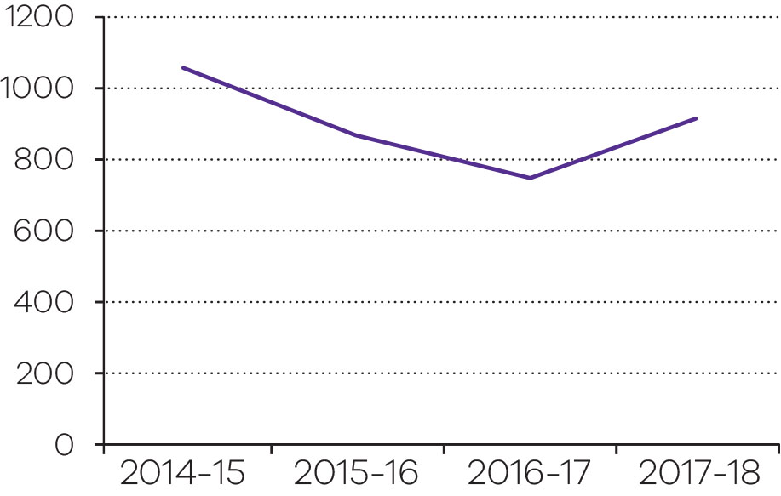
Objective indicator: People assisted through Public Advocate advice and education activities
The objective indicator ‘People assisted through Public Advocate advice and education activities’ counts the number of recorded instances of information and advice provided by the OPA, as well as the number of people who have attended community education sessions delivered by OPA.
Information and advice can relate to powers of attorney, guardianship, administration, or other matters relating to disability. It might be provided to a person with disability, their family members, or to legal professionals. Information and advice is provided through enquiries to the advice service, which are primarily telephone enquiries, but also some email and written correspondence, as well as direct attendance by a member of the public at OPA’s office. OPA provided advice and information in response to 11,752 requests in 2017–18
OPA conducted 138 community education sessions in 2017-18. Community education sessions are presentations to community groups and professional bodies, such as health services, disability service providers, and legal professionals. Sixty-two of these sessions related to the Medical Treatment Planning and Decisions Act, which came into effect on 12 March 2018.
Figures relating to ‘People assisted through Public Advocate advice and education activities’ 2014-15, 2015-16 and 2016-17 have been adjusted to reflect a more accurate method of calculating the incidence of telephone advice. This method was developed in 2016-17 and counts the number of confirmed instances of advice, as recorded in the case management system, rather than the previous method of counting all incoming calls, some of which did not progress to advice provision.
People assisted through Public Advocate advice and education activities 2014–15 to 2017–18
Indicator | 2014-15 | 2015-16 | 2016-17 | 2017-18
People assisted through Public Advocate advice and education activities
Number | 15,011* | 20,448 | 15,611 | 17,932

*This is not reported in the Budget Papers but is detailed in OPA annual reports.
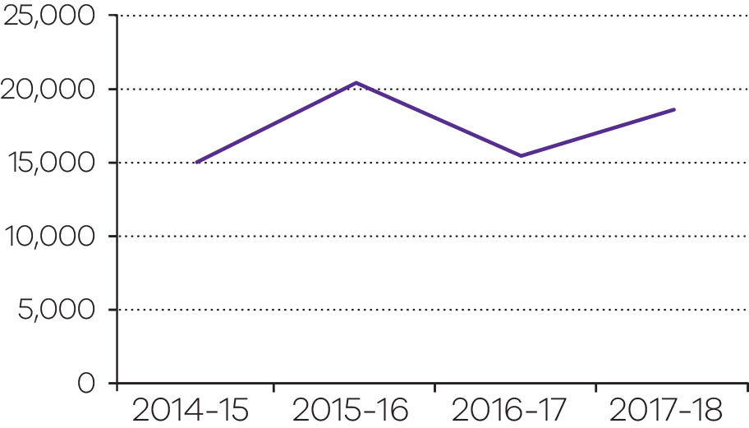

Objective indicator: Births, deaths and marriages registration transaction accuracy rate
The objective indicator ‘Accuracy of the births, deaths and marriages register’ reflects the level of accuracy of the Registry of BDM, and its data entry service provider, in capturing registration data provided by applicants. By achieving a high accuracy rate, BDM is able to ensure a high level of confidence concerning personal identity, particularly in relation to a citizen’s birth, death and, where applicable, marriage.
This objective indicator is calculated as a percentage of accurate registrations out of the total number of registrations for that year. Accurate registrations are those that have not been returned due to an error in the details shown on the certificate, or if returned, are due to an error made by the applicant in supplying the information.
BDM’s core business system is currently being replaced as it is at the end of its life, and no longer meets the needs of BDM and its users. The new system has been designed with new features to increase accuracy and improve services for individuals and organisations who interact with BDM, especially those who wish to interact online.
Accuracy of the births, deaths and marriages register 2014–15 to 2017–18
Indicator | 2014-15 | 2015-16 | 2016-17 | 2017-18
Births, deaths and marriages registration transaction accuracy rate
Per cent | 99.69 | 99.85 | 99.29 | 99.5

Output performance measures: Protection of personal identity and individual/community rights
This output protects personal identity through the registration of significant life events by the Victorian Registry of BDM. It also protects individual and community rights through the work of the VEOHRC, the OPA and the Native Title Unit (NTU).
The VEOHRC provides education and capacity building, and assists parties to resolve disputes. The OPA protects the rights, interests and dignity of people with disabilities and mental illness. The NTU seeks to increase the economic, social and cultural development of traditional owner communities by negotiating comprehensive settlements of native title claims.
Performance measures | Unit of measure | 2017-18 actual | 2017-18  target | Performance variation (%) | Result
Quantity
Complaint files received and handled by VEOHRC | number | 908 | 900–1 050 | 0.0 | ✓
Education and consultancy sessions delivered by VEOHRC | number | 366 | 350 | 4.6 | ✓
Information and advice provided by VEOHRC | number | 8 585 | 8 000–8 500 | 1.0 | ✓
Settlement rate of conciliation | per cent | 64 | 65 | -1.5 | ○
Groups in negotiation towards resolution of Native Title claims (NTU) | number | 4 | 2 | 100 | ✓
The actual is above the target due to a higher number of traditional owner groups seeking to negotiate settlement with the State under the Traditional Owner Settlement Act 2010.
Information and advice provided by OPA | number | 11 752 | 12 650–14 850 | -7.1 | ■
While the commencement of the Medical Treatment Planning and Decisions Act 2016 in March 2018 led to a short-term increase in demand for information and advice, the actual was below the target as demand for information and advice was lower than anticipated.
Community education sessions (OPA) | number | 138 | 100 | 38.0 | ✓
The actual is above the target due to staff at the Office of the Public Advocate (OPA) accepting ad-hoc requests for education sessions from organisations and community groups in addition to the organised calendar of sessions run by OPA. Of the 138 community education sessions conducted, 62 of those sessions related to the Medical Treatment Planning and Decisions Act 2016, which came into effect on 12 March 2018.
Public Advocate auspiced volunteer interventions for people with a disability (OPA) | number | 7 595 | 7 743–8 059 | -1.9 | ○
New guardianship and investigation orders of VCAT actioned by OPA | number | 1 353 | 1 039–1 183 | 14.4 | ✓
The actual is above the target due to a higher number of Victorian Civil and Administrative Tribunal (VCAT) guardianship and investigation orders. OPA is statutorily required to accept all guardianship and investigation orders of VCAT.
Advocacy matters opened by OPA | number | 216 | 301–342 | -28.2 | ■
The actual is below the target due to a high demand for VCAT orders. OPA declines to accept advocacy referrals at times of high demand for guardianship and investigation orders of VCAT, which OPA is statutorily required to accept.
Quality
Births, Deaths and Marriages registration transaction accuracy rate (BDM) | per cent | 99.5 | 99 | 0.5 | ✓
Customer satisfaction rating: Education and consultancy sessions delivered by VEOHRC | per cent | 87 | 85 | 2.4 | ✓
Customer satisfaction rating: Conciliation delivered by VEOHRC | per cent | 98 | 85 | 15.3 | ✓
The actual is above the target due to a number of factors including increased engagement with parties throughout the process, changes to the way that data is collected (using electronic methods rather than a paper survey leading to an increase in the number of respondents) and an increase in the number of customers satisfied with the conciliation process.
Timeliness
VEOHRC complaints finalised within six months | per cent | 76 | 85 | -10.6 | ■
The actual is below the target due to a short-term reduction in complaints file clearance, which is expected to be resolved in 2018–19.
Proportion of Native Title negotiations progressed in accordance with the Department’s annual work plan and timeframes monitored by the Federal Court (NTU) | per cent | 100 | 100 | 0.0 | ✓
Complete applications for birth, death and marriage certificates processed within five days of receipt (BDM) | per cent | 100 | 95 | 5.3 | ✓
The actual is above the target due to all complete applications being processed within five days of receipt.
Average number of days a guardianship or investigation order of VCAT is held on a wait list prior to being allocated to a delegated officer by the Public Advocate (OPA) | number | 35.1 | 45-49 | -22.0 | ✓
While there continues to be rising complexity of guardianship matters, and an increase in demand for VCAT-ordered interventions, the actual is below the target due to the implementation of short-term funded initiatives that have resulted in improvements to the time taken to allocate and complete a matter. This is a positive result.
Cost
Total output cost | $ million | 58.7 | 48.4 | 21.3 | ■
The actual expenditure is above the target primarily due to additional costs in the Registry of Births, Deaths and Marriages to meet high service demand from applicants and the implementation of the core business replacement system. Additionally, there were also greater than budgeted award payments approved by the Appeals Costs Board under the Appeals Costs Act 1998.
Note:
✓ Performance target achieved or exceeded.
○ Performance target not achieved – within 5 per cent variance.
■ Performance target not achieved – exceeds 5 per cent variance.
Output: Dispute resolution and civil justice support services
Increase community access to justice
Implement the Access to Justice Review recommendations supported by the government
The 2016 Access to Justice Review, commissioned by the Attorney–General, made 60 recommendations focused in particular on the need for better legal information, more flexible and integrated services, better use of technology, and stronger leadership, governance and linkages across the sector. The government accepted 57 recommendations in full or in part, and in May 2017 allocated $34.7 million in funding for initiatives to deliver better access to justice through more legal assistance, enhanced dispute resolution options, and greater help and information for everyday legal problems.
The implementation of the Review recommendations constitutes a significant work program, requiring the involvement of multiple government departments and agencies, as well as the courts and Victorian Civil and Administrative Tribunal (VCAT). The department has been leading work on implementation across government and relevant agencies. During 2017–18, significant progress has been made, with most recommendations of the Review now either underway, or fully or partially implemented.
In order to give effect to the 16 Review recommendations that required legislative amendment, the department led the development of the Justice Legislation Amendment (Access to Justice) Act 2018. The Act was introduced into Parliament in March 2018, and received Royal Assent on 29 May 2018.
Promote best practice data and evaluation capability in the civil justice system
The Justice Legislation Amendment (Access to Justice) Act contains amendments to the Victoria Law Foundation Act 2009 to refocus the Victoria Law Foundation (VLF) to become Victoria’s centre for excellence for data analysis, research and evaluation on access to justice, legal assistance, and civil justice issues. The relevant amendments commenced on 1 July 2018, and the department is working with the VLF to manage the transition to its new role.
The department is participating in an inter–jurisdictional working group established under the auspices of the Council of Attorneys-General (CAG) to evaluate and make recommendations on the improvement of civil justice data collection and analysis across all states and territories and the Commonwealth.
Enhance the legal assistance sector’s community education, planning and coordination capabilities
The Justice Legislation Amendment (Access to Justice) Act contains amendments to the Legal Aid Act 1978 that strengthen VLA’s role in coordinating legal assistance services and legal information, drive collaboration between VLA and legal assistance stakeholders, enhance the skills base of the VLA Board, and increase transparency and accountability through improved planning and reporting.
The department is working with VLA to give effect to the amendments, and will participate in new governance arrangements established across the legal assistance sector, to better target legal need by improving long–term planning, coordination, and accountability.
Working with the courts in relation to family violence reform
Throughout 2017–18, the department has worked to respond to the recommendations of the Royal Commission into Family Violence focused on the legislation that establishes the courts and VCAT. The department has:
- led the development of legislation, the Justice Legislation Amendment (Family Violence Protection and Other Matters) Bill 2018, to establish the new Specialist Family Violence Court Division (Recommendation 60): extend the therapeutic treatment order regime to children aged 15 to 17 years (Recommendation 34); support the roll out of online applications for family violence intervention orders (Recommendation 74); and facilitate the electronic issue and transmission of court and tribunal documents
- established a bilateral working group with representatives from the Commonwealth Attorney–General’s Department, Department of Premier and Cabinet and DHHS to advocate for the adoption of family law reforms that reduce fragmentation of jurisdictions in cases involving family violence (Recommendation 129).
The department is co–chairing the multilateral CAG Family Violence Working Group. This group has led work to reduce fragmentation of jurisdictions in cases involving family violence and family law issues. The work program includes supporting the conferral of family law jurisdiction on state and territory children’s courts, which would enable parties to resolve matters in only one court. This conferral of jurisdiction is contained in the Family Law Amendment (Family Violence and Other Measures) Act 2018.
The department has continued to work closely with the Commonwealth Attorney–General’s Department, the Magistrates’ Court, and the Children’s Court to determine the funding implications of the Act. In particular, the department has explored the potential to trial the new family law jurisdiction for the Children’s Court and Magistrates’ Court.
For further information about family violence reform refer to page 51.
Dispute resolution service delivery
DSCV provides free dispute resolution advice and services across Victoria, including conflict coaching and mediation for neighbourhood and community–based disputes. DSCV also mediates appropriate Personal Safety Intervention Order disputes, civil disputes under $40,000 from the Magistrates’ Court of Victoria (in 42 Magistrates’ Court locations across the state), and referrals from Victoria Police.
In 2017–18, DSCV also partnered with:
- VCAT, to provide expanded alternative dispute resolution services for small claims disputes; and
- CAV, to transfer to DSCV, via a triage process, disputes within retirement villages and owners’ corporations that present to CAV in the first instance.
In addition, DSCV continued to deliver formal mediation training and mediator accreditation to national standards.
Support Aboriginal communities to undertake early prevention dispute resolution workshops
Throughout 2017–18, DSCV’s Aboriginal Dispute Resolution Program (ADRP) helped to empower Victorian Aboriginal communities to resolve their own disputes through culturally appropriate training. This training has been designed to minimise the impact of lateral violence and give communities the tools to understand and effectively manage conflict themselves. The 2017–18 State Budget provided $3.2 million over four years and $1.06 million ongoing, to support the state–wide expansion of ADRP.
In 2017–18, 24 conflict resolution training sessions were delivered, reaching a total of 375 people. The ADRP also partnered with Koorreen Enterprises, an Aboriginal training provider, to co–design and support the delivery of 12 lateral violence awareness and early intervention training sessions to 190 participants (these sessions will be delivered in 2018–19).
Harness technology to facilitate dispute prevention and resolution
In 2017–18, DSCV continued to investigate new and emerging technologies in order to improve dispute prevention and resolution processes.
During 2017, DSCV partnered with a team from Code for Victoria, which is a technology–based fellowship that connects government organisations to a team of technologists to work on complex problems. A team consisting of a designer, a programmer, and a user experience expert from the private sector was based at DSCV for six months. During this time, the team developed a prototype client information tool designed to provide DSCV customers with tailored information and advice on fencing disputes. The team drew on extensive research into DSCV services and feedback from DSCV staff and customers. DSCV is currently reviewing its website and aims to integrate the prototype tool into its website.
In 2017–18, the department supported the VCAT to further develop an online dispute resolution pilot, and facilitate the electronic transmission of tribunal services.
Victorian Government Legal Services Panel
The Victorian Government Legal Services Panel (the Panel) continues to provide access to high quality and consistent legal services at competitive rates. Twenty–three law firms participate in the Panel under a State Purchasing Contract that expires on 30 June 2019, with an option to extend it for a further three years. They provide legal services across 13 areas of law. Victorian departments are required to purchase legal services from firms on the Panel or from the Victorian Government Solicitor. Participation on the Panel is voluntary for statutory agencies. The number of agencies that voluntarily opt into the Panel arrangements increases each year. This is attributed to the reduced administrative burden and highly competitive rates offered to Panel clients.
Further detailed information in relation to the Panel’s operations for the 2017–18 financial year is available in the 2017–18 Legal Services Panel Annual Report, which is published on the department’s website.
Progress toward achieving this objective
Objective indicator: Dispute resolution services provided in the Dispute Settlement Centre of Victoria (DSCV)
The objective indicator ‘Dispute resolution services provided in the DSCV counts the number of direct client contacts for dispute resolution services, including telephone calls and face to face interviews, the number of files started in the civil mediation program, and the number of direct capacity-building community engagement sessions delivered by DSCV to organisations and members of the Victorian community.
The number of dispute resolution services provided has remained relatively stable over the past four years. DSCV is committed to continuous improvement, and is developing a range of new service offerings to help people resolve disputes as quickly and easily as possible. DSCV is trialling a range of mediation delivery options, including telephone mediation for community-related disputes (such as minor fencing and tree-related disputes) and sole mediation (rather than having two mediators) in appropriate cases. Trialling different approaches to service delivery ensures that DSCV is accessible and responsive to the needs of its clients across Victoria.
Dispute resolution services provided in the DSCV 2014–15 to 2017–18
Indicator | 2014-15 | 2015-16 | 2016-17 | 2017-18
Dispute resolution services provided by DSCV
Number | 22,311 | 23,038 | 23,504 | 23,467

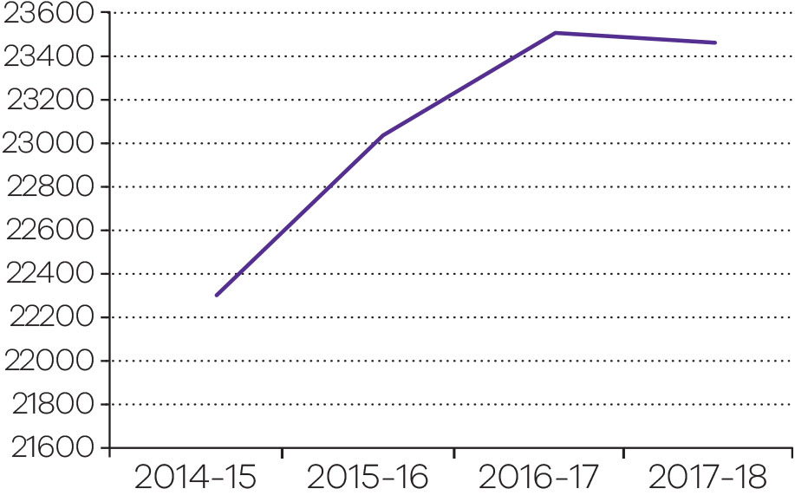
Output performance measures: Dispute resolution and civil justice support services
This output provides dispute resolution and mediation services to members of the community through the DSCV. DSCV’s services cover neighbourhood disputes, workplace disputes and disputes within committees, clubs and incorporated associations.
The output also provides strategic advice and practical legal solutions to the Victorian Government and its statutory authorities through the Victorian Government Solicitor’s Office (VGSO).
Performance measures | Unit of measure | 2017-18 actual | 2017-18 target | Performance variation (%) | Result
Quantity
Dispute resolution services provided in the Dispute Settlement Centre of Victoria (DSCV) | number | 23 467 | 21 500 | 9.2 | ✓
The actual is above the target due to an increase in demand for dispute resolution services across the fourth quarter 2017-18.
Quality
Overall client satisfaction rate (DSCV) | per cent | 79.1 | 85 | -6.9 | ■
The actual is below the target due to a minor change in the counting methodology to represent overall customer satisfaction ratings more accurately.
Settlement rate of mediation (DSCV) | per cent | 92.2 | 85 | 8.5 | ✓
The actual is above the target as the counting methodology for this measure has been updated to capture civil disputes (Magistrates’ Court program) that are resolved post mediation and pre-hearing.
Client satisfaction with quality of legal advice provided (VGSO) | per cent | 85 | 85 | 0.0 | ✓
Timeliness
Intake and mediation services conducted within agreed timeframes by the DSCV | per cent | 86.1 | 85 | 1.3 | ✓
Client satisfaction with timeliness of legal advice provided (VGSO) | per cent | 89 | 85 | 4.7 | ✓
Cost
Total output cost | $ million | 48.0 | 48.9 | -1.8 | ✓
Note:
✓ Performance target achieved or exceeded.
○ Performance target not achieved – within 5 per cent variance.
■ Performance target not achieved – exceeds 5 per cent variance.

Reduce the impact of, and consequences from, natural disasters and other emergencies on people, infrastructure, the economy and the environment
This objective aims to deliver a coordinated, all communities – all emergencies approach to emergency management, focusing on risk mitigation and active partnership with the Victorian community.
Emergency management encompasses prevention, preparation and planning for, responding to and recovering from natural disasters (such as bushfires, floods and severe storms), the consequences of terrorism, hazardous material incidents (such as chemical spills and gas leaks), and individual and personal emergencies (such as land and sea rescues, car accidents and residential and commercial fires).
In 2017–18, the department reported progress against this objective using the following objective indicators and outputs.
Objective indicators
- Value of domestic fire insurance claims
- Rate of deaths from fire events.
Outputs
- Emergency Management Capability
Output: Emergency management capability
Community Resilience Framework
EMV published its Community Resilience Framework (Resilience Framework) in May 2017 to establish a common approach and understanding across the emergency management sector and to place people at the centre of decision-making.
In 2017–18, EMV continued to implement actions to embed community resilience within the sector. The following are examples and outcomes of the work:
- More than 800 people from across the emergency management sector have been briefed on the Resilience Framework and the next steps in supporting and enabling the sector to better support community resilience.
- Increased numbers of municipal emergency management plans now include resilience principles within the aims and objectives of their plans.
- The leadership of Victorian State Emergency Services (VICSES) completing its first–year report against actions of its Community Resilience Strategy 2016–2019.
- National Resilience Awards successfully conducted with the information contained within the nominations used to promote the excellent work being conducted across the state
- Partnering with Resilient Melbourne in the establishment of a network of resilience practitioners, The Resilience Collective.
- Workshop with the Catalyst Network in exploring community resilience challenges and opportunities to shift the culture of dependence to self–reliance.
- Corporate financial support for the establishment of the Strengthening Community Resilience Pilot in the North West Metropolitan Area.
- EMV supporting Melbourne in joining over 60 cities worldwide in a 2–day climate hackathon.
- Community resilience workshops held at Climate Adaptation 2018, the major Australian forum focused exclusively on climate impacts and adaptation.
- Partnering with Resilient Melbourne and Local Government Victoria to investigate and conduct training for resilience practitioners within local government.
Emergency relief and recovery reform
Throughout 2017–18, EMV led the development of the Resilient Recovery Strategy to reform Victoria’s emergency relief and recovery system.
Strategy development included the release of a discussion paper that generated 57 submissions, workshops with state government agencies and partners, and a series of eight regional workshops targeting local government, community volunteers, and regional organisations.
The resulting Resilient Recovery Strategy aims to:
- commit to community-led recovery
- invest in the capability and capacity of the relief and recovery workforce and the maturity of our systems and processes
- agree shared community outcomes for the recovery sector.
EMV will develop a series of strategic actions to implement the strategy.
Critical infrastructure resilience
Critical infrastructure supports our most basic needs—safe drinking water, food, reliable transport, public health services, energy, banking, government services, and global communications networks—and is essential to Victoria’s wellbeing, social cohesion and economic viability. It includes those physical facilities, supply chains, systems, assets, information technologies and communication networks which, if destroyed, degraded or rendered unavailable for an extended period, would significantly impact on the social or economic wellbeing of the Victorian community.
As Victoria faces an increasing range of emergencies, the importance of continuing to build the resilience of critical infrastructure is self-evident.
As part of legislative obligations under the 2017 Resilience Improvement Cycle, owners and operators of critical infrastructure assessed as being of vital importance to Victoria’s economic and social well-being, identified emergency risks and undertook exercises to test preparedness.
Victoria’s Critical Infrastructure Sector Resilience Networks have prepared 2017–18 Sector Resilience Plans, which highlight improvement initiatives completed in the past year, and those planned for the coming year. The plans were consolidated into the All Sectors Resilience Report endorsed by the State Crisis and Resilience Council (SCRC) in November 2017 and released by the Minister for Emergency Services in December 2017.
In November 2017, the Water and Transport Sector Resilience Networks completed desktop exercises on cyber threats as part of the implementation of the Victorian Cyber Security Strategy, released in September 2017.
In May 2018, more than 130 representatives from Victoria’s critical infrastructure sectors attended the All Sectors Resilience Network Forum. The forum discussed impacts and opportunities for critical infrastructure in relation to climate change, cyber security, pandemic flu and collaboration during emergencies.
EMV Strategy Refresh 2020
In 2017–18, as EMV approached its third year of operation, it initiated Strategy Refresh 2020 (the refresh) to ensure it continues to respond to the evolving and complex environment. The refresh examined EMV’s business, its strategic priorities, its operating and business models and organisational culture.
The outcomes of the refresh have been built into EMV’s new three year EMV Strategic Plan, a Plan for Our People and Culture, and a Stakeholder Engagement Strategy.
The EMV Strategic Plan 2020 was published in November 2017 and distributed to staff and the sector. Its strategic themes are: leading change; stewardship; and system delivery and high performing organisation. In 2018, 40 strategic priorities linked to these themes have been revised with some completed and new priorities added.
Emergency management planning reform
The Emergency Management Legislation Amendment Act 2018, which received Royal Assent on 21 August 2018, establishes an integrated, coordinated and comprehensive framework for emergency management planning at the state, regional and municipal levels.
EMV has been preparing to lead the implementation of the Act, in collaboration with the sector. This work includes developing guidelines and a toolkit to provide practical guidance on the new legislative requirements.
Stronger planning will contribute to community safety by ensuring that Victoria is prepared for all likely emergencies. While planning for emergencies already occurs, the new legislation leverages existing work by establishing a system to bring agencies together and supporting continuous improvement.
Volunteers and volunteerism
EMV, in collaboration with the Volunteer Consultative Forum has led a project to capture, quantify, validate and communicate the value of Victoria’s emergency management volunteers (the people), volunteering (the activities) and volunteerism (the culture); referred to as the 3Vs.
The 3Vs Interim Report: The value hidden in plain sight was released in August 2017. The report articulated the impact and consequences of volunteering to better understand the human, economic, environmental, social, physical and cultural value to community, agencies, business and government. Importantly, it acknowledged the limitations of the current understanding of value with respect to volunteers’ efforts and provides direction to improve the understanding for a range of recipients and the broader community.
In 2017-18, EMV continued to support the emergency service volunteers through:
- finalisation of the $15 million Emergency Services Volunteer Sustainability Grants Program in July 2017
- the $1.38 million Valuing Volunteers Program
- the $13 million Volunteer Emergency Services Equipment Program.
Workforce capability and capacity
EMV is developing a Multilateral Agreement (the Agreement) as a whole of government platform to effectively and efficiently generate a surge workforce capability, to support emergency management operations. The agreement is sponsored by the SCRC.
The first stage of the Agreement trialled a surge workforce to support the State Control Centre (SCC) between January and March 2018. During the trial, 37 participants from six departments were recruited, trained and deployed to the SCC in support of heat events, storms and the Barwon South West fires and subsequent relief and recovery operations. The SCC trial explored the policies, systems and training necessary to underpin any future agreement. EMV presented the findings of the trial and recommended future directions to the SCRC in July 2018.

Diversity and inclusion
In 2017–18, EMV continued to implement and support the Emergency Management Diversity and Inclusion Framework: Respect and Inclusion for All (the Framework). The Framework guides the Victorian emergency management sector’s actions in creating a more diverse, inclusive and stronger sector, that is more reflective of and better connected to all of Victoria’s communities. This involves long-term change and comprises many initiatives, at sector and individual agency level. Work included: developing clear and consistent messaging on diversity and inclusion; targeted leadership; training and awareness programs; research on effectively engaging and enabling diverse communities to participate in emergency management; and developing a common approach to gathering diversity-related data as the evidence base against which progress can be measured.
Coordinate implementation of strategic priorities and actions in the Strategic Action Plan
The Victorian Emergency Management Strategic Action Plan (SAP) Update #2 2017–20 was released in November 2017. The SAP outlines state–wide strategic priorities and actions, to guide ‘all communities, all emergencies’ reform and supports Victoria in achieving its vision of safer and more resilient communities. Update #2 focused on key achievements over the last two years and reflected on the growth and progress across each priority area.
Of the 31 actions included in the SAP, 20 actions are underway and seven have been completed or closed, including: critical infrastructure resilience; specific risk mitigation; the single source web portal; the Community Resilience Framework; and enhancing public information and warnings. The annual update of the SAP is now underway and will focus on a critical review of remaining actions to determine their ongoing need and relevance.
IGEM continues to report and monitor progress annually on the delivery of SAP actions, and released the Annual Progress Report on the SAP in December 2017.
Emergency management capability
During 2017–18, EMV continued to enhance emergency management sector capability through:
- implementing reforms arising from inquiries, reviews and audits including: the Hazelwood Mine Fire Inquiry; Parliamentary Inquiry into Marine Rescue Services; Fire Services Review; pool safety recommendations arising from coronial inquests; and Parliamentary Inquiry into the Country Fire Authority Training College at Fiskville
- supporting the Emergency Management Commissioner’s role as the state emergency management coordinator, through operating the SCC, supporting an integrated approach across the emergency management system, focused on response, consequence management and recovery from emergencies
- continuing to support and enhance communication systems and platforms to deliver integrated information and decision–making services including: Emergency Management Operational Communications; Emergency Management Common Operating Picture; VicEmergency platforms, including the website and app, and management of the Emergency Alert on behalf of Australia.
Emergency Management Operational Communications program
The Emergency Management Operational Communications program ensures that the in–field operational communications systems used by emergency services responders are contemporary, resilient, fit–for–purpose and affordable and enables key actions and deliverables. In 2017–18, significant progress was made to transition all first responders to the state’s digital radio network, including:
- the introduction of Victoria Police to the State’s Regional Mobile Radio Service Agreement, providing them with a digital encrypted radio system in regional Victoria
- the addition of VICSES, Life Saving Victoria and Corrections Victoria to the State’s Regional and Metropolitan Mobile Radio Service Agreements to allow these agencies to transition their radio operations into a compliant part of the 400MHz spectrum band in response to Commonwealth regulatory requirements
- the commencement of the expansion of the Regional Mobile Radio network to replace CFA’s aging analogue radio network operating in the outer–metropolitan districts.
VicEmergency Channels
VicEmergency incorporates an app, website, hotline and social media channels to provide Victorians with access to information about warnings and incidents such as fires, floods, storms, earthquakes, avalanches, shark sightings, tsunamis, water safety, thunderstorm asthma and heat.
In 2017–18, a new VicEmergency hotline was launched to ensure Victorians receive the best possible emergency information all year round through a single number, combining flood, fire, relief and recovery and other emergency information.
Community feedback has driven a number of improvements to the VicEmergency app and website since they were launched, making them faster, more responsive, removing bugs and introducing new enhancements. In 2017–18, a number of new features have also been added, including introduction of the thunderstorm asthma forecast map and thunderstorm asthma warnings.
Marine Search and Rescue
Following the Parliamentary Inquiry into Victoria’s Marine Rescue Services in 2017–18, EMV established an Interim Marine Search and Rescue (MSAR) office as part of ongoing arrangements to deliver improved capability, training and risk management in this sector.
Work continued in 2017–18 on the development of a sustainable financial operating model for the sector. An insurance scheme provided by the Victorian Managed Insurance Authority has been established for volunteer MSAR providers, in addition to a grants scheme that provides MSAR volunteers with much needed equipment, fuel (for training and exercising) and professional development opportunities.
Progress toward achieving this objective
Objective indicator: Value of domestic fire insurance claims
The value of asset losses from fire events is defined as the estimated monetary value of the damage to domestic property and contents caused by the fire and firefighting operations based on insurance claims. It does not include land value. The value of insurance claims from fire events is the sum of the incurred claims on insurance companies related to fires and explosions reported to Insurance Statistics Australia (ISA). The value of domestic fire insurance claims consists of two data sets, sourced from ROGS 2018 Emergency services for fire and other events dataset:
- average value of fire event insurance claims in Victoria
- total value of fire event insurance claims per person in the population in Victoria.
The value of insurance claims from fire events reflects efforts to reduce the likelihood, effect and consequences of emergencies on communities.
Data relating to insurance claims may not reflect actual asset losses due to the following factors:
- insurance pay-outs are limited by the estimated value of assets a policy holder provides when taking out insurance
- data provided by the ISA covers an estimated 69 per cent of Australian dwellings
- new for old policies replace an old asset for a new equivalent.
Small fire incidents are not recorded where no insurance claim is made by the policy holders (due to requirement for policy holders to pay excess).
Historically, Victoria has been vulnerable to a range of hazards. Bush and grass fires pose the largest annual risk to the safety of Victorians; however, other hazards also pose serious risks to the physical, social, environmental and economic wellbeing of Victoria.
In Victoria from 2013–14 to 2016–17, the value of fire event insurance claims showed:
- a 30 per cent increase from an average claim of $47,807 in 2013–14 to an average claim of $62,149 in 2016–17
- a 6.3 per cent decrease from $25.04 per person in the population in 2013–14, to $23.47 per person in the population in 2016–17.
The average value of fire event insurance claims in Victoria is roughly in line with the Australian average of $61,709, with the total value of claims per person in Victoria at $23.47 in 2016-17, also aligning to the Australian result of $23.19.
The claim per person value has fluctuated in Victoria over the past five years, with the lowest claim value shown in 2014-15 ($20.81 per person in the population), and the highest claim value in 2015-16 ($26.81 per person in the population). Events such as Wye River-Separation Creek, Scotsburn and Barnawatha-Chiltern bushfires may have contributed to the increase in insurance claims seen in 2015–16, where landowners have experienced building, livestock or crop loss as a result of fires.
There has been an overall 13.6 per cent decrease observed in the number of structure fires that occurred in Victoria (from 5,977 in 2013–14 to 5,166 in 2016-17). The work of the emergency management sector continues to support a move towards safer and more resilient communities, which contributes to the department’s objective of minimising injury and property loss.
Value of domestic fire insurance claims in Victoria 2013–14 to 2016–17
Unit of measure | 2013-14 | 2014-15 | 2015-16 | 2016-17
Average value in Victoria
$ value | 47,807 | 48,597 | 60,761 | 62,149
Total value per person in the population in Victoria
$ value | 25.04 | 20.81 | 26.81 | 23.47
Source: Report on Government Services (ROGS) 2018. Note this is the most recent data available from ROGS. 2017-18 data are published in 2019.
Time series financial data are adjusted to 2016-17 dollars using the Domestic Final Demand (DFD) deflator (2016-17 = 100).
Average value in Victoria 2013–14 to 2016–17
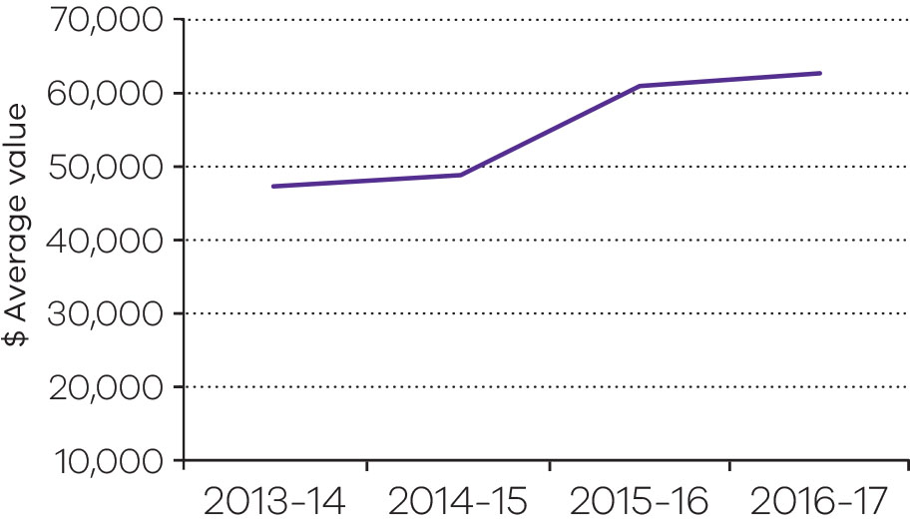

Total value per person in the population in Victoria 2013–14 to 2016–17
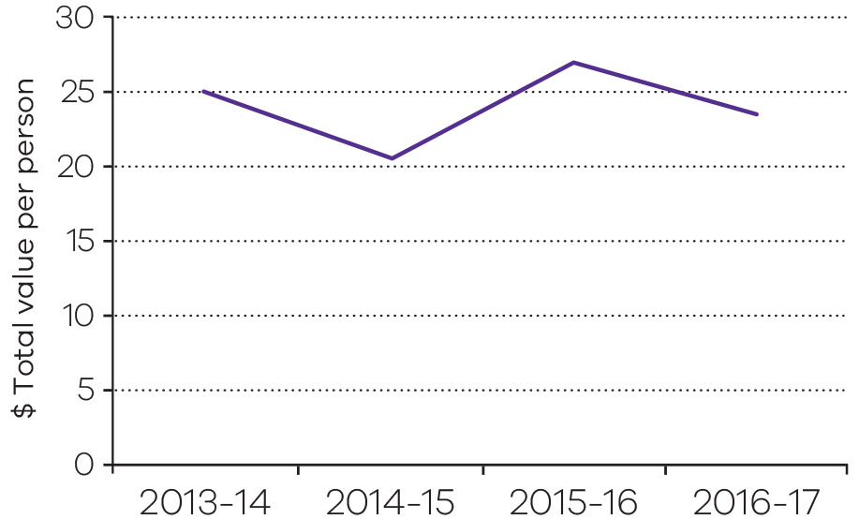
Objective indicator: Rate of deaths from fire events
‘Rate of deaths from fire events’ is defined as the number of deaths per million people in a calendar year whose underlying cause of death is fire related to smoke, fire and flames, including all structure and landscape fires.
This data is sourced from the ROGS 2018 emergency services for fire and other events dataset, Australian Bureau of Statistics Causes of Death data and Estimated Resident population data. The latest data available from ROGS for this objective indicator is the 2016 calendar year due to the time it takes the coronial court to verify a code for a case, and then close the case.
The rate of deaths from fire events in Victoria has decreased by 4.8 per cent from 4.2 deaths per million people in 2015 to 4 deaths per million people in 2016. However, it should be noted that annual fire death rates can be particularly volatile because of the small number of fire deaths and the influence of large irregular fire events. The trend in deaths from fire events in Victoria shows that the department is making progress to achieving its objective of minimising injury and property loss through a coordinated and integrated emergency response.
The frequency and severity of these fire events and other emergency events are beyond the control of Victoria’s emergency service agencies. However, EMV continues to work closely with communities, government, agencies and business to reduce the impact of emergency events. Current and future EMV programs and initiatives including (and not limited to) the Community Resilience Framework for Emergency Management, the Victorian Preparedness Framework, Community Based Emergency Management and the VicEmergency website and app are focused on strengthening the communities capacity to withstand, plan for, respond to and recover from emergencies. This continued commitment to reduce the impact of emergency events and enhancement of Victoria’s resilience demonstrates the department’s progress towards its objective of minimising injury and property loss through an interoperable emergency service delivery.
Rate of deaths from fire events in Victoria (per million people) 2013 to 2016
Unit of measure | 2013 | 2014 | 2015 | 2016
Number per million people | 4.0 | 6.2 | 4.2 | 4.0

Source: Report on Government Services 2018. Note this is the most recent data available from ROGS. 2017-18 data is published in 2019
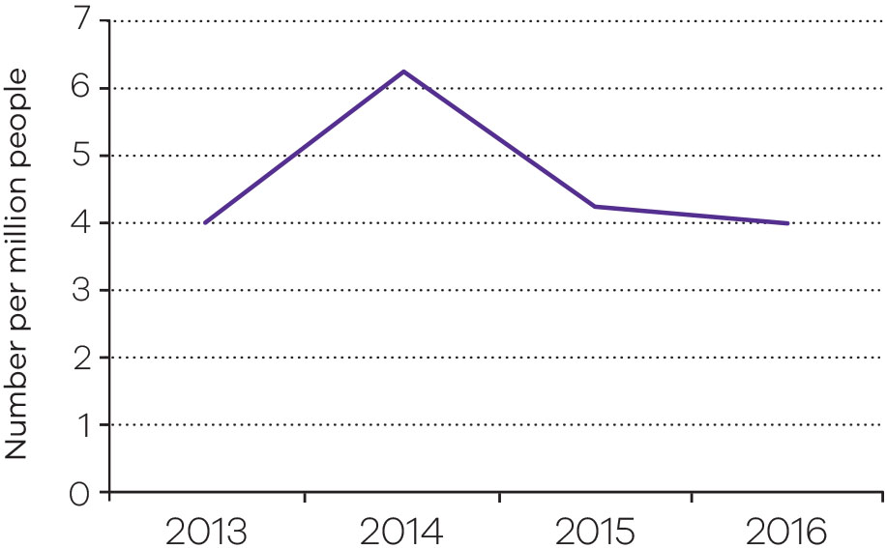

Output performance measures: Emergency management capability
This output provides for the management of emergencies by developing and adopting emergency prevention and mitigation strategies, providing fire suppression and road crash rescue services and supporting local government and communities in disaster mitigation and recovery.
Key components of this output reduce the level of risk to the community of emergencies occurring and the adverse effects of emergency events, such as death and injury rates.
Performance measures | Unit of measure | 2017-18 actual | 2017-18  target | Performance variation (%) | Result
Quantity
Permanent operational staff | number | 3 384 | 3 385 | -0.03 | ○
Permanent support staff | number | 1 494 | 1 406 | 6.3 | ✓
The 2017-18 actual is higher than the 2017-18 target due to more fixed term staff transitioning from fixed-term to permanent.
Volunteers – Operational | number | 38 133 | 43 000–44 000 | -11.3 | ■
The 2017-18 actual figures are lower than the 2017-18 target for operational volunteers and higher than the 2017-18 target for support volunteers. These variations are due to challenges in retaining and recruiting volunteers arising from changing demographics factors, including ageing of the existing volunteer cohort.
Volunteers – Support | number | 21 393 | 18 000–19 000 | 12.6 | ✓
The 2017-18 actual figures are higher than the 2017-18 target for support volunteers and lower than the 2017-18 target for operational volunteers. These variations are due to challenges in retaining and recruiting volunteers arising from changing demographic factors, including ageing of the existing volunteer cohort.
Quality
Level 3 Incident Controller trained staff and volunteers | number | 76 | 96 | -20.8 | ■
The 2017-18 actual is lower than the 2017-18 target due to less personnel than anticipated transitioning to, and maintaining, Level 3 Incident Controller accreditation.
Road accident rescue accredited brigades/units | number | 130 | 131 | -0.8 | ○
Structural fire confined to room of origin | per cent | 83.7 | 80 | 4.6 | ✓
Multi agency joint procurements of systems or equipment | number | 1 | 2 | -50.0 | ■
The 2017-18 actual is lower than the 2017-18 target due to only one of the multi-agency joint procurements being executed within the financial year.
Timeliness
Emergency response times meeting benchmarks – emergency medical response | per cent | 94.6 | 90 | 5.1 | ✓
Emergency response times meeting benchmarks – road accident rescue response | per cent | 90.5 | 90 | 0.6 | ✓
Emergency response times meeting benchmarks – structural fires | per cent | 89.4 | 90 | -0.7 | ○
Cost
Total output cost | $ million | 1 207.7 | 1 138.7 | 6.1 | ■
The actual expenditure is above target due to additional costs associated with firefighting related activities, in particular the Fire Services Statement, increases in salary and allowance costs for Country Fire Authority and Metropolitan Fire Brigade, and the establishment of the Emergency Management Infrastructure Authority post the 2017-18 Budget. Additionally, there was funding transfer from Victoria Police for the implementation of the Police Digital Radio Upgrade program.
Note:
✓ Performance target achieved or exceeded.
○ Performance target not achieved – within 5 per cent variance.
■ Performance target not achieved – exceeds 5 per cent variance.

A fair market place for Victorian consumers and businesses with responsible and sustainable liquor, gambling and racing sectors
This objective relates to harm minimisation through the regulation of the gambling and liquor industries, as well as support and development of the racing sector.
This objective also promotes the empowerment of consumers and businesses to know their rights and responsibilities to promote a well–functioning market economy through regulation and support to consumers and businesses. There is a specific focus on the needs of vulnerable and disadvantaged consumers.
In 2017–18, the department reported progress against this objective using the following objective indicators and outputs.
Objective indicators
- Percentage of licenced venues with a rating that is greater than three stars
- Responsive Gamblers Help services
- Wagering turnover on Victorian racing as a proportion of the national market
- Increased access by consumers, tenants and businesses to digital information
Outputs
- Regulation of the Victorian Consumer Marketplace
- Gambling, Liquor and Racing
Output: Gambling, liquor and racing
Post–2018 public lottery licence transition
On 1 June 2017, Tattersalls Sweeps Pty Ltd (Tatts) was awarded the 10–year Victorian Public Lottery Licence (the Licence) that commenced on 1 July 2018.
Throughout 2017–18 the department worked with Tatts to ensure a smooth transition to the Licence. This included monitoring Tatts’ progress against its transition plan, preparing amendments to the new Licence and providing advice on transition issues as they arose.
Review of the gaming machine post–2022 allocation project
Gaming machine entitlements held by clubs and hotels for the operation of gaming machines will expire in late 2022.
On 7 July 2017, the Minister for Consumer Affairs, Gaming and Liquor Regulation announced the future policy settings for the gaming industry following a review conducted by the department in 2016–17. These include:
- capping the number of gaming machines in Victoria at 27,372
- retaining the maximum number of machines in a single venue at 105
- making changes to gaming machine taxation arrangements to make them more progressive
- extending the term of gaming entitlements for hotels and clubs to 20 years to give the industry more certainty.
The administrative process to allocate new gaming machine entitlements that allow the operation of gaming machines after 2022 is currently underway, with entitlements due to be allocated late–2018.
YourPlay
YourPlay is a voluntary pre-commitment scheme that enables players of electronic gaming machines to track the time and money they spend playing gaming machines and to set time and loss limits on their play. The department continues to work with industry to educate and support gaming venues to promote YourPlay to gaming machine players.
In 2017–18, the department hosted ten YourPlay forums for YourPlay Ambassadors and venue managers from throughout the state. It also organised two YourPlay Day promotional events to assist venue staff to approach and talk to players about the scheme, demonstrate how it works and encourage take-up of the scheme. Each event resulted in increased registrations and use of YourPlay by gaming machine players in the participating venues.
Improving harm minimisation measures for gaming machines
In 2017–18, the department prepared the Gambling Regulation Amendment (Gaming Machine Arrangements) Act 2017, which amends the Gambling Regulation Act 2003 to create new harm-minimisation measures for gaming machines and improve the operation of existing measures.
The amendments were prepared in response to a review of gaming machine harm minimisation measures conducted by the department in 2016–17.
The new harm minimisation measures include:
- limiting cash withdrawals by Electronic Funds Transfer at Point of Sale to $500 per card per day
- providing for payment of winnings via electronic funds transfer where available
- prohibiting the promotion or operation of cheque cashing services in, or on, the property of an approved venue
- prohibiting a venue operator from cashing cheques in an approved venue
- inserting new provisions regulating the operation of cashless gaming systems
- making changes to the legislative framework for Responsible Gambling Codes of Conduct
- making changes to the legislative framework for self-exclusion programs in gaming venues
- changing the legislative requirements for reviewing Responsible Gambling Codes of Conduct and self-exclusion programs.
Review the Liquor Control Reform Act 1998
The review of the Liquor Control Reform Act 1998 being undertaken by the department continued throughout 2017–18. The review aims to ensure the Act supports a strong, diverse and responsible liquor industry while improving the effectiveness of the harm minimisation measures that aim to help protect the community from the harms caused by the misuse and abuse of alcohol.
The Liquor and Gambling Legislation Amendment Act 2018, which contains red tape reforms, enhances harm minimisation and enhances the protection of minors, was introduced into the Parliament on 28 March 2018. The measures in the Act address some of the issues identified during the first phase of the review.
The department will consider the more complex issues during the second phase of the review.
Enhancing the governance and integrity functions of the Victorian racing industry
Racing governance
The Racing Amendment (Modernisation) Act 2018 came into effect on 14 March 2018. The Act supports the changes that were made to the constitution of Racing Victoria (RV) in 2017 to ensure that the board is independent and that conflicts of management are minimised and appropriately managed. The Act specifies that the Minister may perform any functions, exercise any powers and carry out any duties conferred on the Minister by the constitution in relation to the selection, appointment, resignation and removal of Directors of RV and makes it clear that RV is not a public entity.
In 2017, the Secretary convened an advisory panel which made recommendations to the Minister about suitable candidates for appointment to the reconstituted RV Board and a new board commenced on 9 October 2017.
Racing integrity
During 2017–18, the department developed a bill to establish the Victorian Racing Integrity Board (VRIB), a new body that will be responsible for overseeing the integrity and assurance functions of the three controlling bodies being RV, Harness Racing Victoria and Greyhound Racing Victoria. The bill, which was passed by Parliament in August 2018, gives the VRIB powers to consult, advise, make recommendations and, where necessary, provide direction, in relation to the management and conduct of the integrity assurance operations of the racing controlling bodies.
The legislation will also strengthen the racing appeals and disciplinary system by creating a single cross–code Victorian Racing Tribunal. The new tribunal will replace the three existing Racing Appeals and Disciplinary Boards and will ensure a consistent approach to hearing and determining serious charges under the rules of racing and appeals against decisions of racing stewards.
Victorian Racing Industry Grants
During 2017–18, the department continued to administer the Victorian Racing Industry Fund. The fund allocated $22.68 million to 217 projects worth $62.45 million, to grow Victoria’s racing industry through new racing infrastructure, enhanced integrity measures, support for animal welfare initiatives and marketing to new audiences.
Progress toward achieving this objective
Objective indicator: Percentage of licensed venues with a rating greater than three stars
This objective indicator demonstrates how the department is encouraging and rewarding responsible behaviours. The star rating system for licensed venues commenced in February 2012. Upon commencement, all new and existing liquor licences were given a three star rating. The star rating of a licence is determined based on the following criteria:
Rating | Criteria
One star | Three or more non-compliance incidents in the previous 12 months
Two star | One or two non-compliance incidents in the previous 12 months
Three star | No non-compliance incidents in the previous 12 months
Four star | No non-compliance incidents in the previous 24 months
Five star | No non-compliance incidents in the previous 36 months

Under the star rating system, licensees who achieve a four or five star rating receive a discount on their annual liquor licence renewal fees. A four or five star rating can only be achieved where a licensee has had no non-compliance incidents in the previous 24 months (four star) or 36 months (five star).
The star rating system encourages responsible practices in licensed premises and contributes to the department’s objective to promote responsible industry behaviour. The Victorian Commission for Gambling and Liquor Regulation (VCGLR) regulates the liquor and gambling industries to achieve high levels of compliance with liquor laws by setting clear expectations, encouraging the right behaviour and taking strong enforcement action where required.
In 2017–18, a total of 18,666 (85 per cent) liquor licences had a star rating greater than three.
This percentage remains consistent with the result for 2016-17.
Percentage of licensed venues with a rating greater than three stars 2014–15 to 2017–18
Unit of measure | 2014-15 | 2015-16 | 2016-17 | 2017-18
Per cent | 87.0 | 86.6 | 85.0 | 85.0
Source: Victorian Commission for Gambling and Liquor Regulation
Objective indicator: Responsive Gambler’s Help services
Responsive Gambler’s Help services contributes to the objective by demonstrating the responsiveness of these Help services. This indicator measures the percentage of clients who receive a service within five days of referral to a Gambler’s Help service funded by the Victorian Responsible Gambling Foundation (VRGF).
In 2017-18, the percentage of clients receiving a service within five days remains high and is trending in a positive direction following a slight decline in 2016-17, which is attributed to an increase in the demand for services and the use of part-time workers. This trend reflects the commitment of the state-wide system of Gambler’s Help services to provide timely support for Victorians experiencing gambling related harm.
Percentage of clients who receive a service within five days of referral 2014–15 to 2017–18
Unit of measure | 2014-15 | 2015-16 | 2016-17 | 2017-18
Per cent | 100 | 99 | 94 | 95
Source: The Victorian Responsible Gambling Foundation’s GH Connect case management system
Objective indicator: Wagering turnover on Victorian racing as a proportion of the national market
Victorian Government support for racing is based on its economic, social and cultural contribution to communities. The health of the racing industry is demonstrated through the professional presentation of racing events.
This objective indicator is used to determine the health of the Victorian racing industry by measuring the proportion of Tabcorp customers nationwide who bet on Victorian racing. The measure includes all racing turnover held by Tabcorp on Victorian racing events.
While Victoria has approximately 25 per cent of the national population and hosts around 25 per cent of the national racing program, it attracts almost 40 per cent of the national wagering pool. This trend has remained reasonably consistent during the four years from 2014–15 to 2017–18 and indicates that the level of public confidence in Victorian racing is high. It also reflects government and industry commitment to a racing industry that is well managed and fairly conducted.
Wagering turnover on Victorian racing as a proportion of the national market 2014–15 to 2017–18
Unit of measure | 2014-15 | 2015-16 | 2016-17 | 2017-18
Per cent | 39.2 | 39.3 | 39.1 | 38.3
Source: Tabcorp
Output performance measures: Gambling, liquor and racing
This output provides for monitoring and regulation of gambling and liquor activities in Victoria, including the operations of the VCGLR and the VRGF. It also provides leadership and strategic policy advice to the Minister for Liquor and Gaming Regulation and the Minister for Racing on the regulation of the gambling, liquor and racing industries, problem gambling and harm minimisation in relation to liquor and gambling, as well as development support for the racing industry.
Performance measures | Unit of measure | 2017-18 actual | 2017-18 target | Performance variation (%) | Result
Quantity
Liquor and gambling approvals, licence, permit applications and variations determined by the VCGLR | number | 54 936 | 46 000 | 19.4 | ✓
The actual is above the target due to the increase in demand for permanent licences and proof of age cards.
Liquor and gambling information and advice (VCGLR) | number | 129 890 | 128 000 | 1.5 | ✓
Liquor and gambling inspections completed by the VCGLR – metropolitan | number | 12 339 | 11 400 | 8.2 | ✓
The actual is above the target due to 15 fixed-term assistant inspectors who focused on the less time consuming low to medium risk inspections which will enhance the VCGLR’s ability to target high risk, more complex and time consuming inspection activities in the future.
Liquor and gambling inspections completed by the VCGLR – regional | number | 2 031 | 1 600 | 26.9 | ✓
The actual is above the target due to factors that include the establishment of the regional hubs in April 2018. Additional resources in the regions contributed to an increase in inspection numbers particularly in the latter part of 2017-18.
Office of Liquor, Gaming and Racing briefings processed | number | 518 | 700 | -26.0 | ■
The actual is below the target due to a lower than expected number of briefings processed.
Operations with co-regulators to identify licensees supplying alcohol to minors or persons who are intoxicated | number | 22 | 20 | 10.0 | ✓
The actual is above the target due to additional requests from Victoria Police with a focus on intoxication and/or minors during the fourth quarter 2017-18.
Racing industry development initiatives delivered by the Victorian Racing Industry Fund | number | 7 | 7 | 0.0 | ✓
Racing matters processed (including licences, permits and grant applications) | number | 414 | 274 | 51.1 | ✓
The actual is above the target due to a significantly higher than expected increase in the number of Victorian Racing Industry Fund applications submitted.
Quality
Liquor and gambling licensing client satisfaction (VCGLR) | per cent | 98.5 | 80 | 23.1 | ✓
The actual is above the target as the industry survey aimed at measuring satisfaction provided higher client satisfaction results than the expected target.
Timeliness
Calls to VCGLR client services answered within 60 seconds | per cent | 77.2 | 80 | -3.5 | ○
Gamblers Help Service clients who receive a service within five days of referral (VRGF) | per cent | 94.7 | 96 | -1.4 | ○
Liquor and gambling approvals, licence, permit applications and variations completed within set time (VCGLR) | per cent | 94 | 80 | 17.5 | ✓
The actual is above the target due to improvements to forms, increased uptake of web-based applications and the streaming of applications based on risk.
Cost
Total output cost | $ million | 120.7 | 128.8 | -6.3 | ✓
The actual expenditure is below target mainly due to recashflow of funding from 2017-18 into future years for Victorian Racing Industry Fund grants, which was partially offset by additional funding for the construction of on-course stabling at the Geelong Racing Club.
Note:
✓ Performance target achieved or exceeded.
○ Performance target not achieved – within 5 per cent variance.
■ Performance target not achieved – exceeds 5 per cent variance.
Output: Regulation of the Victorian consumer marketplace
Ensuring a fair and safe rental market for Victorians
Residential Tenancies Act review
CAV has led a comprehensive and evidence–based review of the Residential Tenancies Act 1997. The review fulfils a commitment in the government’s plan for Fairer, Safer Housing, and responds to substantial changes in market conditions since the Act was passed almost twenty years ago.
The reform package promotes a modern and dynamic rental market that meets the needs of the Victorian community now and into the future. The proposed new laws also address recommendations from the Royal Commission into Family Violence to better protect family violence survivors in rental accommodation.
The Victorian Government has already announced a selection of reforms it has approved that specifically focus on increasing the security and rights of Victorians who rent. The full reform package was introduced into Parliament in August 2018.
Long–term tenancy agreements
The Residential Tenancies Amendment (Long–term Tenancy Agreements) Act 2018 received Royal Assent on 28 August 2018. A draft-standard long-term tenancy agreement, to enable leases for five years or more, is being developed after consultation with key stakeholders. The agreement is expected to be available to landlords and tenants in early 2019.
Implementation of rooming house scheme
New legislation introducing the requirement for operators of rooming houses to hold a licence commenced under the Rooming House Operators Act 2016 in 2017. The purpose of the Act is to foster professionalism and reduce exploitative and undesirable practices in the rooming house sector, by establishing a licensing scheme for rooming house operators administered by the Business Licensing Authority. As at 30 June 2018, 867 Rooming House Operator licences have been approved.
Ensuring a modern and effective consumer law framework
CAV’s legislative program aims to improve the efficiency and effectiveness of legislation while ensuring a risk–based approach to consumer protection.
The following are examples of legislation passed and under review in 2017–18:
- The Owners Corporations Amendment (Short–Stay Accommodation) Act 2018 received Royal Assent on 14 August 2018. The new laws will commence operation by 1 February 2019, to protect residents of high-rise apartments from unruly parties in short–stay accommodation.
- The Justice Legislation Amendment (Protective Services Officers and Other Matters) Act 2017 received Royal Assent on 26 September 2017 and came into operation on 30 May 2018. Among other matters, the Act amends the Second–Hand Dealers and Pawnbrokers Act 1989 to introduce a ban on the receipt and payment of cash for the sale and purchase of scrap metal.
For further information in relation to cash for scrap metal reforms refer to page 19.
Consumer Policy Research Centre
In August 2017, the Victorian Government established the Consumer Policy Research Centre, an independent and not–for–profit centre to research issues important to Victorian consumers and inform the development of policy and services.
The centre undertakes research and policy development on consumer protection issues for the public benefit, and will monitor grassroots consumer issues and focus on issues for disadvantaged consumers and regional and rural Victorians. To deliver this, in addition to its own research program, the centre launched its Research Pathways Program in February 2018.
Empowering Victorians to exercise their consumer rights
In 2017–18, CAV provided information and advice to over 304,000 callers to its telephone service and responded to over 65,000 written and online queries. Social media presence continues to grow with over 42,600 Facebook likes and 10,175 Twitter followers.
Over 32,800 Victorians were assisted with financial counselling in 2017–18. This included specialist family violence financial counselling for 2421 women subject to family violence.
Digital first strategy
CAV’s ‘digital first’ approach provides comprehensive web information to consumers, tenants and businesses about issues that affect them. In 2017–18, the CAV website received over 3.6 million visits.
CAV is creating a single, modern information technology system to support all of its regulatory functions. Following the implementation of myCAV for incorporated associations in 2015, the rooming house operator licensing scheme commenced on this new system in 2017, and myCAV was further expanded for estate agents in November of the same year.
Tenancy and Consumer Program
In July 2017, advocacy services were remodelled to launch the Tenancy and Consumer Program, which targets financially disadvantaged Victorians and those experiencing family violence. This followed an extensive review, which involved consultation with service providers and other stakeholders.
In 2017–18, over 7,800 vulnerable tenants and consumers received information, assistance with negotiating with landlords and traders and, where required, support and advocacy for VCAT hearings.
Ensure businesses are compliant with consumer laws
Enforcement outcomes
In 2017–18, CAV undertook a range of enforcement actions against businesses for unfair and illegal practices. The following are examples of outcomes CAV achieved:
- In December 2017, the Federal Court found that Fletcher & Parker (Balwyn) Pty Ltd engaged in misleading or deceptive conduct, and made false or misleading representations about the sale of land in respect of 22 properties. Fletcher and Parker (Balwyn) was ordered to pay a pecuniary penalty of $0.88 million in fines, $0.04 million in legal costs to CAV and implement a program to educate its agents about their legal obligations. This is the largest penalty for underquoting in Victoria’s history and is the result of ongoing investigations through Taskforce Vesta.
- CAV has issued criminal charges against Truc Tanh Le Nguyen (also known as Judy Nguyen) and Tri Duc Ngo (also known as Joseph Ngo) for breaches of the Estate Agents Act 1980 relating to misappropriation of trust moneys. Ms Nguyen was the sole director of JNT Law Investments Pty Ltd, a licensed estate agency trading as LJ Hooker Glen Waverley, and her husband, Mr Ngo was employed at JNT Law Investments Pty Ltd as an agents’ representative until 27 May 2013 and then as an estate agent. Joseph Ngo entered a plea of guilty in July 2017 to various charges and on 15 March 2018, he was found guilty and sentenced to five years jail with a minimum of 3 years. He was also ordered to repay the Victorian Property Fund the monies it paid to satisfy claims the state government had paid out as a result of the misappropriation of monies totalling in excess of $2.1 million. Judy Nguyen’s trial is scheduled to begin in April 2019.
- Daiso Industries (Australia) Pty Ltd, is a national retailer who sold unsafe products to Victorian, New South Wales and Queensland consumers and was ordered by the Federal Court to pay a $1 million pecuniary penalty and $0.16 million in legal costs. Daiso Industries (Australia) was found to have supplied, offered to supply or possessed goods that did not comply with mandatory product safety and information standards in contravention of the federal Australian Consumer Law and the Australian Consumer Law (Vic). A cross–jurisdiction investigation, involving CAV counterparts in New South Wales and Queensland, led to the seizure of more than 6,500 non–compliant products from 15 Daiso stores, including seven stores in Victoria.
- CAV took action in the Federal Court against Annabelle (Belle) Gibson and her company, Inkerman Road Nominees Pty Ltd (in liquidation), for engaging in misleading or deceptive conduct, making false or misleading representations, and engaging in unconscionable conduct under the Australian Consumer Law (Vic). The Federal Court found Ms Gibson, and the company, misled or deceived consumers in relation to claims she made about being diagnosed with cancer, having months to live and having rejected conventional cancer treatments in favour of healing herself naturally. Ms Gibson was ordered to pay penalties for five contraventions of the unconscionable conduct provisions of the Australian Consumer Law (Vic), totalling $0.41 million.
New underquoting laws
The Estate Agents Amendment (Underquoting) Act 2016 commenced on 1 May 2017, introducing new underquoting laws. CAV integrated these new laws into its ongoing State Inspection Program, checking estate agents’ compliance. Since implementation, CAV has two ongoing investigations under Taskforce Vesta 2. Both relate to potential contraventions of the new laws. CAV also monitored the marketing of 100 properties during the Spring 2017 and the Autumn 2018 Auction Monitoring Campaigns, testing compliance with the new underquoting laws. A proactive review was also completed assessing compliance with the new requirements relating specifically to statements of information.
Empowering Victorians to resolve their domestic building disputes
New services to help builders and building owners
The Domestic Building Dispute Resolution Victoria (DBDRV) commenced in 2017, an outcome of significant reforms to strengthen the domestic building consumer protection framework. This free service was established to assist builders and home owners resolve their disputes without the cost and time often associated with courts and tribunals. In its first year of operation, DBDRV received almost 6,500 applications. In the same timeframe, CAV answered over 28,000 calls on the building information line, assisting callers with information about how to resolve a building matter, DBDRV services and how to lodge applications.
The Victorian Government also established the Domestic Building Legal Service, a no–cost legal advice service for eligible Victorian domestic building consumers in special need of assistance. The Domestic Building Legal Service commenced in July 2017, and is delivered by not–for–profit community legal service Justice Connect, with the assistance of pro bono legal practitioners.
New online tool – understanding the building process
Developed jointly by CAV, DBDRV, Victorian Building Authority and the Victorian Managed Insurance Authority, the online self–service domestic building tool streamlines access to building and renovating information to help people make informed decisions, understand their legal rights and obligations, and resolve issues such as defects or delays. Research was undertaken in 2017 to identify areas where the tool could be improved, and those findings have led to enhancements to expand on the information the tool provides.
Progress toward achieving this objective
Objective indicator: Increased access by consumers, tenants and businesses to digital information
This objective indicator measures the volume of consumer, tenant and business information disseminated throughout the community, predominantly through access to online information provided by CAV. The increasing use of technology and rapidly developing digital marketplace requires CAV to deliver services both through traditional and online channels. By providing accurate information and support across digital channels, CAV empowers Victorians to exercise their consumer rights, and enables businesses to comply with consumer protection laws.
The data for this objective indicator is an annual figure, derived from online or digital information provided by CAV and comprises of:
- CAV website visits
- Facebook likes
- Twitter followers
- CAV YouTube video views
- CAV SoundCloud audio plays
- CAV e-newsletter subscribers
- CAV mobile app downloads.
CAV’s digital first approach provides comprehensive web information to consumers, tenants and businesses that they can access based on issues that affect them. The CAV website had 3.6 million views in 2017-18.
In June 2017, CAV launched a new website providing significant enhancements to usability and accessibility, enabling access from any device or platform. The website provides education, advice and self-help information resources in a range of formats that are easy to find, understand and act on. In addition to text content, the use of video, icons and other visual tools helps consumers understand their rights and responsibilities, and businesses to understand what they have to do to comply with the law.
CAV’s social media presence continues to grow, with 10,175 Twitter followers and 42,600 Facebook page likes, as at 30 June 2018. This represents an increase across both social media platforms since 2016-17.
Following the successful implementation of myCAV in 2015, which enables incorporated associations to manage their responsibilities online, CAV is expanding this platform to create a single, modern information technology system to support all of its regulatory functions. The rooming house operator licensing scheme commenced on myCAV in April 2017, and the system was further expanded this financial year for estate agents. This system makes it easier for businesses to comply with their obligations.
Increased access by consumers, tenants and businesses to digital information 2014–15 to 2017–18
Unit of measure | 2014-15 | 2015-16 | 2016-17 | 2017-18
Number | 3,154,806 | 3,007,205 | 3,516,493 | 3,990,142
Source: Consumer Affairs Victoria, Department of Justice and Regulation
CAV website visits for 2014-15, 2015-16 and 2016-17 have been adjusted to remove previously reported sessions attributed to uptime monitoring.
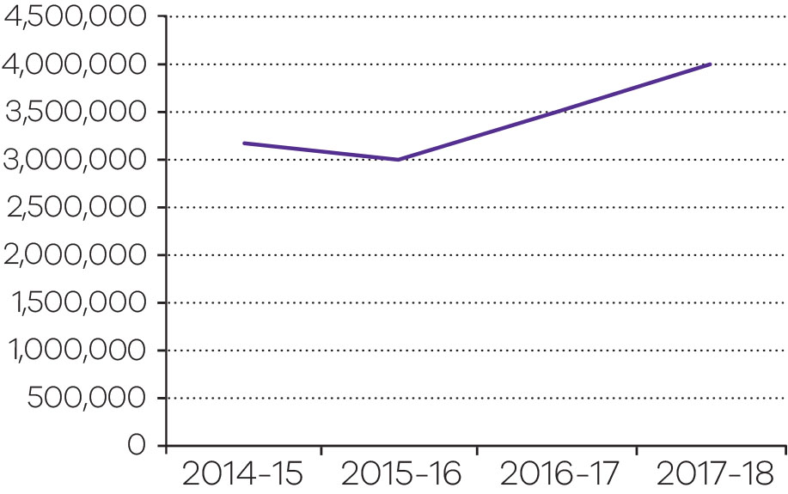
Output performance measures: Regulation of the Victorian consumer marketplace
This output upholds a fair and competitive Victorian marketplace. As Victoria’s consumer regulator, CAV works to ensure that the market works effectively by detecting and addressing non-compliance with the law. The output provides for informing consumers and businesses about their rights and responsibilities under the law, engaging with business to ensure compliance, registration and occupational licensing for individuals and organisations and regulation of the residential tenancies market. DBDRV is an independent government agency that provides free services to help resolve domestic (residential) building disputes.
Performance measures | Unit of measure | 2017-18 actual | 2017-18 target | Performance variation (%) | Result
Quantity
Compliance activities, from compliance assistance through to court actions | number | 9 584 | 9 600 | -0.2 | ○
Information and advice provided to consumers, tenants and businesses: through other services including written correspondence, face to face and dispute assistance | number | 118 309 | 114 300 | 3.5 | ✓
Information and advice provided to consumers, tenants and businesses: through telephone service | number | 304 048 | 325 800 | -6.7 | ■
The actual is lower than the target due to a reduction in call volumes. This is in line with Consumer Affairs Victoria’s (CAV) strategic intent to increase uptake of its digital services, thereby reducing the need for further telephone assistance.
Transactions undertaken: Residential Tenancies Bonds Authority (RTBA) transactions | number | 461 137 | 469 000 | -1.7 | ○
Transactions undertaken: registration and licensing transactions | number | 93 186 | 86 700 | 7.5 | ✓
The actual is above the target due to an increase in registration activity and estate agent transactions, in part as a result of making electronic transactions simpler through myCAV.
Victims of family violence assisted with financial counselling | number | 2 421 | 2 250 | 7.6 | ✓
The actual is above the target due to demand exceeding initial forecasts for this new service.
Dispute resolution services provided by Domestic Building Dispute Resolution Victoria | number | 5 981 | 3 000 | 99.4 | ✓
The actual is above the target due to demand for Domestic Building Dispute Resolution Victoria (DBDRV) far exceeding initial estimates for this new service.
Quality
Rate of compliance with key consumer laws | per cent | 99.3 | 95 | 4.5 | ✓
Timeliness
Regulatory functions delivered within agreed timeframes | per cent | 97.7 | 93 | 5.1 | ✓
The actual is above the target due to the prompt processing of regulatory functions.
Cost
Total output cost | $ million | 140.6 | 139.7 | 0.6 | ○
Note:
✓ Performance target achieved or exceeded.
○ Performance target not achieved – within 5 per cent variance.
■ Performance target not achieved – exceeds 5 per cent variance.

Five-year financial summary and review of financial conditions
($ thousand)
 | 2018 | 2017 | 2016 (ii) | 2015 (iii) | 2014 (iv)
Income from government (i) | 6,837,664 | 6,054,737 | 5,510,616 | 5,178,419 | 5,226,476
Total income from transactions | 6,957,167 | 6,166,460 | 5,617,256 | 5,283,278 | 5,330,781
Total expenses from transactions | (6,937,704) | (6,160,999) | (5,608,125) | (5,277,809) | (5,292,871)
Net result from transactions | 19,463 | 5,461 | 9,131 | 5,469 | 37,910
Net result for the period | 29,824 | (1,543) | 6,764 | (8,435) | 50,150
Net cash flow from operating activities | 88,966 | 100,076 | 109,504 | 86,714 | 136,283
Total assets | 4,809,430 | 3,826,386 | 3,439,423 | 3,597,308 | 4,164,738
Total liabilities | 1,753,930 | 1,116,384 | 984,926 | 1,085,039 | 1,454,352
i. Income from government includes both output and special appropriations.
ii. The 2015-16 comparative has been adjusted to correct a prior period error. Costs were incorrectly included in a building asset under construction, these costs should have been expensed.
iii. The 2014-15 comparative has been adjusted to correct a prior period error on moving assets in and out of trusts by using revenue and expenses. Additionally, in 2014-15, some items of equipment and expense were incorrectly capitalised as part of a building asset.
iv. The 2013-14 comparative has been adjusted to correct a prior period error and remove balances relating to the office of the Freedom of Information Commissioner.
Income from government and total income from transactions increased in 2017-18 due to:
- New and increased funding mainly for the corrections and youth justice portfolios, including funding for the commencement of the new Ravenhall Correctional Centre and a full year funding impact for youth justice custodial and community based services.
- New and increased Victoria Police funding for initiatives including the Community Safety Statement and Public Safety – Police Response.
- Additional funding for Prison Capacity Expansion and Youth Justice Review and Strategy announced in the 2017-18 Budget update.
Total expenses from transactions increased in 2017-18 due to:
- Growth in the employee benefit expense across the justice system, primarily in the corrections and youth justice portfolios, due to increased staff numbers and incurring a full year expense for youth justice since its transfer from the DHHS in April 2017.
- An increase in grant funding passed onto entities such as Victoria Police, CFA, Metropolitan Fire and Emergency Services Board (MFB) and VLA.
- An increase in outsourced contract costs mainly for new and increased prison correction service fees and increased Youth Justice Service Agreement Management Systems costs.
Net result increased in 2017-18 mainly due to:
- An increase in returns on the department’s managed investment schemes in this financial year.
- A change in the interest rates on the revaluation of the long service leave provision.
Total assets increased in 2017-18 mainly due to the recognition of property, plant and equipment upon completion of Ravenhall Correctional Centre in November 2017.
Total liabilities increased in 2017-18 mainly due to the recognition of a finance lease liability upon completion of Ravenhall Correctional Centre.
Detailed financial information about the performance of each of the department’s output activities is contained in note 4 of the financial statements.
In general, delivery of services by the output activities of the department were within defined budgetary objectives. A comparison of budget and actual financial statements is contained under Budget Portfolio Outcomes in Appendix 2.

Disclosure of grants and other transfers (other than contributions by owners)
The department has provided assistance to certain companies and organisations. Financial assistance provided in 2017-18 was as follows:
Organisation | ($ thousand)
Policing and Crime Prevention
Victoria Police | 3,051,625
Local councils | 9,674
Community support groups | 7,127
Other | 37
Sub total | 3,068,463
Enforcing and Managing Correctional Orders
Community support groups | 3,044
Department of Health and Human Services | 3,226
Court Services Victoria | 1,265
Other | 1,192
Sub total | 8,727
Youth Justice
Other | 682
Sub total | 682
Criminal Justice Services
Victoria Legal Aid | 171,387
Office of Public Prosecutions | 70,816
Victorian Institute of Forensic Medicine | 36,771
Community support groups | 36,308
Sentencing Advisory Council | 2,018
Court Services Victoria | 1,787
Other | 2,029
Sub total | 321,116
Civil Justice Services
Victorian Equal Opportunity and Human Rights Commission | 9,428
Community support groups | 1,697
Court Services Victoria | 272
Other | 772
Sub total | 12,169
Emergency Management
Country Fire Authority | 593,192
Metropolitan Fire and Emergency Services Board | 380,932
Victoria State Emergency Service Authority | 57,765
Emergency Services Telecommunications Authority | 45,324
Life Saving Victoria | 11,328
Ambulance Victoria | 9,214
Local councils | 2,498
Community support groups | 2,872
Other | 472
Sub total | 1,103,597
Industry Regulation and Support
Victorian Commission for Gambling and Liquor Regulation | 37,893
Racing clubs and services | 27,861
Community support groups | 21,429
Court Services Victoria | 20,082
Victorian Responsible Gambling Foundation | 2,417
Department of Health and Human Services | 6,420
Director of Housing | 2,408
Other | 853
Sub total | 119,363
Total | 4,634,117

Jesuit Social Services and Catholic Social Services, Dropping Off the Edge, 2015 (https://dote.org.au/).
One additional minimum-security prisoner absconded while on escorted leave in 2017-18. This incident is not classified as an open perimeter or secure perimeter escape according to Reporting on Government Services (RoGS) counting rules.
The previously published figure for 2016-17 was 33.1 per cent.
Young people may receive diversion on more than one occasion.
A figure of three was reported for the 2014-15 year in last years annual report. The correct figure is six. Three references were finalised during the year. However, completed projects are defined for the purposes of the BP3 figures as a publication. There were six publications completed during the 2014-15 financial year.
Figures reported in the 2016-17 Annual Report were the number of applications processed. This year the percentage of negative notices issued have been reported to align with BP3 figures.

